**Technologies used:**

1. **My Web API has been built on:**

* .Net Framework (Web API 2.0)
* C#
* HTTP protocol
* User authentication required for accessing the service
* Cacheable
* Secure access
* Create your username and password by following the below screenshot in order to gain access:

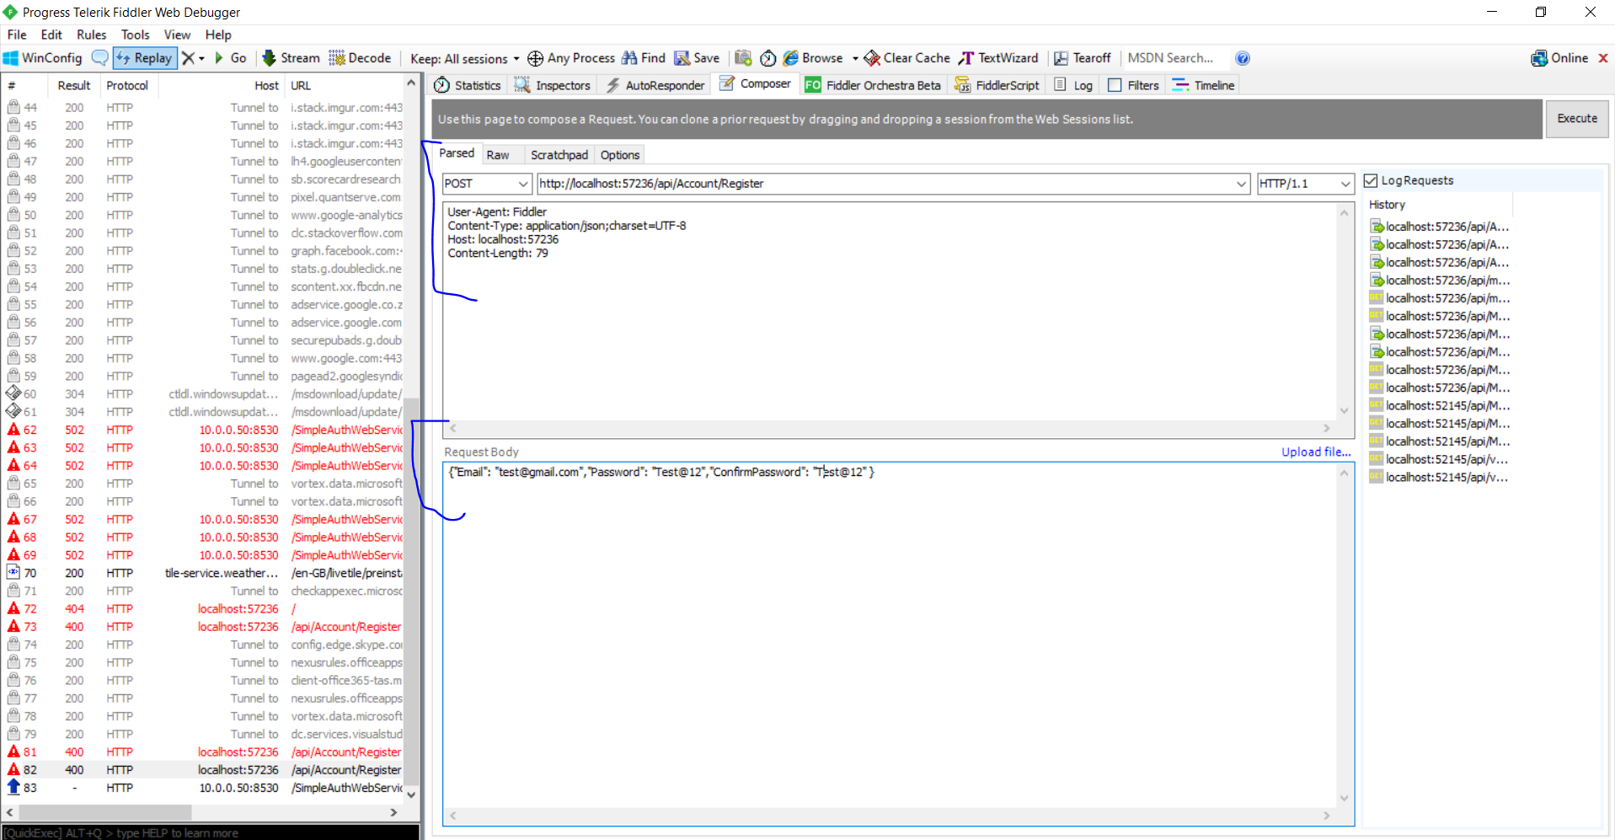

* Please note that you need the following application in order to mock My service:

**Postman** or **Fiddler**. Alternatively, you can you the **MVC Application**

HTTP Verb URI Description

GET api/MoviesAndSeries/1 Returns Movie

GET api/MoviesAndSeries returns all movies

1. **External party Service(s):**

* Used the below:
* <https://swapi.co/api/films/>
* This service provides with a list of Movies containing: Date created, producers, directors, summary or description of the Movies

1. **MVC dummy Application**

* Shows a searched movie
* Search individual movie or all movies
* Used **.Net MVC 5**, and **Jquery** for making service calls

1. **Google Drive URL:**

**This is the location where my solution file has been saved as a zip file**

* **OneSolutionService** – this is my Web API
* **MvcApplication** – This is a mock MVC application

1. **I wish myself the best of luck to be given a chance to show what else I got!**