Synchronous improvement of methane production and digestate dewaterability in sludge anaerobic digestion by nanobubble

Supplementary materials

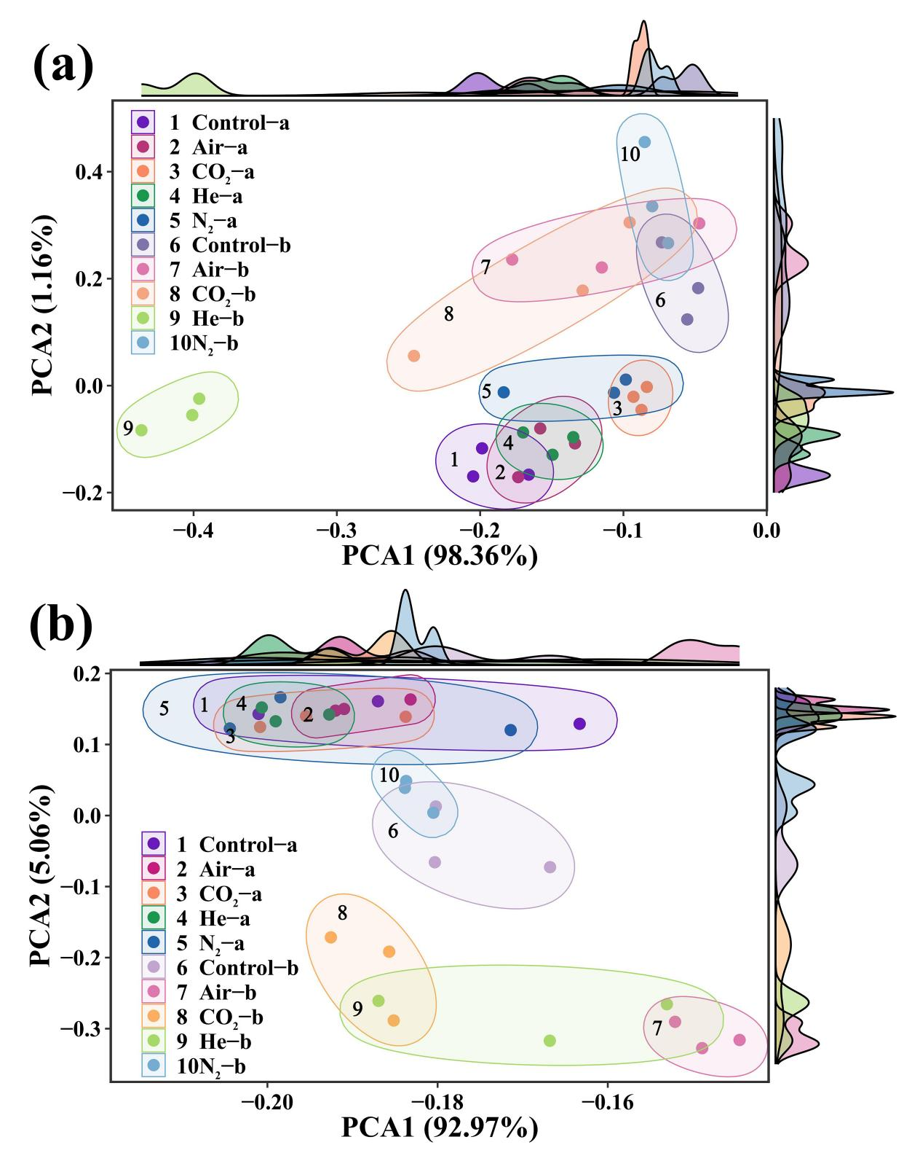
Fig.S1 Plot of PCA analysis of archaea (a) and bacteria (b)

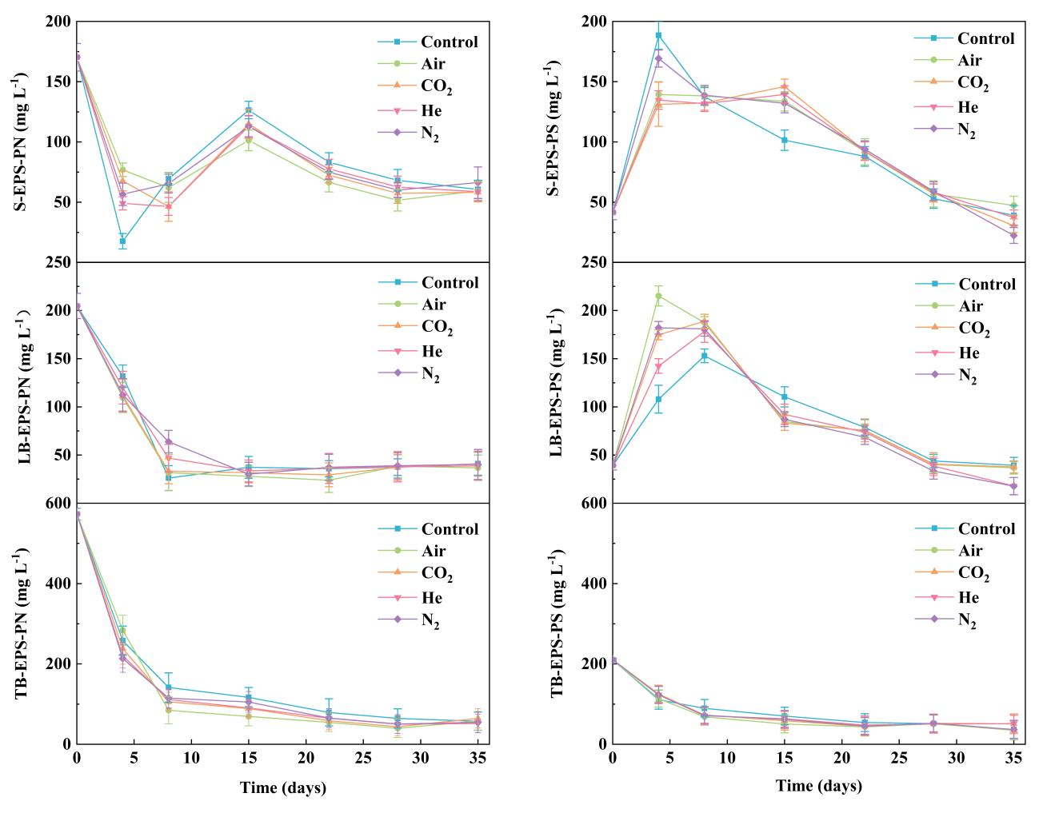
Fig.S2 Changes in EPS during anaerobic digestion

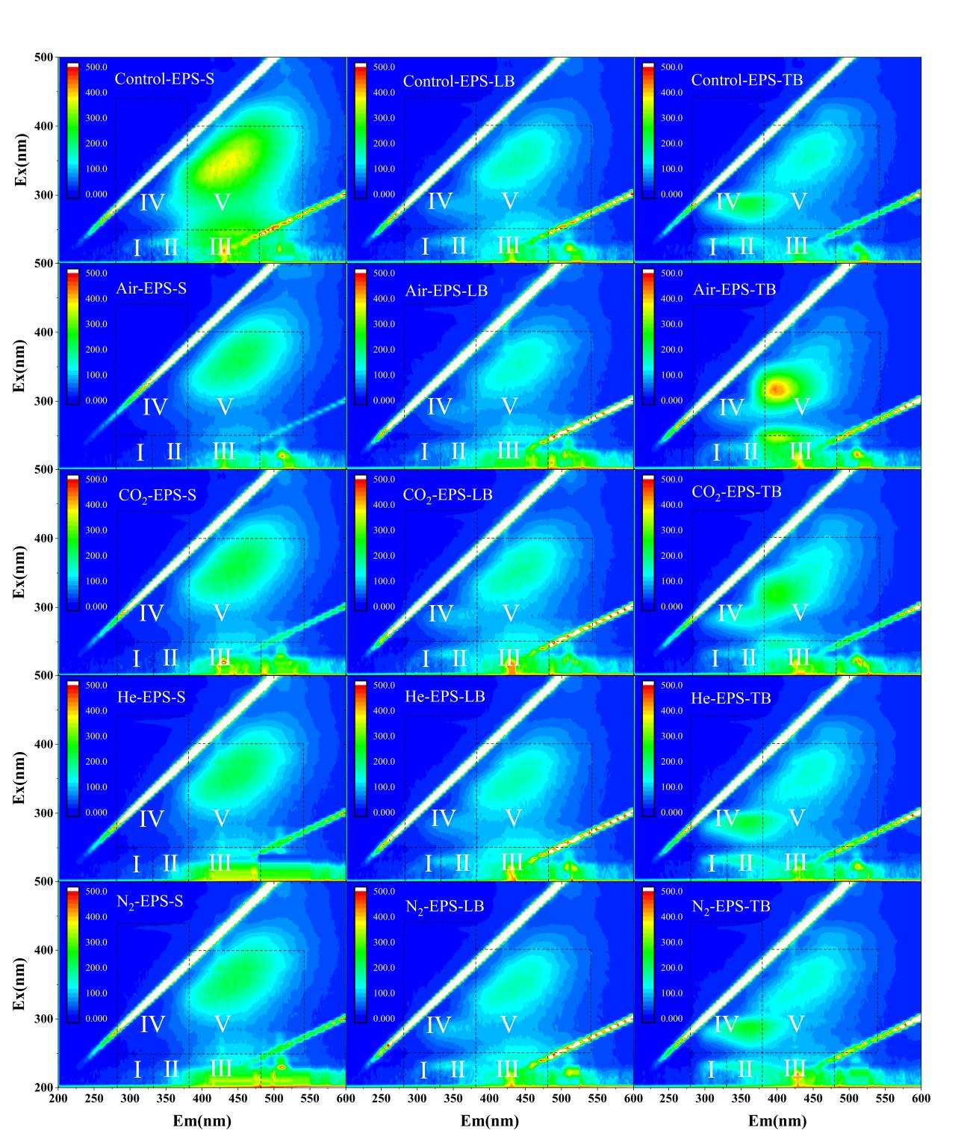
Fig.S3 3D-EEM maps of EPS of digestate

Table S1 Properties of inoculum and substrate
 | Seed sludge |  | Dewatered sludge | Initial sludge (mixture of  Seed sludge, DWS, and NBW)
TS (%) |  | 5.4±0.7 | 13.1±1.0 | 6.4±0.5
VS (%) |  | 2.5±0.3 | 7.4±0.5 | 3.5±0.1
VS/TS (%) |  | 46.1±1.3 | 56.7±0.3 | 55.6±0.8
pH |  | 7.64±0.12 | 7.25±0.09 | 7.33±0.02
SCOD (mg L⁻¹) |  | 2803.2±27.8 | 4168.1±60.6 | 2994.9±67.4
TAN (mgN L⁻¹) |  | 1351.0±71.4 | 831.6±40.6 | 477.4±7.0
FAN (mgN L⁻¹) |  | 71.5±0.1 | 18.2±0.1 | 12.7±0.1
SRF (10¹² m kg⁻¹) |  | - | - | 6.5±0.9
CST (s) |  | - | - | 15.0±0.4
MC (%) |  | - | - | 85.6±0.2
C (%) |  | 29.6±1.0 | 22.8±1.4 | -
N (%) |  | 2.3±0.1 | 3.0±0.1 | -
H (%) |  | 4.3±0.1 | 3.7±0.1 | -
S (%) |  | 0.61±0.03 | 0.76±0.01 | -
C/N |  | 13.0±0.2 | 7.6±0.1 | -
Note: The initial sludge mass mixing ratio was DWS: NBW: seed sludge = 682g:682g:136g and the initial sludge properties are based on five operating conditions; TS: total solid; VS: volatile solid; SCOD: soluble chemical oxygen demand; TAN: total ammonia nitrogen; FAN: free ammonia nitrogen; SRF: specific resistance to filtration; CST: capillary suction time; MC: moisture content is based on dewatered sludge cake; Determination of C, N, H, and S content are all based on the dry weight of the sludge.
Table S2 Alpha correlation index of archaea and bacteria
Sample | OTUs | Shannon | Chao1 | Simpson
Archaea Control-a | 52.6±10.0 | 0.29±0.02 | 8.3±0.5 | 0.64±0.03
Archaea Air-a | 60.3±2.4 | 0.29±0.03 | 9.0±3.6 | 0.66±0.35
Archaea CO₂-a | 58.6±4.5 | 0.25±0.01 | 8.3±2.5 | 0.74±0.01
Archaea He-a | 52.0±10.8 | 0.31±0.03 | 8.3±0.7 | 0.63±0.04
Archaea N₂-a | 53.6±11.9 | 0.29±0.07 | 7.8±1.4 | 0.68±0.09
Archaea Control-b | 46.6±8.1 | 0.19±0.03 | 10.6±1.1 | 0.81±0.04
Archaea Air-b | 38.3±2.0 | 0.29±0.11 | 9.1±1.2 | 0.68±0.13
Archaea CO₂-b | 45.3±14.5 | 0.36±0.07 | 11.1±4.2 | 0.60±0.11
Archaea He-b | 42.3±6.1 | 0.39±0.05 | 11.6±3.3 | 0.53±0.22
Archaea N₂-b | 42.7±6.6 | 0.27±0.05 | 9.0±1.0 | 0.72±0.05
Bacteria Control-a | 2724.0±261.2 | 2.51±0.01 | 2724.9±261.1 | 0.0085±0.0015
Bacteria Air-a | 2738.3±55.1 | 2.53±0.04 | 2739.3±55.3 | 0.0086±0.0008
Bacteria CO₂-a | 2853.6±227.2 | 2.61±0.03 | 2854.8±227.2 | 0.0074±0.0010
Bacteria He-a | 2861.3±101.4 | 2.41±0.04 | 2651.0±101.4 | 0.0166±0.0008
Bacteria N₂-a | 2700.6±122.7 | 2.54±0.04 | 2701.6±122.5 | 0.0083±0.0009
Bacteria Control-b | 2195.0±59.6 | 2.18±0.07 | 2196.3±59.6 | 0.0343±0.0021
Bacteria Air-b | 2232.3±133.5 | 2.24±0.05 | 2233.5±133.7 | 0.0279±0.0012
Bacteria CO₂-b | 2351.0±122.5 | 2.18±0.07 | 2352.1±112.5 | 0.0359±0.0132
Bacteria He-b | 2147.1±145.7 | 2.08±0.09 | 2147.9±145.7 | 0.0367±0.0060
Bacteria N₂-b | 2347.2±40.0 | 2.08±0.03 | 2348.1±40.3 | 0.0362±0.0005
Note: The first ten groups are alpha correlation indices for archaea and the last ten groups are alpha correlation indices for bacteria; ‘-a’ shows microorganisms on Day 8 of anaerobic digestion; ‘-b’ shows microorganisms on Day 35 of anaerobic digestion.

