Supplementary information
Inoculum source | O₂ partial pressure [$P_{O_{2}}$ %] | VOSiCs concentration [ppm] | Substrate | Treatment
Non-acclimated | 0 | 0 | OS | C1_N
Non-acclimated | 0 | 50 | OS + D4:D5 | T1_N
Non-acclimated | 0 | 500 | OS + D4:D5 | T2_N
Non-acclimated | 1 | 0 | OS | C2_N
Non-acclimated | 1 | 50 | OS + D4:D5 | T3_N
Non-acclimated | 1 | 500 | OS + D4:D5 | T4_N
Non-acclimated | 3 | 0 | OS | C3_N
Non-acclimated | 3 | 50 | OS + D4:D5 | T5_N
Non-acclimated | 3 | 500 | OS + D4:D5 | T6_N
Non-acclimated | None | None | None | C0_N
Acclimated | 0 | 0 | OS | C1_A
Acclimated | 0 | 50 | OS + D4:D5 | T1_A
Acclimated | 0 | 500 | OS + D4:D5 | T2_A
Acclimated | 1 | 0 | OS | C2_A
Acclimated | 1 | 50 | OS + D4:D5 | T3_A
Acclimated | 1 | 500 | OS + D4:D5 | T4_A
Acclimated | 3 | 0 | OS | C3_A
Acclimated | 3 | 50 | OS + D4:D5 | T5_A
Acclimated | 3 | 500 | OS + D4:D5 | T6_A
Acclimated | None | None | None | C0_A
Supplementary Table 1. Experimental design and nomenclature for the treatments used in this study. C: control, T: Treatment, A: Acclimated, and N: Non-acclimated. *OS: Organic substrate (200 ppm).
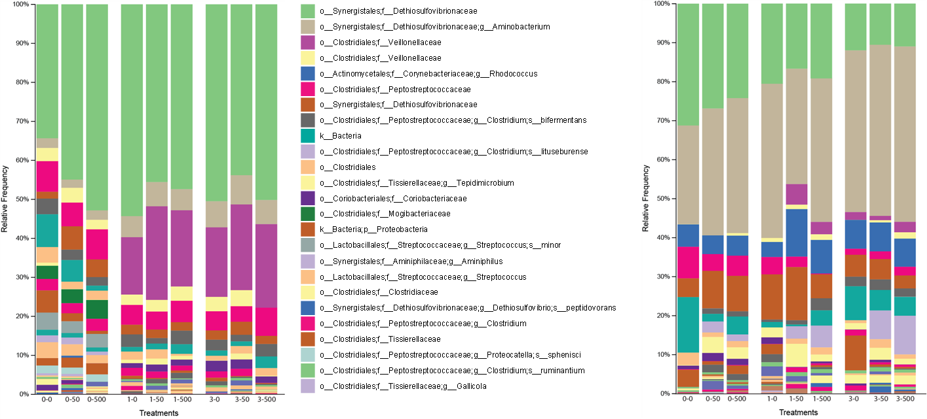
Fig. S1 16S rRNA sequencing taxonomic classification of the selected samples. Left, non-acclimated inoculum. Right, acclimated inoculum. Treatments in the X-axis correspond to the oxygen concentration used and the VOSiCs supplemented.

Fig. S2 Beta diversity tests between non-acclimated and acclimated inoculum treatments. A. Weighted Unifrac analysis; B. Jaccard analysis; C. Bray-Curtis analysis.

