Supplementary material
Table S1 Characteristics of FMW and DMW at 1%TS for use in the experiments (n≥5)

Parameter | Unit | Wastewater at 1 %TS
Parameter | Unit | FMW | DMW
ORP | mV | 49±10 | 54±8
pH | - | 7.63±0.05 | 7.22±0.05
NH₄⁺ | mg/L as NH₄⁺-N | 67±4 | 33±4
Alkalinity | mg/L as CaCO₃ | 596±16 | 490±19
TVFA | mg/L as HAc | 580±15 | 229±20
Acetic acid | mg/L | 201±7 | 53±5
Propionic acid | mg/L | 124±5 | 25±4
Butyric acid | mg/L | 146±6 | 23±3
Varleric acid | mg/L | 28.8±4 | not detected
SCOD | mg/L | 1,893±75 | 639±48
TCOD | mg/L | 15,721±817 | 14,527±562

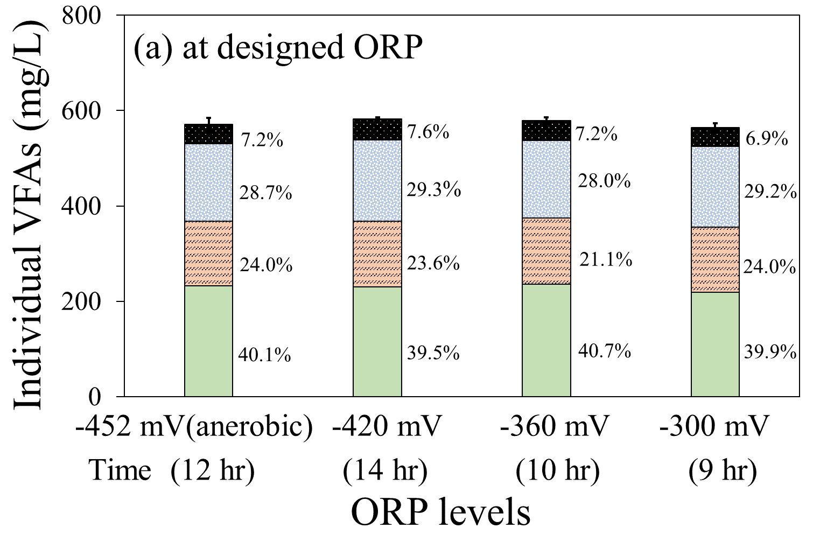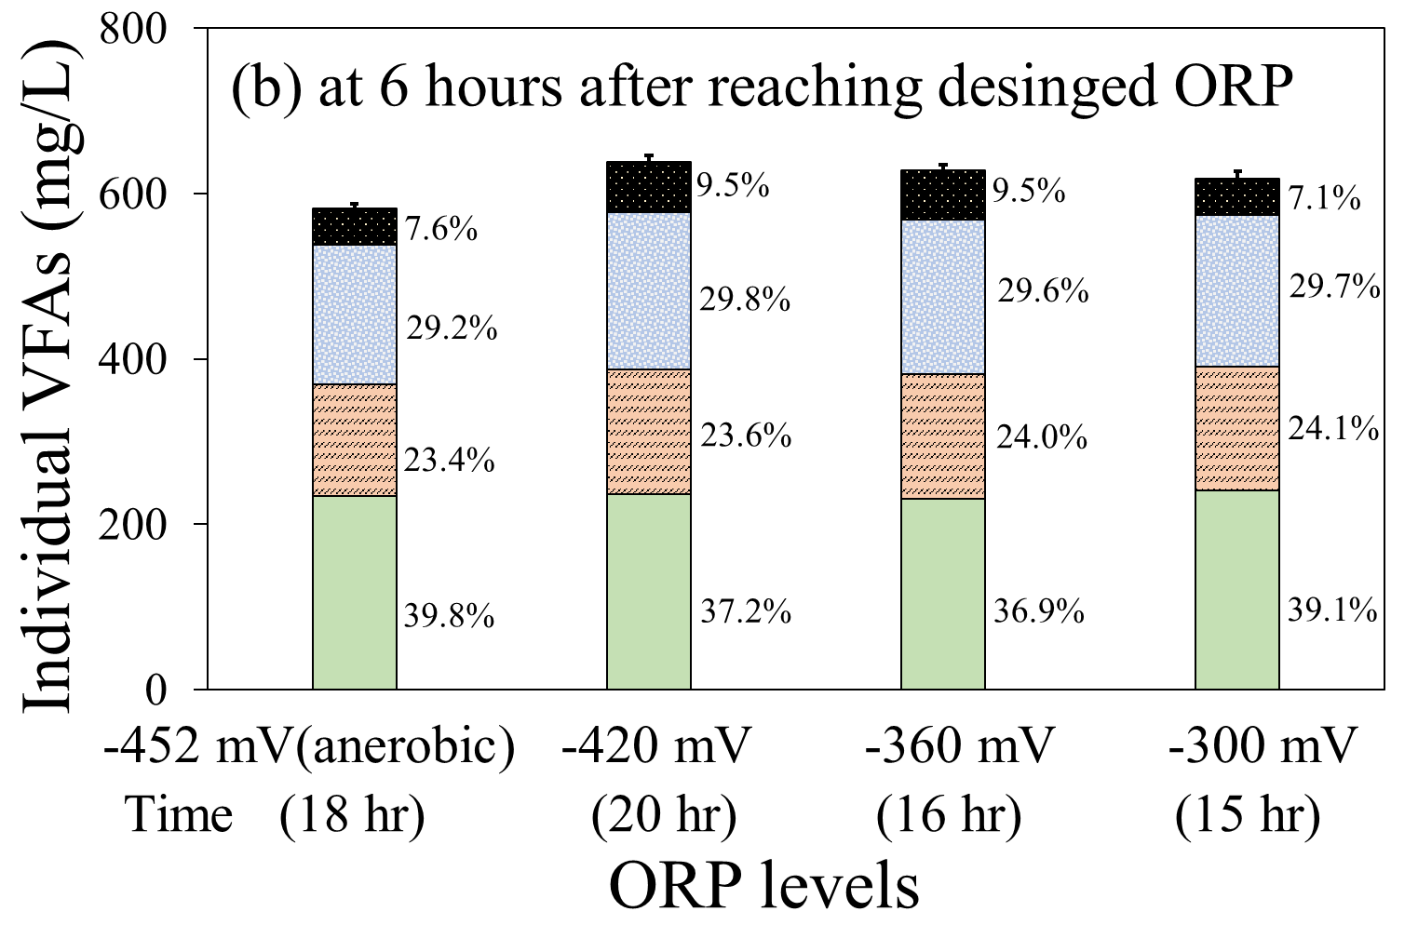
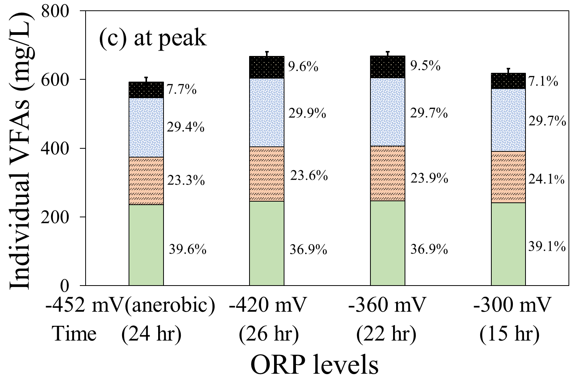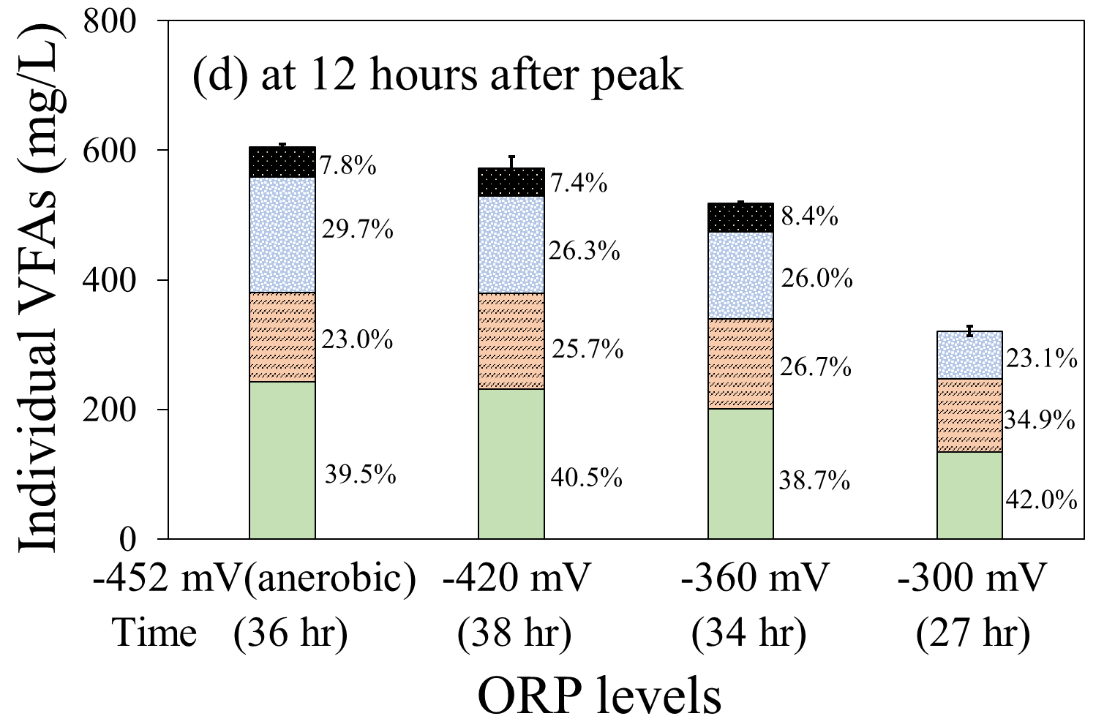
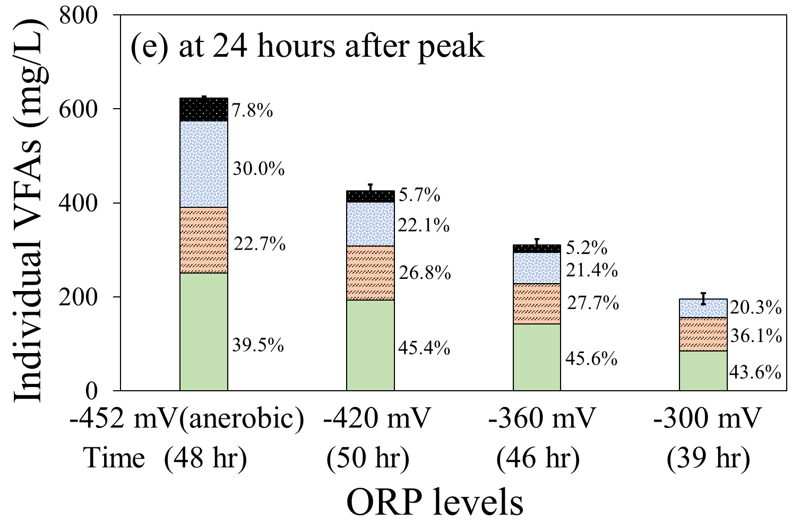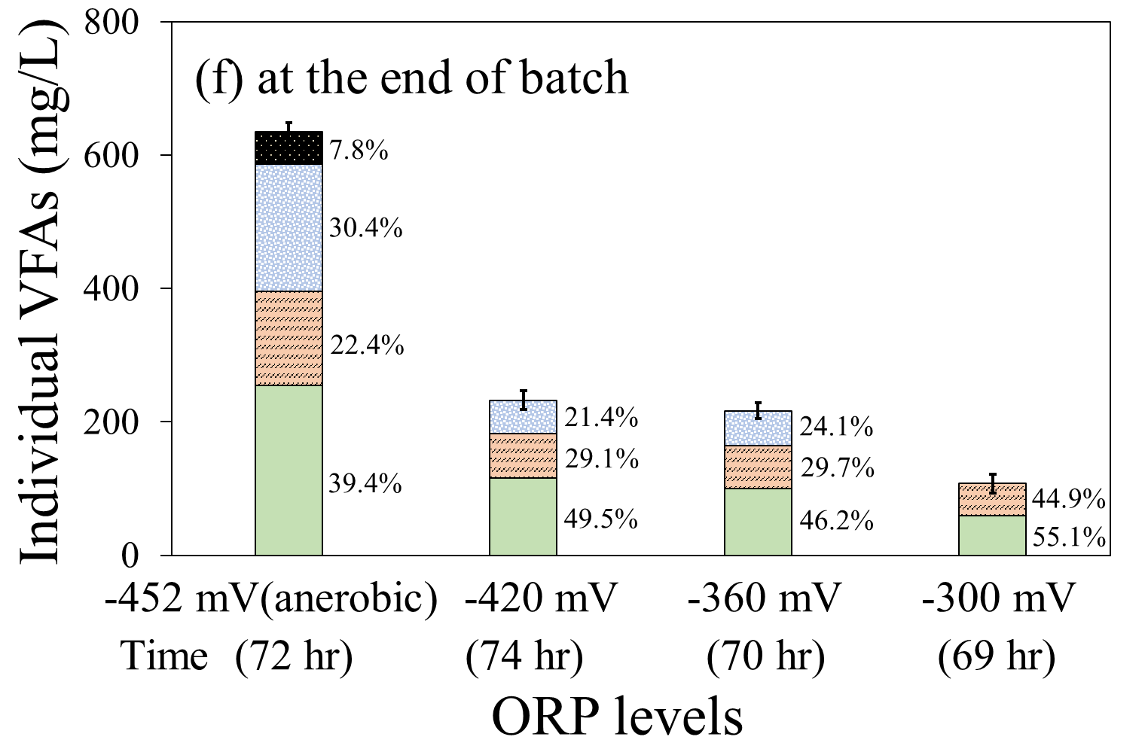
HAc HPr HBu HVa

Figure S1 Individual VFA profile (a) at the time reaching designed ORP, (b) at 6 hours after reaching designed ORP, (c) at the time reaching peak total VFA, (d) at 12 hours after peak total VFA, (e) at 24 hours after peak total VFA, and (f) at the end of batch

