Microaeration enhances methane production in anaerobic digestion: A systematic review and meta-analysis

Table S1. Studies included in the qualitative synthesis and meta-analysis after eligibility assessment.
ID | Reference
1 | Loughrin, J., & Lovanh, N. (2019). Aeration to improve biogas production by recalcitrant feedstock. Environments - MDPI, 6(4). https://doi.org/10.3390/environments6040044
2 | Song, Y., Mahdy, A., Hou, Z., Lin, M., Stinner, W., Qiao, W., & Dong, R. (2020). Air Supplement as a Stimulation Approach for the in Situ Desulfurization and Methanization Enhancement of Anaerobic Digestion of Chicken Manure. Energy and Fuels, 34(10), 12606 – 12615.  https://doi.org/10.1021/acs.energyfuels.0c01724
3 | Song, C., Li, W., Cai, F., Liu, G., & Chen, C. (2021). Anaerobic and Microaerobic Pretreatment for Improving Methane Production From Paper Waste in Anaerobic Digestion. Frontiers in Microbiology, 12.  https://doi.org/10.3389/fmicb.2021.688290
4 | Azizi, S. M. M., Zakaria, B. S., Haffiez, N., Niknejad, P., Maal-Bared,R., Molla, S., & Dhar, B. R. (2023). Bench-Scale Liquid-Phase Microaeration and Iron Dosing Comparison for In Situ Biogas Desulfurization and Antibiotic Resistance Management in Mesophilic Anaerobic Digestion. ACS ES&T Water, 3(8), 2458–2470.  https://doi.org/10.1021/acsestwater.3c00103
5 | Silva, T. P., de Oliveira, M. G., Mourao, J. M. M., Possetti, G. R. C.,Pereira, E. L., & dos Santos, A. B. (2022). Bioenergy recovery potential from upflow microaerobic sludge blanket reactor fed with swine wastewater. Biochemical Engineering Journal , 187.  https://doi.org/10.1016/j.bej.2022.108675
6 | Fu, S. F., Shi, X. S., Dai, M., & Guo, R. B. (2016). Effect of Different Mixed Microflora on the Performance of Thermophilic Microaerobic Pretreatment. Energy and Fuels, 30(8), 6413–6418.  https://doi.org/10.1021/acs.energyfuels.6b00440
7 | Tsapekos, P., Kougias, P. G., Vasileiou, S. A., Lyberatos, G., & Angelidaki, I. (2017). Effect of micro-aeration and inoculum type on the biodegradation of lignocellulosic substrate. Bioresource Technology, 225, 246–253.  https://doi.org/10.1016/j.biortech.2016.11.081
8 | Wang, Z., Liu, J., & Tan, F. (2022). Effect of microaeration combined with ferric chloride pretreatment on anaerobic digestion of corn stalk. Energy sources part a-recovery utilization and environmental effects.  https://doi.org/10.1080/15567036.2022.2039330
9 | Diaz, I., Donoso-Bravo, A., & Fdz-Polanco, M. (2011). Effect of microaerobic conditions on the degradation kinetics of cellulose. Bioresource Technology, 102(21), 10139–10142.  https://doi.org/10.1016/j.biortech.2011.07.096
10 | Rashvanlou, B. R., Rezaee, A., Farzadkia, M., Gholami, M., & Kermani, M. (2020). Effect of micro-aerobic process on improvement of anaerobic digestion sewage sludge treatment: Flow cytometry and ATP assessment. RSC Advances, 10(59), 35718–35728.  https://doi.org/10.1039/d0ra05540a
11 | Oliveira, M.G., Mourao, J. M. M., Silva, F. S. S., Santos, A. B. Dos, & Pereira, E. L. (2021). Effect of microaerophilic treatment on swine wastewater (SWW) treatment:Engineering and microbiological aspects. Journal of Environmental Management, 299.  https://doi.org/10.1016/j.jenvman.2021.113598
12 | Zhen, X., Zhang, X., Li, S., Li, M., & Kang, J. (2020). Effect of micro-oxygen pretreatment on gas production characteristics of anaerobic digestion of kitchen waste. Journal of Material Cycles and Waste Management, 22(6), 1852–1858  https://doi.org/10.1007/s10163-020-01072-9
13 | Diaz, I., Perez, S. I., Ferrero, E. M., & Fdz-Polanco, M. (2011). Effect of oxygen dosing point and mixing on the microaerobic removal of hydrogen sulphide in sludge digesters. Bioresource Technology, 102(4), 3768–3775.  https://doi.org/10.1016/j.biortech.2010.12.016
14 | Wang, L., Liu, C., Wei, B., Song, C., Cai, F., Liu, G., & Chen, C. (2021). Effects of different microbial pretreatments on the anaerobic digestion of giant grass under anaerobic and microaerobic conditions. Bioresource Technology, 337.  https://doi.org/10.1016/j.biortech.2021.125456
15 | Hu, Y., Lu, C. S., Yang, Y., & Li, Y. Y. (2022). Effects of operational variations of micro-oxygenation and pH shock on the competition between methane production and sulfate reduction in a UASB reactor. Journal of Environmental Chemical Engineering, 10(5), 108390.  https://doi.org/10.1016/j.jece.2022.108390
16 | Stephenson, R. J., Patoine, A., & Guiot, S. R. (1999). Effects of oxygenation and upflow liquid velocity on a coupled anaerobic/aerobic reactor system. Water Research, 33(12), 2855 – 2863.  https://doi.org/10.1016/S0043-1354(98)00505-3
17 | Aynur, S. K., Riffat, R., & Murthy, S. (2014). Efficiency of Autothermal Thermophilic Aerobic Digestion Under Two Different Oxygen Flow Rates. Water Environment research, 86(1), 87–96.  https://doi.org/10.2175/106143013X13596524517021
18 | Zhan, Y., Zhu, J., Xiao, Y., Schrader, L. C., Xiao Wu, S., Aka Robinson Jr, N., & Wang, Z. (2023). Employing micro-aeration in anaerobic digestion of poultry litter and wheat straw: Batch kinetics and continuous performance. Bioresource Technology, 368.  https://doi.org/10.1016/j.biortech.2022.128351
19 | Lim, J. W., & Wang, J. Y. (2013). Enhanced hydrolysis and methane yield by applying microaeration pretreatment to the anaerobic co-digestion of brown water and food waste. Waste Management, 33(4), 813–819.  https://doi.org/10.1016/j.wasman.2012.11.013
20 | Amin, F. R., Khalid, H., Li, W., Chen, C., & Liu, G. (2021). Enhanced methane production and energy potential from rice straw by employing microaerobic pretreatment via anaerobic digestion. Journal of Cleaner Production, 296, 126434.  https://doi.org/10.1016/j.jclepro.2021.126434
21 | He, S., Fan, X., Luo, S., Katukuri, N. R., & Guo, R. (2017). Enhanced the energy outcomes from microalgal biomass by the novel biopretreatment. Energy Conversion and Management, 135, 291–296.  https://doi.org/10.1016/j.enconman.2016.12.049
22 | Tsapekos, P., Alvarado-Morales, M., Kougias, P. G., Treu, L., & Angelidaki, I. (2021). Enhancing anaerobic digestion of agricultural residues by microaerobic conditions. Biomass Conversion and Biorefinery, 11(6), 2325 – 2333.  https://doi.org/10.1007/s13399-019-00430-4
23 | Fu, S.-F., Liu, R., Sun, W.-X., Zhu, R., Zou Huaand Zheng, Y., & Wang, Z.-Y. (2020). Enhancing energy recovery from corn straw via two-stage anaerobicdigestion with stepwise microaerobic hydrogen fermentation and methanogenesis. Journal of cleaner production, 247.  https://doi.org/10.1016/j.jclepro.2019.119651
24 | Ruan, D., Zhou, Z., Pang, H., Yao, J., Chen, G., & Qiu, Z. (2019). Enhancing methane production of anaerobic sludge digestion by microaeration: Enzyme activity stimulation, semi-continuous reactorvalidation and microbial community analysis. Bioresource Technology, 289. https://doi.org/10.1016/j.biortech.2019.121643
25 | Loughrin, J., Antle, S., Bryant, M., Berry, Z., & Lovanh, N. (2020). Evaluation of microaeration and sound to increase biogas production from poultry litter. Environments - MDPI, 7(8), 1 – 10.  https://doi.org/10.3390/environments7080062
26 | Fu, S.-F., Wang, F., Shi, X.-S., & Guo, R.-B. (2016). Impacts of microaeration on the anaerobic digestion of corn straw andthe microbial community structure. Chemical Engineering JournaL, 287, 523–528.  https://doi.org/10.1016/j.cej.2015.11.070
27 | Xu, W., Fu, S., Yang, Z., Lu, J., & Guo, R. (2018). Improved methane production from corn straw by microaerobic pretreatment with a pure bacteria system. Bioresource Technology, 259, 18 – 23.  https://doi.org/10.1016/j.biortech.2018.02.046
28 | Jenicek, P., Keclik, F., Maca, J., & Bindzar, J. (2008). Use of microaerobic conditions for the improvement of anaerobicdigestion of solid wastes. Water Science and Technology, 58(7), 1491–1496.  https://doi.org/10.2166/wst.2008.493
29 | Nguyen, D., Wu, Z., Shrestha, S., Lee, P.-H., Raskin, L., & Khanal, S. K. (2019). Intermittent micro-aeration: New strategy to control volatile fatty acid accumulation in high organic loading anaerobic digestion. Water Research, 166. https://doi.org/10.1016/j.watres.2019.115080
30 | Krayzelova, L., Bartacek, J., Kolesarova, N., & Jenicek, P. (2014). Microaeration for hydrogen sulfide removal in UASB reactor. Bioresource Technology, 172, 297–302.  https://doi.org/10.1016/j.biortech.2014.09.056
31 | Ramos, I., & Fdz-Polanco, M. (2014). Microaerobic control of biogas sulphide content during sewage sludge digestion by using biogas production and hydrogen sulphide concentration. Chemical Engineering Journal, 250, 303–311.  https://doi.org/10.1016/j.cej.2014.04.027
32 | Morello, R., Di Capua, F., Pontoni, L., Papirio, S., Spasiano, D., Fratino, U., Pirozzi, F., & Esposito, G. (2021). Microaerobic digestion of low-biodegradable sewage sludge: Effect of air dosing in batch reactors. Sustainability (Switzerland), 13(17).  https://doi.org/10.3390/su13179869
33 | Ramos, I., Perez, R., Reinoso, M., Torio, R., & Fdz-Polanco, M. (2014). Microaerobic digestion of sewage sludge on an industrial-pilot scale: The efficiency of biogas desulphurisation under different configurations and the impact of O-2 on the microbial communities. Bioresource Technology, 164, 338–346.  https://doi.org/10.1016/j.biortech.2014.04.109
34 | Montalvo, S., Huiliñir, C., Ojeda, F., Castillo, A., Lillo, L., & Guerrero, L. (2016). Microaerobic pretreatment of sewage sludge: Effect of air flow rate, pretreatment time and temperature on the aerobic process and methane generation. International Biodeterioration and Biodegradation, 110, 1–7.  https://doi.org/10.1016/j.ibiod.2016.01.010
35 | Oliveira, M. G., Mourao, J. M. M., de Oliveira, A. K. M., dos Santos, A. B., & Pereira, E. L. (2021). Microaerophilic treatment enhanced organic matter removal and methaneproduction rates during swine wastewater treatment: A long-termengineering evaluation. Renewable Energy, 180, 691–699.  https://doi.org/10.1016/j.renene.2021.08.120
36 | Xu, S., Selvam, A., & Wong, J. W. C. (2014). Optimization of micro-aeration intensity in acidogenic reactor of a two-phase anaerobic digester treating food waste. Waste Management, 34(2), 363 – 369.  https://doi.org/10.1016/j.wasman.2013.10.038
37 | Meng, Y., Jost, C., Mumme, J., Wang, K., & Linke, B. (2016). Oxygen tolerance capacity of upflow anaerobic solid-state (UASS) withanaerobic filter (AF) system. Journal of Environmental Sciences, 45, 200–206.  https://doi.org/10.1016/j.jes.2016.01.009
38 | Wang, L., Jin, W., Cai, F., Song, C., Jin, Y., Liu, G., & Chen, C. (2024). Performance and mechanism of various microaerobic pretreatments on anaerobic digestion of tobacco straw. Bioresource Technology, 393, 130092.  https://doi.org/10.1016/J.BIORTECH.2023.130092
39 | Zhen, F., Luo, X., Xing, T., Sun, Y., Kong, X., & Li, W. (2021). Performance evaluation and microbial community analysis of microaerobic pretreatment on thermophilic dry anaerobic digestion. Biochemical Engineering Journal, 167.  https://doi.org/10.1016/j.bej.2020.107873
40 | Montalvo, S., Ojeda, F., Huiliñir, C., Guerrero, L., Borja, R., & Castillo, A. (2016). Performance evaluation of micro-aerobic hydrolysis of mixed sludge: Optimum aeration and effect on its biochemical methane potential. Journal of Environmental Science and Health - Part A Toxic/Hazardous Substances and Environmental Engineering, 51(14), 1269–1277. https://doi.org/10.1080/10934529.2016.1215195
41 | Feng, L., Li, R., & You, X. (2013). Performance Evaluation of Oxygen and Air for the Microaerobic Removal of Hydrogen Sulphide in Biogas from Cow Manure Anaerobic Digestion. Journal of pure and applied microbiology, 7(SI), 577–587.
42 | Díaz, I., Lopes, A. C., Pérez, S. I., & Fdz-Polanco, M. (2010). Performance evaluation of oxygen, air and nitrate for the microaerobic removal of hydrogen sulphide in biogas from sludge digestion. Bioresource Technology, 101(20), 7724 – 7730.  https://doi.org/10.1016/j.biortech.2010.04.062
43 | Siqueira, J. P. S., Pereira, A. M., Dutra, A. M. M., Firmino, P. I. M., & dos Santos, A. B. (2018). Process bioengineering applied to BTEX degradation in microaerobictreatment systems. Journal of Environmental Management, 223, 426–432.  https://doi.org/10.1016/j.jenvman.2018.06.066
44 | Mahdy, A., Song, Y., Salama, A., Qiao, W., & Dong, R. (2020). Simultaneous H2S mitigation and methanization enhancement of chicken manure through the introduction of the micro-aeration approach. Chemosphere, 253.  https://doi.org/10.1016/j.chemosphere.2020.126687
45 | Fu, S.-F., He, S., Shi, X.-S., Katukuri, N. R., Dai, M., & Guo, R.-B. (2015). The chemical properties and microbial community characterization of the thermophilic microaerobic pretreatment process. Bioresource Technology, 198, 497 – 502.  https://doi.org/10.1016/j.biortech.2015.09.029
46 | Zhu, R., Zhang, Y., Zou, H., Guo, R.-B., & Fu, S.-F. (2022). The effects of micro-aeration on semi-continued anaerobic digestion of corn straw with increasing organic loading rates. Renewable Energy, 195, 1194 – 1201.  https://doi.org/10.1016/j.renene.2022.06.106
47 | Fu, S.-F., Wang, F., Yuan, X.-Z., Yang, Z.-M., Luo, S.-J., Wang, C.-S., & Guo, R.-B. (2015). The thermophilic (55°C) microaerobic pretreatment of corn straw for anaerobic digestion. Bioresource Technology, 175, 203 – 208.  https://doi.org/10.1016/j.biortech.2014.10.072
48 | Zhu, R., Wang, D.-H., Zheng, Y., Zou, H., & Fu, S.-F. (2022). Understanding the mechanisms behind micro-aeration to enhance anaerobic digestion of corn straw. Fuel, 318.  https://doi.org/10.1016/j.fuel.2022.123604
49 | Li, W., Liu, Y., Wu, B., Gu, L., & Deng, R. (2022). Upgrade the high-load anaerobic digestion and relieve acid stress through the strategy of side-stream micro-aeration: biochemical performances, microbial response and intrinsic mechanisms. Water Research, 221.  https://doi.org/10.1016/j.watres.2022.118850
50 | Jenicek, P., Keclik, F., Maca, J., & Bindzar, J. (2008). Use of microaerobic conditions for the improvement of anaerobic digestion of solid wastes. Water Science and Technology, 58(7), 1491 – 1496.  https://doi.org/10.2166/wst.2008.493
51 | Khadir, A., Nakhla, G., Karki, R., Raskin, L., Muller, C., Guevarra, K., Summers, A., Pierce, L., Shahbaz, P., Bell, K., Skerlos, S., & Bronstad, E. (2025). Micro-aeration for hydrogen sulfide reduction in full-scale anaerobic digesters with limited headspace: Performance and sulfide reduction kinetics. Process Safety and Environmental Protection, 196.  https://doi.org/10.1016/j.psep.2025.106911
52 | Jin, Z., Yu, Q., Zhao, Z., & Zhang, Y. (2025). Insight into the role of intermittent microaeration in enhancing lignocellulose-containing anaerobic digestion and humic substances formation. Chemical Engineering Journal, 520.  https://doi.org/10.1016/j.cej.2025.166500
53 | Li, X., Yan, Y.-J., Wu, H.-M., Gadow, S. I., Jiang, H., Kong, Z., & Hu, Y. (2025). Enhancing mesophilic methanogenesis in oleate-rich environments through optimized micro-aeration pretreatment. Waste Management, 193, 171–179.  https://doi.org/10.1016/j.wasman.2024.12.005
54 | Wang, X., Wang, Z., Deng, Y., Mao, H., Yu, Q., & Zhang, Y. (2025). Reactive oxygen species generation induced by coupling Phanerochaete chrysosporium with intermittent micro-aeration to enhance methane production. Chemical Engineering Journal, 521.  https://doi.org/10.1016/j.cej.2025.166351
55 | Ding, K., Wu, B., Wang, Y., Xu, L., Liu, M., Xiang, J., Chen, Y., Gu, L., Li, J., Li, L., He, Q., & Liu, S. (2024). Study on synergistic effect of carrier combined with micro-aeration on anaerobic digestion of food waste. Chemical Engineering Journal, 498.  https://doi.org/10.1016/j.cej.2024.155731
56 | Wu, B., Wang, Y., He, L., Liu, M., Xiang, J., Chen, Y., Gu, L., Li, J., Li, L., Pan, W., & He, Q. (2024). Enhancing Anaerobic Digestion of Food Waste by Combining Carriers and Microaeration: Performance and Potential Mechanisms. ACS ES&T engineering, 4(10), 2506–2519.  https://doi.org/10.1021/acsestengg.4c00298
57 | Ortiz-Ardila, A. E., Celis, C., Usack, J. G., Angenent, L. T., & Labatut, R. A. (2024). Microaeration promotes volatile siloxanes conversion to methane and simpler monomeric products. Bioresource Technology, 400.  https://doi.org/10.1016/j.biortech.2024.130673
58 | Di, Y., Hou, W., Bian, C., Zheng, T., Xiao, B., & Li, L. (2025). Enhancing anaerobic digestion of swine manure using microbial electrolysis cell and microaeration. Chemical engineering journal, 514.  https://doi.org/10.1016/j.cej.2025.163319

Table S2. Substrate group classification.
Category | Substrates
Biomass | Sugarcane bagasse
Biomass | Giant grass
Biomass | Corn straw
Biomass | Maize straw
Biomass | Microalgae
Biomass | Napier grass
Biomass | Rice straw
Biomass | Wheat straw
Biomass | Corn stalk
Biomass | Tobacco straw
Co-digestion | Poultry litter and wheat straw
Co-digestion | Cattle slurry and wheat straw
Co-digestion | Poultry litter
Co-digestion | Corn straw and mixed sludge
Co-digestion | Food waste and brown water
Animal manure | Chicken manure
Animal manure | Swine wastewater
Animal manure | Cow manure
Sludge | Mixed sludge
Sludge | Sewage sludge
Sludge | Activated sludge
Urban solid waste | Food waste
Urban solid waste | Paper waste
Synthetic wastewater | Acetate
Synthetic wastewater | Siloxane
Synthetic wastewater | Organic
Synthetic wastewater | Glucose
Synthetic wastewater | Acetate with oleate
Synthetic wastewater | Cellulose
Synthetic wastewater | Antibiotics
Synthetic wastewater | Sacarose

Table S3. Volatile solids and microaeration dose classification.
Category | Specifications
VS1 | Volatile solids concentrations ≤ 10 g L⁻¹
VS2 | Volatile solids > 10 g L⁻¹ up to 30 g L⁻¹
VS3 | Volatile solids > 30 up to 100 g L⁻¹
VS4 | Volatile solids > 100 g L⁻¹
G1 | Microaeration doses ≤ 10 mLO₂ gVS⁻¹
G2 | Microaeration doses > 10 up to 30 mLO₂ gVS⁻¹
G3 | Microaeration doses ≥ 30 up to 60 mLO₂ gVS⁻¹
G4 | Microaeration doses > 60 mLO₂ gVS⁻¹

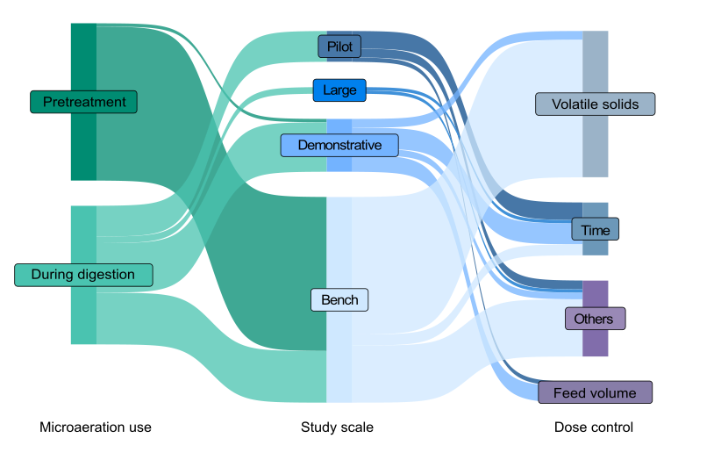
Fig. S1. Interaction flows among microaeration use, study scale and dose control.

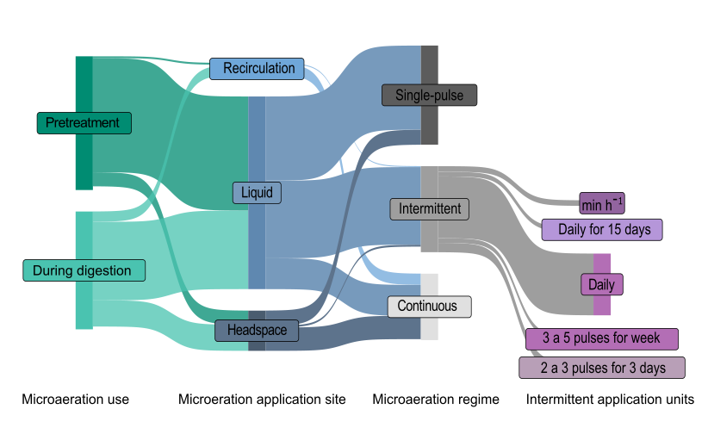
Fig. S2. Interaction flows among microaeration use, application site, regime and intermittent application units.

