SUPPORTING INFORMATION

Large-scale Micro-Aerobic Digestion Studies at Municipal Water Resource Recovery Facilities for Process-Integrated Biogas Desulfurization
Norbertus Joannes Richardus Kraakman, Israel Diaz, Maria Fdz-Polanco, Raul Muñoz

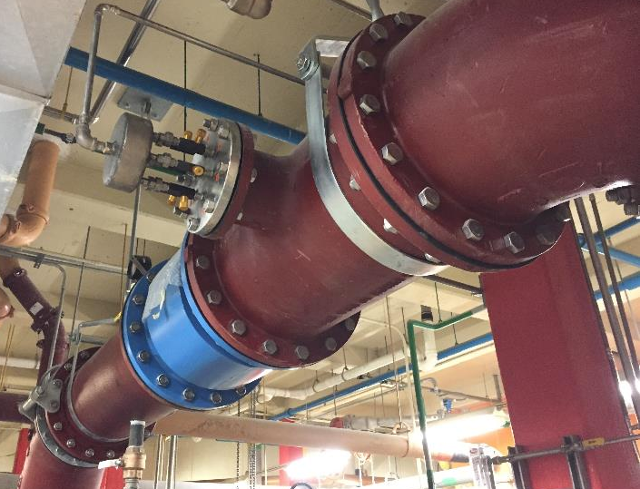
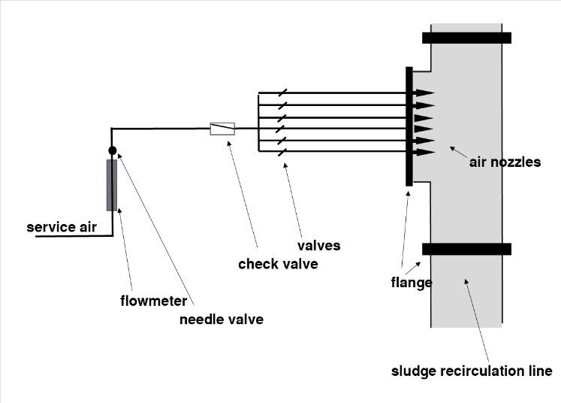
Figure S-1: Schematic of the micro-aeration test set-up (left) and the micro-aeration air injection point (right) during Case Study #1.

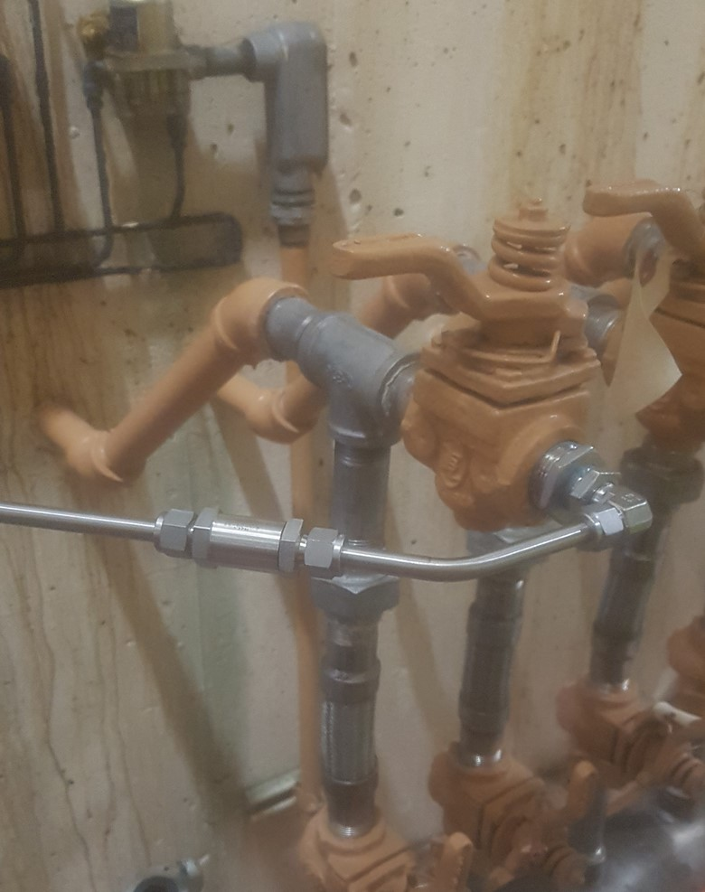
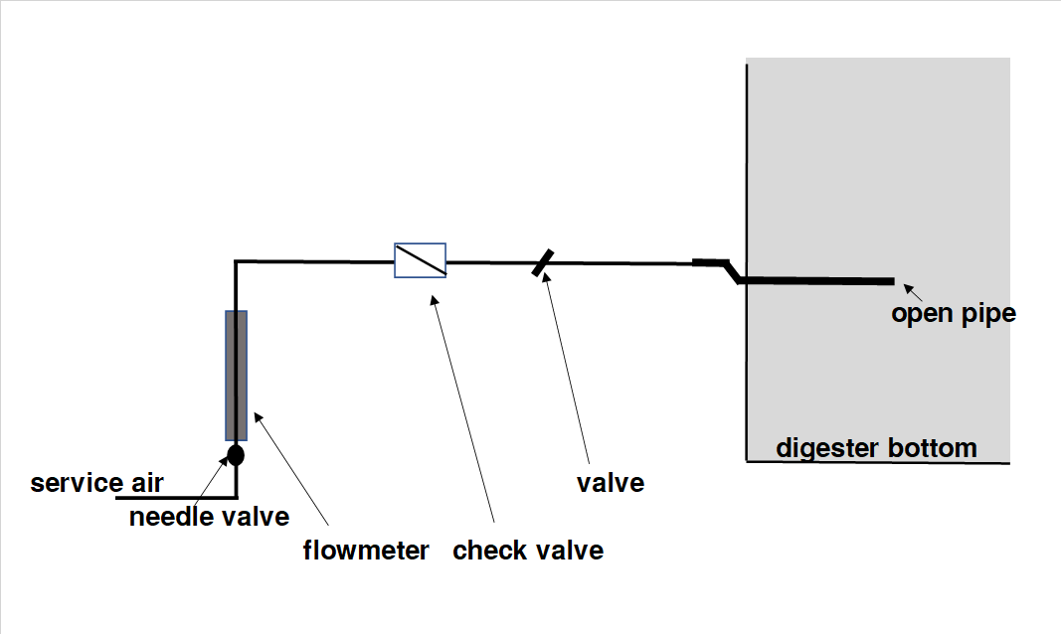
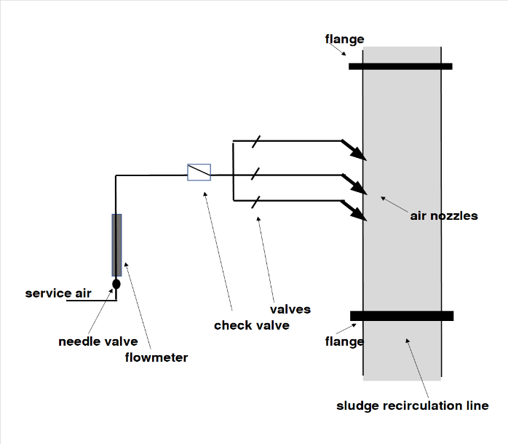
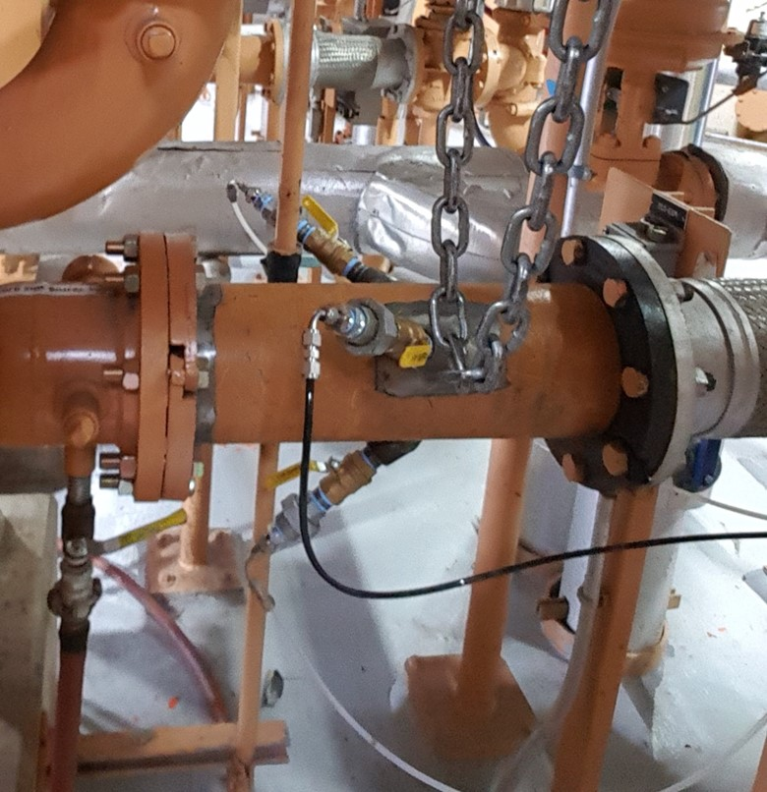
Figure S-2a: Schematic of the micro-aeration test set-up up (left) and the micro-aeration air injection point (right) during Case Study #2 when the air was injected in the sludge heating pipe.
Figure S-2b: Schematic of the micro-aeration test set-up up (left) and the micro-aeration air injection point (right) during Case Study #2 when the air was injected in the bottom of the digester reactor.

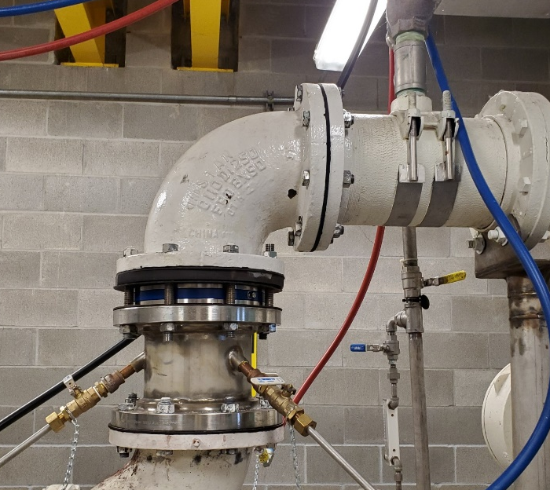
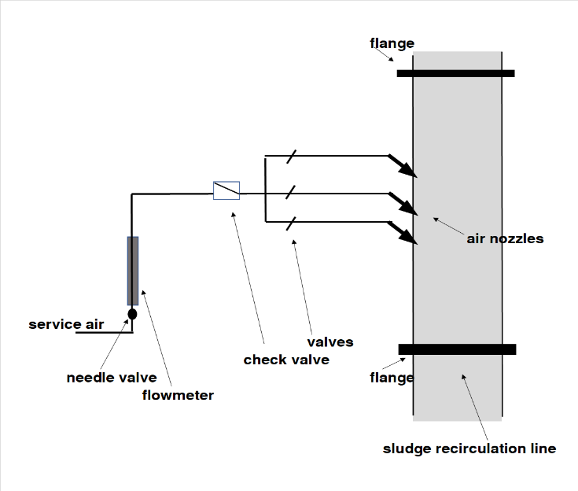
Figure S-3: Schematic of the micro-aeration test set-up up (left) and the micro-aeration air injection point (right) during Case Study #3 when the air was injected in the sludge recirculation pipe.

