Microbial electrolysis cell simultaneously enhancing methanization and reducing hydrogen sulfide production in anaerobic digestion of sewage sludge

Xiangyu Chen^{1,2}, Benyi Xiao^{1,2}*, Xinyi Tang^{1,2}, Chunlin Bian^{1,3}, Junxin Liu^{1,2}, Lin Li^{1,2}
1. Research Center for Eco-Environmental Sciences, Chinese Academy of Sciences, Beijing 100085, China; 2. University of Chinese academy of Science, Beijing 100049, China. 3. School of Civil Engineering, Inner Mongolia University of Technology, Hohhot 010051, PR China

Supplement Material

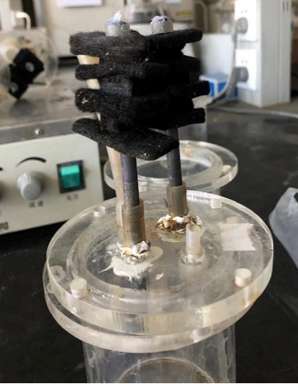
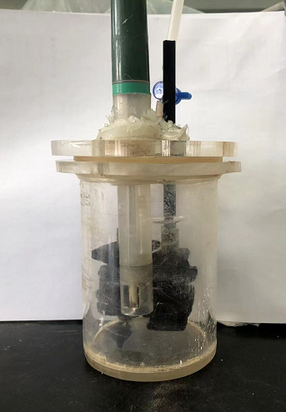
MEC-digester
Electrodes

Figure S1. Photos for MEC-digester and electrodes
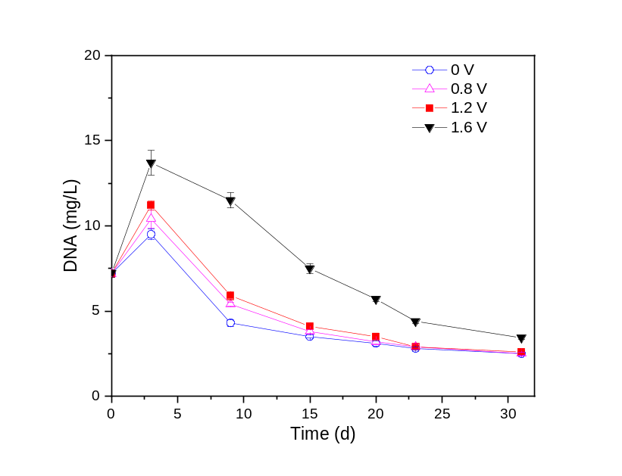
Figure S2. Changes in soluble DNA of digestates in the test

Figure S3. Scanning electron microscopies for digestates at the end of test
0 V
1.6 V
1.3 V
0.8 V

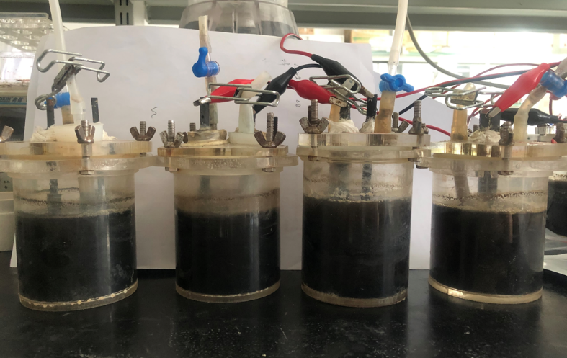
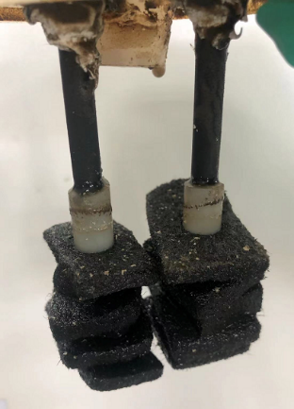
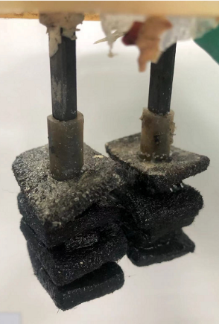
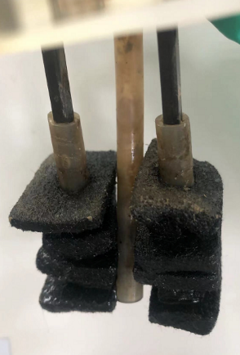
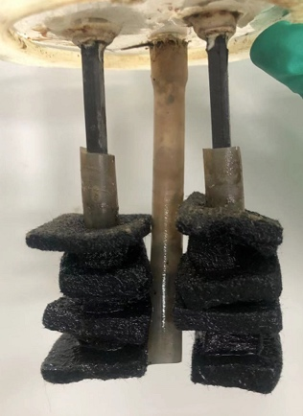
0 V
0.8 V
1.3 V
1.6 V
0.8 V
1.6 V
0 V
1.3 V

Figure S4. Elemental sulfur on the surface of digestate and cathode
Table S1. The relative abundance of bacteria at phylum level in the inoculum and digestate
Phylum | Inoculum | 0 V-31 d | 0.8 V-31 d | 1.3 V-31 d | 1.6 V-31 d
Proteobacteria | 27.70 | 23.64 | 40.13 | 29.02 | 24.21
Chloroflexi | 23.29 | 16.31 | 10.19 | 19.49 | 13.65
Bacteroidetes | 14.85 | 15.20 | 10.88 | 16.19 | 13.83
Firmicutes | 1.32 | 15.84 | 13.19 | 8.27 | 16.04
Patescibacteria | 10.47 | 6.89 | 3.08 | 3.90 | 7.91
Actinobacteria | 4.83 | 4.95 | 3.94 | 6.53 | 5.67
Armatimonadetes | 0.29 | 4.14 | 6.93 | 6.33 | 6.08
Acidobacteria | 9.74 | 3.38 | 2.62 | 2.01 | 2.27
Synergistetes | 0.11 | 5.48 | 6.11 | 0.48 | 4.85
Gemmatimonadetes | 1.37 | 1.12 | 0.52 | 3.50 | 1.08
Planctomycetes | 1.22 | 0.40 | 0.38 | 0.76 | 0.44
Nitrospirae | 1.94 | 0.02 | 0.01 | 0.01 | 0.01
Zixibacteria | 1.21 | 0.05 | 0.04 | 0.02 | 0.10
Others | 1.65 | 2.57 | 1.97 | 3.50 | 3.84

Table S2. The relative of SRB and SOB at the phylum level
Item | Phylum | Inoculum | 0 V-31 d | 0.8 V-31 d | 1.3 V-31 d | 1.6 V-31 d
Sulfur-reducing  bacteria | Desulfobulbus | 0.03 | 0.41 | 0.35 | 0.19 | 0.13
Sulfur-reducing  bacteria | Desulfovibrio | 0 | 0.39 | 0.41 | 0.05 | 0.16
Sulfur-reducing  bacteria | Desulforhabdus | 0.02 | 0.21 | 0.14 | 0.06 | 0.03
Sulfur-reducing  bacteria | Desulfarculaceae | 0.11 | 0.09 | 0.11 | 0.03 | 0.04
Sulfur-reducing  bacteria | Desulfomicrobium | 0.02 | 0.11 | 0.13 | 0 | 0.01
Sulfur-reducing  bacteria | Desulfuromonas | 0.11 | 0 | 0 | 0 | 0
Sulfur-reducing  bacteria | Desulfoprunum | 0.07 | 0.00 | 0.00 | 0 | 0
Sulfur-reducing  bacteria | norank_f__Desulfovibrionaceae | 0 | 0 | 0.03 | 0 | 0
Sulfur-reducing  bacteria | Desulfatirhabdium | 0.02 | 0.01 | 0 | 0 | 0
Sulfur-reducing  bacteria | [Desulfobacterium]_  catecholicum_group | 0.03 | 0.00 | 0 | 0 | 0
Sulfur-reducing  bacteria | Desulfatitalea | 0 | 0.01 | 0 | 0 | 0
Sulfur-reducing  bacteria | Desulfomonile | 0 | 0.01 | 0 | 0 | 0
Sulfur-reducing  bacteria | Desulfitobacterium | 0 | 0 | 0 | 0 | 0.00
Sulfur-oxidizing  bacteria | Thiobacillus | 0.01 | 0.03 | 0.03 | 0.14 | 0.31
Sulfur-oxidizing  bacteria | Acinetobacter | 0 | 0.01 | 0.01 | 0.03 | 0.04
Sulfur-oxidizing  bacteria | Thioalkalispira | 0 | 0.00 | 0.05 | 0.00 | 0.02
Sulfur-oxidizing  bacteria | Sulfuritalea | 0.13 | 0.02 | 0.02 | 0.03 | 0.03
Sulfur-oxidizing  bacteria | Thiomonas | 0 | 0.05 | 0.01 | 0.00 | 0.00
Sulfur-oxidizing  bacteria | Ferritrophicum | 0.02 | 0 | 0 | 0.00 | 0
Sulfur-oxidizing  bacteria | KCM-B-112 | 0.01 | 0 | 0 | 0.00 | 0
Sulfur-oxidizing  bacteria | Sulfuricurvum | 0 | 0 | 0 | 0.00 | 0.01
Sulfur-oxidizing  bacteria | Arcobacter | 0 | 0 | 0 | 0.00 | 0.00

Table S3. The relative abundance of archaea at phylum level in the inoculum and digestate
phylum | Inoculum | 0 V-31 d | 0.8 V-31 d | 1.3 V-31 d | 1.6 V-31 d
Methanobacterium | 15.73 | 32.50 | 95.43 | 95.58 | 77.51
Methanosarcina | 1.72 | 47.49 | 0.01 | 0.94 | 11.60
Methanosaeta | 67.53 | 13.80 | 0.15 | 0.18 | 0.53
Candidatus_Nitrocosmicus | 0.58 | 4.70 | 2.83 | 2.57 | 8.78
Methanocorpusculum | 0.04 | 0.00 | 0.49 | 0.00 | 0.00
Methanobrevibacter | 4.18 | 0.15 | 0.27 | 0.22 | 0.53
Methanomethylovorans | 2.92 | 0.19 | 0.07 | 0.09 | 0.06
Methanospirillum | 0.77 | 0.13 | 0.45 | 0.02 | 0.03
Candidatus_Methanofastidiosum | 1.85 | 0.39 | 0.01 | 0.01 | 0.09
Others | 4.68 | 0.64 | 0.30 | 0.38 | 0.86

*Corresponding author. E-mail address: byxiao@rcees.ac.cn (Benyi Xiao)

