Supplementary Materials

Enhanced hydrolysis and acidification of cellulose at high loading for methane production via anaerobic digestion supplemented with high mobility nanobubble water
Xuezhi Wangª, Tian Yuanª, Zitao Guoª, Hanlin Hanª, Zhongfang Lei^{a,∗} , Kazuya Shimizuª, Zhenya Zhangª, Duu-Jong Lee^{b,c}

ª Graduate School of Life and Environmental Sciences, University of Tsukuba, 1-1-1 Tennodai, Tsukuba, Ibaraki 305-8572, Japan
^{b} Department of Chemical Engineering, National Taiwan University, Taipei 10617, Taiwan
^{c} Department of Chemical Engineering, National Taiwan University of Science and Technology, Taipei 10607, Taiwan

*Corresponding author.
Email address: lei.zhongfang.gu@u.tsukuba.ac.jp (Z.Lei)

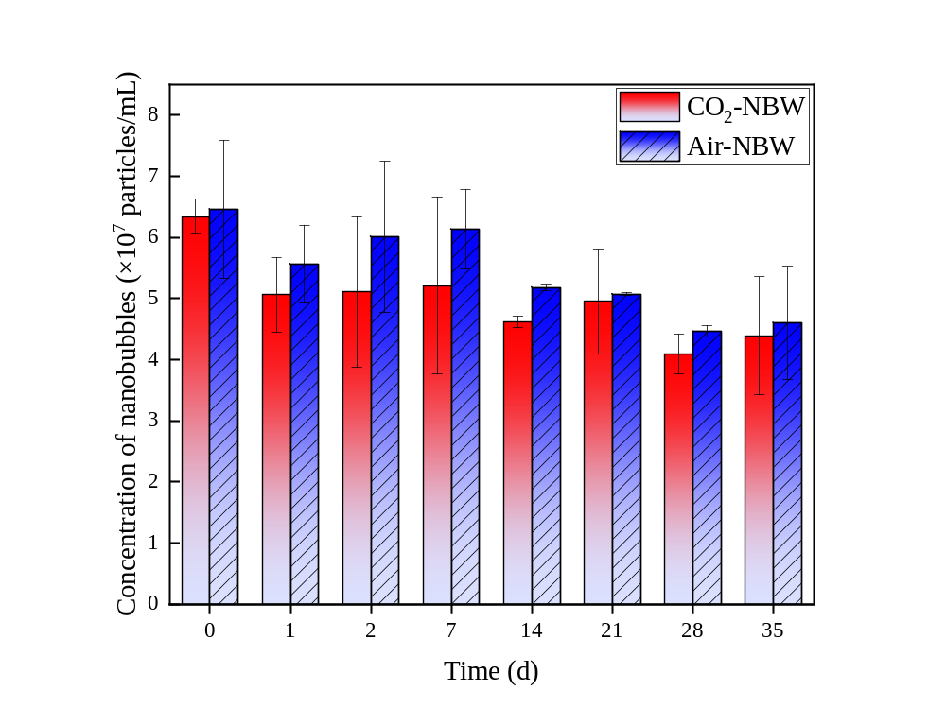Fig. S1. Variations of nanobubble concentration in CO₂-NBW and Air-NBW during 35 days’ storage at 35±1°C. NBW, nanobubble water.

Fig. S2. Changes in zeta potential of the two different nanobubble waters (Air-NBW and CO₂-NBW) during 35 days at 35±1°C 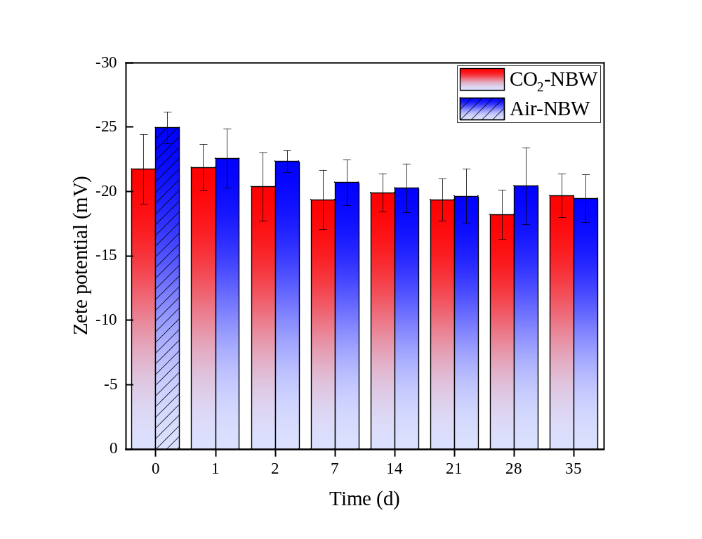. NBW, nanobubble water.

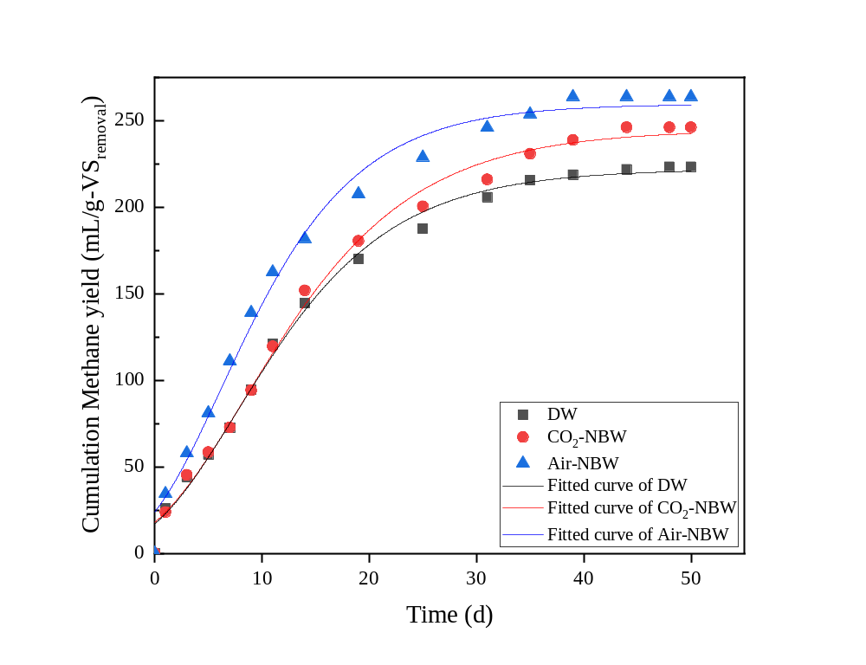
Fig. S3. Simulated methane yields of cellulose under DW, CO₂-NBW and Air-NBW addition using modified Gompertz model, respectively. NBW, nanobubble wateter.
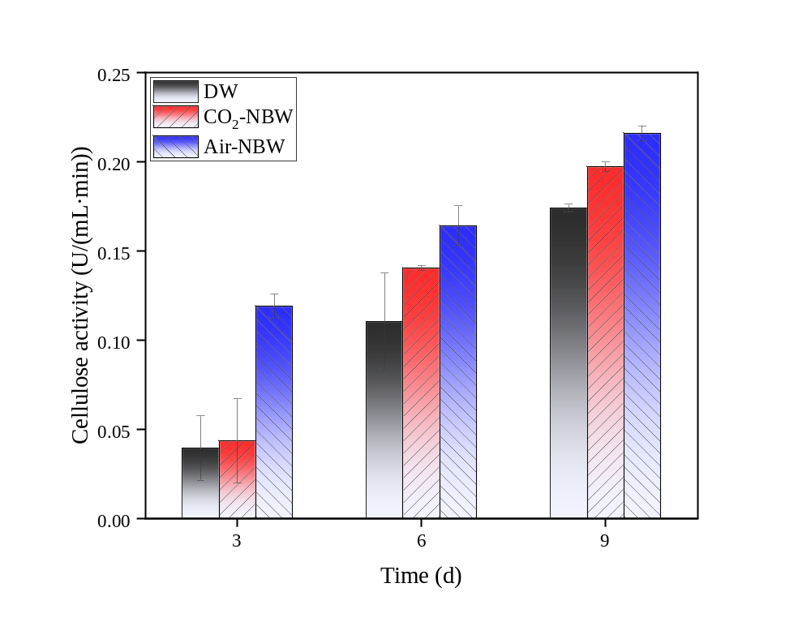Fig. S4. Changes in cellulase activity during hydrolytic-acidification stage under DW, CO₂-NBW and Air-NBW addition. DW, deionized water; NBW, nanobubble water.
Table S1
The characteristics of digested sludge and cellulose used in this study.
Items | Unit | Digested sludge | Cellulose
pH | - | 6.6±0.2 | NA
TS | %, w.b. | 1.1±0.001 | 97.6±0.2
VS | %, w.b. | 0.81±0.07 | 97.5±0.1
Total carbon | %, d.b | 27.2±1.8 | 41.6±0.1
Total nitrogen | %, d.b | 2.7±0.8 | 0.1±0.003
TVFAs | mg/L | 44.8±2.3 | 0
Soluble organic carbon | mg/L | 122.7±3.4 | 6.6±0.4
Soluble carbohydrates | mg/L | 67.3±2.2 | 2.5±0.2
Soluble proteins | mg/L | 7.9±0.6 | 0
Cellulose | %, d.b | 14.2±3.0 | 97.1±4.3
Cellulose crystallinity | % | 43.56±1.1 | 82.63±4.2
TS, total solids; VS, volatile solids; TVFAs, total volatile fatty acids; w.b., wet basis; d.b., dry basis; NA, not detected.

Table S2 Operation information in different reactors
Reactors | DW | CO₂-NBW |  | Air-NBW
F/M (based on VS) | 3.5
TS (%, w.b) | 0.017 |  | 0.016 |  | 0.017
VS (%, w.b) | 0.015 |  | 0.014 |  | 0.014
Reactor volume (mL) | 100
DW/NBW (mg) | 30
Initial pH | 7
Temperature (°C) | 35±1
F/M, feed-to-microorganisms ratio; TS, total solids; VS, volatile solids; DW, deionized water; NBW, nanobubble water; w.b., wet basis.

Table S3 Richness and diversity indexes of microbial communities in different reactors.
 | Specimens | Sequence number | OTUs number | Shannon | ACE | Chao | Coverage | Simpson
Bacteria | DW | 53861 | 46071 | 3.34 | 776.8 | 810.3 | 0.996 | 0.075
 | CO₂-NBW | 60519 | 53686 | 3.57 | 885.4 | 868.6 | 0.996 | 0.074
 | Air -NBW | 56048 | 50002 | 3.78 | 925.2 | 922.0 | 0.995 | 0.067
Archaea | DW | 30208 | 27015 | 0.95 | 39.3 | 44.5 | 0.999 | 0.451
 | CO₂-NBW | 42291 | 38870 | 0.96 | 50.6 | 50.5 | 0.999 | 0.354
 | Air -NBW | 55944 | 48954 | 1.35 | 80.7 | 63.5 | 0.999 | 0.564
DW, deionized water, NBW, nanobubble water

