3.2. The enhancement of methanogenic performance
Throughout the 87-day fermentation, the PCM reactor maintained lower TAN levels (Fig. S1) and achieved higher methane productivity than the untreated CM reactor.
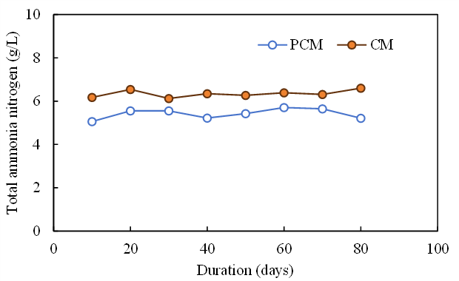
Fig. S1 Changes in total ammonia nitrogen levels during chicken manure digestion

