Supplementary Material

Short-Term Aerobic Pretreatment of Swine Manure Enhances Short-Chain Fatty Acid Production in Anaerobic fermentation: Performance and Mechanisms

Bangjie Xiong ^{1,2}, Ju Chen^{1,2}, Liangbin Zhao¹, Mengting Chen^{1,2}, Xiaoxia Hao^{1,2}, Weiping Sang¹, Zhenzhen Guo¹, Dongmei Jiang^{1,2}, Shuo Liu ^{1,2}, Li Zhu², Lin Bai^{1,2*}

¹Lab of Animal Ecology and Environmental Control, College of Animal Science and Technology, Sichuan Agricultural University, Chengdu, 611130, P. R. China
²State Key Laboratory of Swine and Poultry Breeding Industry, College of Animal Science and Technology, Sichuan Agricultural University, P. R. China

*Corresponding author
To whom correspondence e-mail: blin16@126.com; lsjiayouya@126.com.
ª These authors contributed equally to the paper as first author
Text A.1
The "Aerobic composting pretreatment" does not refer to new equipment or devices but rather employs traditional composting methods to treat the materials. In this study, the composting setup used was a thick-walled foam box with inner dimensions of 55 cm (length) × 50 cm (width) × 80 cm (height). A perforated plate and an aeration pipe were installed at the bottom of the box (as shown in the figure below). During the composting process, an aerator was used to intermittently force aeration through the aeration pipe, with an aeration frequency of 5 minutes per hour and an aeration rate of 600–800 ml per minute.

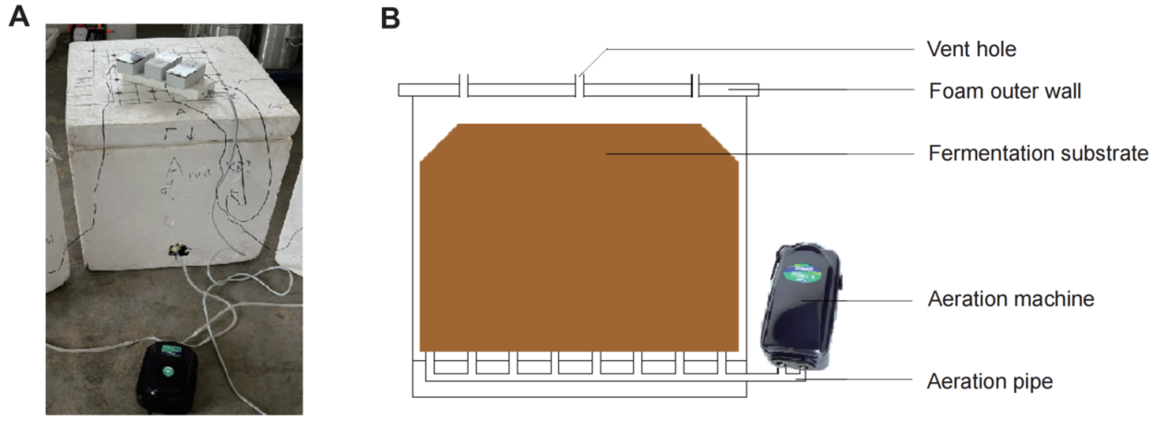

Text A.2
Production cost (CNY/g) = Electricity consumption × Electricity price ÷ Total SCFAs production. For conventional low-temperature thermal pretreatment, energy consumption was mainly from oven heating; for aerobic composting pretreatment, energy consumption was primarily from aeration.

Table S1: Physicochemical properties of raw materials in this test
Physicochemical Property | Swine Manure | Wheat Straw | Swine Manure+Wheat Straw
pH | 7.90±0.16 | 7.04±0.05 | 7.67±0.02
Moisture Content (%) | 76.81±0.23 | 10.35±0.78 | 62.88±0.01
TOC (%) | 42.07±0.72 | 45.16±1.02 | 42.70±2.11
TN (%) | 3.05±0.15 | 0.57±0.02 | 2.27±0.08

Figure A.1 Schematic diagram of the experimental design.
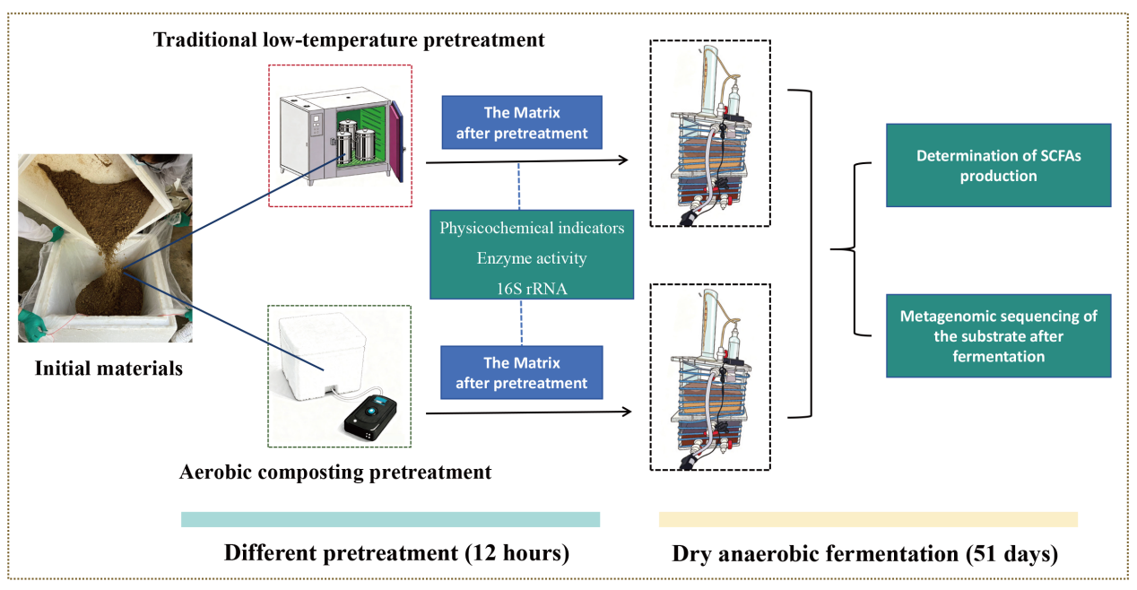

Figure A.2 Schematic Diagram of the Dry Anaerobic Fermentation Experimental Setup.