Supplementary Information for
Enhanced heavy metal stability of sludge anaerobic digestion by different dosages of air nanobubble water
Contents:
Table S1: Parameters of the modified Gompertz model
Table S2: Recovery of heavy metals
Fig. S1: The relationship between the concentration and size of nanobubbles
Fig. S2: Changes in VFA during anaerobic digestion
Fig. S3: Changes in (a) pH, (b) SCOD, (c) TAN, and (d) FAN during anaerobic digestion
Fig. S4: Abundance changes of key enzymes (EC values) in major methanogenesis pathways based on KEGG database and PICRUSt2 prediction (grey numbers are the absolute abundance of each pathway as a proportion of the total absolute abundance in the four pathways)
Fig. S5: X-ray photoelectron spectroscopy analysis of Cu in final digestate
Fig. S6: X-ray photoelectron spectroscopy analysis of Ni in final digestate
Fig. S7: X-ray photoelectron spectroscopy analysis of Zn in final digestate
Fig. S8: X-ray photoelectron spectroscopy analysis of Pb in final digestate
Fig. S9: X-ray photoelectron spectroscopy analysis of Mn in final digestate
Fig. S10: X-ray photoelectron spectroscopy analysis of Cr in final digestate

Table S1 Parameters of the modified Gompertz model
Group | Ultimate methane production, UMP (mL g^{-l} VS_{added}) | Maximum methane production rate, R_{m} (mL g⁻¹ VS_{added} d⁻¹) | Lag phase, λ(d) | R²
A20 | 149.6±5.8ª | 6.6±0.2^{b} | 3.6±0.1^{b} | 0.994±0.001
C20 | 130.6±1.6^{b} | 5.9±0.1^{c} | 4.6±0.1ª | 0.994±0.001
A40 | 155.5±5.1ª | 7.5±0.5ª | 3.1±0.3^{c} | 0.997±0.001
C40 | 133.9±4.1^{b} | 6.5±0.2^{b,c} | 3.0±0.1^{c} | 0.997±0.001
A60 | 109.7±2.3^{c} | 7.5±0.3ª | 3.1±0.2^{c} | 0.999±0.001
C60 | 98.3±5.6^{d} | 6.8±0.6^{c} | 3.0±0.3^{c} | 0.999±0.001
Note: a, b, and c are labeled according to Duncan's test, and a significant difference between the two groups is considered to be significant at the p<0.05 level when the labeled symbols between the two groups do not have repeated alphabets. All values are expressed as mean ± standard deviation (n = 3).

Table S2 Recovery of heavy metals
Group | Days | Cu (%) | Ni (%) | Zn (%) | Pb (%) | Mn (%) | Cr (%)
A20 | 0 | 104.8±4.1 | 98.1±4.9 | 107.6±1.7 | 96.8±7.7 | 103.5±7.0 | 95.0±4.1
A20 | 4 | 93.3±3.3 | 102.7±2.6 | 102.0±2.9 | 107.8±4.3 | 97.0±1.9 | 96.3±1.9
A20 | 15 | 95.6±1.5 | 90.7±0.9 | 105.4±1.2 | 102.0±4.5 | 98.4±0.8 | 96.3±1.5
A20 | 43 | 83.3±1.2 | 107.0±2.0 | 92.9±1.0 | 104.9±3.9 | 100.3±1.0 | 93.4±1.2
C20 | 0 | 104.8±4.1 | 98.1±4.9 | 107.6±1.7 | 96.8±7.7 | 103.5±7.0 | 95.0±4.1
C20 | 4 | 93.3±10.4 | 99.1±9.3 | 100.5±9.7 | 103.1±15.3 | 104.8±9.4 | 99.9±8.6
C20 | 15 | 88.3±2.9 | 93.6±2.5 | 101.0±2.5 | 98.6±3.4 | 94.0±1.8 | 99.0±5.2
C20 | 43 | 85.9±4.0 | 107.9±4.6 | 96.2±4.3 | 104.1±3.1 | 99.3±2.7 | 99.6±4.0
A40 | 0 | 104.8±4.1 | 98.1±4.9 | 107.6±1.7 | 96.8±7.7 | 103.5±7.0 | 95.0±4.1
A40 | 4 | 91.5±4.4 | 103.2±4.6 | 110.9±4.6 | 106.8±7.7 | 104.1±5.9 | 103.2±8.0
A40 | 15 | 90.3±1.5 | 97.6±1.3 | 99.5±2.2 | 96.8±7.6 | 97.4±2.2 | 100.1±3.1
A40 | 43 | 88.0±2.3 | 101.1±2.4 | 93.9±2.3 | 98.3±7.0 | 99.0±2.2 | 99.9±2.6
C40 | 0 | 104.8±4.1 | 98.1±4.9 | 107.6±1.7 | 96.8±7.7 | 103.5±7.0 | 95.0±4.1
C40 | 4 | 97.4±5.3 | 105.8±2.7 | 106.2±2.3 | 110.5±2.6 | 98.4±3.5 | 98.1±2.6
C40 | 15 | 92.1±2.3 | 93.5±4.2 | 100.2±2.9 | 97.8±6.8 | 95.3±2.4 | 99.3±2.3
C40 | 43 | 90.0±3.1 | 97.5±1.7 | 97.3±2.4 | 101.4±3.6 | 101.5±2.4 | 95.2±2.2
A60 | 0 | 104.8±4.1 | 98.1±4.9 | 107.6±1.7 | 96.8±7.7 | 103.5±7.0 | 95.0±4.1
A60 | 4 | 102.6±5.1 | 100.0±4.4 | 106.6±3.8 | 103.3±9.4 | 114.4±3.6 | 95.0±3.8
A60 | 15 | 90.4±2.3 | 92.4±2.3 | 109.6±2.2 | 106.0±4.1 | 101.0±1.8 | 107.1±2.7
A60 | 43 | 91.6±1.0 | 98.0±1.3 | 101.8±1.8 | 103.9±3.7 | 103.6±1.3 | 104.1±1.0
C60 | 0 | 104.8±4.1 | 98.1±4.9 | 107.6±1.7 | 96.8±7.7 | 103.5±7.0 | 95.0±4.1
C60 | 4 | 94.8±4.8 | 103.1±4.5 | 105.2±6.1 | 108.7±10.3 | 106.7±6.1 | 100.9±7.7
C60 | 15 | 91.7±3.6 | 89.4±3.5 | 105.5±2.0 | 101.9±5.5 | 98.6±1.7 | 100.1±2.0
C60 | 43 | 92.7±1.1 | 97.4±0.5 | 101.2±1.5 | 96.2±4.8 | 101.5±1.1 | 95.6±1.7
Note: All values are expressed as mean ± standard deviation (n =3)

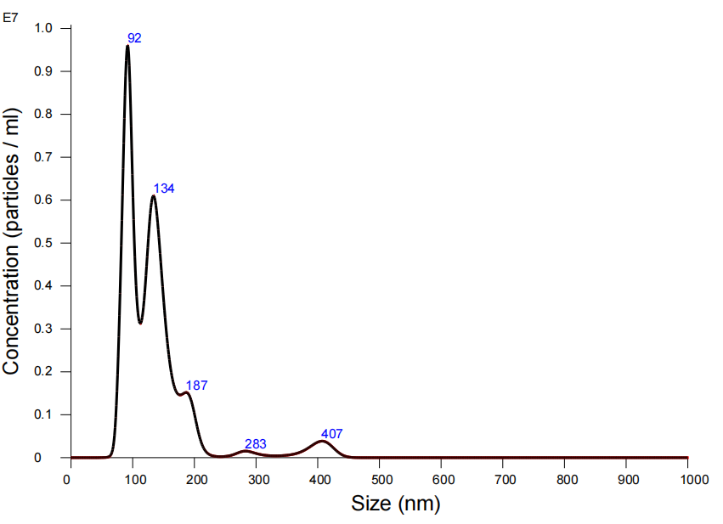
Fig. S1 The relationship between the concentration and size of nanobubbles

Fig. S2 Changes in VFA during anaerobic digestion

Fig. S3 Changes in (a) pH, (b) SCOD, (c) TAN, and (d) FAN during anaerobic digestion

Fig. S4 Abundance changes of key enzymes (EC values) in major methanogenesis pathways based on KEGG database and PICRUSt2 prediction (grey numbers are the absolute abundance of each pathway as a proportion of the total absolute abundance in the four pathways)
Fig. S5 X-ray photoelectron spectroscopy analysis of Cu in final digestate
Fig. S6 X-ray photoelectron spectroscopy analysis of Ni in final digestate

Fig. S7 X-ray photoelectron spectroscopy analysis of Zn in final digestate

Fig. S8 X-ray photoelectron spectroscopy analysis of Pb in final digestate

Fig. S9 X-ray photoelectron spectroscopy analysis of Mn in final digestate

Fig. S10 X-ray photoelectron spectroscopy analysis of Cr in final digestate

