Enhancing anaerobic digestion of swine manure using microbial electrolysis cell and microaeration

Yanqiang Di^{a1}, Wenxue Hou^{b1}, Chunlin Bian^{b,c}, Tianlong Zheng^{b}, Benyi Xiao^{b}∗, Lin Li^{b}
a. China Academy of Building Research, Beijing 100013, China; b. Research Center for Eco-Environmental Sciences, Chinese Academy of Sciences, Beijing 100085, China; c. Jiangsu Jiangnan Water Co., Ltd., Jiangyin 214400, China.

Supplemental material

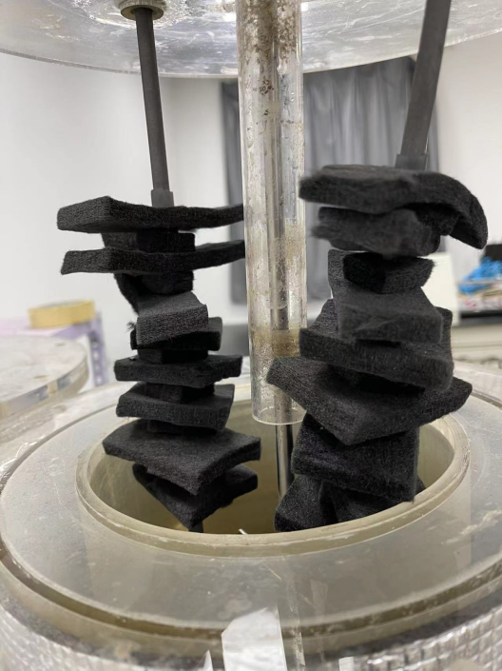
Figure S1. The electrodes used in the test
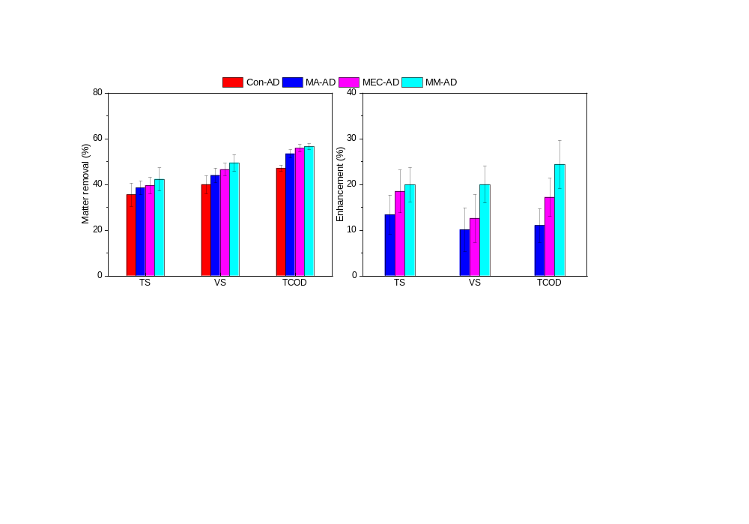
Figure S2. Matter removals and its enhancements for the four ADs during the stable stage
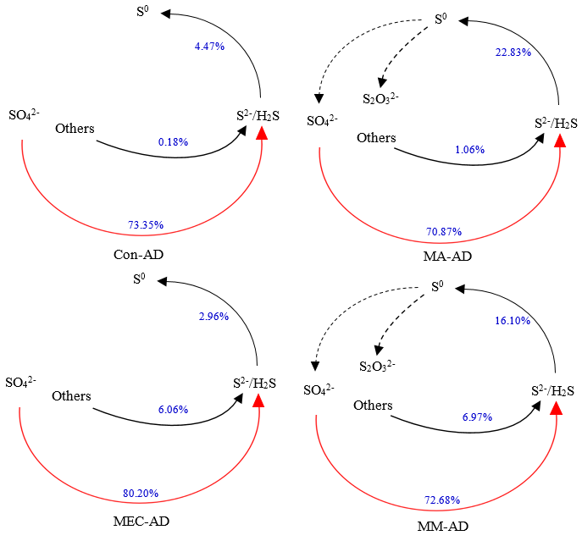
Figure S3. The conversion pathways for sulfur in the four ADs.
Table S1. p value of statistical analysis
Item | MA-AD | MEC-AD | MM-AD
CH₄ content
Con-AD | 0.001 | 0.000 | 0.120
MA-AD |  | 0.000 | 0.000
MEC-AD |  |  | 0.000
CH₄ production
Con-AD | 4.235E-19 | 6.001E-36 | 1.754E-36
MA-AD |  | 3.062E-28 | 2.694E-29
MEC-AD |  |  | 2.539E-02
TS
Con-AD | 0.022 | 0.001 | 0.001
MA-AD |  | 0.019 | 0.017
MEC-AD |  |  | 0.045
VS
Con-AD | 0.008 | 0.000 | 0.000
MA-AD |  | 0.017 | 0.014
MEC-AD |  |  | 0.028
TCOD
Con-AD | 1.413E-07 | 5.446E-09 | 2.162E-10
MA-AD |  | 1.702E-02 | 1.775E-03
MEC-AD |  |  | 4.212E-01
pH
Con-AD | 0.379 | 0.197 | 0.864
MA-AD |  | 0.096 | 0.455
MEC-AD |  |  | 0.172

Table S2. Enhancement of biogas production during the stable stage
Item | MA-AD | MEC-AD | MM-AD
Biogas production (%) | 28.53±9.33 | 58.87±9.20 | 65.97±10.21
CH₄ content (%) | -2.96±3.56 | 3.53±3.06 | 1.41±4.12
H₂S concentration (%) | -67.93±14.20 | 175.26±96.80 | -12.94±17.81
CH₄ production (%) | 24.74±10.31 | 64.45±11.87 | 68.24±11.36
H₂S production (%) | -58.49±19.45 | 338.28±162.58 | 44.61±30.59
Biogas yield (%) | 28.21±7.84 | 58.51±7.25 | 65.52±8.25
CH₄ yield (%) | 24.24±5.68 | 63.97±6.21 | 67.70±6.13

Table S3. The coefficients of variation for the biogas production during the test
Item | Con-AD | MA-AD | MEC-AD | MM-AD
Biogas production | 0.049 | 0.049 | 0.033 | 0.025
Methane content | 0.033 | 0.024 | 0.016 | 0.021
CH₄ production | 0.057 | 0.041 | 0.032 | 0.034
H₂S concentration | 0.462 | 0.825 | 0.476 | 0.536
pH | 0.010 | 0.020 | 0.014 | 0.012
TS | 0.040 | 0.031 | 0.019 | 0.061
VS | 0.046 | 0.088 | 0.035 | 0.055
TCOD | 0.018 | 0.013 | 0.036 | 0.041
SCOD | 0.005 | 0.029 | 0.132 | 0.107
TAN | 0.086 | 0.123 | 0.076 | 0.067
TVFA | 0.388 | 0.269 | 0.464 | 0.089
TA | 0.149 | 0.125 | 0.127 | 0.109

Table S4. Characteristics of SM and digestates during the stable stage
Item | Substrate | Con-AD | MA-AD | MEC-AD | MM-AD
pH | 7.37±0.11 | 7.91±0.08 | 7.96±0.16 | 7.84±0.11 | 7.91±0.09
ORP (mV) | - | -358±5 | -351±4 | -372±4 | -365±4
TS (g/L) | 78.23±3.87 | 50.32±2.04 | 48.01±1.49 | 47.17±0.89 | 45.02±2.76
VS (g/L) | 63.83±3.26 | 38.26±1.75 | 35.81±3.17 | 34.07±1.20 | 32.21±1.79
VS/TS | 0.82±0.03 | 0.76±0.05 | 0.75±0.07 | 0.72±0.03 | 0.72±0.01
TCOD (g/L) | 86.34±1.57 | 45.63±0.60 | 40.21±1.47 | 38.14±1.58 | 37.54±1.30
SCOD (g/L) | 18.22±0.37 | 5.15±0.03 | 4.64±0.14 | 3.70±0.50 | 3.53±0.39
TAN (g/L) | 3.08±0.33 | 3.66±0.32 | 3.97±0.49 | 4.01±0.31 | 4.19±0.28
FAN (g/L) | 0.27±0.00 | 0.92±0.00 | 1.09±0.00 | 0.90±0.00 | 1.06±0.00
TVFAs (g/L) | 8.91±0.81 | 0.12±0.05 | 0.32±0.09 | 0.07±0.03 | 0.17±0.01
Hac(g/L) | 4.51±0.36 | 0.05±0.02 | 0.28±0.02 | 0.04±0.02 | 0.13±0.01
HPc (g/L) | 1.27±0.11 | 0.02±0.01 | 0.02±0.01 | 0.01±0.01 | 0.02±0.02
HBu(g/L) | 2.47±0.38 | 0.04±0.03 | 0.02±0.01 | 0.01±0.01 | 0.01±0.01
TA (g CaCO₃/L) | 12.12±1.11 | 12.68±1.89 | 12.23±1.53 | 12.24±1.56 | 12.62±1.38
TVFAs/TA | 0.743±0.108 | 0.011±0.006 | 0.028±0.010 | 0.006±0.003 | 0.013±0.002
Total sulfur (mg/g TS) | 7.05±0.53 | 9.68±0.45 | 10.45±0.56 | 8.25±0.19 | 10.63±0.91

Table S5. The relative abundances of sulfate conversion
Module | Con-AD | MEC-AD | MA-AD | MM-AD
Assimilatory sulfate reduction, sulfate => H₂S (%) | 0.181 | 0.183 | 0.152 | 0.093
Dissimilatory sulfate reduction, sulfate => H₂S (%) | 0.004 | 0.003 | 0.007 | 0.004
Sulfate-sulfur assimilation (%) | 0.005 | 0.005 | 0.015 | 0.001

Table S6. The methanogenesis pathways for each AD during the steady period.
Item | Con-AD | MEC-AD | MA-AD | MM-AD
Hydrogenotrophic methanogenesis | 66.79 | 43.53 | 45.82 | 12.68
Acetoclastic methanogenesis | 15.62 | 37.42 | 1.60 | 53.08
Methylotrophic methanogenesis | 3.39 | 3.56 | 0.45 | 1.81
Versatile methanogenesis | 13.19 | 14.17 | 51.82 | 31.48

¹ These authors contributed equally to this work. ∗Corresponding author. Tel.: +86-10-62912465; Fax: +86-10-62849108. E-mail: byxiao@rcees.ac.cn

