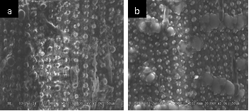

Supplementary material 1. Scanning electron microscope of rice straw and composting rice straw. (a) rice straw; (b) composting rice straw

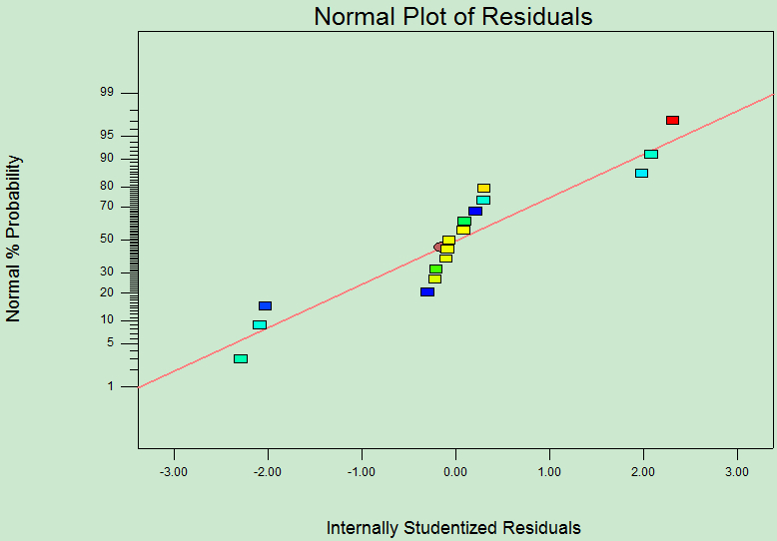

Supplementary material 2. Actual biogas production VS. predicted biogas production

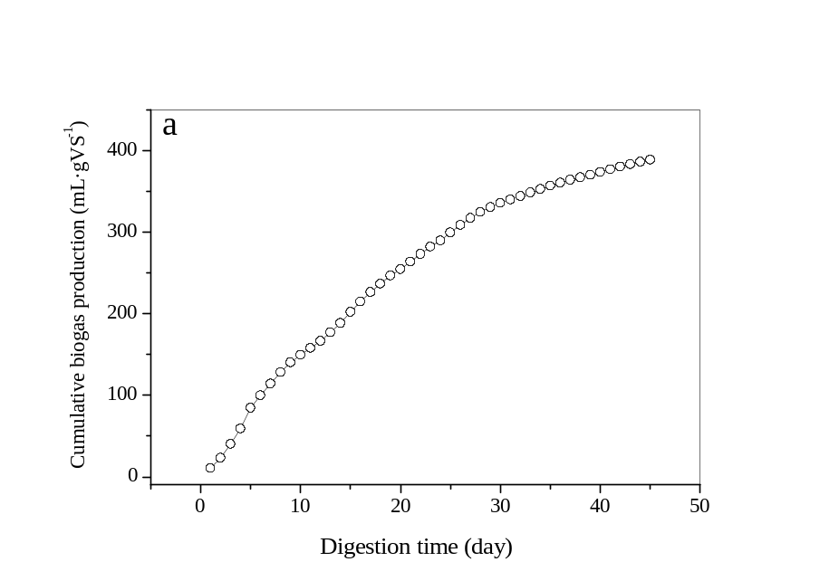

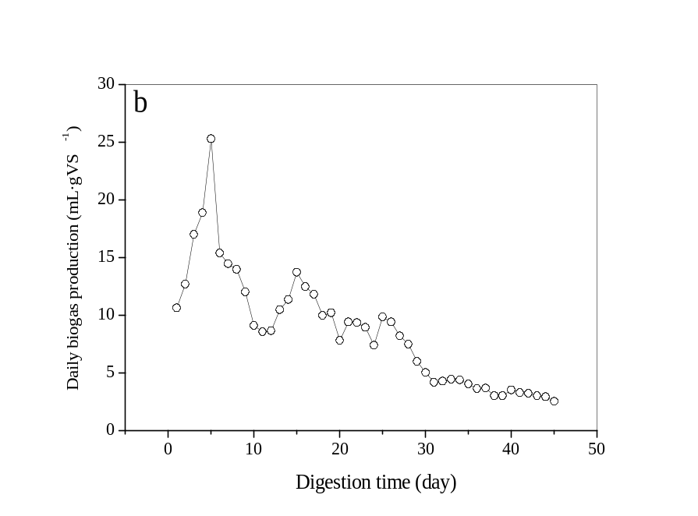

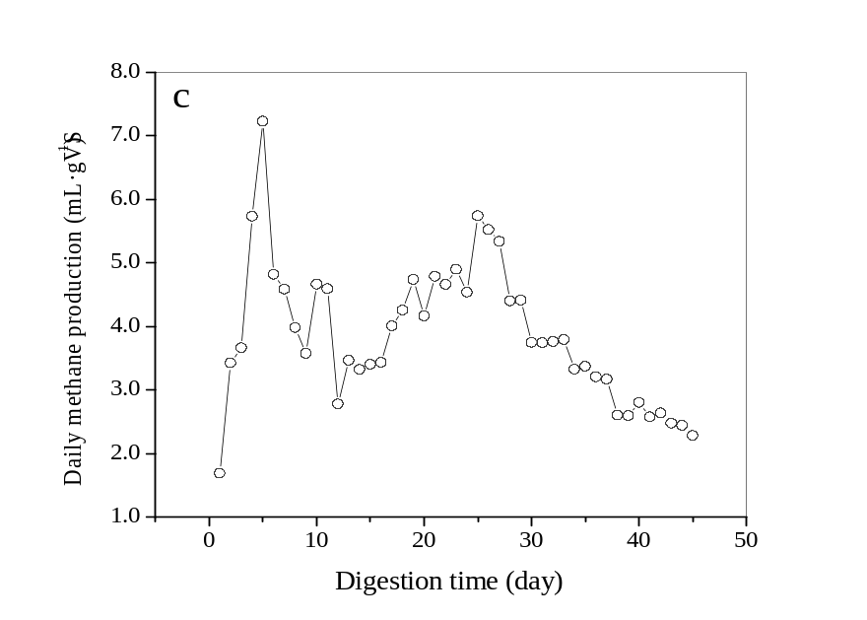

Supplementary material 3. Changes in biogas production and methane content during the process of SS-AD. (a) Cumulative biogas production. (b) Daily biogas production. (c) Methane production.

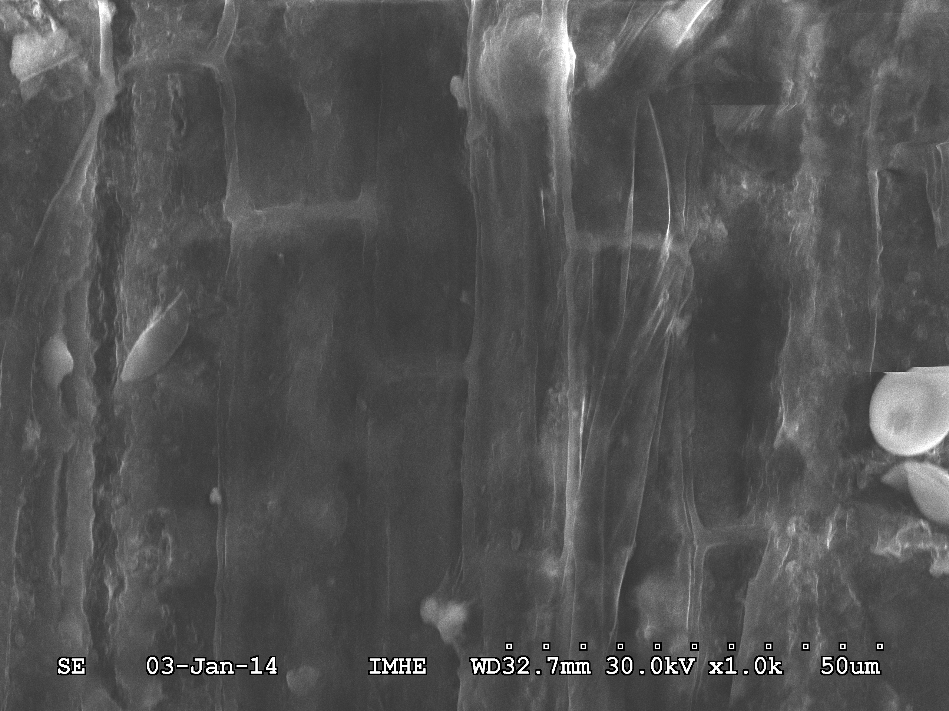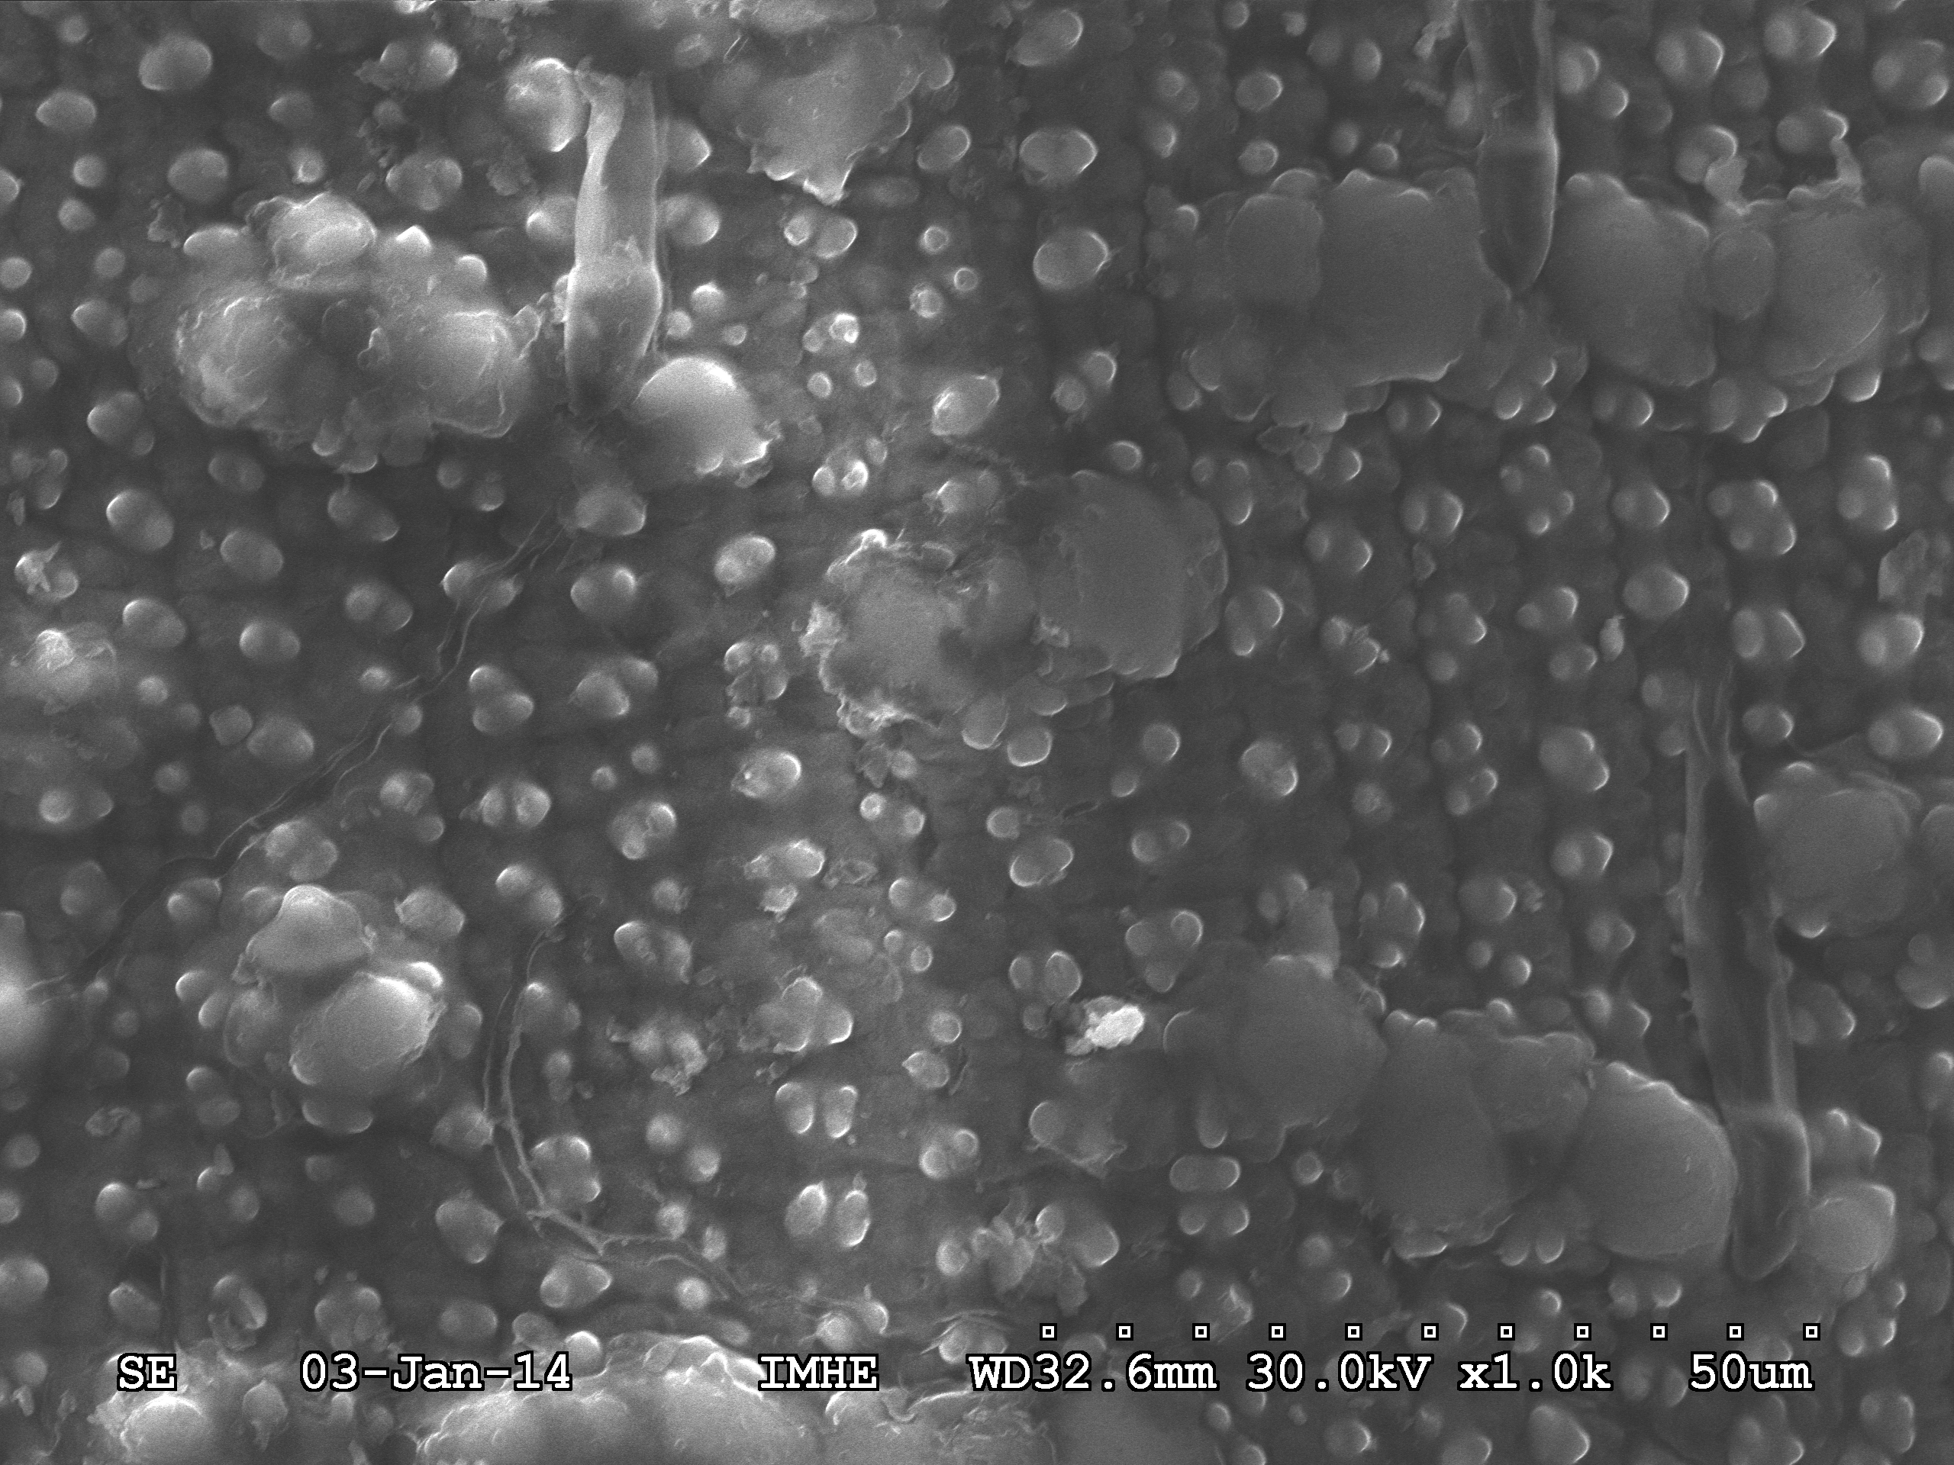
b
a

Supplementary material 4. Morphological characteristics of composting rice straw before and after SS-AD. (a) Before SS-AD. (b) After SS-AD

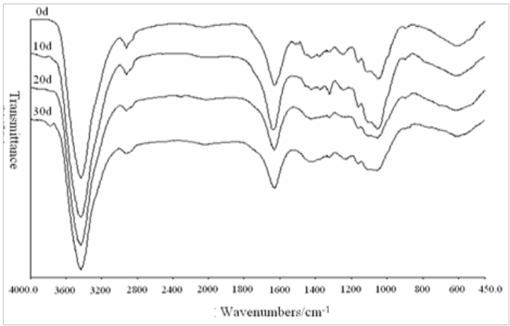

Supplementary material 5. FT-IR spectra of composting rice straw during the process of SS-AD.

