Supporting information

Coupling of membrane-based bubbleless micro-aeration for 2,4-dinitrophenol degradation in a hydrolysis acidification reactor

Zhuowei Zhang^{a, b, c}, Hongbo Xi^{a, c}, Yin Yu^{a, c**}, Changyong Wu^{a, c}, Yang Yang^{a, c, d}, Zhenzhen Guo^{a, c, e}, Yuexi Zhou^{a, b, c}∗

ª Research Center of Environmental Pollution Control Technology, Chinese Research Academy of Environmental Sciences, Beijing 100012, PR China
^{b} College of Water Sciences, Beijing Normal University, Beijing, 100875, PR China
^{c} State Key Laboratory of Environmental Criteria and Risk Assessment, Chinese Research Academy of Environment Sciences, Beijing, 100012, PR China
^{d} College of Chemical and Environmental Engineering, China University of Mining & Technology, Beijing, Beijing 100083, China
^{e} College of Environmental and Municipal Engineering, Lanzhou Jiaotong University, Lanzhou 730070, China

Text S1 Oxygen transfer test
Before the startup of the limited aeration HA reactors, an oxygenation experiment in clean water was carried out to investigate the oxygen transfer characteristics of the bubble and bubbleless aeration. The essence of aeration is the gas-liquid mass transfer process. This process is generally described by double-film theory. Based -on this theory, the overall oxygen transfer coefficient k_{La} was used to evaluate the oxygen transfer performance as shown in Eqs. (1) (Mei et al., 2019). k_{La} was measured by the dynamic method according to the previous lectures (Garcia-Ochoa et al., 2009; Berth et al., 2019). The specific operation process was as follows: firstly, in the absence of aeration, oxygen was removed from the clean water with flushing nitrogen, thus controlling the initial level of DO. Secondly, air was turned back on and the change in the DO concentration was monitored with the DO online monitoring probe. When the DO concentration was stabilized (t=t₁), the DO in the system was continuously monitored for the sufficient data to be collected (t=t₂). The variations of DO were measured under different aeration pressures (0.010 MPa, 0.030 MPa, and 0.050 MPa) and at different circulation ratios (10, 20, and 30). During the experiment, the water temperature in the reactors was maintained at 25°C using the automatic temperature control system.
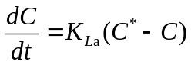 (1)
where K_{La} is the overall oxygen transfer coefficient, h⁻¹; C* is the saturated dissolved oxygen concentration in water (25°C, 8.34 mg/L); C is the dissolved oxygen in water at t (h), mg/L.

Text S2 Biomass of the biofilm on the membrane surface measurement
For each measurement, triplicate samples (length: 3 cm) of biomass were taken at the top, middle, and bottom of each membrane biofilm module and then suspended in 50 mL of demineralized water by a sonifier. This was followed by filtering through a 0.22 μm filter (GE Whatman Filter Paper) to obtain the average weight of the biomass

Text S3 Label-free quantitative proteomic profiling
Four samples (MBL-MHA-I, MBL-MHA-II, MHA and HA) were all 100 mL each, centrifuged for 15 min at 8000 rpm, respectively, then the supernatants were discarded and the precipitates were reserved and stored at −80 °C until analysis (three parallel samples were set for each sample). Proteins were extracted from three samples and the protein concentrations were measured using the BCA kit (Thermo Scientific Pierce) with standard curve. Then the protein samples were subjected to SDS-PAGE electrophoresis. The purified proteins were reduced and alkylated according to the manufacturer’s instructions of protein alkylated Kit (Sigma, St. Louis, MO, USA) with some modifications. The alkylated protein samples were digested overnight at 37 °C with trypsin and Sep-Pak was used to remove added salts, detergents, and other interfering substances. The desalted peptides were quantified according to the manufacturer’s instructions of peptide quantitative Kit (Thermo Fisher Scientific, No.23275, USA). 0.5 $μ$g/μL peptides were dissolved with mass spectrometric buffer solution and the analyses were performed using a Q-Exactive Plus Orbitrap mass spectrometer (Thermo Fisher Scientific, USA). MS analysis was performed in three biological triplicates for each sample to ensure the accuracy of the mass spectrometry results. The raw mass spectrometry MS/MS spectra search was processed using PEAKS Studio 8.5. The protein quantification and calculation of statistical significance were carried out using Student’s t-test and error correction (p-value < 0.05) using the method of Benjamini–Hochberg. To perform functional analysis, the identified proteins were carried on the follow-up biological information function analysis using GO (Gene Ontology, http://www.geneontology.org/). Pathway mapping of identified proteins was performed using the KEGG database (Kyoto Encyclopedia of Genes and Genomes, http://www.genome.jp/kegg/) (Poleti et al., 2018; Yin et al., 2018).

Figure captions
Fig. S1. Schematic diagram of circulation cup structure
Fig. S2. pH values in each HA during the experiment
Fig. S3. The intermediate products detected by LC-MS in the bubbleless limited aeration HA (A) and the bubbleless limited aeration HA (B)
Fig. S4. Nitrogen transformation within a given HRT in the bubbleless limited aeration HA (A) and the bubbleless limited aeration HA (B)
Fig. S5. UV-vis of LB-EPS (A) and TB-EPS (B) from different samples. Note: R-a-I (MBL-MHA-I); R-a-II (MBL-MHA-II); R-b (MHA); R-c (HA)
Fig. S6. FT-IR of LB-EPS (A) and TB-EPS (B) from different samples
Fig. S7. SEM images of the morphologies of suspended sludge of MBL-MHA, biofilm on the membrane surface of MBL-MHA, and suspended sludges of MHA and anaerobic HA during stable operation in phase II
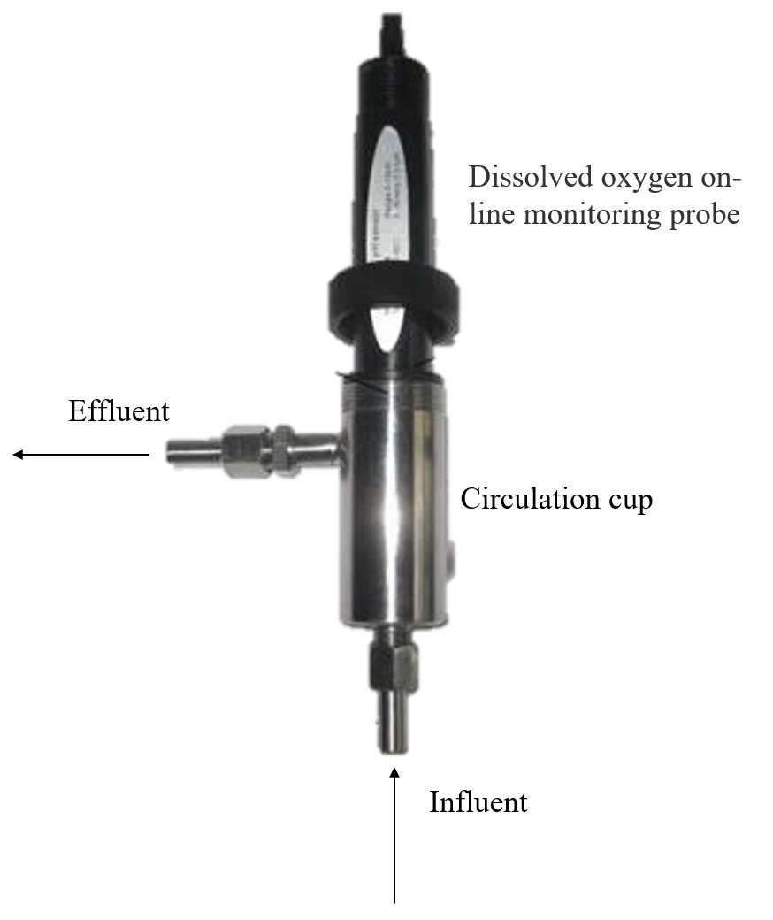
Fig. S1.

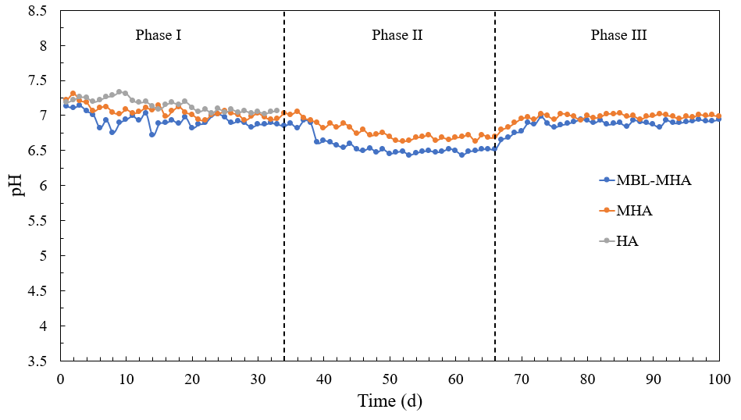
Fig. S2.

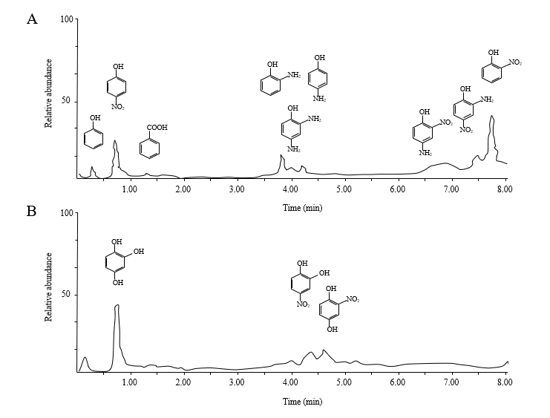
Fig. S3.

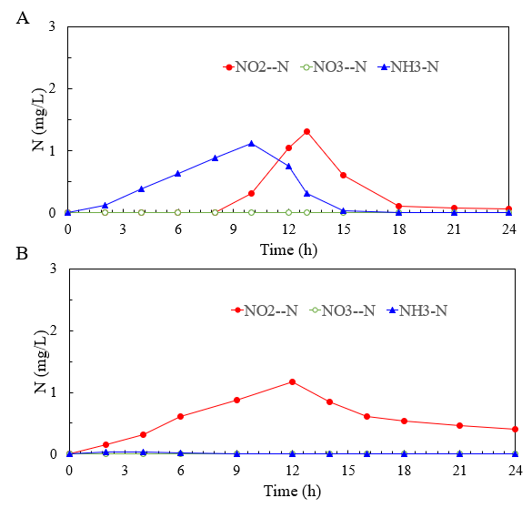
Fig. S4.

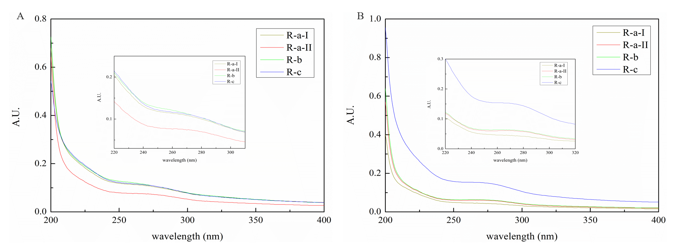
Fig. S5.

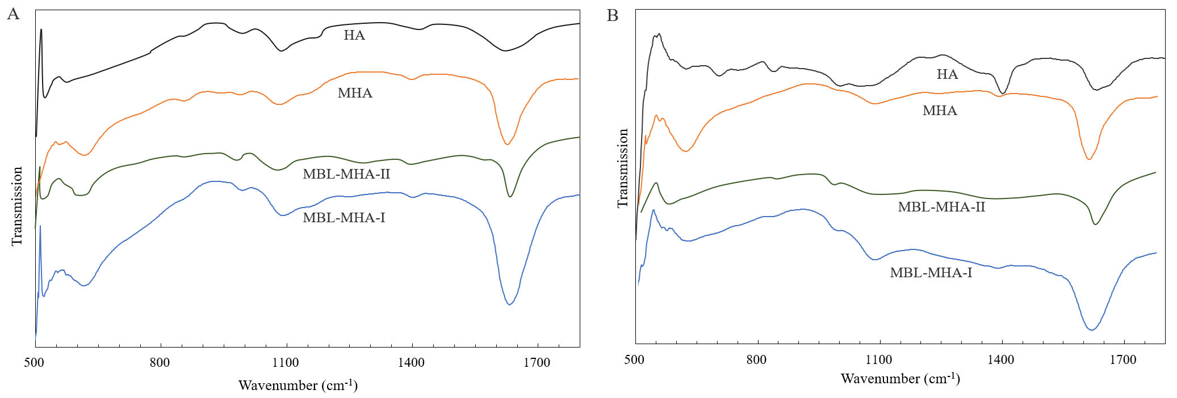
Fig. S6.

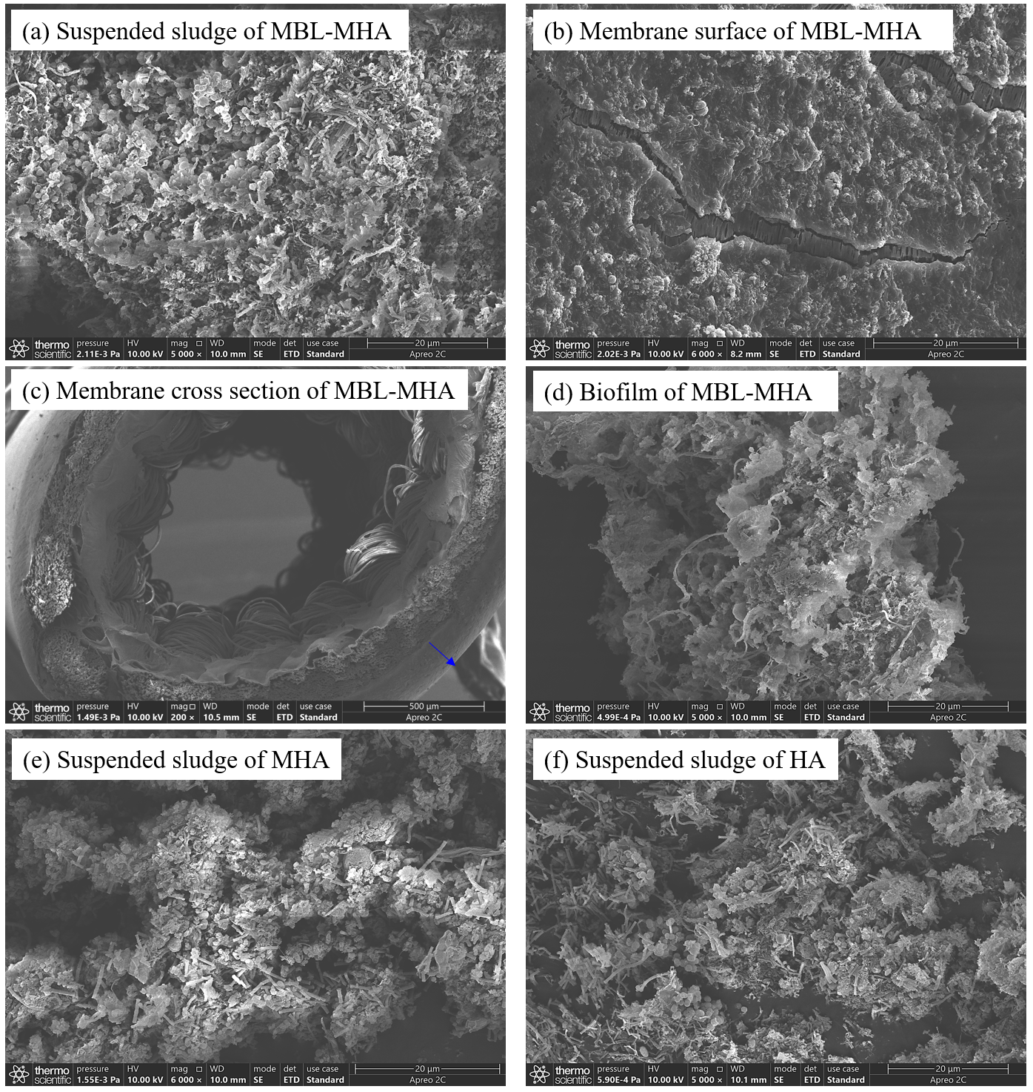
Fig. S7.

Table captions
Tab. S1. The characteristics of anaerobic granular sludge in this experiment
Tab. S2. Fluorescence peaks of 3D-EEM under different Ex/Em wavelengths
Tab. S3. Oxygen transfer coefficient under different conditions.

Tab. S1.
SSª (g/L) | VSS^{b} (g/L) | VSS/SS | settling ratio (%) | settling rate (m/h) | particle size (mm) | pH
12.5±0.5 | 9.2±0.4 | 0.73 | 80~90 | 41.16~49.47 | 0.5~3.0 | 7.1~7.3
a. the concentration of suspended solids
b. the concentration of volatile suspended solids

Tab. S2.
Region | Substances | Ex/Em wavelengths (mm)
I | Tyrosine-like protein | 200-250 / 200-330
II | Tryptophan-like protein | 200-250 / 330-380
III | Fulvic acid-like organics | 200-250 / 380-500
IV | Soluble microbial by-product-like | 250-280 / 200-380
V | Humic acid-like organics | 250-400 / 380-500

Tab. S3.
Aeration pressure (MPa) | Circulation ratio | Membrane with bubbleless | Aeration with bubble
Aeration pressure (MPa) | Circulation ratio | k_{La} (h⁻¹) | k_{La} (h⁻¹)
0.010 | 1:20 | 1.23 | 0.88
0.030 | 1:20 | 1.59 | 1.08
0.050 | 1:20 | 1.96 | 1.22
0.030 | 1:10 | 1.45 | 0.99
0.030 | 1:30 | 1.74 | 1.17

References
Berth A., Lecouturier D., Loubiere K., Dhulster P., Delaplace G. 2019. Modelling and optimisation of gas-liquid mass transfer in a microporous hollow fiber membrane aerated bioreactor used to produce surfactin. Biochem. Eng. J. 145, 109-119. https://doi.org/10.1016/j.bej.2018.10.029
Garcia-Ochoa F., and Gomez E. 2009. Bioreactor scale-up and oxygen transfer rate in microbial processes: an overview, Biotechnol. Adv. 27, 153–176. https://doi.org/10.1016/j.biotechadv.2008.10.006.
Mei X., Liu J., Guo Z., Li P., Bi S., Wang Y., Yang Y., Shen W., Wang Y., Xiao Y., Yang X., Zhou B., Liu H., Wu S. 2019. Simultaneous p-nitrophenol and nitrogen removal in PNP wastewater treatment: Comparison of two integrated membrane-aerated bioreactor systems. J. Hazard. Mater. 363, 99-108. http://dx.doi.org/10.1016/j.jhazmat.2018.09.072
Poleti, M.D., Regitano, L.C.A., Souza, G., Cesar, A.S.M., Simas, R.C., Silva-Vignato, B., Oliveira, G.B., Andrade, S.C.S., Cameron, L.C., Coutinho, L.L., 2018. Longissimus dorsi muscle label-free quantitative proteomic reveals biological mechanisms associated with intramuscular fat deposition. J. Proteomics 179, 30-41.
Wu Y., Wu Z., Chu H., Li J., Ngo H. H., Guo W., Zhang N., Zhang H. 2019. Comparison study on the performance of two different gas-permeable membranes used in a membrane-aerated biofilm reactor. Sci. Total Environ. 658, 1219-1227. https://doi.org/10.1016/j.scitotenv.2018.12.121
Yin, X., Wang, S.L., Alolga, R.N., Mais, E., Li, P., Yang, P., Komatsu, S., Qi, L.W., 2018. Label-free proteomic analysis to characterize ginger from China and Ghana. Food Chem. 249, 1-7.

Corresponding authors at: State Key Laboratory of Environmental Criteria and Risk Assessment, Chinese Research Academy of Environment Sciences, Beijing, 100012, PR China E-mail addresses: zhouyuexi5311@163.com (Y. Zhou). yuyinphoebe@163.com (Y. Yu)

