Supporting Information

Aeration in sludge holding tanks as an economical means for biosolids odor control – A case study
Hao Luoª, Dian Zhang^{b}, Malcolm Taylor^{b}, Caroline Nguyen^{b}, Zhi-Wu Wangª
ªDepartment of Civil and Environmental Engineering, Center for Applied Water Research and Innovation, 44961 Loudoun Water Way, Ashburn VA 20147
^{b}Washington Suburban Sanitary Commission, 14501 Sweitzer Lane, Laurel, MD 20707

Corresponding author:
Dr. Zhi-Wu Wang
9408 Prince William Street, Manassas, VA 20110
Tel: 703-361-5606
Email: wzw@vt.edu
Total pages: 3
Total figures: 2

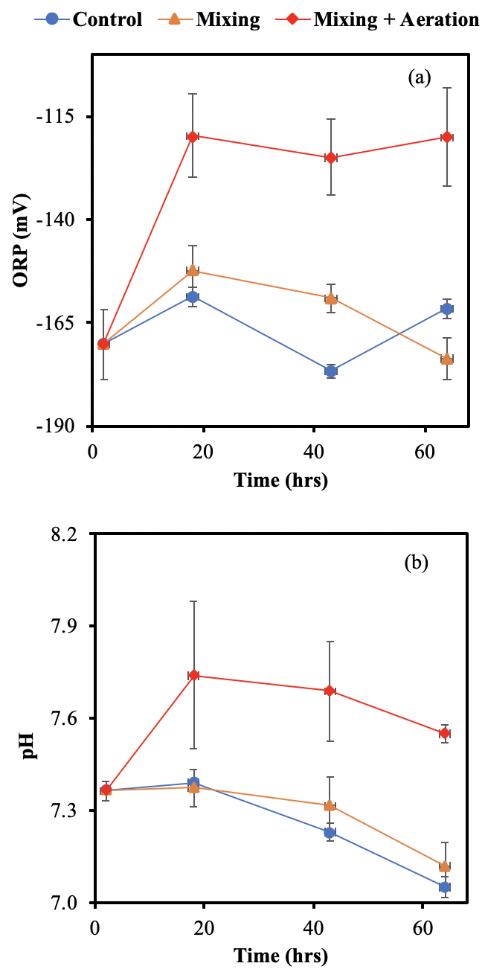

Figure S1. Profiles of (a) ORP and (b) pH measured in the course of the 64-hour sludge holding time in the second-round of bench-scale experiment mimicking SHTs.
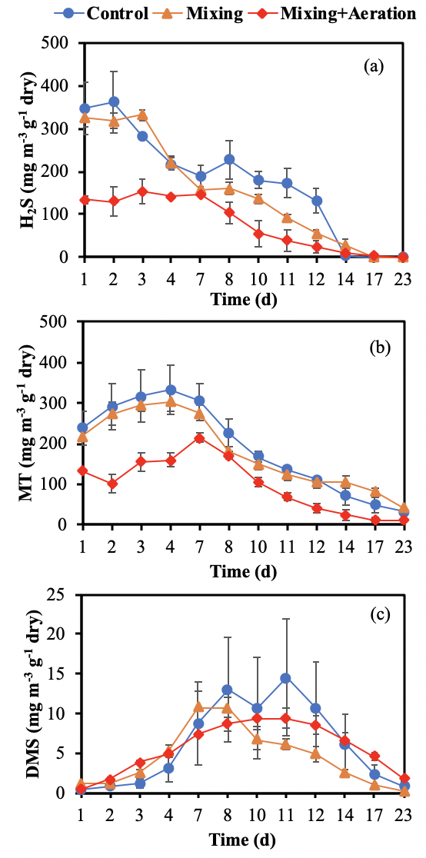

Figure S2. Profiles of (a) H₂S, (b) MT, and (c) DMS measured in the course of the sludge storage time for three groups of sludge with/without mechanical mixing and aeration in the second-round of bench-scale experiment mimicking SHTs

