Supplementary material
Table S1: Characteristics of mixed sludge (digester feed) from the secondary wastewater treatment facility
Parameter | Average (std. dev.; n)
pH | 5.8 (0.2; 14)*
TSª (% w/w) | 3.67 (0.3; 18)
VS^{b} (% w/w) | 3.26 (0.2; 18)
Ammonia (mg/L) | 662 (52; 12)
Nitrate (mg/L) | 14.3 (4.5; 12)
Nitrite (mg/L) | 0.004 (0.003; 12)
Orthophosphate (mg/L) | 251 (23; 12)
Alkalinity (mg as CaCO₃/L) | 1767 (81; 12)
COD^{c} (mg/L) | 57,557 (2233; 12)
TVFA^{d} (mg/L) | 2,568 (162; 12)
ªTS: total solids, ^{b}VS: volatile solids, ^{c}COD: chemical oxygen demands, ^{d}TVFA: total volatile fatty acids. *Data represent mean of replicates (std. dev.: standard deviation, n: number of replicates).

Table S2: Characteristics of anaerobic inoculum used to start up the automated digesters
Parameter |  | Average
pH |  | 5.80 (0.2)*
TSª (% w/w) |  | 1.80 (0.01)
VS^{b} (% w/w) |  | 1.31 (0.01)
Ammonia (mg/L) |  | 1605 (16)
Orthophosphate (mg/L) |  | 176 (1.2)
Alkalinity (mg as CaCO₃/L) |  | 5051 (38)
COD^{c} (mg/L) |  | 21,946 (480)
TVFA^{d} (mg/L) |  | 90 (20)
ªTS: total solids, ^{b}VS: volatile solids, ^{c}COD: chemical oxygen demands, ^{d}TVFA: total volatile fatty acids as summation of acetic, propionic and butyric acids, *Data represent mean of two duplicate samples (absolute difference between duplicates).

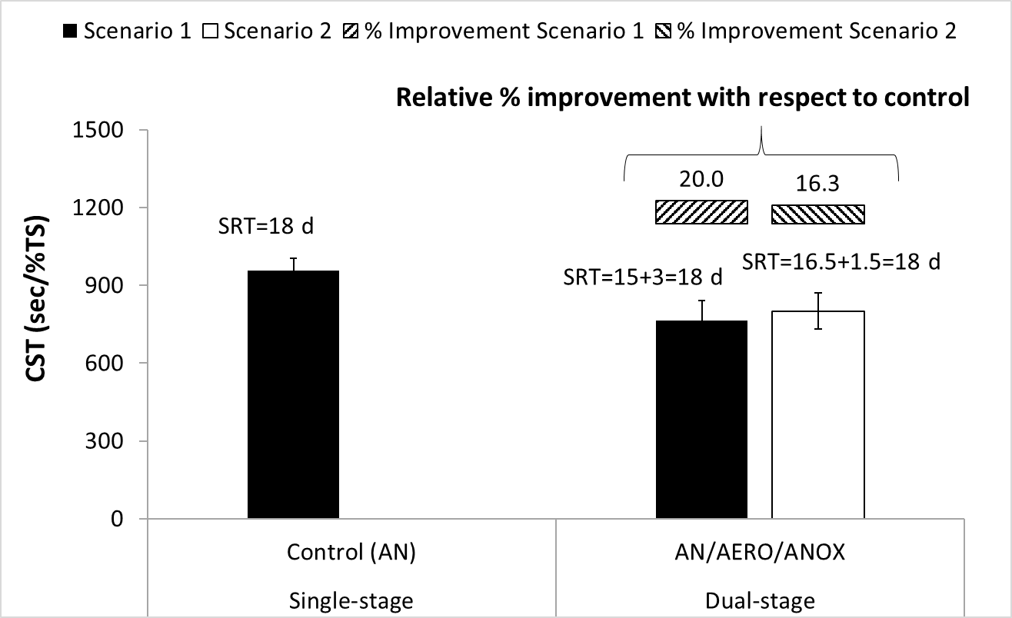
Figure S1: Normalized capillary suction time (CST) values for single-stage and dual-stage digester effluents

