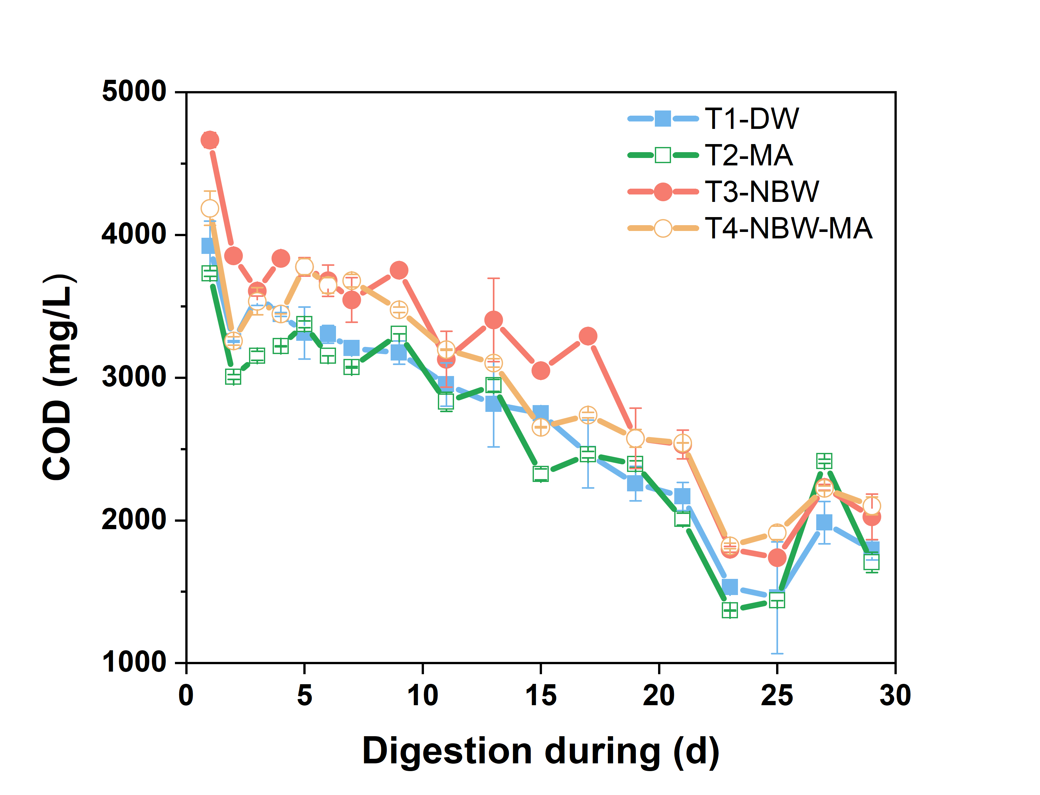
Fig. S1. Profile in COD.

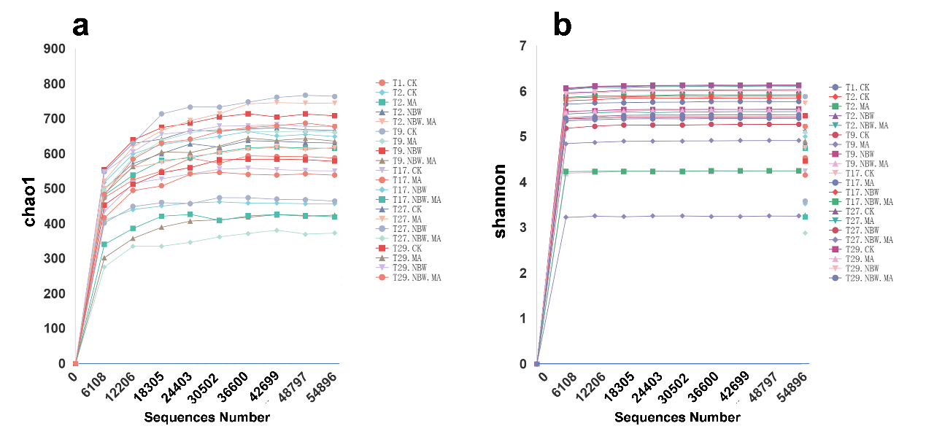
Fig. S2. Bacterial alpha diversity: chao1 indices (a), Shannon indices (b).

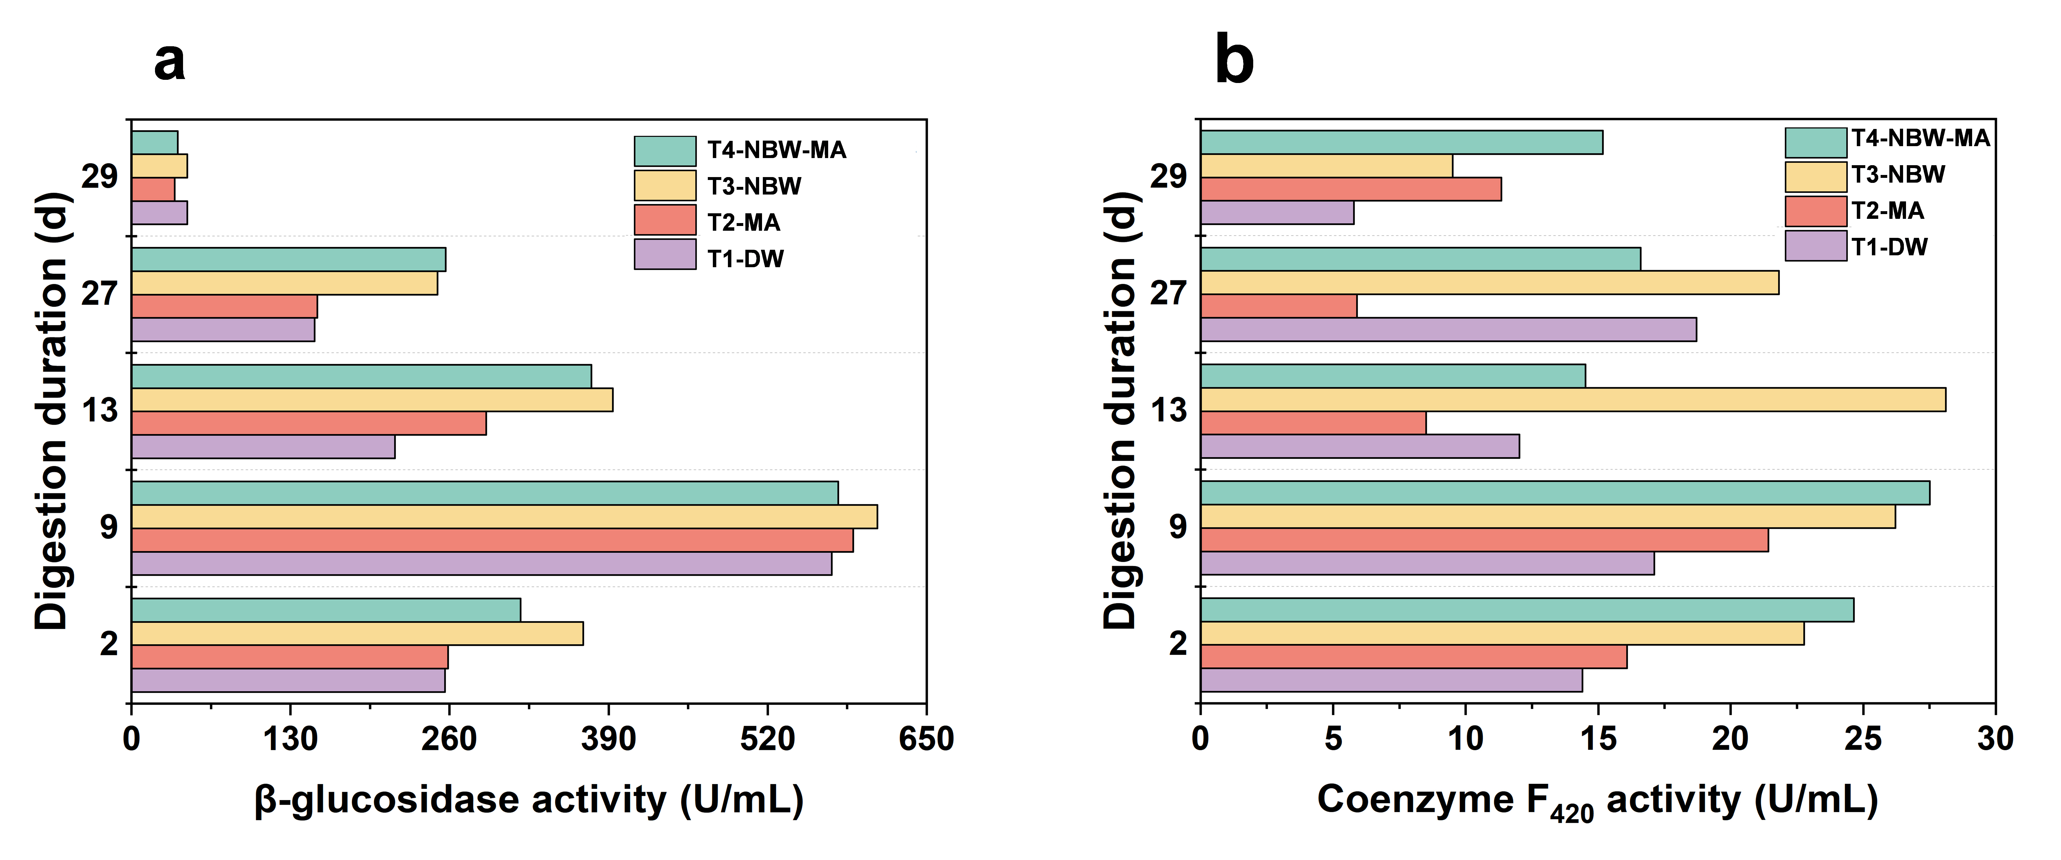
Fig. S3. Enzymatic activities of β-glucosidase (a) and coenzyme F₄₂₀ (b) in treatments T1-DW, T2-MA, T3-NBW, and T4-NBW-MA.

