Supplementary Information
Effects of nano-bubble water on anaerobic co-digestion of cabbage waste and cow manure under mesophilic and thermophilic conditions
Youfei Zhouª, Peilin Guo^{b}, Yi Liu^{b,c}, Weijie Huª, Tianfeng Wang^{b*}

- Design Institute No.3, Shanghai Municipal Engineering Design and Research Institute (Group) Co., Ltd., Shanghai 200092, China
- College of Petrochemical Engineering, Lanzhou University of Technology, Lanzhou 730050, China
- School of Environmental and Municipal Engineering, Xi'an University of Architecture and Technology, Xi'an 710055, China

*Corresponding author: wangtianfeng@lut.edu.cn gloomysmile@163.com (Tianfeng Wang)
Tel: +86-013919026750

List of Figure Captions
Fig. S1. Size and concentration of nano-bubble water prepared by a nanobubble water manufacturing mechanism
Fig. S2. Heatmap of correlation analysis between environmental factors and microbial communities (top five at phylum level bacteria and genus level archaea) at mesophilic conditions (*, p < 0.05; **, p < 0.01; ***, p < 0.001)
Fig. S3. Heatmap of correlation analysis between environmental factors and microbial communities (top five at phylum level bacteria and genus level archaea) at thermophilic conditions (*, p < 0.05; **, p < 0.01; ***, p < 0.001)

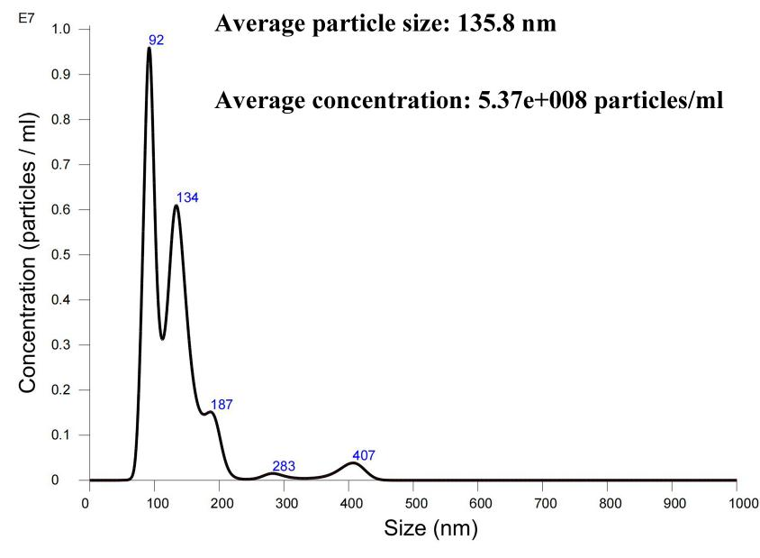
Fig. S1. Size and concentration of nano-bubble water prepared by a nano-bubble water manufacturing mechanism

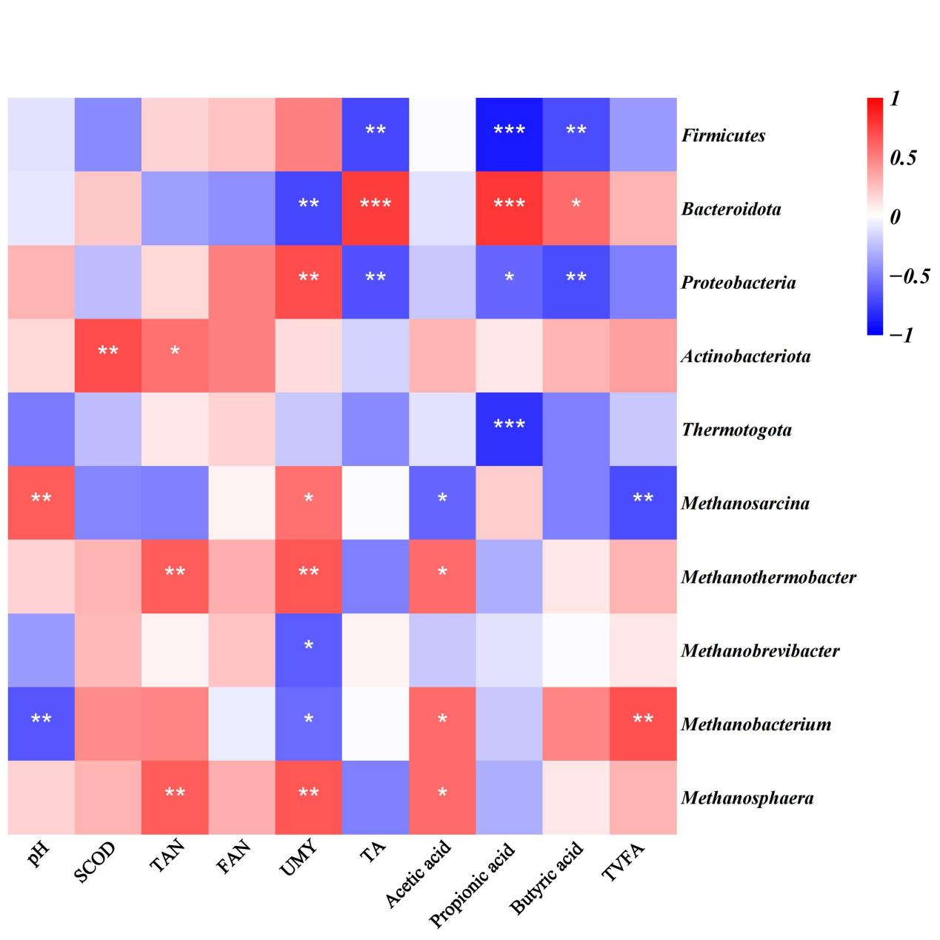
Fig. S2. Heatmap of correlation analysis between environmental factors and microbial communities (top five at phylum level bacteria and genus level archaea) at mesophilic conditions (*, p < 0.05; **, p < 0.01; ***, p < 0.001)

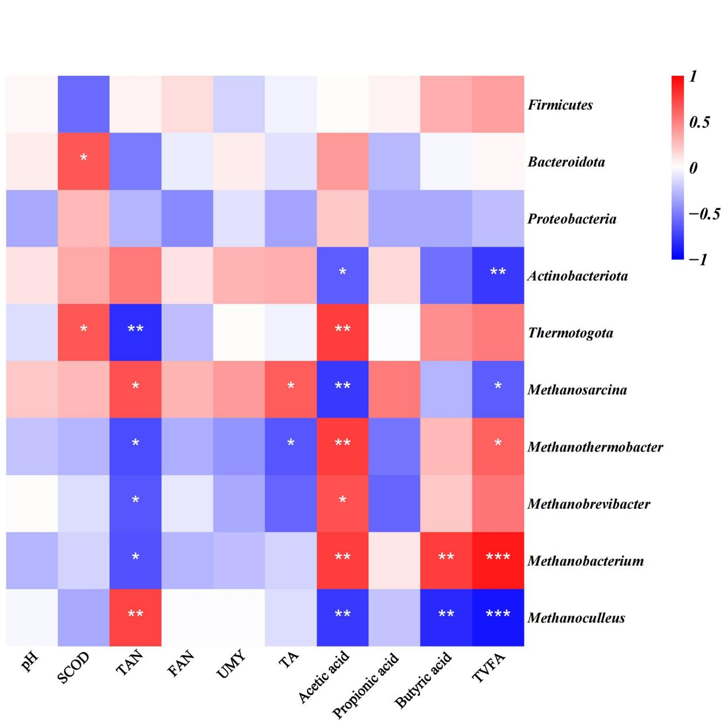
Fig. S3. Heatmap of correlation analysis between environmental factors and microbial communities (top five at phylum level bacteria and genus level archaea) at thermophilic conditions (*, p < 0.05; **, p < 0.01; ***, p < 0.001)

List of Table Captions
Table S1. Alpha diversity index of bacteria
Table S2. Alpha diversity index of archaea

Table S1 Alpha diversity index of bacteria
 | sobs | Shannon | Simpson | Chao1
M | 1887 | 7.2420 | 0.9630 | 1935.95
M-Air | 2127 | 8.1799 | 0.9874 | 2204.58
M-CO₂ | 2241 | 7.7890 | 0.9794 | 2296.27
M-He | 2229 | 8.2191 | 0.9882 | 2300.48
M-N₂ | 2153 | 7.6888 | 0.9718 | 2229.18
T | 1284 | 5.3977 | 0.8952 | 1394.16
T-Air | 1620 | 6.3773 | 0.9524 | 1720.09
T-CO₂ | 1497 | 6.4456 | 0.9524 | 1606.71
T-He | 1413 | 5.8781 | 0.9141 | 1532.25
T-N₂ | 1569 | 6.6394 | 0.9606 | 1680.51

Table S2. Alpha diversity index of archaea
 | sobs | Shannon | Simpson | Chao1
M | 56 | 2.9736 | 0.7977 | 63.00
M-Air | 64 | 3.1723 | 0.8218 | 71.20
M-CO₂ | 64 | 3.2936 | 0.8528 | 65.25
M-He | 58 | 3.1037 | 0.8147 | 60.00
M-N₂ | 59 | 3.3550 | 0.8530 | 59.10
T | 56 | 2.0203 | 0.6038 | 57.00
T-Air | 51 | 2.2723 | 0.6724 | 51.00
T-CO₂ | 58 | 2.3420 | 0.6868 | 61.00
T-He | 58 | 2.3371 | 0.6906 | 61.50
T-N₂ | 56 | 2.3250 | 0.6820 | 67.25

