Supplementary Material
Air nanobubble effectively enhances tetracycline degradation and antibiotic resistance genes reduction in sludge anaerobic digestion

Contents:
Table S1. Parameters of seed sludge and dewatered sludge
Table S2. Basic properties of air nanobubble water
Table S3. Liquid chromatography conditions for the tetracycline detection
Table S4. Mass spectrometry methods for the tetracycline analysis
Table S5. Parameters of the modified Gompertz model
Fig S1. The pH (a), soluble chemical oxygen demand (b), total ammonia nitrogen (c), and free ammonia nitrogen (d) during anaerobic digestion.
Fig S2. Principal component analysis of bacteria (a) and archaea (b).
Fig. S3. Changes in the abundance of the major tetracycline resistance genes during anaerobic digestion (Background color: blue-efflux pump genes, yellow-ribosomal protection protein genes, red-enzymatic modification genes).
Fig S4. Heatmap of correlation between tetracycline resistance genes and bacteria (a) or archaea (b).

Table S1 Parameters of seed sludge and dewatered sludge
 | Seed sludge | Dewatered sludge
TS (%) | 3.16±0.02 | 14.09±0.05
VS (%) | 1.08±0.01 | 7.26±0.05
VS/TS (%) | 34.25±0.06 | 51.62±0.12
pH | 7.83±0.01 | 6.93±0.02
SCOD (mg L⁻¹) | 1328.17±8.34 | 1667.22±14.72
TAN (mg L⁻¹) | 820.67±4.25 | 205.50±4.00
C (%, dry solids) | 16.11±0.21 | 27.01±0.13
N (%, dry solids) | 1.42±0.01 | 3.61±0.02
H (%, dry solids) | 2.63±0.04 | 4.35±0.06
S (%, dry solids) | 0.21±0.00 | 0.20±0.00
C/N | 11.35±0.08 | 7.48±0.01
Note: All values are expressed as mean ± standard deviation (n = 3).

Table S2 Basic properties of air nanobubble water
 | pH | DO (mg L⁻¹) | Zeta potential (mV) | Conductivity (µS cm⁻¹) | Temperature (℃)
Air-NBW | 5.58 ± 0.03 | 8.83 ± 0.37 | -23.5 ± 1.2 | 3.03 ± 0.07 | 23.7 ± 0.2
Note: All values are expressed as mean ± standard deviation (n = 3).

Table S3 Liquid chromatography conditions for the tetracycline detection
Time (min) | Flow velocity (mL min⁻¹) | %A | %B
0 | 0.25 | 90 | 10
1 | 0.25 | 80 | 20
3 | 0.25 | 5 | 95
8 | 0.25 | 5 | 95
10 | 0.25 | 90 | 10
13 | 0.25 | 90 | 10
Note: Separation column is C18 (100*2.1 mm, 1.9 μm); The column temperature is 40 °C, the injection volume is 10 μL; Mobile phase A is 0.1% aqueous formic acid solution; Mobile phase B is acetonitrile.

Table S4 Mass spectrometry methods for the tetracycline analysis
 | Parent ion (m z⁻¹) | Daughter ion (m z⁻¹) | Collision voltage (V) | Collision Energy (eV)
Tetracycline | 445.0 | 410.2 | 40 | 18
Tetracycline | 445.0 | 427.2 | 40 | 14
Tetracycline | 445.0 | 428.0 | 40 | 12
Note: Use positive ion detection mode; The limit of detection is 0.003 ng mL⁻¹, and the limit of quantification is 0.010 ng mL⁻¹.

Table S5 Parameters of the modified Gompertz model
 | Ultimate methane production,  UMP (mL g⁻¹ VS_{added}) | Maximum daily methane production,  R_{m} (mL g⁻¹ VS_{added} d⁻¹) | Lag phase,  λ (d) | R²
A0 | 199.58 ± 3.40ª | 12.85 ± 0.60ª | 0.73 ± 0.24^{bc} | 0.995 ± 0.000
C0 | 167.93 ± 12.25^{b} | 11.33 ± 0.13^{ab} | 0.84 ± 0.18^{ab} | 0.995 ± 0.002
A2 | 170.16 ± 21.59^{b} | 10.96 ± 1.41^{ab} | 0.87 ± 0.11^{ab} | 0.995 ± 0.002
C2 | 153.65 ± 21.14^{b} | 10.74 ± 1.45^{ab} | 1.02 ± 0.14ª | 0.996 ± 0.001
A20 | 166.30 ± 1.97^{b} | 9.90 ± 0.93^{b} | 0.51 ± 0.16^{c} | 0.995 ± 0.001
C20 | 146.83 ± 4.03^{b} | 9.14 ± 1.71^{b} | 0.53 ± 0.02^{c} | 0.993 ± 0.002
Note: All values are expressed as mean ± standard deviation (n =3); a and b were labeled according to Duncan's test. When there were no duplicate labeling symbols between the two groups, they were considered to be significantly different at the p<0.05 level.

Fig S1. The pH (a), soluble chemical oxygen demand (b), total ammonia nitrogen (c), and free ammonia nitrogen (d) during anaerobic digestion.

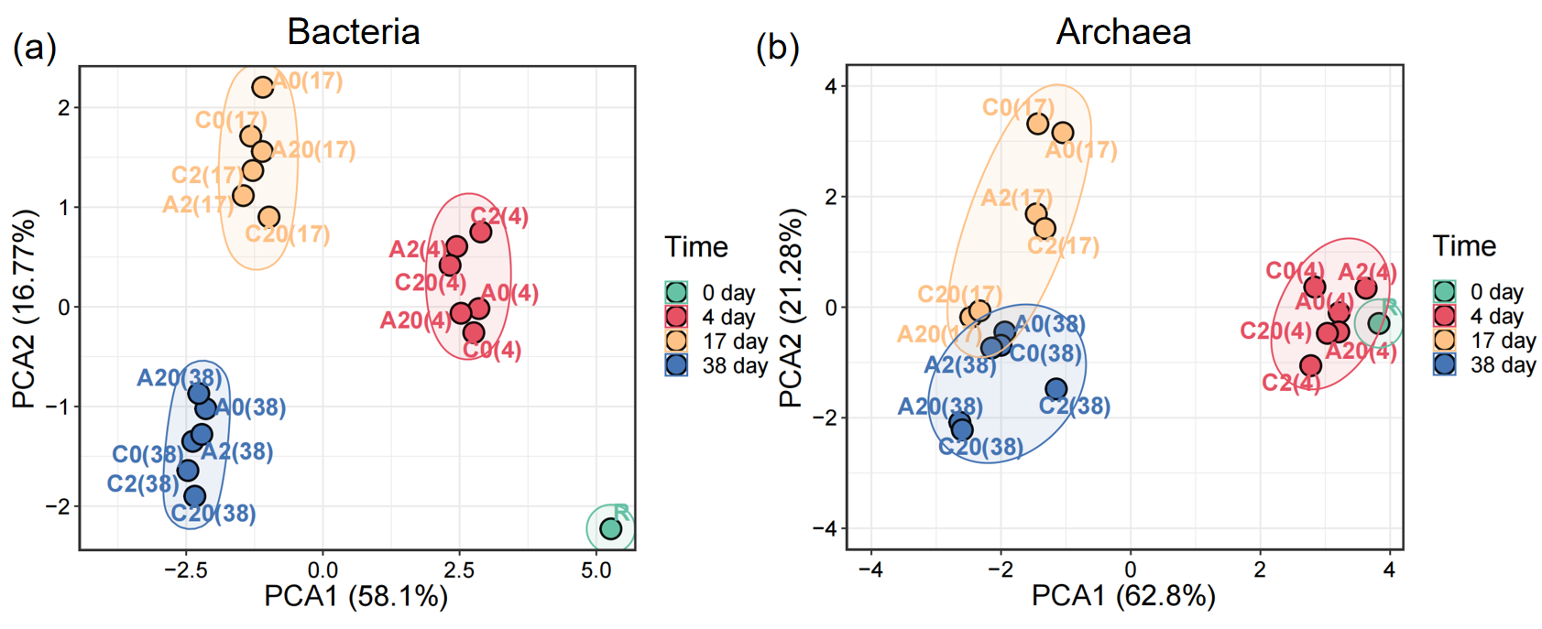
Fig S2. Principal component analysis of bacteria (a) and archaea (b).

Fig S3. Changes in the abundance of the major tetracycline resistance genes during anaerobic digestion (Background color: blue-efflux pump genes, yellow-ribosomal protection protein genes, red-enzymatic modification genes).

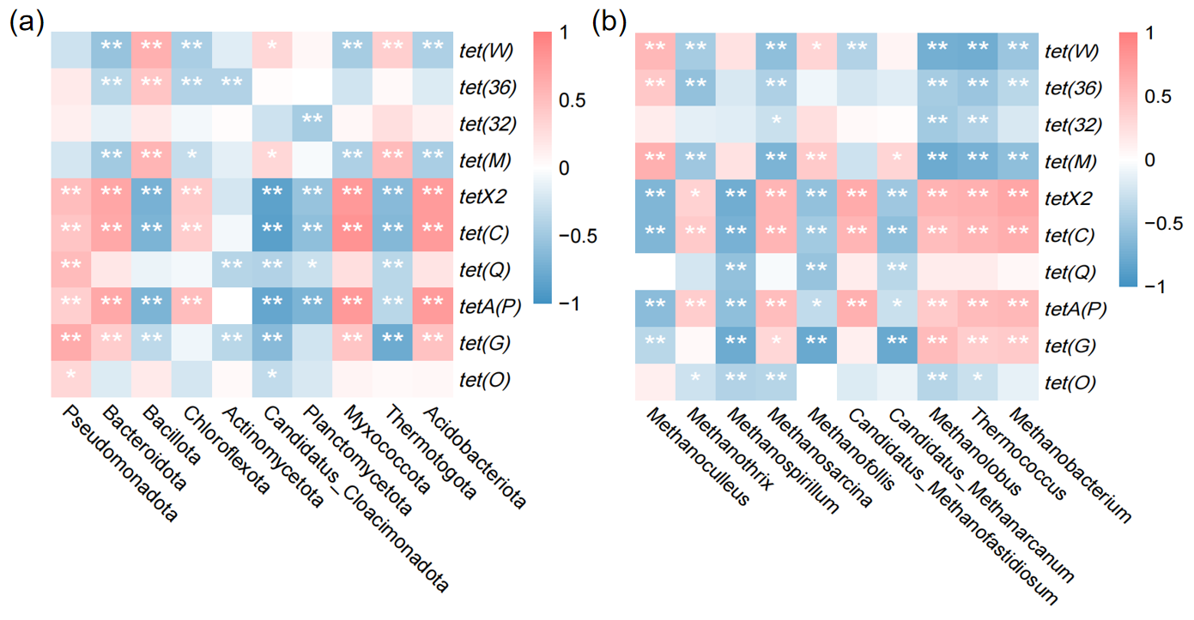
Fig S4. Heatmap of correlation between tetracycline resistance genes and bacteria (a) or archaea (b).

