E-SUPPLEMENTARY FILE
Dose-response effects of microaeration on thermophilic lignocellulose-based anaerobic digestion: performance, stability and microbial community dynamics

Marcin P. Kozera ª, Çağrı Akyol ^{b,}*, Florent Bouchon ^{c,d}, Ramon Ganigué ^{c,d}, Bernard Willems ^{e}, Erik Meers ^{b}, Kai Bester ^{f}, Henrik B. Møller ª

ª Department of Biological and Chemical Engineering, Aarhus University, Blichers Allé 20, 8830 Tjele, Denmark
^{b} Laboratory for Bioresource Recovery (Re-Source), Department of Green Chemistry and Technology, Faculty of Bioscience Engineering, Ghent University, Coupure Links 653, 9000 Ghent, Belgium
^{c} Center for Microbial Ecology and Technology (CMET), Faculty of Bioscience Engineering, Ghent University, Coupure Links 653, 9000 Ghent, Belgium
^{d} Center for Advanced Process Technology for Urban Resource Recovery (CAPTURE), Frieda Saeysstraat, 9052 Ghent, Belgium
^{e} Innolab, Marechalstraat 70, 8020 Oostkamp, Belgium
^{f} Department of Environmental Science, Aarhus University, Frederiksborgvej 399, Roskilde, 4000, Denmark

*Corresponding author
E-mail address: cagri.akyol@ugent.be (Ç. Akyol)

List of supplementary materials
Table S1a. The full monitoring of process parameters in the aerated reactor (MA).
Table S1b. The full monitoring of process parameters in the non-aerated reactor (CON).
Table S2. Diversity metrics Sannon and Inverse Simpson for inoculum and digestates samples under different aeration rates.
Figure S1. Changes in biogas composition and hydrogen sulfide concentration before, during and after the air injection. The figure excludes the content of gaseous nitrous compounds.
Figure S2. The principal component analysis (PCA) for beta diversity analysis among the samples over time.

Table S1a. The full monitoring of process parameters in the aerated reactor (MA).
Period | Date | TS | VS | EC | FOS-TAC | pH | TAN | Acetic acid | Propionic acid | Isobutanoic acid | Butanoic acid | Isovaleric acid | Valeric acid | Caproic acid | P/A ratio
Period | Date | % | %TS | mS/cm | mgHAc/mgCaCO₃ | - | g/L | mg/L |  |  |  |  |  |  | -
D0 | 15.01.2024 | 3,20 | 66,11 | 19,20 | 0,61 | 8,00 | 1,81 | 2632 | 753 | 165 | 167 | 219 | 38 | 44 | 0,3
D0 | 17.01.2024 | 3,60 | 69,55 | 19,59 | 0,50 | 8,15 | 1,85 | 1817 | 942 | 163 | 62 | 237 | 49 | 24 | 0,5
D0 | 22.01.2024 | 4,48 | 70,84 | 19,41 | 0,73 | 7,83 | 1,95 | 2990 | 1111 | 215 | 210 | 315 | 55 | 26 | 0,4
D0 | 29.01.2024 | 3,67 | 67,48 | 19,15 | 0,72 | 8,18 | 1,98 | 3070 | 1340 | 275 | 154 | 467 | 62 | 27 | 0,4
D1 | 05.02.2024 | 4,70 | 73,76 | 17,85 | 0,50 | 8,05 | 1,96 | 1318 | 1590 | 207 | 21 | 332 | 50 | 25 | 1,2
D1 | 12.02.2024 | 6,43 | 79,33 | 17,84 | 0,45 | 8,04 | 1,95 | 1155 | 1645 | 59 | 27 | 173 | 41 | 24 | 1,4
D1 | 19.02.2024 | 5,24 | 74,30 | 19,53 | 0,34 | 8,15 | 2,13 | 1103 | 518 | 64 | 9 | 91 | 12 | 24 | 0,5
D1 | 28.02.2024 | 5,88 | 76,43 | 19,72 | 0,29 | 8,19 | 2,15 | 1013 | 216 | 17 | 10 | 26 | 13 | 26 | 0,2
D2 | 04.03.2024 | 6,24 | 77,29 | 20,18 | 0,26 | 8,16 | 2,16 | 772 | 209 | 11 | 8 | 17 | 11 | 22 | 0,3
D2 | 11.03.2024 | 6,10 | 76,83 | 20,27 | 0,23 | 7,99 | 2,28 | 666 | 146 | 9 | 7 | 11 | 12 | 25 | 0,2
D2 | 18.03.2024 | 6,02 | 75,57 | 20,75 | 0,22 | 8,08 | 2,22 | 488 | 58 | 10 | 8 | 12 | 14 | 27 | 0,1
D3 | 21.03.2024 | 5,82 | 75,74 | 21,50 | 0,22 | 8,20 | 2,34 | 414 | 35 | 9 | 7 | 11 | 12 | 23 | 0,1
D3 | 02.04.2024 | 6,12 | 76,67 | 21,30 | 0,23 | 8,17 | 2,31 | 451 | 55 | 8 | 6 | 10 | 11 | 22 | 0,1
D3 | 08.04.2024 | 6,22 | 76,56 | 21,04 | 0,21 | 8,16 | 2,36 | 423 | 44 | 10 | 8 | 12 | 13 | 26 | 0,1
D3 | 15.04.2024 | 5,76 | 74,56 | 21,11 | 0,21 | 8,22 | 2,33 | 304 | 19 | 10 | 8 | 12 | 13 | 26 | 0,1

Table S1b. The full monitoring of process parameters in the non-aerated reactor (CON).
Period | Date | TS | VS | EC | FOS-TAC | pH | TAN | Acetic acid | Propionic acid | Isobutanoic acid | Butanoic acid | Isovaleric acid | Valeric acid | Caproic acid | P/A ratio
Period | Date | % | %TS | mS/cm | mgHAc/mgCaCO₃ | - | g/L | mg/L |  |  |  |  |  |  | -
D0 | 15.01.2024 | 4,29 | 68,79 | 18,28 | 0,47 | 8,19 | 1,80 | 1687 | 900 | 139 | 49 | 229 | 42 | 23 | 0,5
D0 | 17.01.2024 | 4,33 | 71,48 | 18,98 | 0,54 | 8,02 | 1,85 | 2038 | 930 | 167 | 115 | 234 | 50 | 25 | 0,5
D0 | 22.01.2024 | 3,88 | 68,86 | 19,25 | 0,50 | 8,13 | 1,89 | 1742 | 1184 | 184 | 47 | 266 | 49 | 23 | 0,7
D0 | 29.01.2024 | 3,44 | 66,31 | 18,65 | 0,49 | 8,21 | 1,87 | 1548 | 1339 | 178 | 36 | 293 | 59 | 26 | 0,9
D1 | 05.02.2024 | 4,74 | 73,46 | 18,14 | 0,40 | 8,15 | 1,96 | 740 | 1556 | 29 | 7 | 240 | 18 | 25 | 2,1
D1 | 12.02.2024 | 5,30 | 75,98 | 18,94 | 0,44 | 8,15 | 2,02 | 1489 | 1100 | 91 | 23 | 169 | 28 | 24 | 0,7
D1 | 19.02.2024 | 6,86 | 77,13 | 19,64 | 0,33 | 8,07 | 2,14 | 985 | 327 | 14 | 7 | 54 | 12 | 24 | 0,3
D1 | 28.02.2024 | 6,05 | 75,92 | 19,16 | 0,23 | 8,19 | 2,15 | 550 | 55 | 8 | 6 | 10 | 11 | 21 | 0,1
D2 | 04.03.2024 | 6,38 | 76,97 | 20,27 | 0,23 | 8,21 | 2,20 | 554 | 94 | 8 | 6 | 11 | 11 | 22 | 0,2
D2 | 11.03.2024 | 5,98 | 75,29 | 20,84 | 0,25 | 7,99 | 2,27 | 847 | 164 | 12 | 7 | 15 | 12 | 25 | 0,2
D2 | 18.03.2024 | 6,05 | 74,30 | 20,41 | 0,24 | 8,06 | 2,30 | 656 | 153 | 9 | 7 | 11 | 12 | 13 | 0,2
D3 | 21.03.2024 | 6,04 | 75,28 | 21,40 | 0,24 | 8,24 | 2,33 | 573 | 86 | 9 | 7 | 11 | 12 | 24 | 0,1
D3 | 02.04.2024 | 6,16 | 75,59 | 21,44 | 0,24 | 8,23 | 2,34 | 559 | 81 | 9 | 7 | 11 | 12 | 23 | 0,1
D3 | 08.04.2024 | 6,46 | 76,64 | 20,95 | 0,22 | 8,15 | 2,30 | 480 | 49 | 10 | 7 | 12 | 13 | 25 | 0,1
D3 | 15.04.2024 | 5,78 | 73,57 | 20,88 | 0,20 | 8,21 | 2,37 | 283 | 20 | 9 | 7 | 11 | 12 | 24 | 0,1

Figure S1. Changes in biogas composition and hydrogen sulfide concentration before, during and after the air injection. The figure excludes the content of gaseous nitrous compounds.
Injection of air

Table S2. Diversity metrics Sannon and Inverse Simpson for inoculum and digestates samples under different aeration rates.
Richness estimators | Shannon | InvSimpson
Inoculum | 3.146349 | 7.665611
CON_Period 0 | 3.926413 | 22.337537
MA_Period 0 | 4.116874 | 28.160268
CON_Period 1 | 3.902119 | 19.901755
MA_Period 1 | 3.678658 | 15.576689
CON_Period 2 | 4.024410 | 25.210743
MA_Period 2 | 3.808492 | 19.456728
CON_Period 3 | 3.860063 | 20.539715
MA_Period 3 | 3.688925 | 16.740722

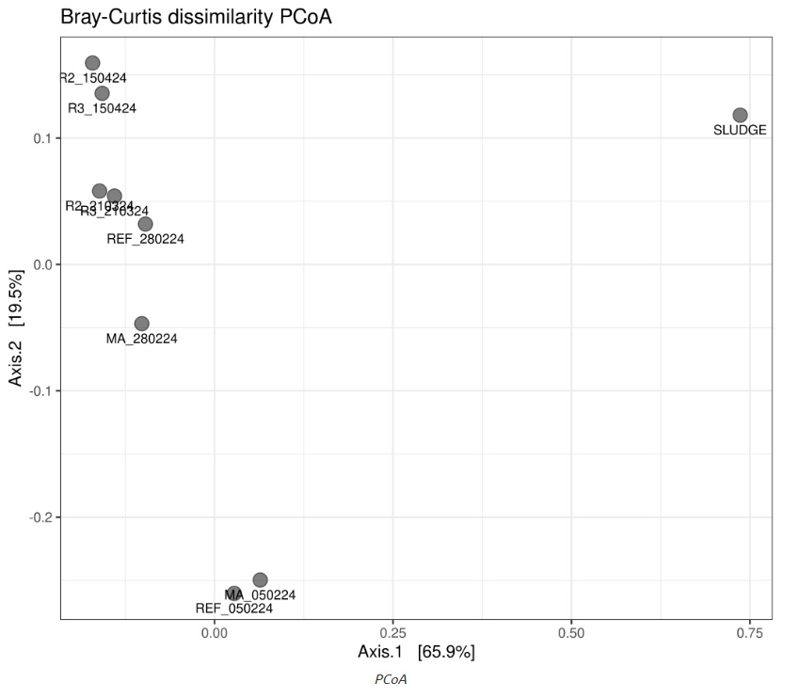
Figure S2. The principal component analysis (PCA) for beta diversity analysis among the samples over time. Note: SLUDGE = inoculum, REF_050224 = CON=Period 0, MA_050224 = MA_050224, REF_280224 = CON_Period1, MA_280224 = MA_Period1, REF_210324 = CON_Period2, MA_210324 = MA_Period2, REF_150424 = CON_Period3, and MA_150424 = MA_Period 3.

