Supplementary information
Impact of micro-aerobic conditions in UASB Reactor using different media to improve the removal efficiency of organics and nutrients from municipal wastewater

Figures
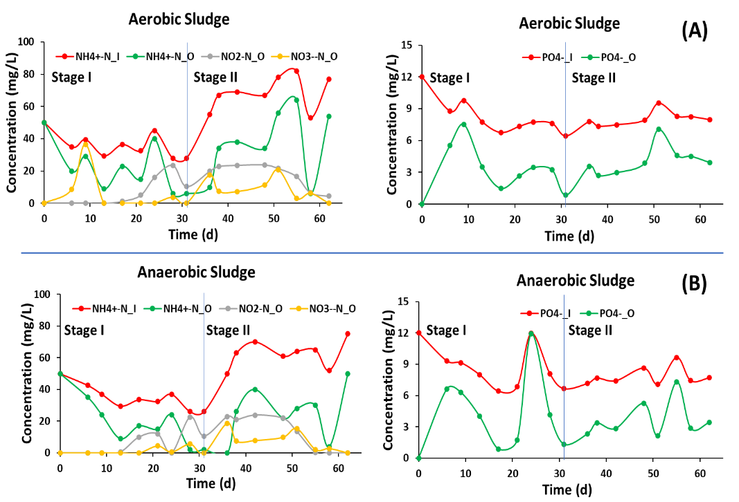
Figure S1. Nitrogen and phosphorus in aerobic and anaerobic sludge without media
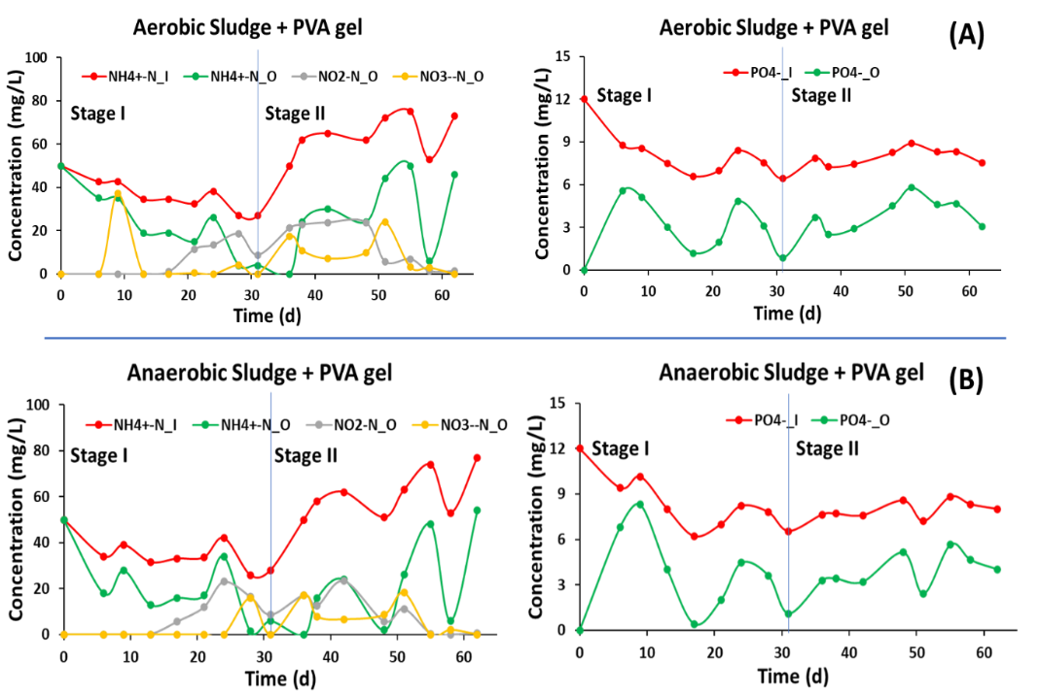
Figure S2. Nitrogen and phosphorus in aerobic and anaerobic sludge with PVA – Gel

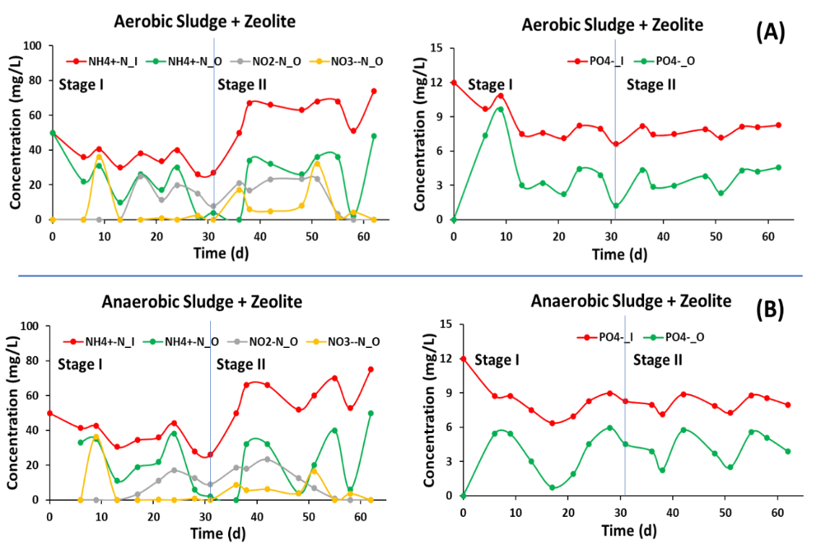
Figure S3. Nitrogen and phosphorus in aerobic and anaerobic sludge with Zeolite
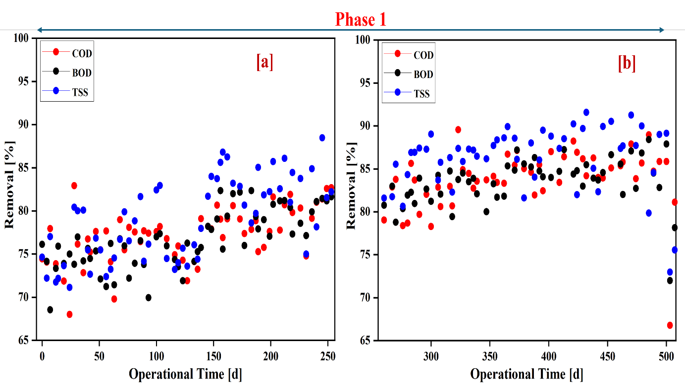
Figure S4. Efficiency removal of the UASB for COD, BOD and TSS [a] condition 1-3 and [b] condition 4-5 in phase 1
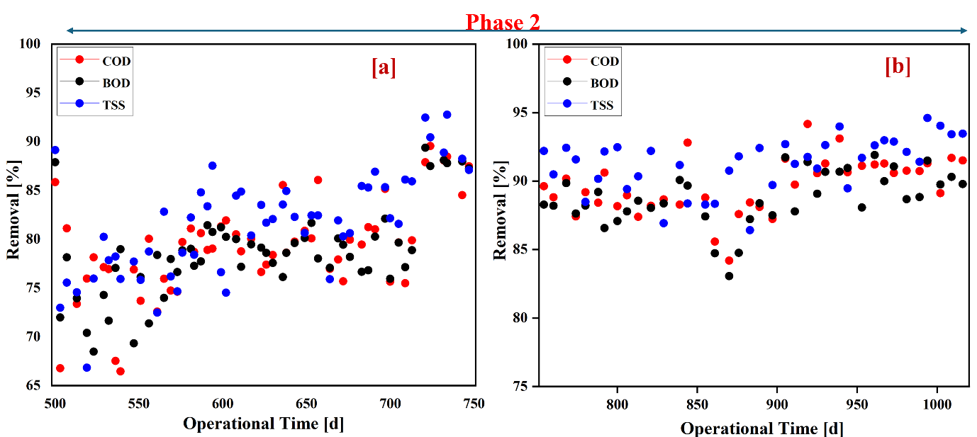
Figure S5. Efficiency removal of the UASB for COD, BOD and TSS [a] condition 1-2 and [b] condition 3-4 in phase 2
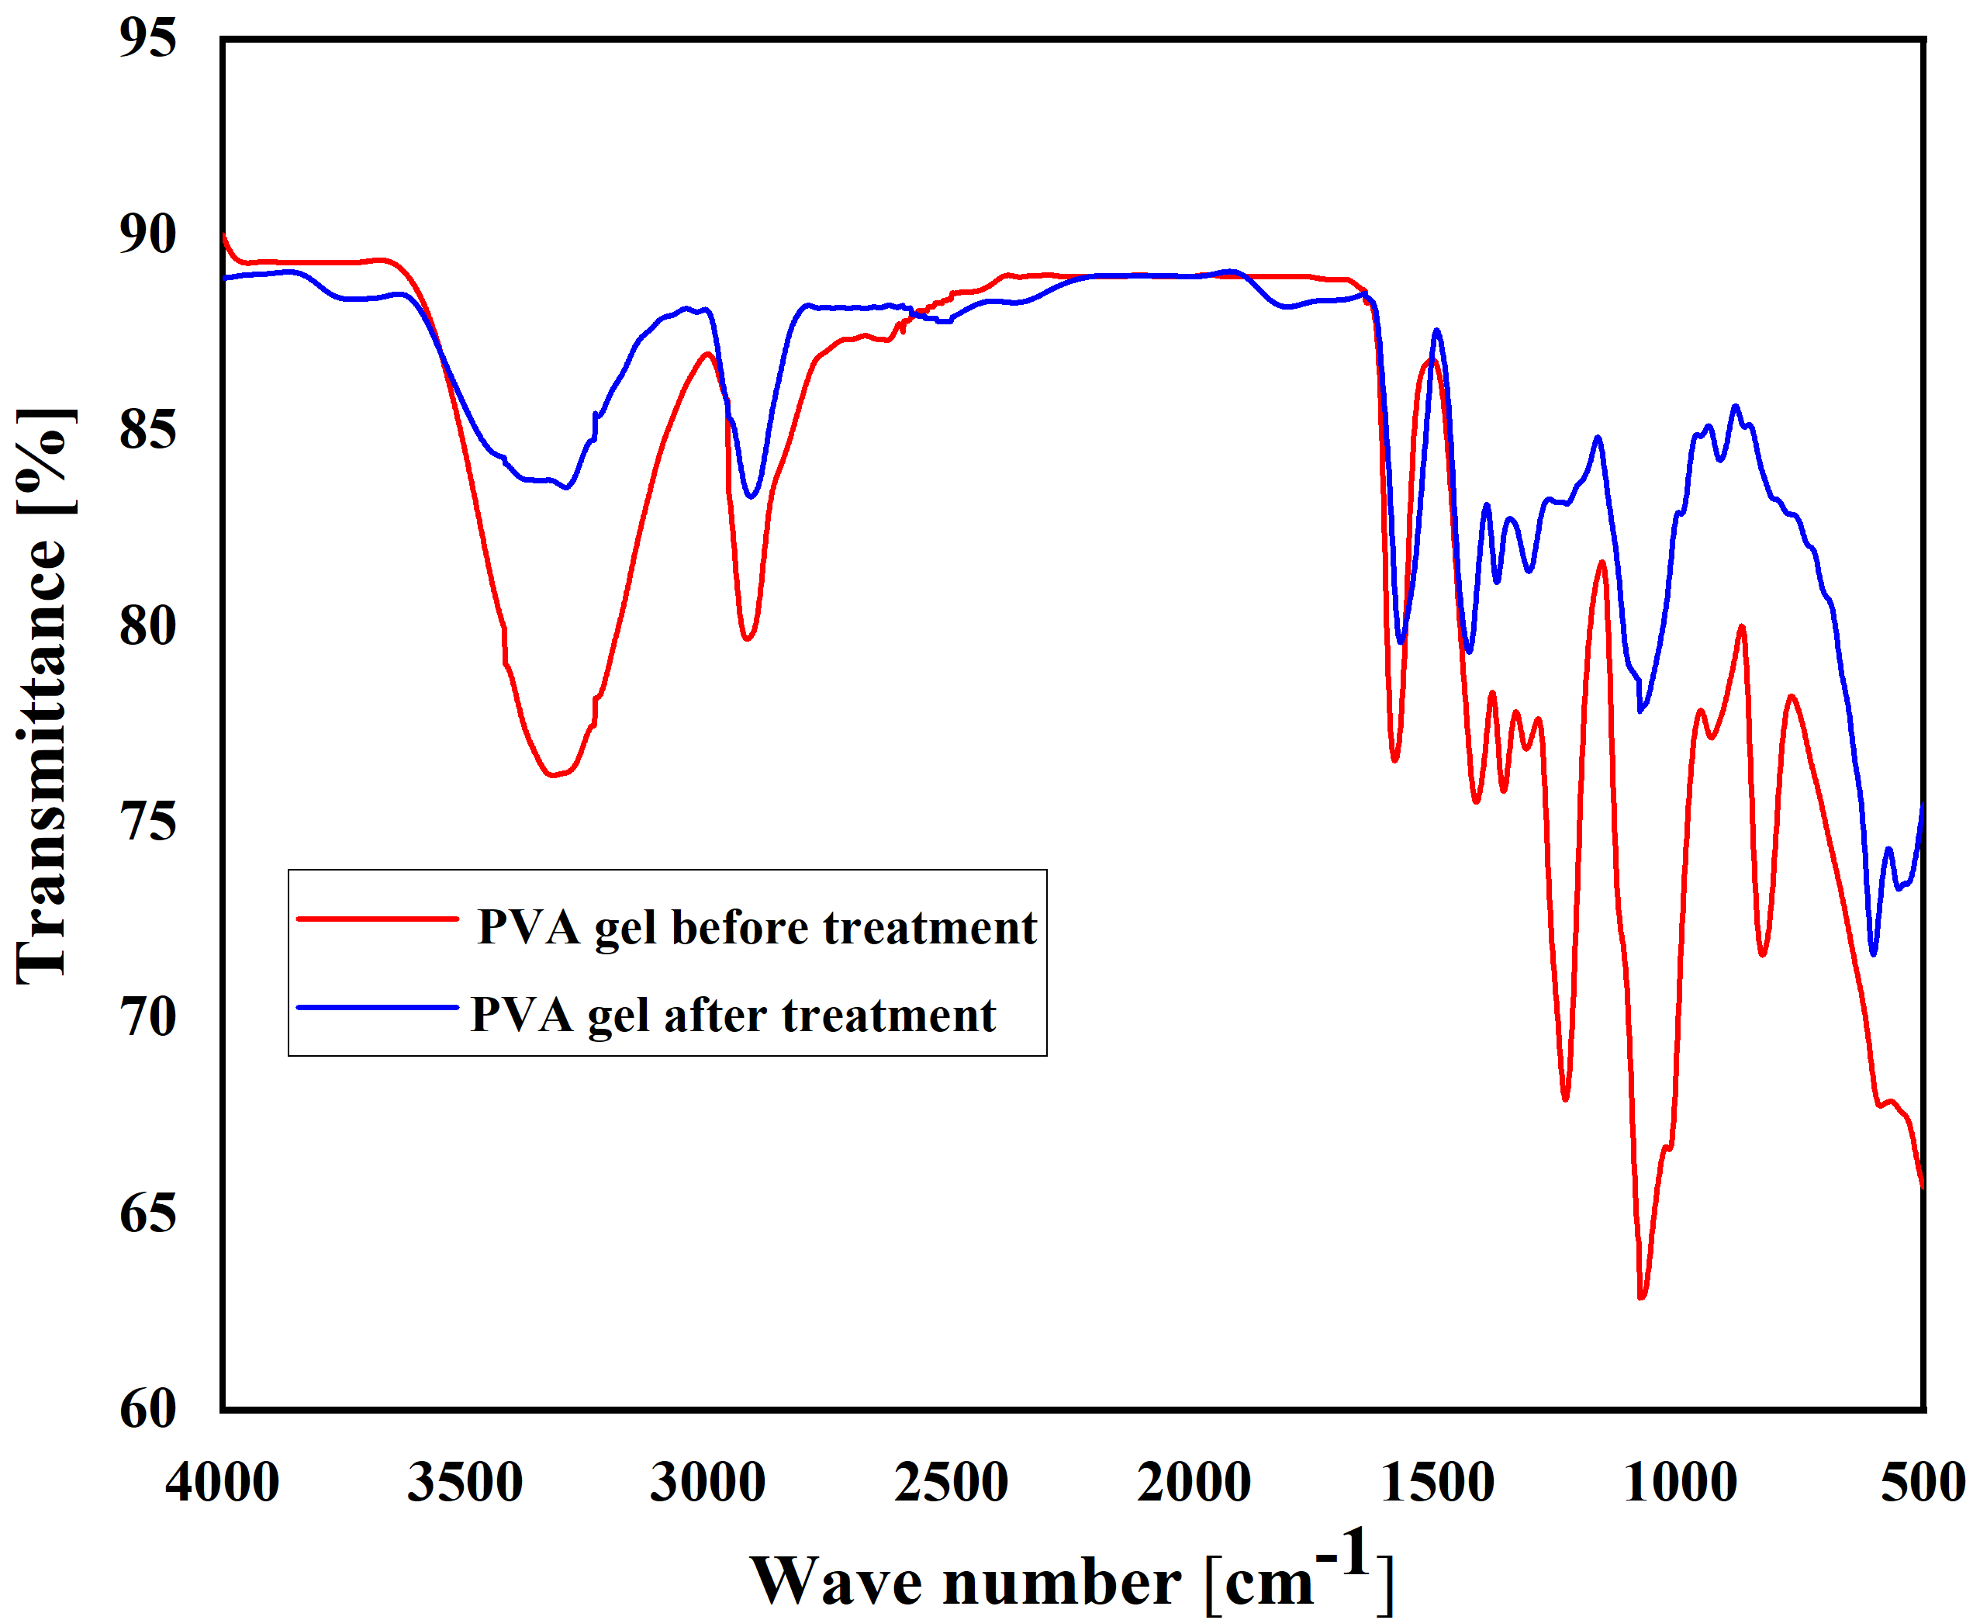
Figure S6. FTIR spectra characteristics of PVA gel before and after micro-aeration in UASB reactor

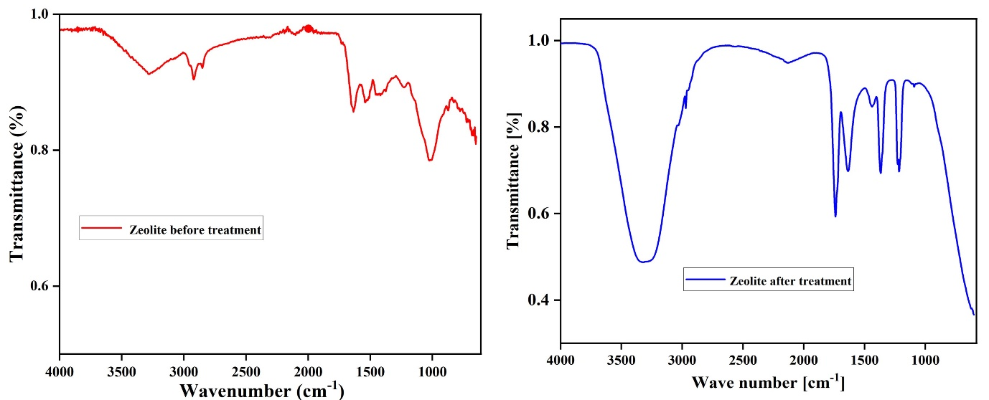
Figure S7. FTIR spectra characteristics of Zeolite before and after micro-aeration in UASB reactor

Tables
Table S1. Operating conditions of the micro-aerobic UASB Process
Study Period (a) days | Phase – 1 – Intermittent Aeration
60 | Condition 1: (DO<1 mg/l)
90 | Condition 2: (DO =1.0-1.5 mg/l)
90 | Condition 3: (DO =1.5-2.0 mg/l)
120 | Condition 4: (DO =1.5-2mg/l) with recycle and media
135 | Condition 5: DO>2 mg/L with recycle and media  (30-40% volume)
Study Period (b) | Phase – 2 – Continuous Aeration
60 | Condition 1: (DO<1 mg/l)
180 | Condition 2: (DO =1.0-1.5 mg/l)
180 | Condition 3: (DO = 1.0 -1.5 mg/l) with recycle in aerobic zone
105 | Condition 4: (DO = 1.0 -1.5 mg/l) with recycle in anaerobic zone

Table S2. Operating conditions for the batch study
Stages | Time (d) | NH₄-N/NO₂-N ratio | COD/NH₄-N ratio
I | 0-30 | 1:0 | 1:0
II | 30-60 | 1:0 | 1:0
III | 60-90 | 1:0.25 | 1:0
IV | 90-120 | 1:0.5 | 1:0
V | 120-150 | 1:1 | 1:0.5
VI | 150-180 | 1:0 | 1:1
VII | 180-210 | 1:0 | 1:1.5
VIII | 210-240 | 1:0 | 1:2

Microscopic images of Figure 6-8 TIF original

Figure 6a. Scanning electron micrographs of sludge before micro-aeration

Figure 6b. Scanning electron micrographs of sludge after micro-aeration

Figure 7a. Scanning electron micrographs of PVA gel before micro-aeration
Figure 7b. Scanning electron micrographs of PVA gel after micro-aeration

Figure 8a. Scanning electron micrographs of zeolite before micro-aeration

Figure 8b. Scanning electron micrographs of zeolite after micro-aeration

