Supplementary information
Revealing mechanism of micro-aeration for enhancing volatile fatty acids from swine manure
Qitao Cao^{a,1}, Wanqin Zhang^{a,1}, Tianjing Lian^{a,b}, Shunli Wangª, Fubin Yinª, Tanlong Zhouª, Xiaoman Weiª, Hongmin Dong^{a,*}
ª Institute of Environment and Sustainable Development in Agriculture, Chinese Academy of Agricultural Sciences, Beijing 100081, PR China
^{b} College of Natural Resources and Environment, Northwest A&F University, Yangling 712100, China

∗ Corresponding Author

List of Supporting Information
Supporting figures:
Fig. S1. Schematic diagram of micro-aeration-based AD system
Fig. S2. ORP, pH and temperature changes during the AD process under different micro-aeration conditions
Fig. S3. Variation of bacterial community structures at class level under different micro-aeration conditions, (A) CK, (B) Air-micro-aeration, (C) N₂-micro-aeration, (D) O₂-micro-aeration
Supporting tables:
Table S1. Operational conditions for the micro-aeration experiment
Table S2. Overview of biogas composition and volumetric CH₄ production rate under different micro-aeration conditions

Supporting figures

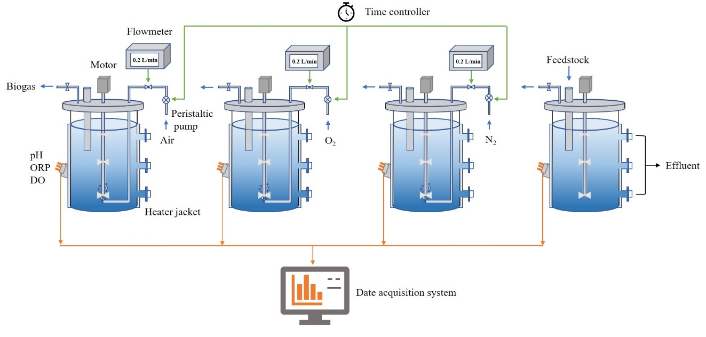
Fig.S1. Schematic diagram of micro-aeration-based AD system

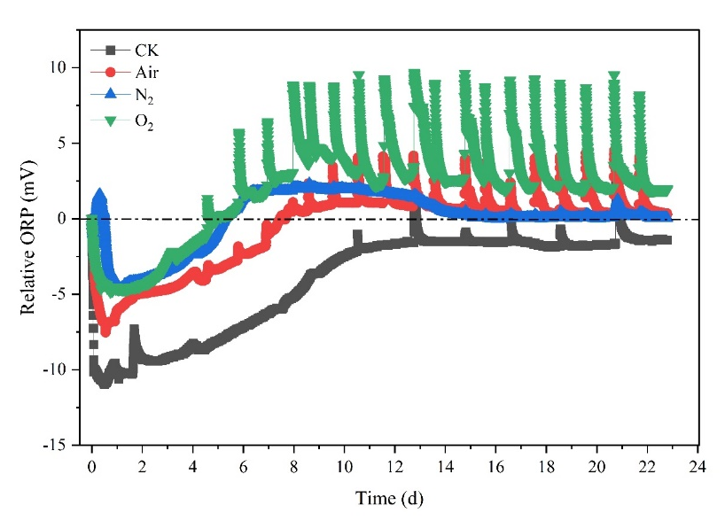
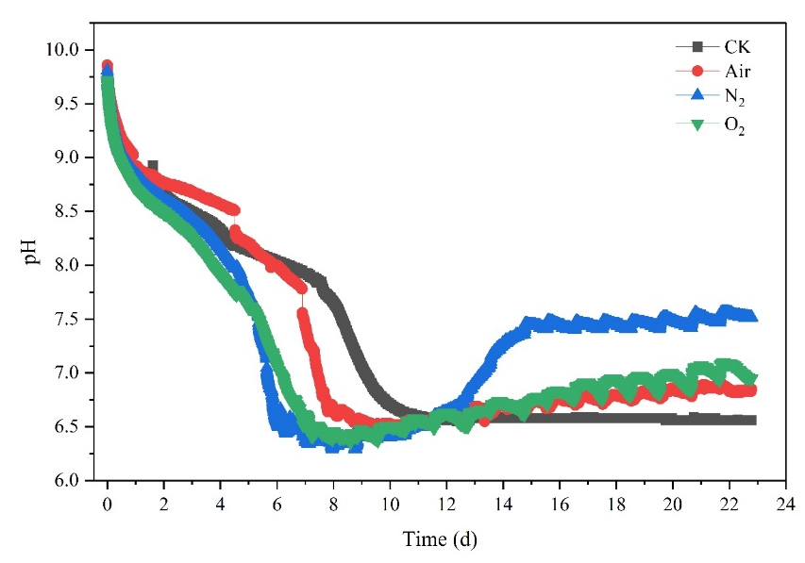
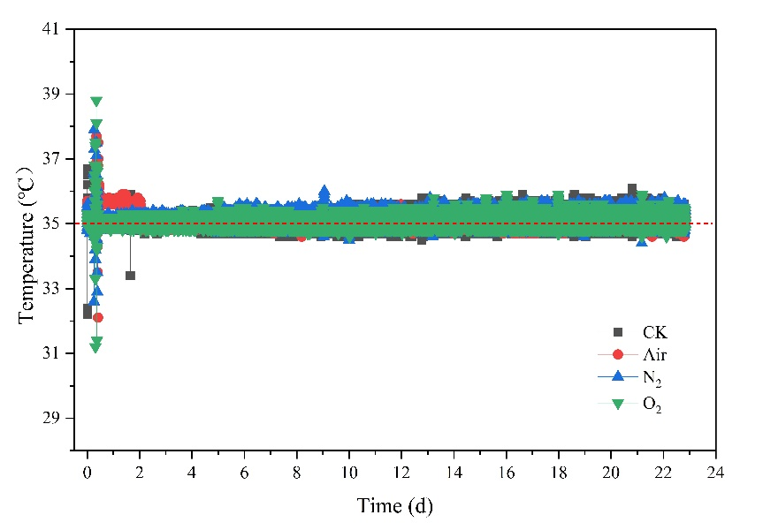
Fig. S2. ORP, pH and temperature changes during the AD process under different micro-aeration conditions

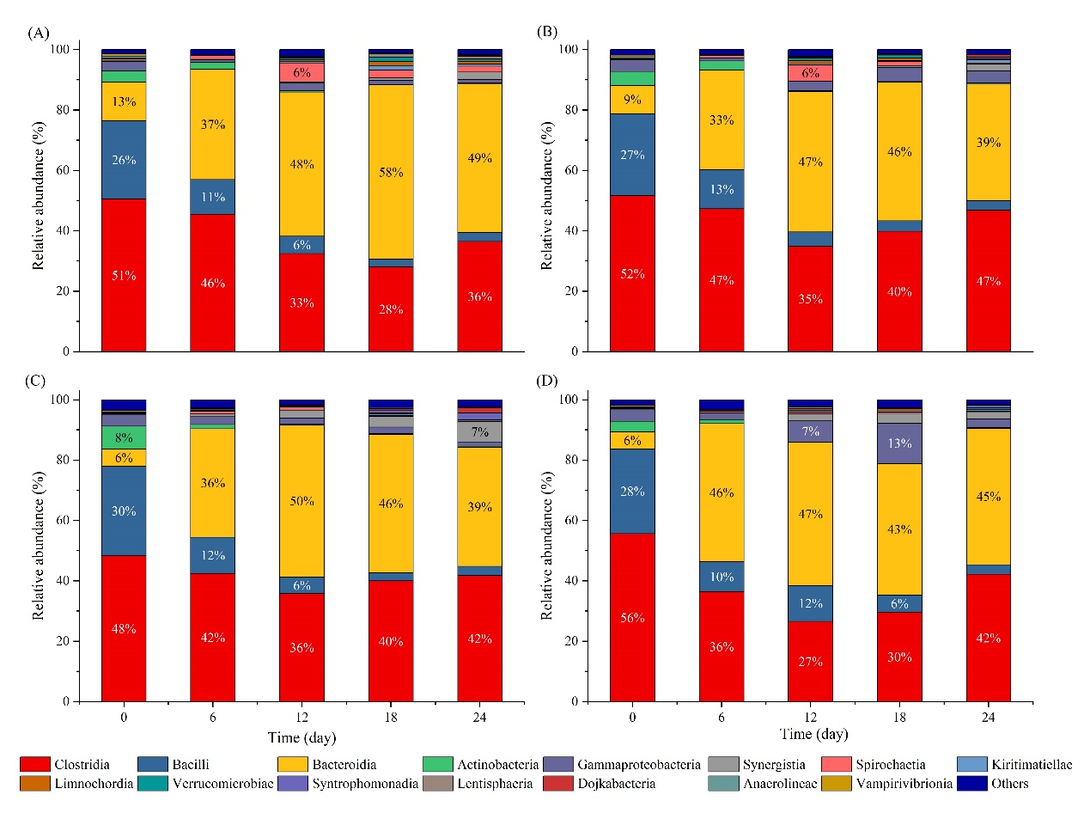
Fig. S3. Variation of bacterial community structures at class level under different micro-aeration conditions, (A) CK, (B) Air-micro-aeration, (C) N₂ addition, (D) O₂-micro-aeration.

Supporting tables
Table S1. Operational conditions for the micro-aeration experiment
Reactor | Substrate concentration | Inoculum | Micro-aeration intensity | Initial pH | Temperature
Air | 4% VS | 600 mL | 1000 mL/L/d | 10.0±0.2 | 35±1℃
O₂
N₂
CK | 4% VS | 600 mL | — | 10.0±0.2 | 35±1℃
CK：Without micro-aeration.

Table S2. Overview of biogas composition and volumetric CH₄ production rate under different micro-aeration conditions
Reactor | Phase Ⅰ |  |  | Phase Ⅱ |  |  |  | Phase Ⅲ
Reactor | CH₄ (%) | CO₂ (%) | CH₄ production rate  (L/L/d) |  | CH₄ (%) | CO₂ (%) | CH₄ production rate  (L/L/d) |  | CH₄ (%) | CO₂ (%) | CH₄ production rate  (L/L/d)
Air | 3.1 | 16.1 | 0.034 |  | 2.2 | 13.0 | 0.023 |  | 36.5 | 16.1 | 0.404
N₂ | 9.7 | 14.5 | 0.109 |  | 28.4 | 13.1 | 0.416 |  | 30.0 | 13.7 | 0.448
O₂ | 2.6 | 23.3 | 0.025 |  | 4.5 | 33.2 | 0.039 |  | 21.2 | 20.9 | 0.238
CK | 0.0 | 0.0 | 0.000 |  | 0.0 | 0.0 | 0.000 |  | 52.8 | 28.1 | 0.345

* Corresponding author. Tel.: +86-10-8210-9979 E-mail address: donghongmin@caas.cn (H. Dong). ¹ Equal contribution of first authorship.

