Supporting Information

Enhancing hydrolysis acidification process for coal gasification wastewater treatment through micro-aeration strategy: The role of micro-oxygen environment

Shengqiang Hei^{a, b, §}, Biming Liu^{a, c, §,} *, Hui Xuª, Xing Lu^{d}, Xinrui Guo^{d},
Danyang Liª, Shuo Zhangª, Xia Huang^{a,} *

ª State Key Laboratory of Regional Environment and Sustainability, School of Environment, Tsinghua University, Beijing 100084, China
^{b} School of Geography and Planning, Ningxia University, Yinchuan 750021, China
^{c} School of Energy and Environment, Anhui University of Technology, Ma Anshan 243002, China
^{d} School of Environmental Sciences and Engineering, Nanjing Tech University, Nanjing 211800, China

Correspondence to: Biming Liu (E-mail: bimingliu@163.com), Xia Huang (E-mail: xhuang@tsinghua.edu.cn)

§These authors contributed equally to this work.
Appendix Text S1:
The aerobic degradation performance of wastewater was evaluated in the long-term batch mode. 1 L of CGW and other effluents were added to the beaker, respectively, followed by the actual aerobic tank sludge (5 g/L). The DO of system was 3~4 mg/L, and the gas volume was controlled by the flowmeter. Each period was divided into aeration (36 h), sedimentation (2 h) and drainage (0.5 h), and the wastewater was supplemented to 2 L to restart the next period. The COD of water samples during different periods was determined after filtration.
The CGW degradation performance of anaerobic sludge was also evaluated in a long-term batch mode at different DO concentrations. 1 L of CGW and 6 g/L of domesticated anaerobic sludge were added to the open reagent bottle (2.5 L), and then placed in a thermostatic shaker at 35 °C and 100 rpm. Gas flow was regulated by a flow meter, and DO levels (0-0.1, 0.1-0.2, 0.2-0.3, 0.3-0.5, 0.5-0.8, and 0.8-1 mg/L) were monitored and adjusted every 3-4 h using a DO meter (HQ30d, Hach, USA). The HRT was maintained at 36 h. The supernatant was taken every 2 d and filtered through the membrane (0.45 μm) for the detection of COD and BOD₅.

Appendix Text S2:
OUR test adopted aerobic sludge sourced from a municipal WWTP, which was washed 3-4 times with distilled water before use. The total volume of test was 20 mL. The test group comprised 8 mL of sludge (4 g/L), 10 mL of water sample, 1 mL of nutrient medium (as detailed in the Table S2) and 1 mL of deionized water. In contrast, the control group contained 8 mL of sludge (4 g/L), 1 mL of nutrient matrix and 11 mL of deionized water. Initially, the water samples were vigorously agitated in a high-speed magnetic stirrer for 1-2 h until DO achieved saturation. Furthermore, the deionized water, sludge, and nutrient medium were rapidly blended and aerated for 30 min until DO reached saturation. It is noteworthy that the DO concentration was monitored at 10 s intervals until it descended below 0.5 mg/L. Prior to the sample assessment, 3,5-dichlorophenol was employed as a standard toxin (EC₅₀: 2-25 mg/L) to ascertain the sensitivity of sludge. The method of testing for heterotrophic bacteria OUR is the same as that for total OUR, and 1 mL ATU (232 mg/L of propylene sulfur) was added to the experimental group before testing. Subsequently, nitrifying bacteria OUR was calculated as the difference between total OUR and heterotrophic bacteria OUR (Hei et al. 2022).

Appendix Text S3:
The mixture for testing nitrification rate was composed of nutrient medium, sludge and water samples, and distilled water was added to make up the volume to 100 mL. The remaining components are mixed first and then the activated sludge inoculum is added. During the microbial incubation process, the microorganisms in the activated sludge in the incubator ensure full contact with CGW. The incubator temperature was controlled at 22±2 °C and the incubation time was 4 h. Subsequently, the conical flask was removed from the incubator and the sealing film was detached, and a certain volume of mixed liquid was extracted with a sealed syringe, and finally the liquid was filtered by an aqueous polyethersulfone needle filter (Zhu et al. 2023). The NIR of sludge for different DO gradient of influent and effluent, as shown in Eq. S1. NO₃ˉ and NO₂ˉ concentrations were tested by ion chromatography.
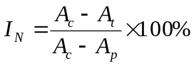 (S1)
Where, A_{c} is the concentration of NO₃ˉ and NO₂ˉ (mg/L) in the blank control after incubation; A_{t} is the concentration of NO₃ˉ and NO₂ˉ (mg/L) in the influent and effluent test groups at different stages after incubation; A_{p} is the concentration of NO₃ˉ and NO₂ˉ (mg/L) in the control containing ATU inhibitor after incubation.

Appendix Text S4:
Firstly, 0.05 mL of sludge from the reactor during stage III was taken and washed three times using PBS solution. Then, live/dead cells of the sludge were fluorescently stained with a staining kit (Beijing Solarbio Science & Technology Co., Ltd., China). And the kit contained two solutions, calcein and propidium iodide (PI), for staining live (Ex=490 nm, Em=515 nm) and dead (Ex=535 nm, Em=617 nm) cells, respectively. Both calcein and PI can be excitable by light at 490 nm, thus laser scanning confocal microscope (LSCM, LEXT OLS5100, OLYMPUS, Japan) could be used to monitor both live and dead cells. Finally, the color of dead and live cells in the stained sludge was observed to be red and green, respectively, by LCSM at an emission wavelength of 505-620 nm, an excitation wavelength of 490 nm, and an exposure time of 4-10 us/pixel. Based on the distribution of colors, the number of live and dead cells could be observed to determine the activity of the sludge.

Appendix Text S5:
The supernatant was removed from the sludge mixture by centrifugation at 5000 r/min and washed three times with 0.1 M PBS. The sludge was then sonicated (200 W) at 4 °C for 30 min and broken up, followed by centrifugation at 20000 r/min, and the resulting supernatant is the crude enzyme solution. 0.2 mM NADPH, 1 mM FAD, 0.8 mM EDTA, 40 mM PBS and 50 µL crude enzyme solution were added sequentially to an enzyme plate. FAD acts as a coenzyme for phenol hydroxylase which hydroxylates phenol to catechol, and NADPH provides the H⁺ required for hydroxylation, thus the absorbance of NADPH at 340 nm can be measured by using a microplate reader to characterize the activity of phenol hydroxylase (Zhang et al. 2022). Enzyme activity was calculated according to Eq. S2.
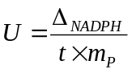 (S2)
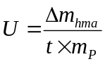 (S3)
Where U is the unit of enzyme activity; ∆_{NADPH} and ∆m_{hma} refer the variation of amount in NADPH and 2-hydroxymuconic acid, respectively (µmol); t is time (min); m_{P} is the amount of protein in system (mg), and protein was detected by using the Beyoncé BCA method kit.

Appendix Text S6:
First, 0.3 mL crude enzyme solution (as tested for phenol hydroxylase) and 2 mL catechol (0.1 M) were added to the centrifuge tube, respectively, and then the absorbance at 375 nm was immediately measured using a microplate reader. As catechol is cleaved to yellow 2-hydroxymuconic acid by the action of catechol dioxygenase, a specific absorption peak occurs at 375nm, so the variation in absorbance can characterize the activity of catechol dioxygenase. The relevant equation is shown in Eq. S3.

Appendix Text S7:
- Microbial community analysis
High-throughput sequencing was utilized to determine the microbial community structure of sludge samples during stage III. The operation process of microbial Community analysis was based on the references (Song et al. 2019, Tian et al. 2020). Firstly, DNA in sludge samples was extracted using the Mag-Bind® Soil DNA Kit (Omega Bio-tek, Norcross, GA, USA) according to the manufacturer's instruction. The 16srRNA gene of the V3-V4 target region was amplified by PCR with preprimer 341F (CCTACGGGGNGGCWGCAG) and reverse primer 805R (GACTACHVGGGGTATCTAATCC). All polymerase chain reaction mixtures were purified using the MinElute Gel Extraction Kit (Qiagen, Germany). Then, the PCR-amplified products were purified and quantified by SanPrep DNA Gel Extraction Kit (Sangong Bio, China) and Qubit 3.0 DNA Detection Kit (Life, USA), respectively. Finally, the PCR products were adjusted to equalize their DNA concentrations and then sequenced on the Miseq sequencing platform (Illumina, USA). Analysis of 16S rRNA gene sequences was conducted according to previous method (Wang et al. 2011).
- Genetic analysis and statistical method
DNA extraction and PCR amplification methods were performed in the same way as for the microbial community structure tests. Metagenomic sequencing was conducted using the Illumina NovaSeq sequencing platform (Shanghai Meiji Biomedical Technology Co., Ltd., China). Firstly, the optimized sequences were assembled by splicing using the assembler software (MEGAHIT, https://github.com/voutcn/megahit, version 1.1.2) based on the principle of succinct de Bruijn graphs (Li et al. 2015). Among the splicing results, contigs larger than 300 bp were screened as the final assembly results. ORF prediction of contigs from the splicing results was subsequently performed using Prodigal/MetaGene (http://metagene.cb.k.u-tokyo.ac.jp/) (Noguchi et al. 2006). Genes with nucleic acid lengths greater than 100 bp were selected and translated into amino acid sequences. In the construction of non-redundant gene set, the gene sequences predicted from all samples were clustered (parameters: 90% identity, 90% coverage) using CD-HIT (http://www.bioinformatics.org/cd-hit/, version 4.6.1) (Fu et al. 2012), and the longest gene in each class was taken as the representative sequence to construct the non-redundant gene set.
High-quality reads from each sample were individually compared to the non-redundant gene set (95% identity) using SOAPaligner software (http://soap.genomics.org.cn/, version 2.21) (Li et al. 2008) to statistically characterize the abundance information of genes in the corresponding samples. Diamond (http://www.diamondsearch.org/index.php, version 0.8.35) (Buchfink et al. 2015) was utilized to align amino acid sequences with the NR database (BLASTP with an e-value of 1eˉ⁵). Simultaneously, employing the taxonomic information database within the NR repository, we acquired species annotations. Ultimately, species abundance was computed by summing the gene abundances corresponding to the respective species. Additionally, Diamond was employed to align amino acid sequences with the KEGG database (BLASTP with an e-value of 1eˉ⁵), providing the KEGG functions associated with the respective genes. The abundances of functional categories were calculated by summing the abundances of genes corresponding to KO, Pathway, EC, and Module.

Figures:
Fig. S1. Images of (a) CGW and (b) inoculation sludge.

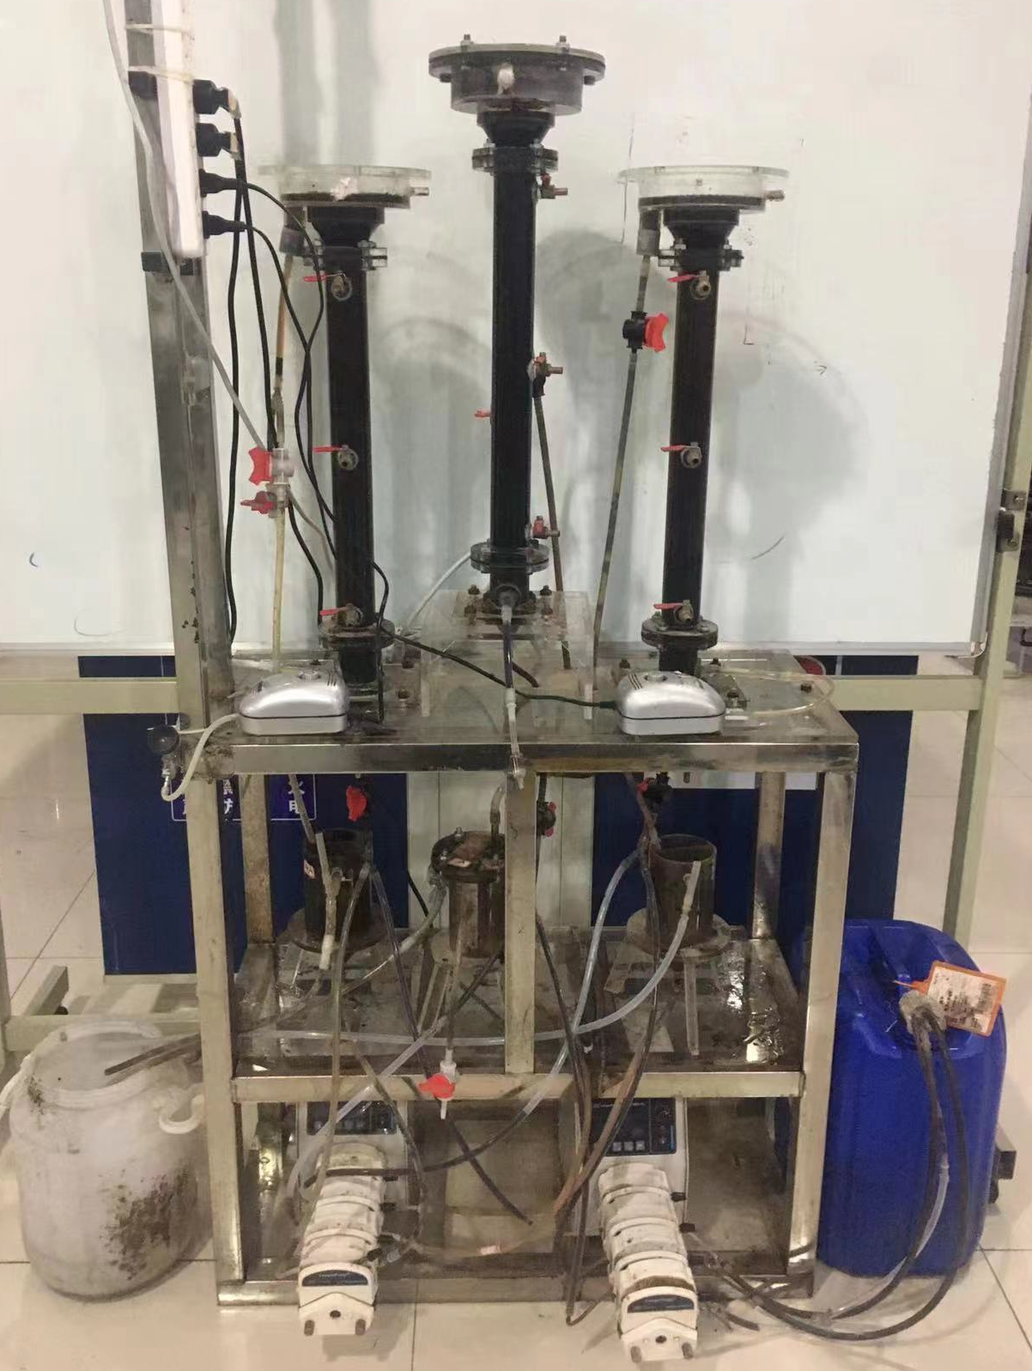
Fig. S2. Image of the set-up of the micro-aeration HA process for CGW treatment.

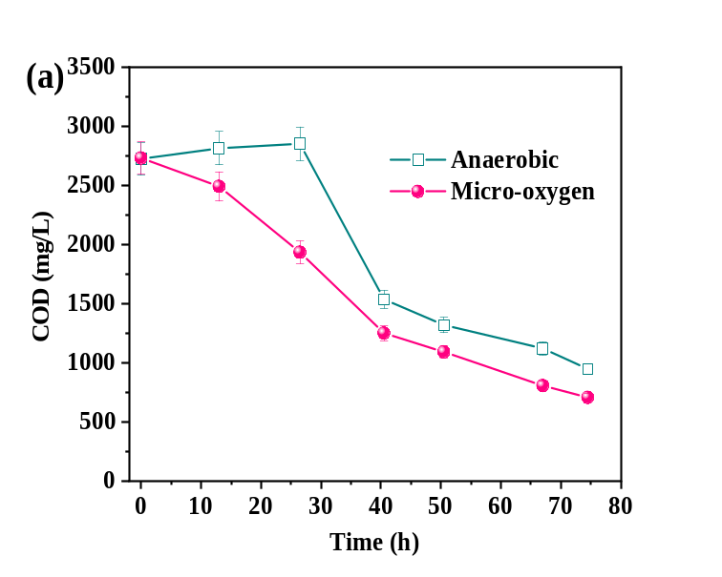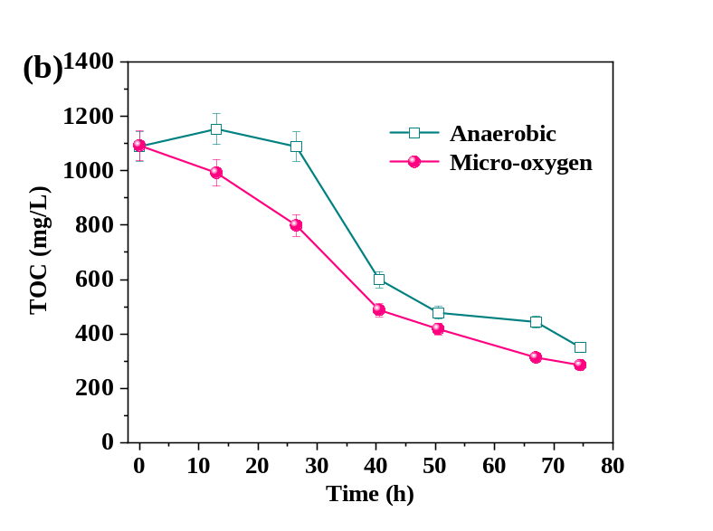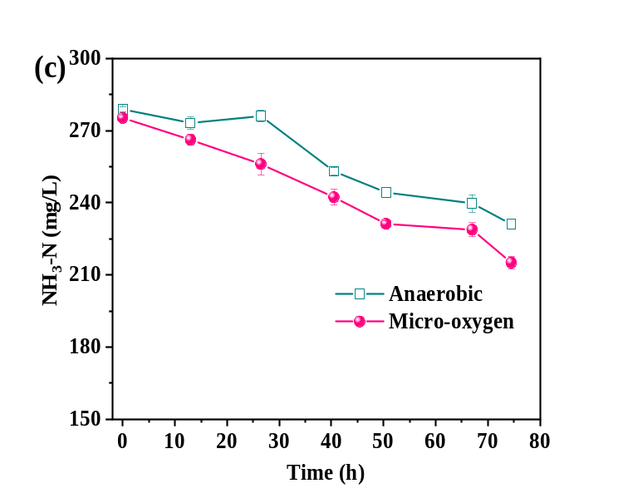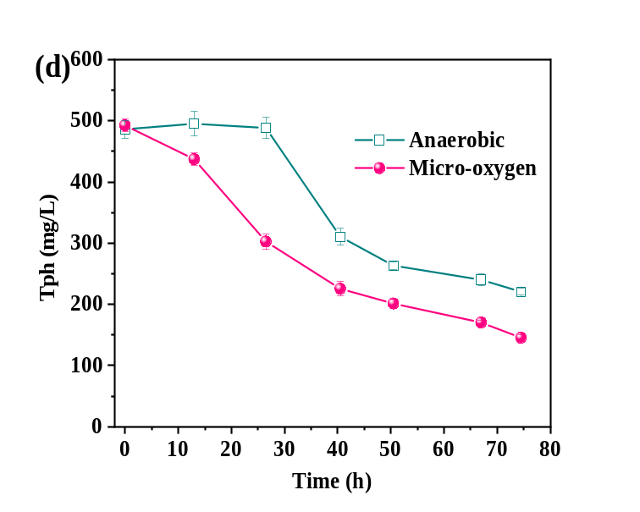
Fig. S3. Effect of MAHA and anaerobic HA on the (a) COD, (b) TOC, (c) NH₃-N and Tph removal efficiencies of CGW.
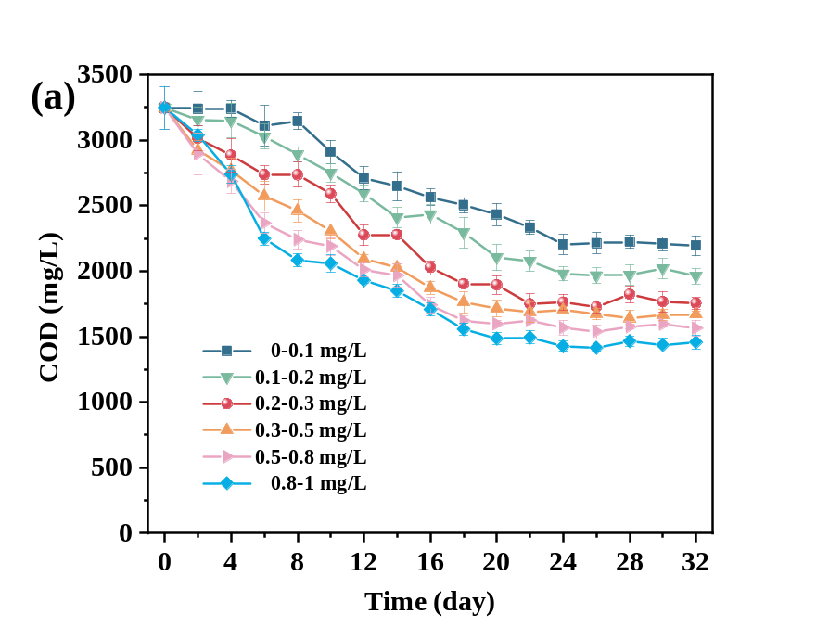
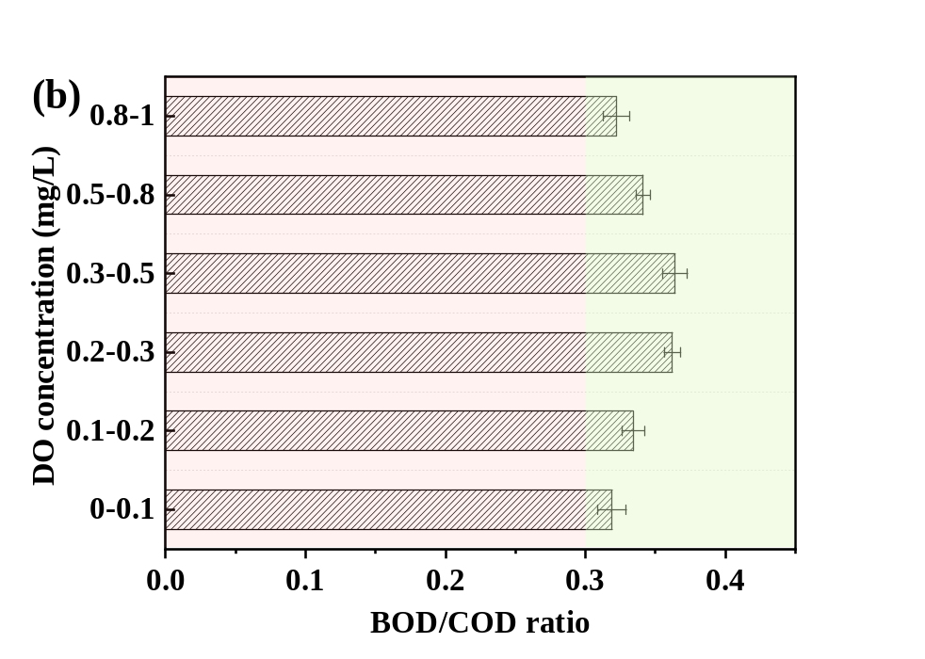
Fig. S4. The removal efficiencies of COD (a) and the BOD/COD ratio (b) under various DO concentrations.

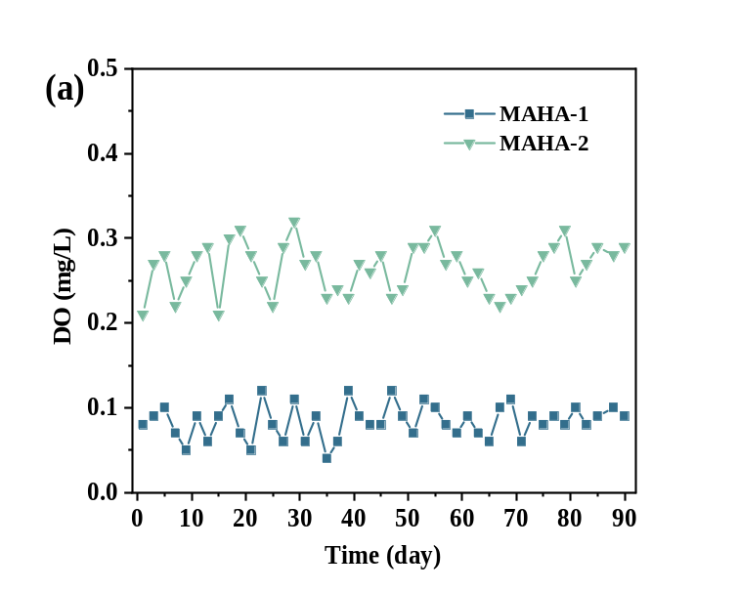
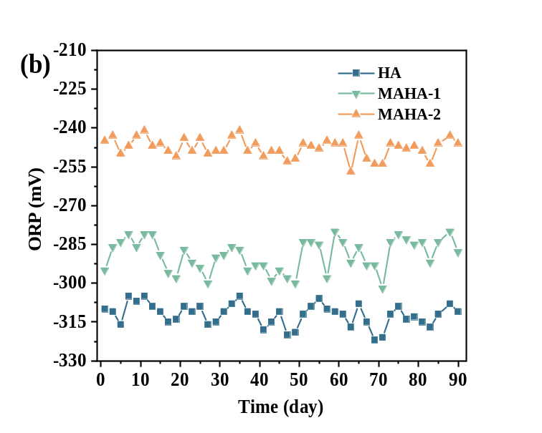
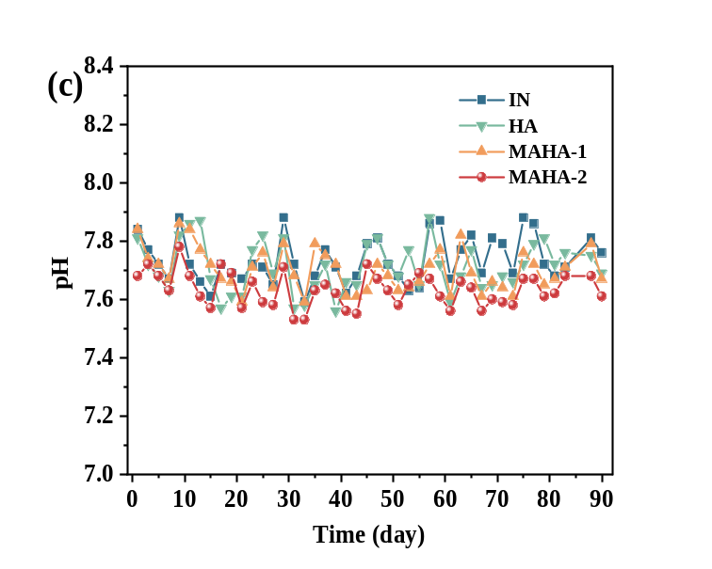
Fig. S5. Variations of (a) DO, (b) ORP and (c) pH values in different bioreactors.

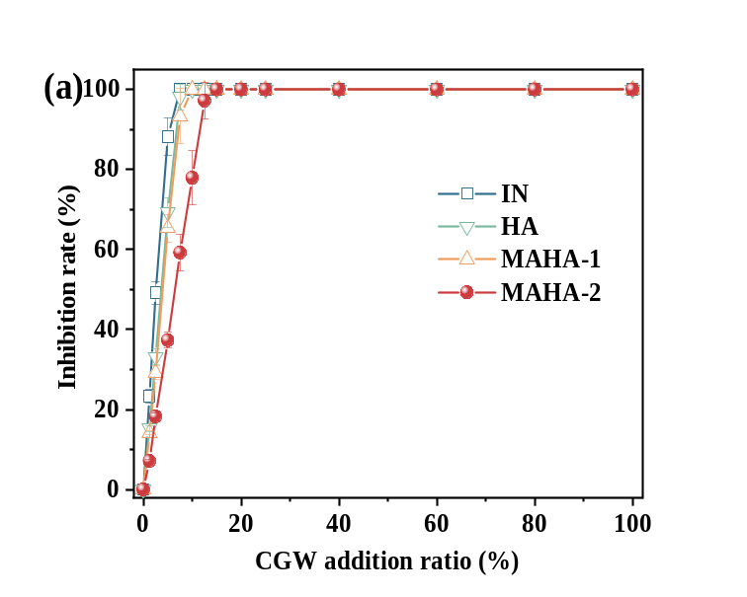
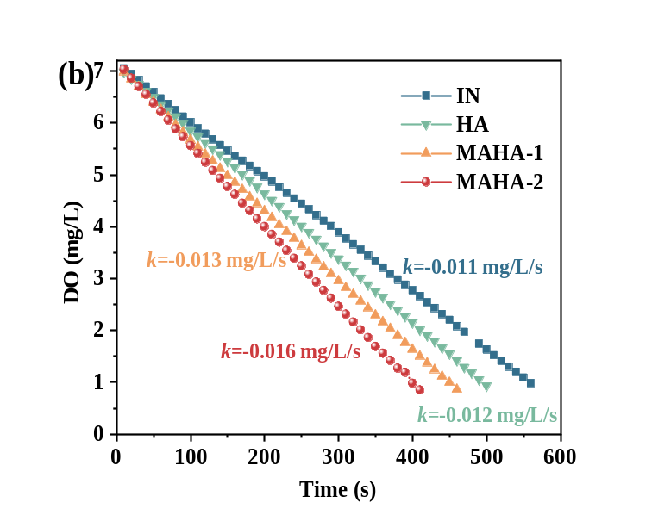
Fig. S6. (a) Inhibition rate of CGW in different reactors on photobacterium luminescens T3; (b) Date fitting of OIR under different DO concentrations.

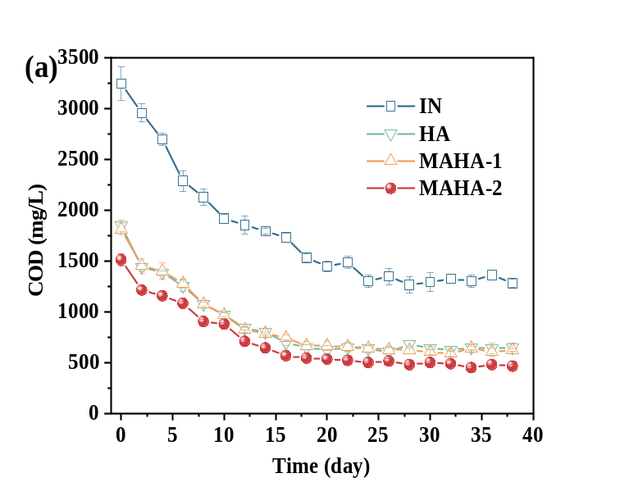
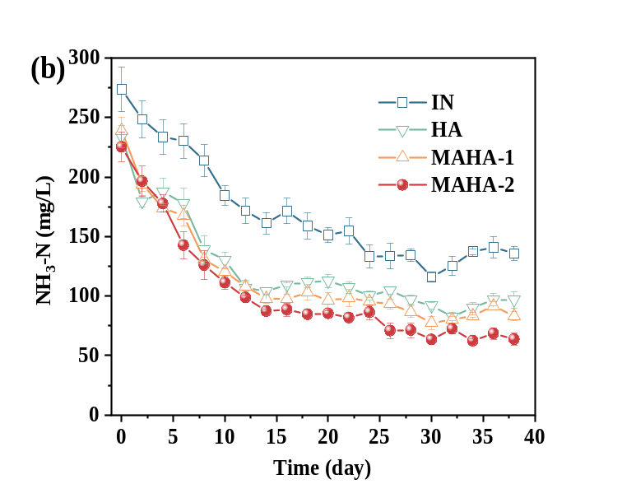
Fig. S7. (a) COD and (b) NH₃-N removal efficiencies of CGW without pretreatment and after different reactors treatment by aerobic biological process.
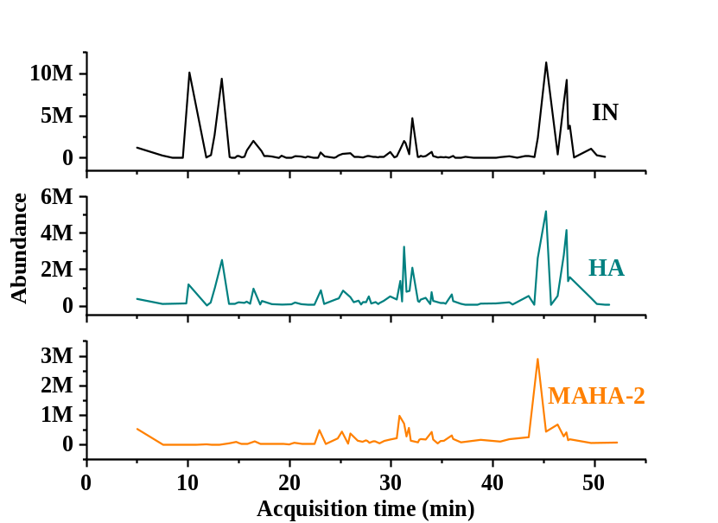
Fig. S8. GC-MS diagrams of CGW after HA and MAHA-2 treatment.

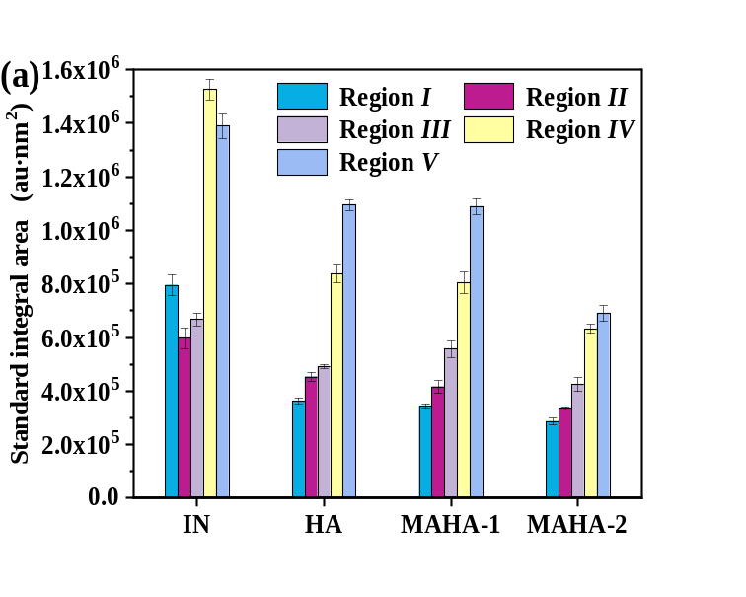
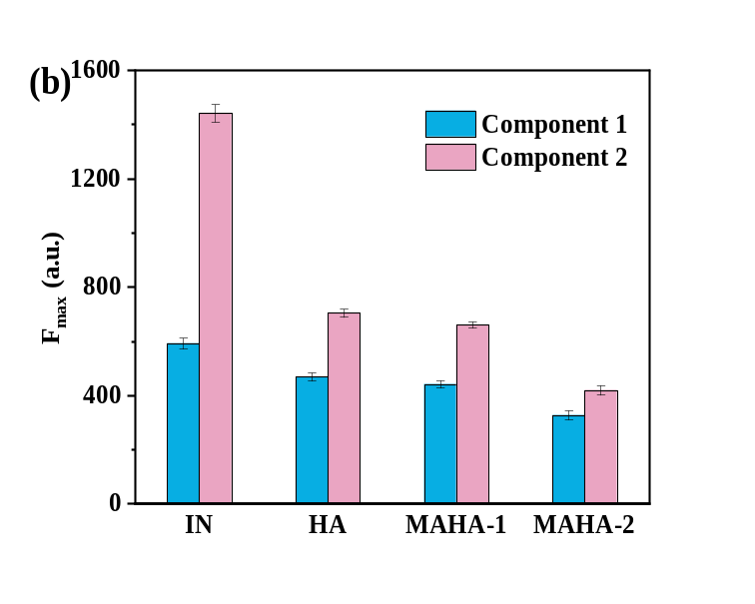
Fig. S9. (a) Standard integral area of five regions and (b) the F_{max} values of component 1 and component 2 under the raw CGW and the treatment of different reactors.

Fig. S10. The concentrations of (a) phenol hydroxylase, (b) catechol 1,2-dioxygenase, (c) dehydrogenase and (d) ATP activity under HA, MAHA-1 and MAHA-2 reactors.

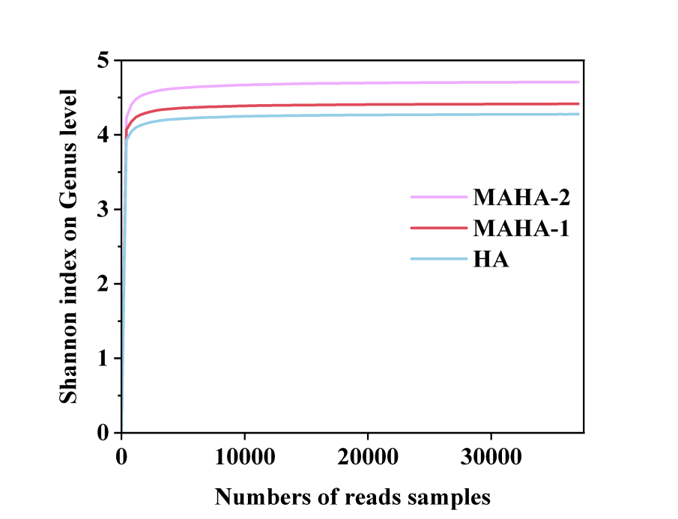
Fig. S11. Shannon dilution curves at genus level.

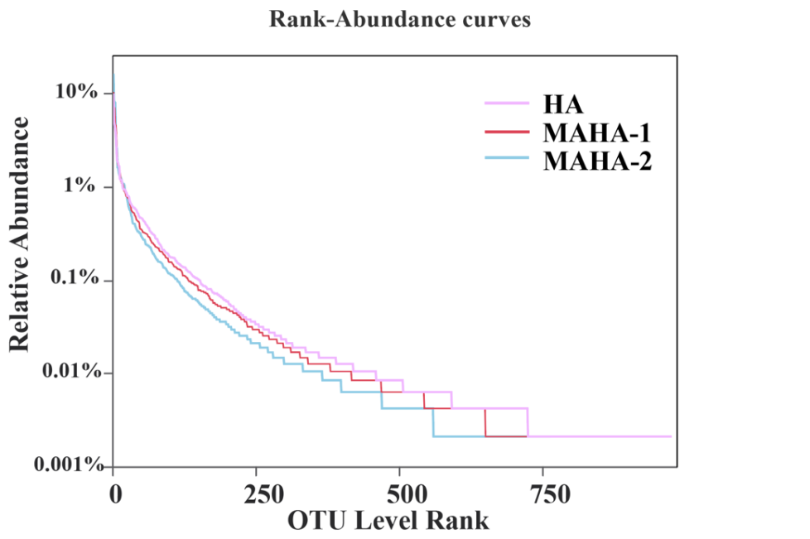
Fig. S12. Rank-Abundance curves under different DO concentrations.
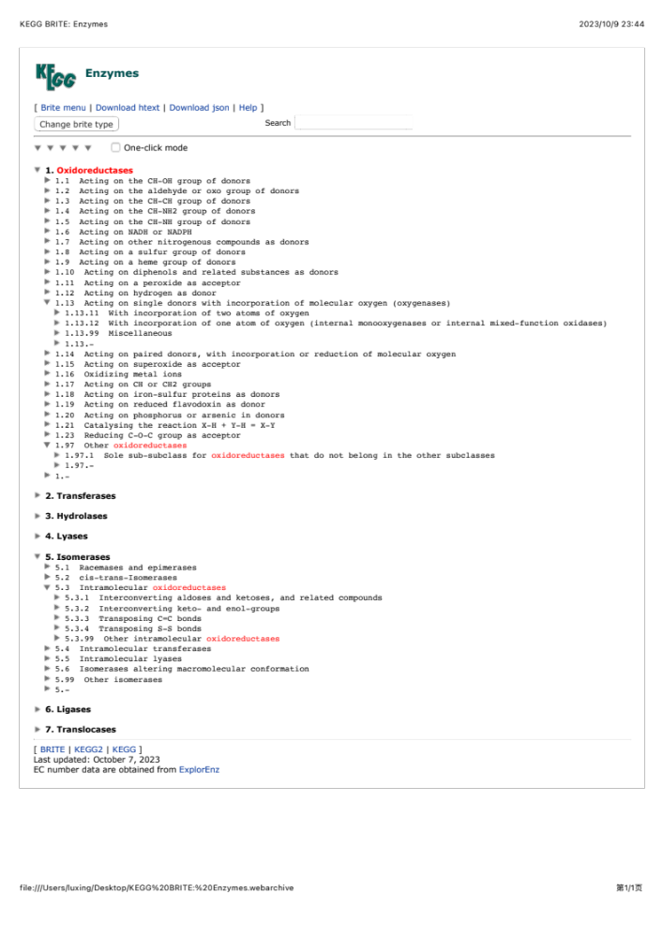
Fig. S13. Overview diagram of KEGG database enzyme information.
(https://www.kegg.jp/kegg-bin/get_htext?htext=ko01000.keg&query=Oxidoreductases)

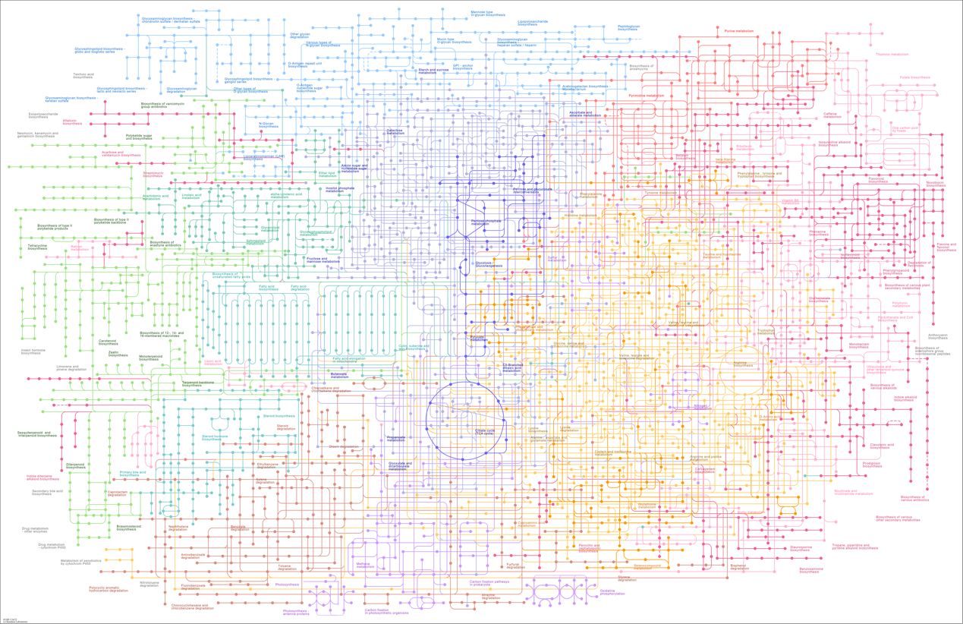
Fig. S14. The general metabolic pathway map of bacteria. (https://www.kegg.jp/pathway/map01100)

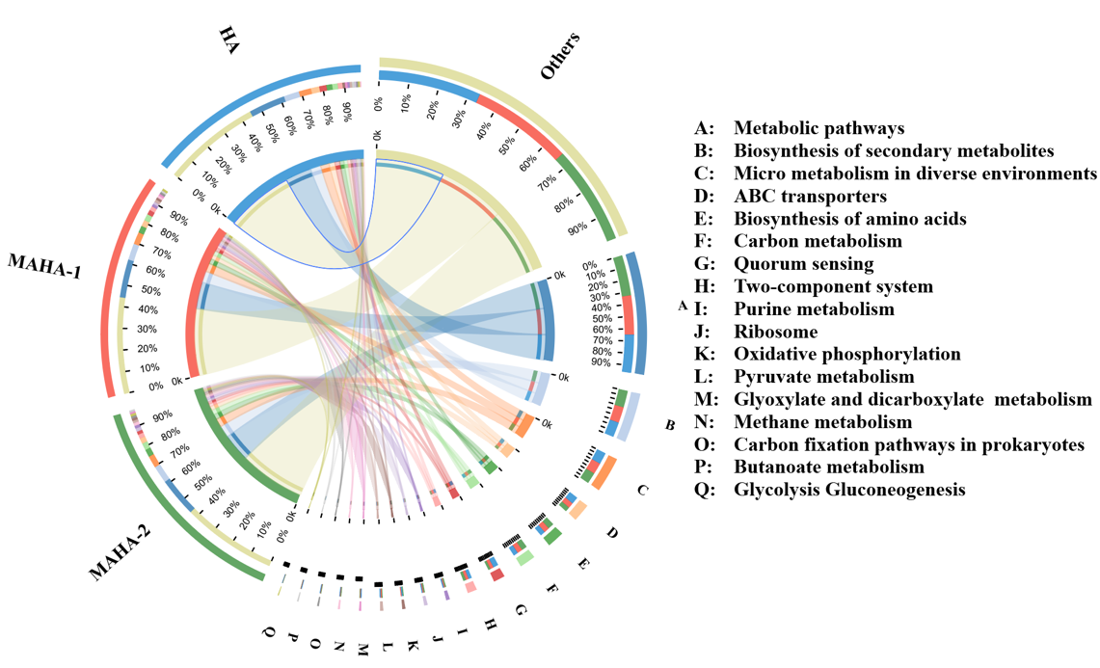
Fig. S15. Pathway at third level visualized using Circos.

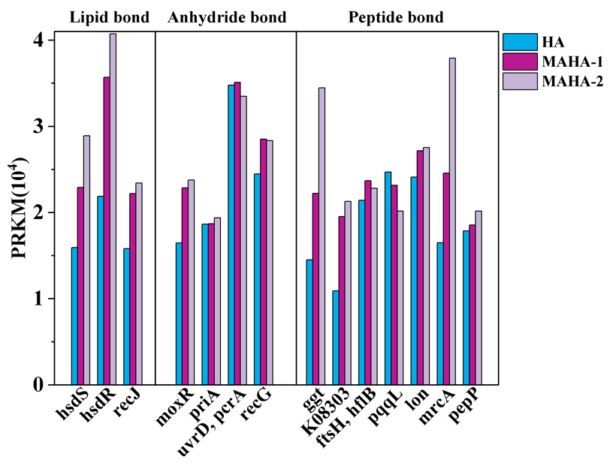
Fig. S16. Genes abundance of enzyme associated with organics hydrolysis.

Tables:
Table S1. Water quality analysis of raw CGW.
Parameters | Concentration range | Average value
COD (mg/L) | 3012-3622 | 3317
BOD₅ (mg/L) | 1028-1372 | 1200
BOD₅/COD (mg/L) | 0.34-0.38 | 0.36
NH₃-N (mg/L) | 241.3-285.1 | 263.2
NO₃ˉ (mg/L) | 5.2-7.7 | 5.5
NO₂ˉ (mg/L) | ND | ND
Organic nitrogen | 39.8-51.7 | 45.8
TN (mg/L) | 298.2-332.6 | 315.4
TOC (mg/L) | 1125-1369 | 1247
TP (mg/L) | 2.36-3.52 | 2.94
Clˉ (mg/L) | 0.45-1.32 | 0.89
Tph (mg/L) | 512-535 | 523.5
pH | 7.39-7.62 | 7.51
Conductivity (us/cm) | 1728-1916 | 1822
Chromaticity | 4096 | 4096

Table S2. The parameters of reactor process and operational stages.
Reactor | Stage | Days | COD (mg/L) | OLR (kg_{COD}/kg_{VSS·L·d}) | HRT (h) | Reflux ratio | DO (mg/L)
HA | I | 1~37 | 1120~1417 | 0.11-0.14 | 40 | 6:1 | 0
HA | II | 38~51 | 2464 ~2763 | 0.25~0.28 | 40 | 6:1 | 0
HA | III | 52~90 | 2916~3439 | 0.29~0.34 | 40 | 6:1 | 0
MAHA-1 | I | 1~37 | 1120~1417 | 0.11-0.14 | 40 | 6:1 | 0~0.1
MAHA-1 | II | 38~51 | 2464 ~2763 | 0.25~0.28 | 40 | 6:1 | 0~0.1
MAHA-1 | III | 52~90 | 2916~3439 | 0.29~0.34 | 40 | 6:1 | 0~0.1
MAHA-2 | I | 1~37 | 1120~1417 | 0.11-0.14 | 40 | 6:1 | 0.2~0.3
MAHA-2 | II | 38~51 | 2464 ~2763 | 0.25~0.28 | 40 | 6:1 | 0.2~0.3
MAHA-2 | III | 52~90 | 2916~3439 | 0.29~0.34 | 40 | 6:1 | 0.2~0.3

Table S3. The required substrates for OUR testing.
Ingredient | Concentration (mg/L)
Baeto | 16.0
Beef extract | 11.0
Urea | 3.0
NaCl | 0.7
CaCl₂•2H₂O | 0.4
MgSO₄•7H₂O | 0.2
K₂HPO₄ | 2.8
Sodium acetate | 0.09

Table S4. The semi-quantitative analysis results of CGW organic matters ingredients.
Organic species | Organic compounds | IN | HA | MAHA-2
Phenols | Phenol | 28.74 | 8.24 | 5.32
Phenols | 2-Methyl-phenol | 3.82 | 2.56 | 1.98
Phenols | 4-Methyl-phenol | 14.58 | 9.31 | 3.98
Phenols | 2,4-Dimethylphenol | 1.32 | 0.56 | ND
Phenols | 3,5-Dimethylphenol | 2.87 | 3.08 | 1.61
Phenols | 3,4-Dimethylphenol | 0.93 | 0.94 | 0.52
Phenols | Catechol | 3.78 | 1.23 | 0.78
Phenols | 4-Isopropylphenol | 1.15 | 0.23 | ND
Phenols | 2-Ethyl-5-methylphenol | 0.38 | 0.34 | 0.19
Phenols | 2,4-Di-tert-butylphenol | 0.36 | 0.63 | 1.15
Phenols | 3-Amino-o-cresol | 0.82 | 0.11 | ND
Phenols | 2,2'-Methylenebis-(4-methyl-6-tert-butylphenol) | 1.16 | 4.04 | 5.24
Phenols | 1-Ethyl-piperidine | 0.35 | 0.58 | 0.14
Phenols | 3-Methylquinolin-2-one | 0.28 | 0.11 | 0.44
Heterocyclic | 1-Hydroxyisoquinoline | 1.49 | 6.92 | 5.21
Heterocyclic | 2-Methyl-3-phenyl-1H-indole | 10.69 | 9.28 | 1.92
Heterocyclic | 5-Methyl-2-phenyl-1H-indole | 2.8 | 2.55 | 2.8
Heterocyclic | 7-Methyl-1H-indazole | 0.06 | 0.15 | 0.28
Heterocyclic | 2-Methyl-3-mercaptofuran | 0.38 | 1.02 | 1.36
Heterocyclic | N,N-Dimethyloctanamide | 0.14 | 0.27 | 0.92
Heterocyclic | 1,3-Diazaspiro[4,5]decane-2,4-dione | 0.82 | 3.16 | 5.5
Heterocyclic | 1-Benzylbenzimidazole | 0.91 | 0.67 | 0.71
Heterocyclic | 6-Methyl-2-(3-pyridyl)-1H-indole | 0.24 | 0.21 | 0.13
Heterocyclic | 5-Isobutyl-5-methylhydantoin | 0.4 | 1.8 | 2.82
Heterocyclic | Isoindolin-1-one | 0.26 | 0.92 | 0.56
Heterocyclic | 3,5,5-Trimethyl-2(5H)-furanone | 0.11 | 0.45 | 0.13
Heterocyclic | 4,4-Dimethyl-5-methylene-2-pyrrolidinone | 0.06 | 0.92 | 0.87
Heterocyclic | 5,5-Dimethyl-2,4-imidazolidinedione | 0.28 | 0.92 | 0.71
Heterocyclic | n-Octadecyrrolidine | 0.64 | 1.08 | 0.87
Heterocyclic | 4-Phenylamino-piperidine | 0.33 | 0.2 | 0.38
Heterocyclic | (3,2-f)Dihydrobenzofuran | 0.24 | 0.36 | 0.69
Heterocyclic | 2-Acetyl-5-(5-methylfurfuryl)furan | 0.42 | 0.12 | 0.32
Heterocyclic | N-Methyl-1H-benzo[D]imidazol-2-amine | 0.15 | 0.21 | 0.25
Heterocyclic | 4-Methoxy-2-(4-fluorophenyl)pyrimidine | 0.43 | 1.26 | 1.78
Heterocyclic | 5,6-Dihydro-5-methyluracil | 0.05 | 0.52 | 1.07
Heterocyclic | 2-Acetyl-5-(5-methylfurfuryl)furan | 0.42 | 0.61 | 1.23
Long-chain alkanes | Hexadecane | 0.07 | 0.16 | 0.42
Long-chain alkanes | Heptazane | 0.18 | 1.49 | 1.28
Long-chain alkanes | Octadecane | 0.08 | 0.36 | 1.87
Long-chain alkanes | n-eicosane | 0.06 | ND | 0.31
Long-chain alkanes | Oleic acid amide | 0.24 | 0.92 | 1.82
Long-chain alkanes | 1-Nineteen-ene | 0.06 | ND | 0.45
Long-chain alkanes | Bis(4-hydroxy-3,5-dimethylphenyl)methane | 0.16 | 0.67 | 0.85
Long-chain alkanes | n-nineteenthane | 0.16 | 0.59 | 1.55
Long-chain alkanes | trans-1,2-Diphenylcyclobutane | 2.38 | 3.09 | 4.33
Long-chain alkanes | 5-Methyl-2-undecene | 0.23 | 1.35 | 1.67
Long-chain alkanes | 2-Methyldodecane | 0.09 | 1.89 | 1.61
Long-chain alkanes | Bis(4-hydroxy-3,5-dimethylphenyl)methane | 0.11 | 0.67 | 2.85
Polycyclic aromatic hydrocarbons | 2-Isopropylthioanthrone | 0.16 | 0.85 | 2.25
Polycyclic aromatic hydrocarbons | 1,2,3,4-Tetrahydro-1-naphthol | 0.38 | 1.67 | 2.64
Polycyclic aromatic hydrocarbons | 9-Methoxy-anthracene | 0.12 | 0.68 | 1.35
Polycyclic aromatic hydrocarbons | Phenanthrene | 0.4 | 0.82 | 1.28
Polycyclic aromatic hydrocarbons | 1-propene,3-(2-cyclopentenyl)-2-methyl-1,1-biphenyl | 2.05 | 1.86 | 1.83
*The data in the table is the percentage (%) of the relevant compound area to the total peak area. ND: not detected.

Table S5. Community richness and diversity indices of samples in different reactors.
Sample | OTUs | Shannon | Simpson | ACE | Chao | Coverage
HA | 764 | 4.12 | 0.0516 | 966.6 | 993.7 | 0.9957
MAHA-1 | 940 | 4.63 | 0.0291 | 1149.2 | 1136.8 | 0.9956
MAHA-2 | 1029 | 4.85 | 0.0224 | 1286.8 | 1319.9 | 0.9953

Table S6. Correspondence between functional enzymes and genes related to phenol metabolism.
Enzyme ID | KO Description | Gene name
Pathway A-1
1.13.11.37 | hydroxyquinol 1,2-dioxygenase | chqB
1.13.11.1 | catechol 1,2-dioxygenase | catA
5.5.1.1 | muconate cycloisomerase | catB
5.3.3.4 | muconolactone D-isomerase | catC
3.1.1.24 | 3-oxoadipate enol-lactonase | pcaD
2.8.3.6 | 3-oxoadipate CoA-transferase | pcaJ
2.3.1.174 | 3-oxoadipyl-CoA thiolase | pcaF
2.3.1.16 | acetyl-CoA acyltransferase | fadA, fadI
Pathway A-2
1.13.11.37 | hydroxyquinol 1,2-dioxygenase | chqB
1.13.11.2 | catechol 2,3-dioxygenase | catE
1.13.11.2 | catechol 2,3-dioxygenase | dmpB, xylE
3.7.1.9 | 2-hydroxymuconate-semialdehyde hydrolase | dmpD, xylF
4.2.1.80 | 2-keto-4-pentenoate hydratase | mhpD
4.21.80 | 2-oxopent-4-enoate/cis-2-oxohex-4-enoate hydratase | bphI, xylK
4.1.3.39 | 4-hydroxy 2-oxovalerate aldolase | mhpE
Pathway B
4.1.1.61 | vanillate/4-hydroxybenzoate decarboxylase subunit C | bsdC
6.2.1.27 | 4-hydroxybenzoate-CoA ligase | hbaA
6.2.1.27 | 3-hydroxybenzoate/4-hydroxybenzoate---CoA ligase | hcl
1.1.7.1 | 4-hydroxybenzoyl-CoA reductase subunit gamma | hcrC, hbaB
1.1.7.1 | 4-hydroxybenzoyl-CoA reductase subunit alpha | hcrA, hbaC
1.1.7.1 | 4-hydroxybenzoyl-CoA reductase subunit beta | hcrB, hbaD
1.3.7.8 | benzoyl-CoA reductase subunit D | bcrD, badG
1.3.7.8 | benzoyl-CoA reductase subunit A | bcrA, badF
1.3.7.8 | benzoyl-CoA reductase subunit C | bcrC, badD
1.3.7.8 | benzoyl-CoA reductase subunit B | bcrB, bade
4.2.1.100 | cyclohexa-1,5-dienecarbonyl-CoA hydratase | dch
1.1.1.368 | 6-hydroxycyclohex-1-ene-1-carbonyl-CoA dehydrogenase | had
3.7.1.21 | 6-oxocyclohex-1-ene-carbonyl-CoA hydrolase | oah
Ester-bond
3.1.21.3 | type I restriction enzyme, R subunit | hsdS
3.1.21.3 | type I restriction enzyme, S subunit | hsdR
3.1.-.- | single-stranded-DNA-specific exonuclease | recJ
Anhydride-bond
3.6.3.- | MoxR-like ATPase | moxR
3.6.4.- | primosomal protein N' (replication factor Y) (superfamily II helicase) | priA
3.6.4.12 | DNA helicase II / ATP-dependent DNA helicase PcrA | uvrD, pcrA
3.6.4.12 | ATP-dependent DNA helicase RecG | recG
Peptide-bond
3.4.19.13 | gamma-glutamyltranspeptidase/glutathione hydrolase | ggt
3.4.-.- | putative protease | K08303
3.4.24.- | cell division protease FtsH | ftsH, hflB
3.4.24.- | zinc protease | pqqL
3.4.21.53 | ATP-dependent Lon protease | Lon
3.4.16.4 | penicillin-binding protein 1A | mrcA
3.4.11.9 | Xaa-Pro aminopeptidase | pepP

References
Buchfink, B., Xie, C. and Huson, D.H. (2015) Fast and sensitive protein alignment using DIAMOND. Nature Methods 12(1), 59-60.
Fu, L., Niu, B., Zhu, Z., Wu, S. and Li, W. (2012) CD-HIT: accelerated for clustering the next-generation sequencing data. Bioinformatics 28(23), 3150-3152.
Hei, S.Q., Xu, H., Liu, B.M., Zhu, X.Z., Zhang, S., Zhang, X., Li, R.W. and Huang, X. (2022) Enhanced pre-treatment of sepiolite on coal gasification wastewater: Performance and adsorption mechanism. Journal of Hazardous Materials 440, 129842.
Li, D., Liu, C.-M., Luo, R., Sadakane, K. and Lam, T.-W. (2015) MEGAHIT: an ultra-fast single-node solution for large and complex metagenomics assembly via succinct de Bruijn graph. Bioinformatics 31(10), 1674-1676.
Li, R., Li, Y., Kristiansen, K. and Wang, J. (2008) SOAP: short oligonucleotide alignment program. Bioinformatics 24(5), 713-714.
Noguchi, H., Park, J. and Takagi, T. (2006) MetaGene: prokaryotic gene finding from environmental genome shotgun sequences. Nucleic Acids Research 34(19), 5623-5630.
Song, G., Yu, Y., Liu, T., Xi, H. and Zhou, Y. (2019) Performance of microaeration hydrolytic acidification process in the pretreatment of 2-butenal manufacture wastewater. Journal of Hazardous Materials 369, 465-473.
Tian, X., Song, Y., Shen, Z., Zhou, Y., Wang, K., Jin, X., Han, Z. and Liu, T. (2020) A comprehensive review on toxic petrochemical wastewater pretreatment and advanced treatment. Journal of Cleaner Production 245, 118692.
Wang, A.-J., Cheng, H.-Y., Liang, B., Ren, N.-Q., Cui, D., Lin, N., Kim, B.H. and Rabaey, K. (2011) Efficient Reduction of Nitrobenzene to Aniline with a Biocatalyzed Cathode. Environmental Science & Technology 45(23), 10186-10193.
Zhang, Z.W., Xi, H.B., Yu, Y., Wu, C.Y., Yang, Y., Guo, Z.Z. and Zhou, Y.X. (2022) Coupling of membrane-based bubbleless micro-aeration for 2,4-dinitro-phenol degradation in a hydrolysis acidification reactor. Water Research 212, 118119.
Zhu, X.Z., Tian, T., Li, D.Y., Hei, S.Q., Chen, L., Song, G.Q., Lin, W.C. and Huang, X. (2023) Interface interaction between silica and organic macromolecule conditioned forward osmosis membranes: Insights into quantitative thermodynamics and dynamics. Water Research 232, 119721.

