Table A.1. Physicochemical characteristics of dairy wastewater.
Parameters
pH | 6.63 ± 0.1
TDS (mg/L) | 3115 ± 8
EC (ms/cm) | 4.935
TSS (mg/L) | 55
COD (mg/L) | 3850 ± 10
BOD (mg/L) | 1900 ± 5
Oil & Grease (mg/L) | 78.8 ± 0.1

Table A.2. Optical density of maltose by spectrophotometry
Optical density  (OD) | Concentration  (μmol/mL) | Distilled water  (mL) | Stoke maltose solution (mL)
0 | - | 5 | Control
0.094 | 0.5 | 4.82 | 0.18
0.178 | 1 | 4.7 | 0.3
0.614 | 2.5 | 4.1 | 0.9
2.323 | 5 | 3.2 | 1.8
2.92 | 7.5 | 2.3 | 2.7
- | 10 | 1.4 | 3.6

Fig. A.1. The maltose standard curve.

Table A.3. Optical density of L-tyrosine by spectrophotometry
Optical density  (OD) | Concentration  (μmol/mL) | Distilled water  (mL) | Stock L-tyrosine solution  (mL)
0 | - | 2 | Control
0.041 | 0.055 | 1.95 | 0.05
0.189 | 0.111 | 1.9 | 0.1
0.353 | 0.221 | 1.8 | 0.2
0.683 | 0.442 | 1.6 | 0.4
0.819 | 0.553 | 1.5 | 0.5

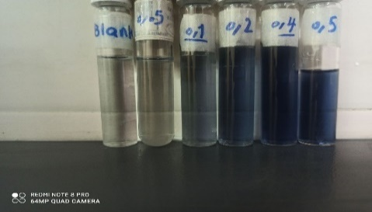

Fig. A.2. The L-tyrosine standard curve.
Table A.4. Cumulative biogas production in anaerobic biological reactors loaded with sludge and pretreated with to different ratios of enzyme solution extracted from the organic waste (R1, R2, R3 and R4, control).

 | % Enzyme solution | Cumulative gas production
Control | 0 | 6565
R1 | 5 | 7095
R2 | 10 | 8100
R3 | 15 | 6900

