In-situ intermittent micro-aeration in food waste and sewage sludge anaerobic co-digestion: Performance, stability, and microbial dynamics
Table S1. Substrates and inoculum characteristics (mean ± SD), n = 3
Parameter | Unit | FW | SS | ADWAS
TS | %, wet basis | 27.7 ± 1.1 | 6.3 ± 0.7 | 3.1 ± 0.0
VS | %, TS | 95.0 ± 3.9 | 78.6 ± 8.7 | 64.2 ± 0.1
pH | N/A | 4.1 ± 0.0 | 6.4 ± 0.0 | 8.0 ± 0.01
TC | %, dry basis | 51.9 ± 0.3 | 38.4 ± 0.1 | n.a.
TN | %, dry basis | 3.1 ± 0.1 | 7.5 ± 0.0 | n.a.
C/N ratio | N/A | 16.8 ± 0.6 | 5.2 ± 0.0 | n.a.
sCOD | gCOD/L | 120.5 ± 2.0 | 19.8 ± 0.1 | n.a.
TAN | mgN/L | 26.9 ± 0.6 | 125.2 ± 3.7 | n.a.
TS: total solids; VS: Volatile solids; TC: Total carbon; TN: Total nitrogen; sCOD: Soluble chemical oxygen demand; TAN: Total ammonia nitrogen.

Table S2. Experimental design of oxidation-reduction potential (ORP)-based in-situ micro-aeration in co-digestion.
- Co-substrate ratio variation
OLR (g VS/L·d) | 2.25
Biogas recirculation | Without recirculation |  | With recirculation
FW:SS (VS basis) | 0:100 | 40:60 |  |  |  |  | 60:40 |  |  |  | 80:20
Microaeration |  |  | AN |  | MA |  | AN |  | MA |  | AN | MA
Phase | I | II | III |  | IV |  | V |  | VI |  | VII | VIII
- Organic loading rate variation
Biogas recirculation | Recirculation
FW:SS (VS basis) | 80:20
OLR (g VS/L·d) | 2.25 |  |  | 4.0 |  |  |  | 6.0
Microaeration | AN | MA |  | AN |  | MA |  | AN |  | MA
AN: Anaerobic; MA: Micro-aerobic; OLR: Organic loading rate; FW: Food waste; SS: Sewage sludge

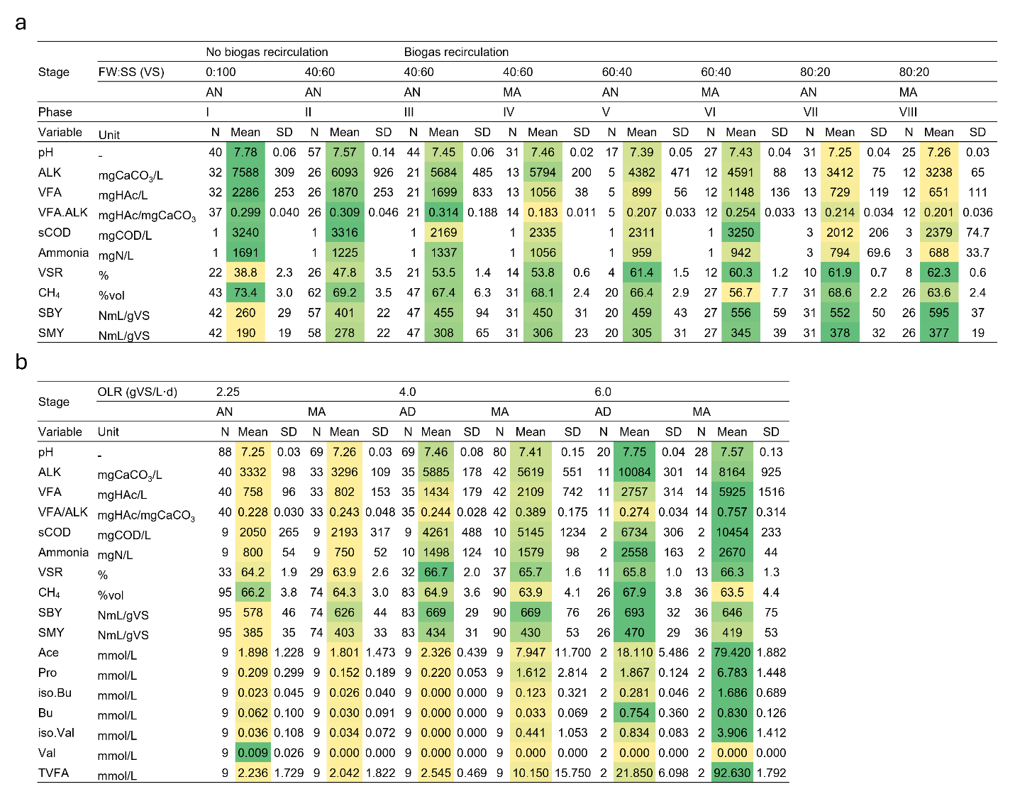
Fig. S1 Data summary of the co-substrate ratio variation experiment under anaerobic (AN) and micro-aerobic (MA) conditions (a). Data summary of organic loading rate variation experiment under anaerobic (AN) and micro-aerobic (MA) conditions (b). Yellow-to-green heatmap indicates low-to-high values across the dataset.
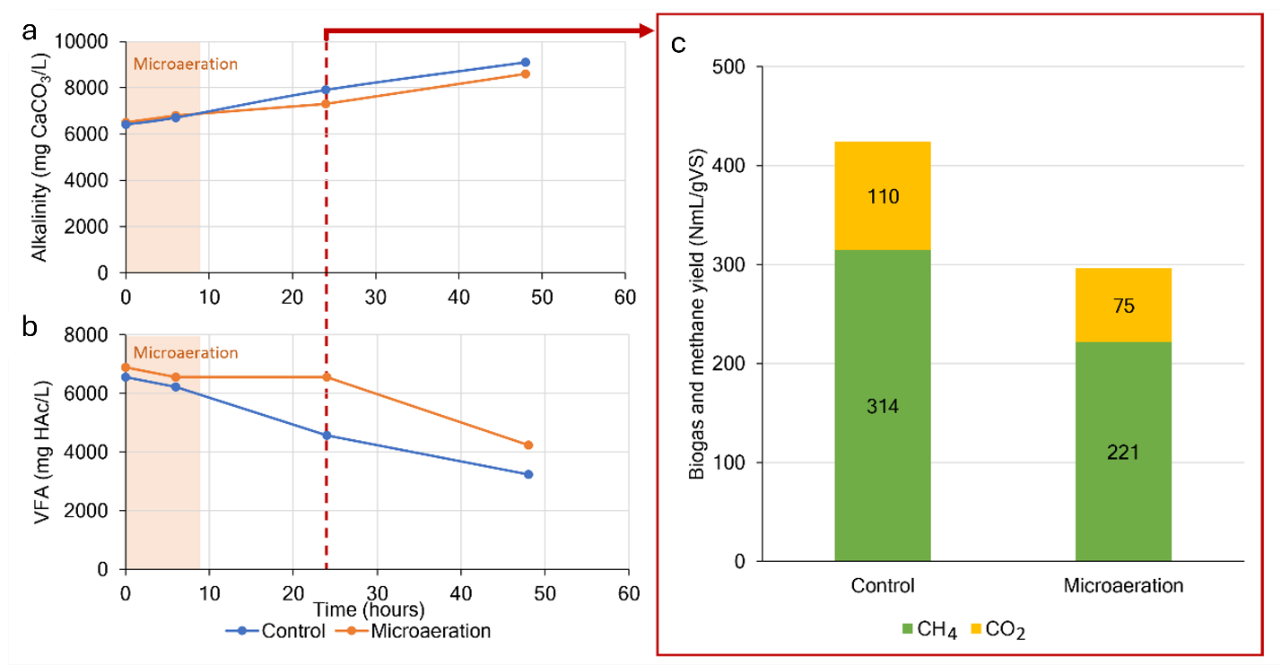
Fig. S2 Effects of micro-aeration for 9.6 hrs with an intensity of 17 mL-O₂/L·hr with an oxidation-reduction potential (ORP) of +25 mV above baseline ORP during system inhibition under an organic loading rate (OLR) of 5.0 g VS/L·d on alkalinity (a), total volatile fatty acids (VFAs) concentration (b), and specific biogas and methane yield (c).

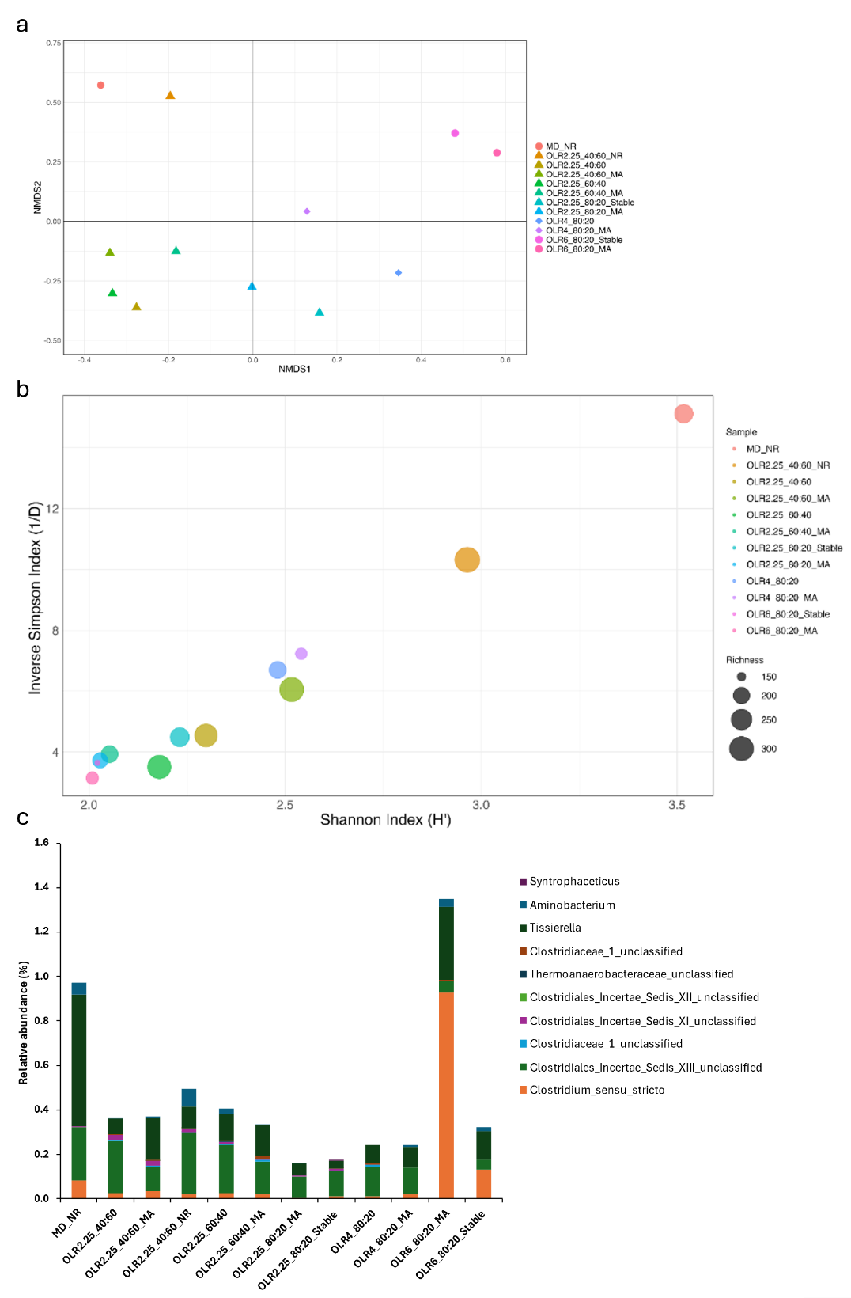
Fig. S3 Non-metric multidimensional scaling (NMDS) plot with two dimensions using a Bray Curtis dissimilarity matrix of biomass samples (a). Bubble chart showing the alpha diversity indices: InvSimpson (1/D) on the y-axis and Shannon index (H’) on the x-axis, with bubble sizes representing the richness index (b). Relative abundance of key syntrophic acetate-oxidizing bacteria (SAOB) (c). Triangles indicate an organic loading rate (OLR) of 2.25 g VS/L·d, diamonds for an OLR of 4 g VS/L·d, and circles for micro-aerobic (MA) and an OLR of 6 g VS/L·d. MA: Micro-aeration; MD: mono-digestion; NR: Non-recirculation; OLR: Organic loading rate.

