Effect of nanobubble water on medium chain carboxylic acids production in anaerobic digestion of cow manure

Authors:
Yang Liu^{a,b}, Xiaomei Yeª, Kequan Chen^{b}, Xiayuan Wu^{b}, Lihua Jiaoª, Hongyu Zhangª, Fei Zhuª, Yonglan Xi^{a,c}*

* Corresponding author, E–mail address: yonglanxi@jaas.ac.cn.

Affiliations:

a. Jiangsu Academy of Agriculture Sciences, Nanjing 210014, China; Key Laboratory of Crop and Livestock Integration, Ministry of Agriculture and Rural Affairs; Jiangsu Collaborative Innovation Center for Solid Organic Waste Resource Utilization, 210014 Nanjing, China.

b. State Key Laboratory of Materials–Oriented Chemical Engineering, College of Biotechnology and Pharmaceutical, Nanjing Tech University, Nanjing 210009, China.

c. Department of Applied Ecology, Faculty of Environmental Sciences, Czech University of Life Sciences Prague, Kamýcka 129, Praha–Suchdol, 16500, Czech Republic.

Table S1
The characteristics of cow manure and inoculum used in AD
 | Total solids (%) | Volatile solids (%) | Total carbon (g/kg) | Total nitrogen (g/kg) | C/N | Cellulose  (%) | Hemicellulose  (%) | Lignin  (%)
Cow manure | 20.85±1.15ª | 60.18±0.33 | 266.11±0.35 | 14.88±0.12 | 17.88 | 22.99±0.12 | 25.01±0.13 | 9.41±0.07
Inoculum for acidification | 4.11±0.05 | 63.99±0.48 | NA^{b} | NA | NA | NA | NA | NA
Inoculum for chain elongation | 3.85±0.04 | 55.88±0.41 | NA^{b} | NA | NA | NA | NA | NA
a Each value presented is the average of three independent replicates, and the data is expressed as mean ± standard deviation.
b No analysis

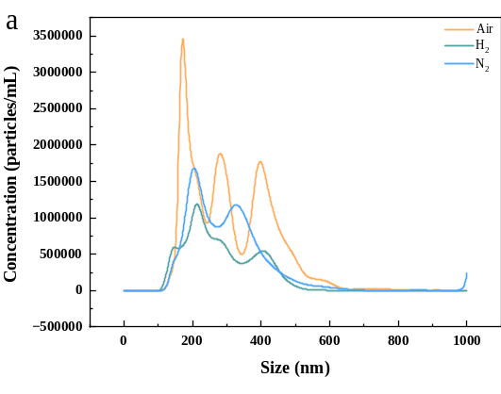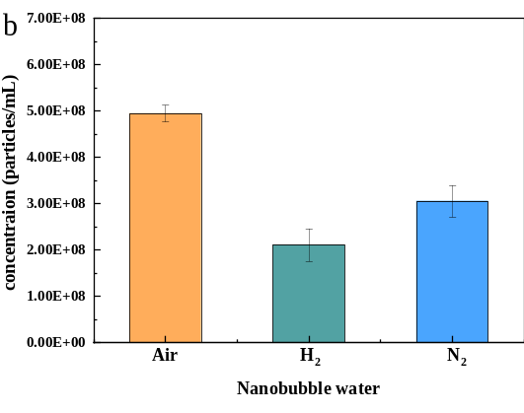
e

c
d
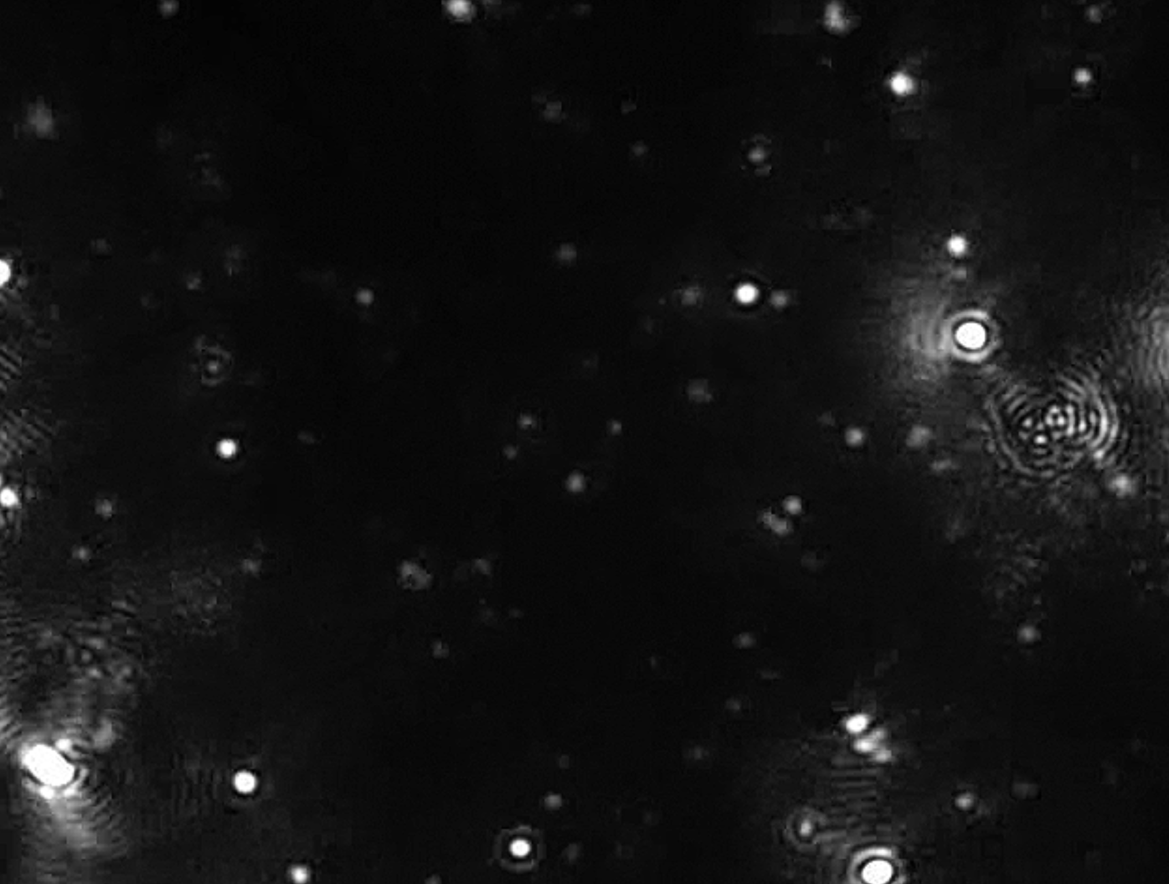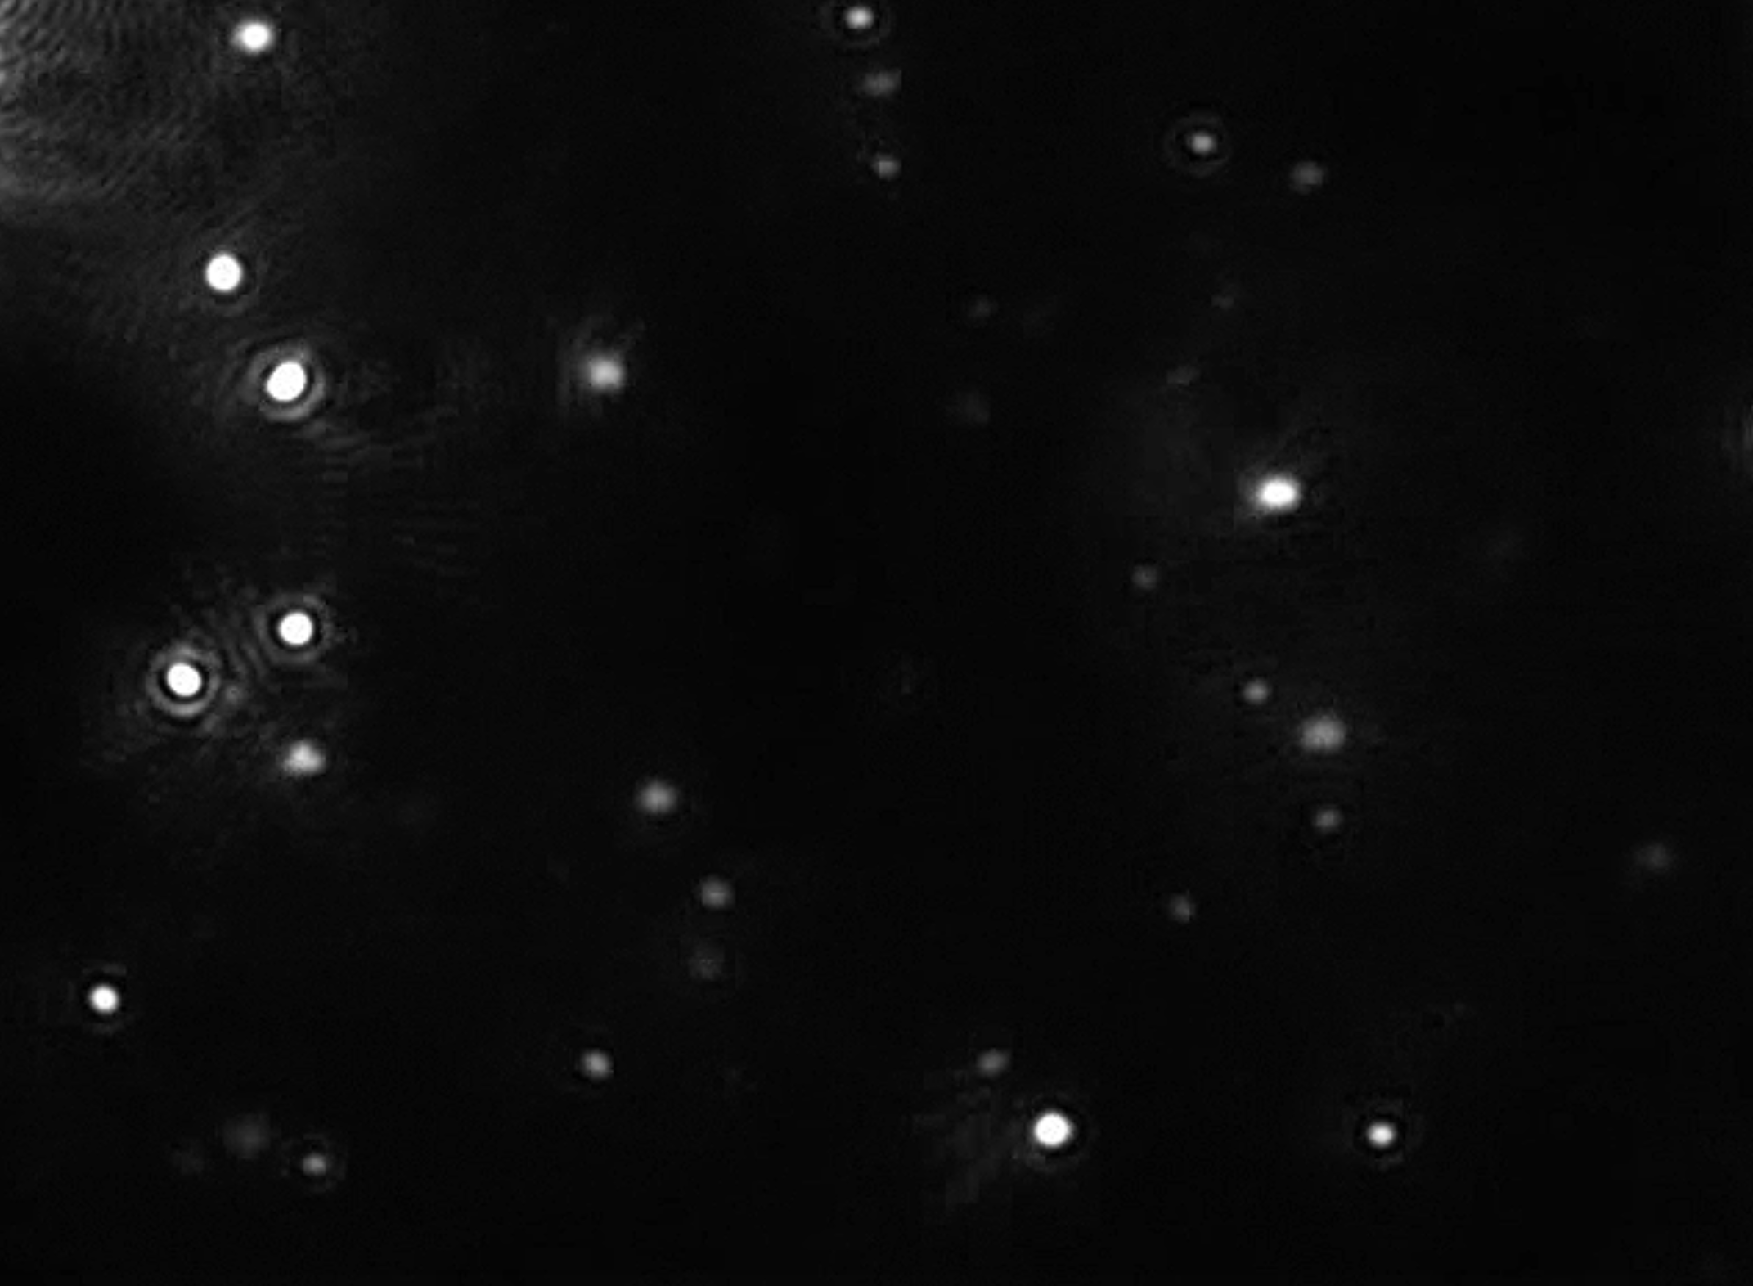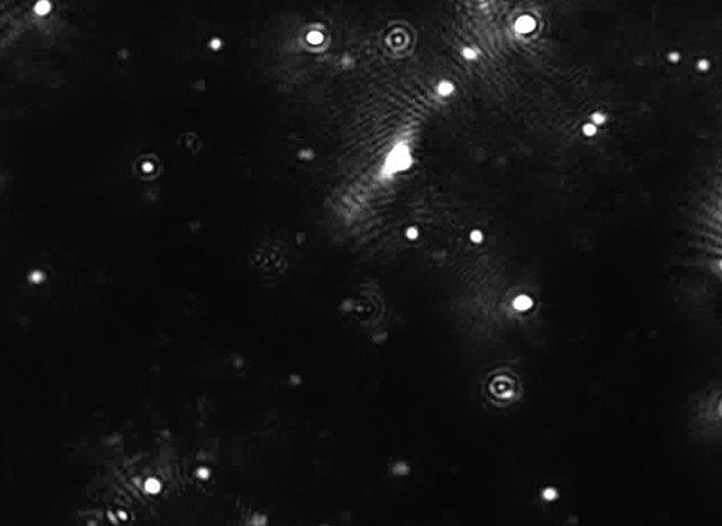

Fig. S1. Comparison of nanobubbles size distribution among the different nanobubble water (a), nanobubble concentration of different nanobubble water (b), and
Brownian motion figures (c: Air–NBW, d: H₂–NBW, e: N₂–NBW)

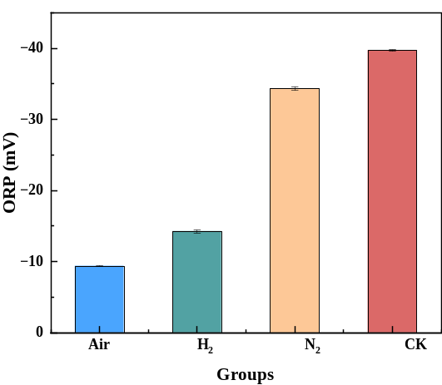
Fig. S2. ORP changes among different experimental groups.

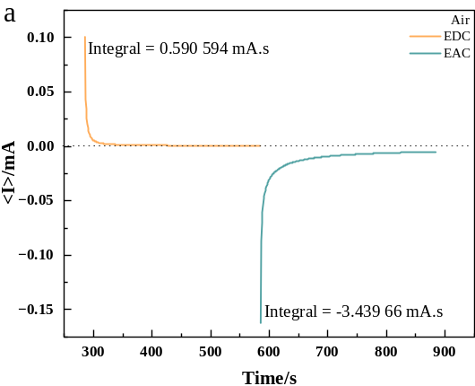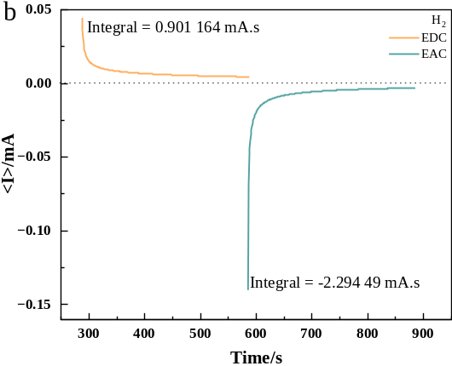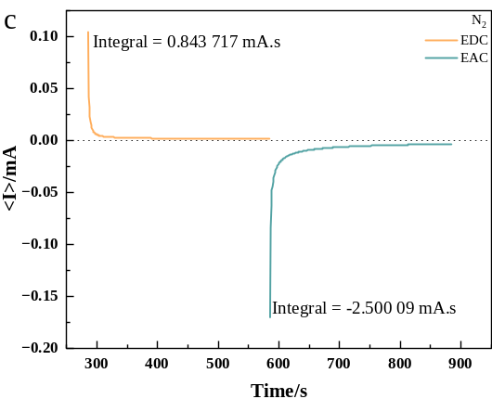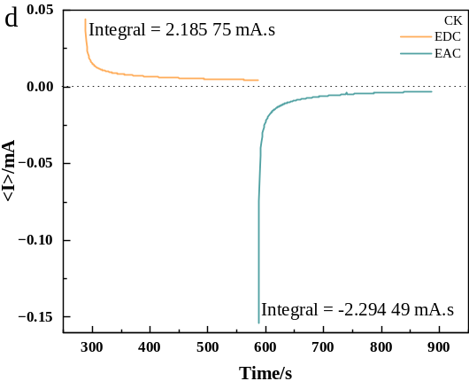
Fig. S3. I–t curve (a–d) in groups treated with different nanobubble water. All data were the averages from three parallel experiments.

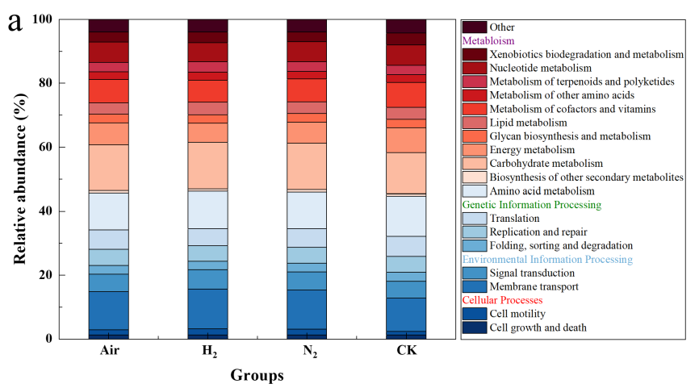
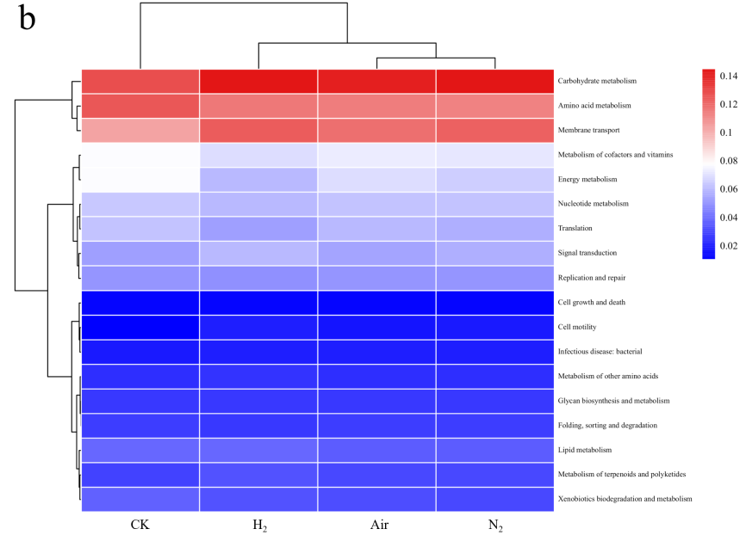
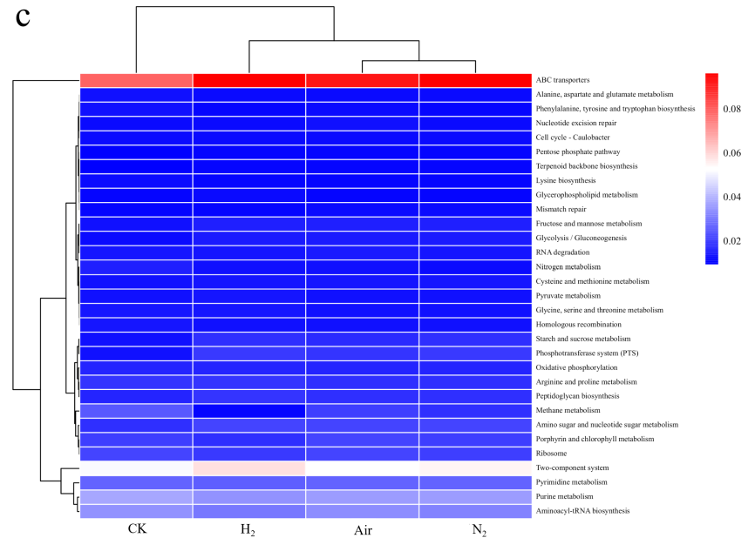

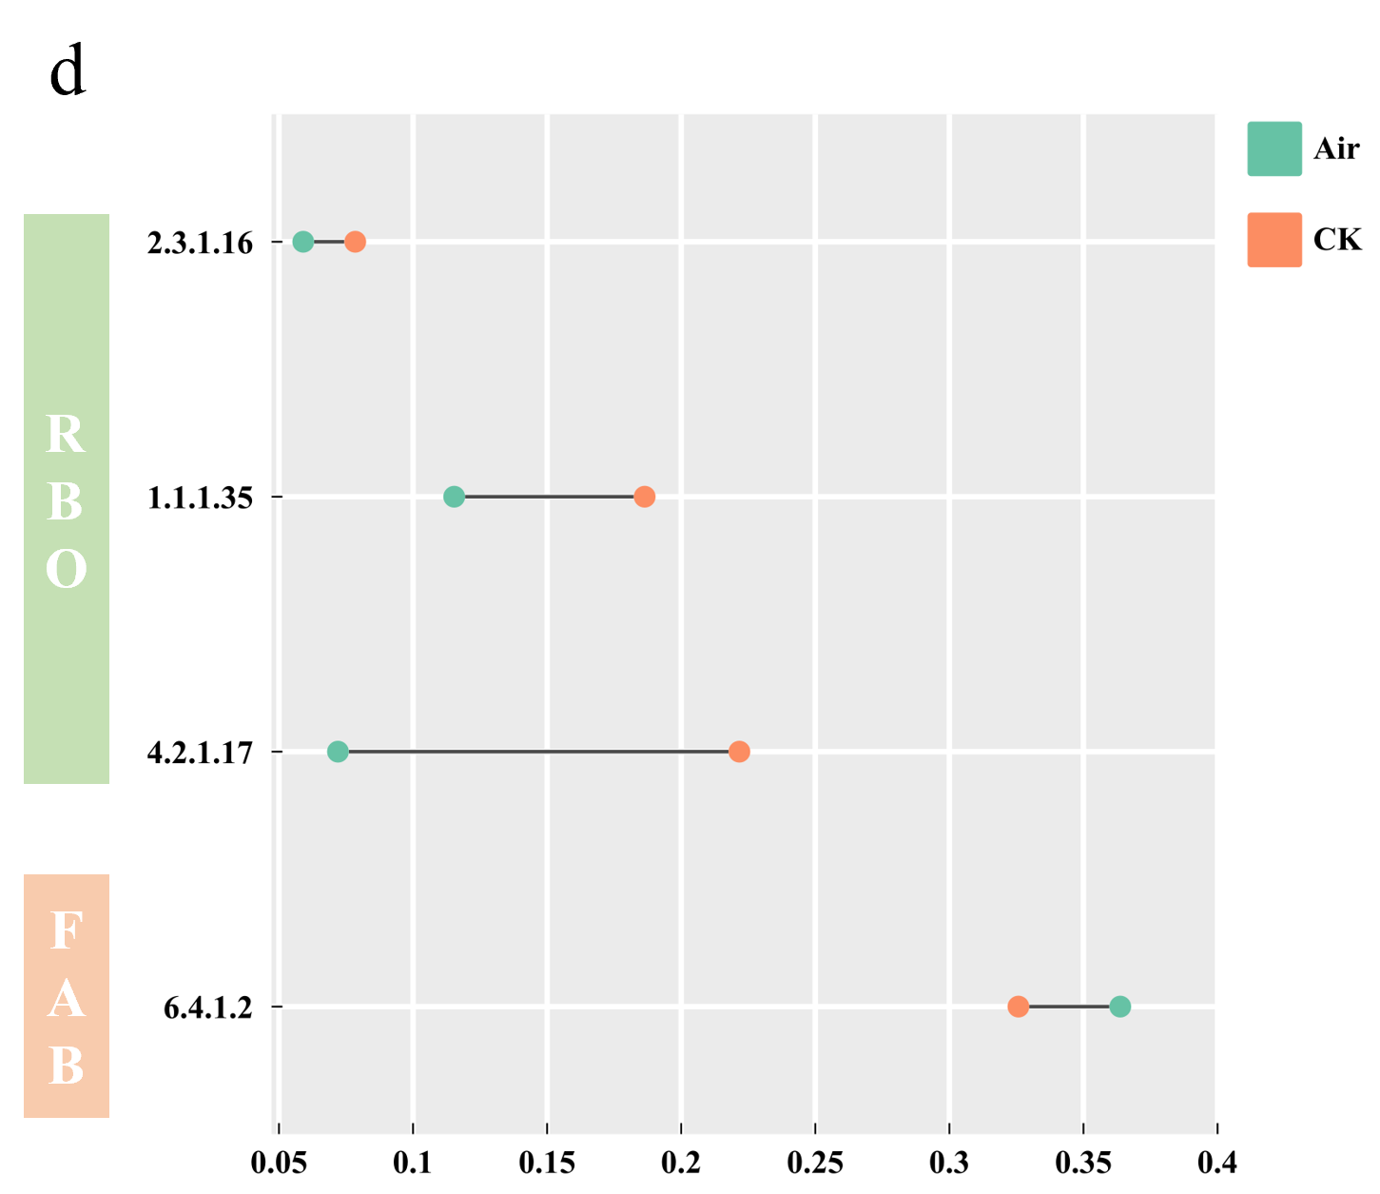
Fig. S4. Microbial metabolism function profiles: function categories (a), level 2 metabolic function heat map (b), level 3 metabolic function heat map (c)，and key enzyme of CE metabolic pathway (d).

