Supplementary Materials
Enhanced anaerobic digestion performance and sludge filterability by membrane microaeration for anaerobic membrane bioreactor application

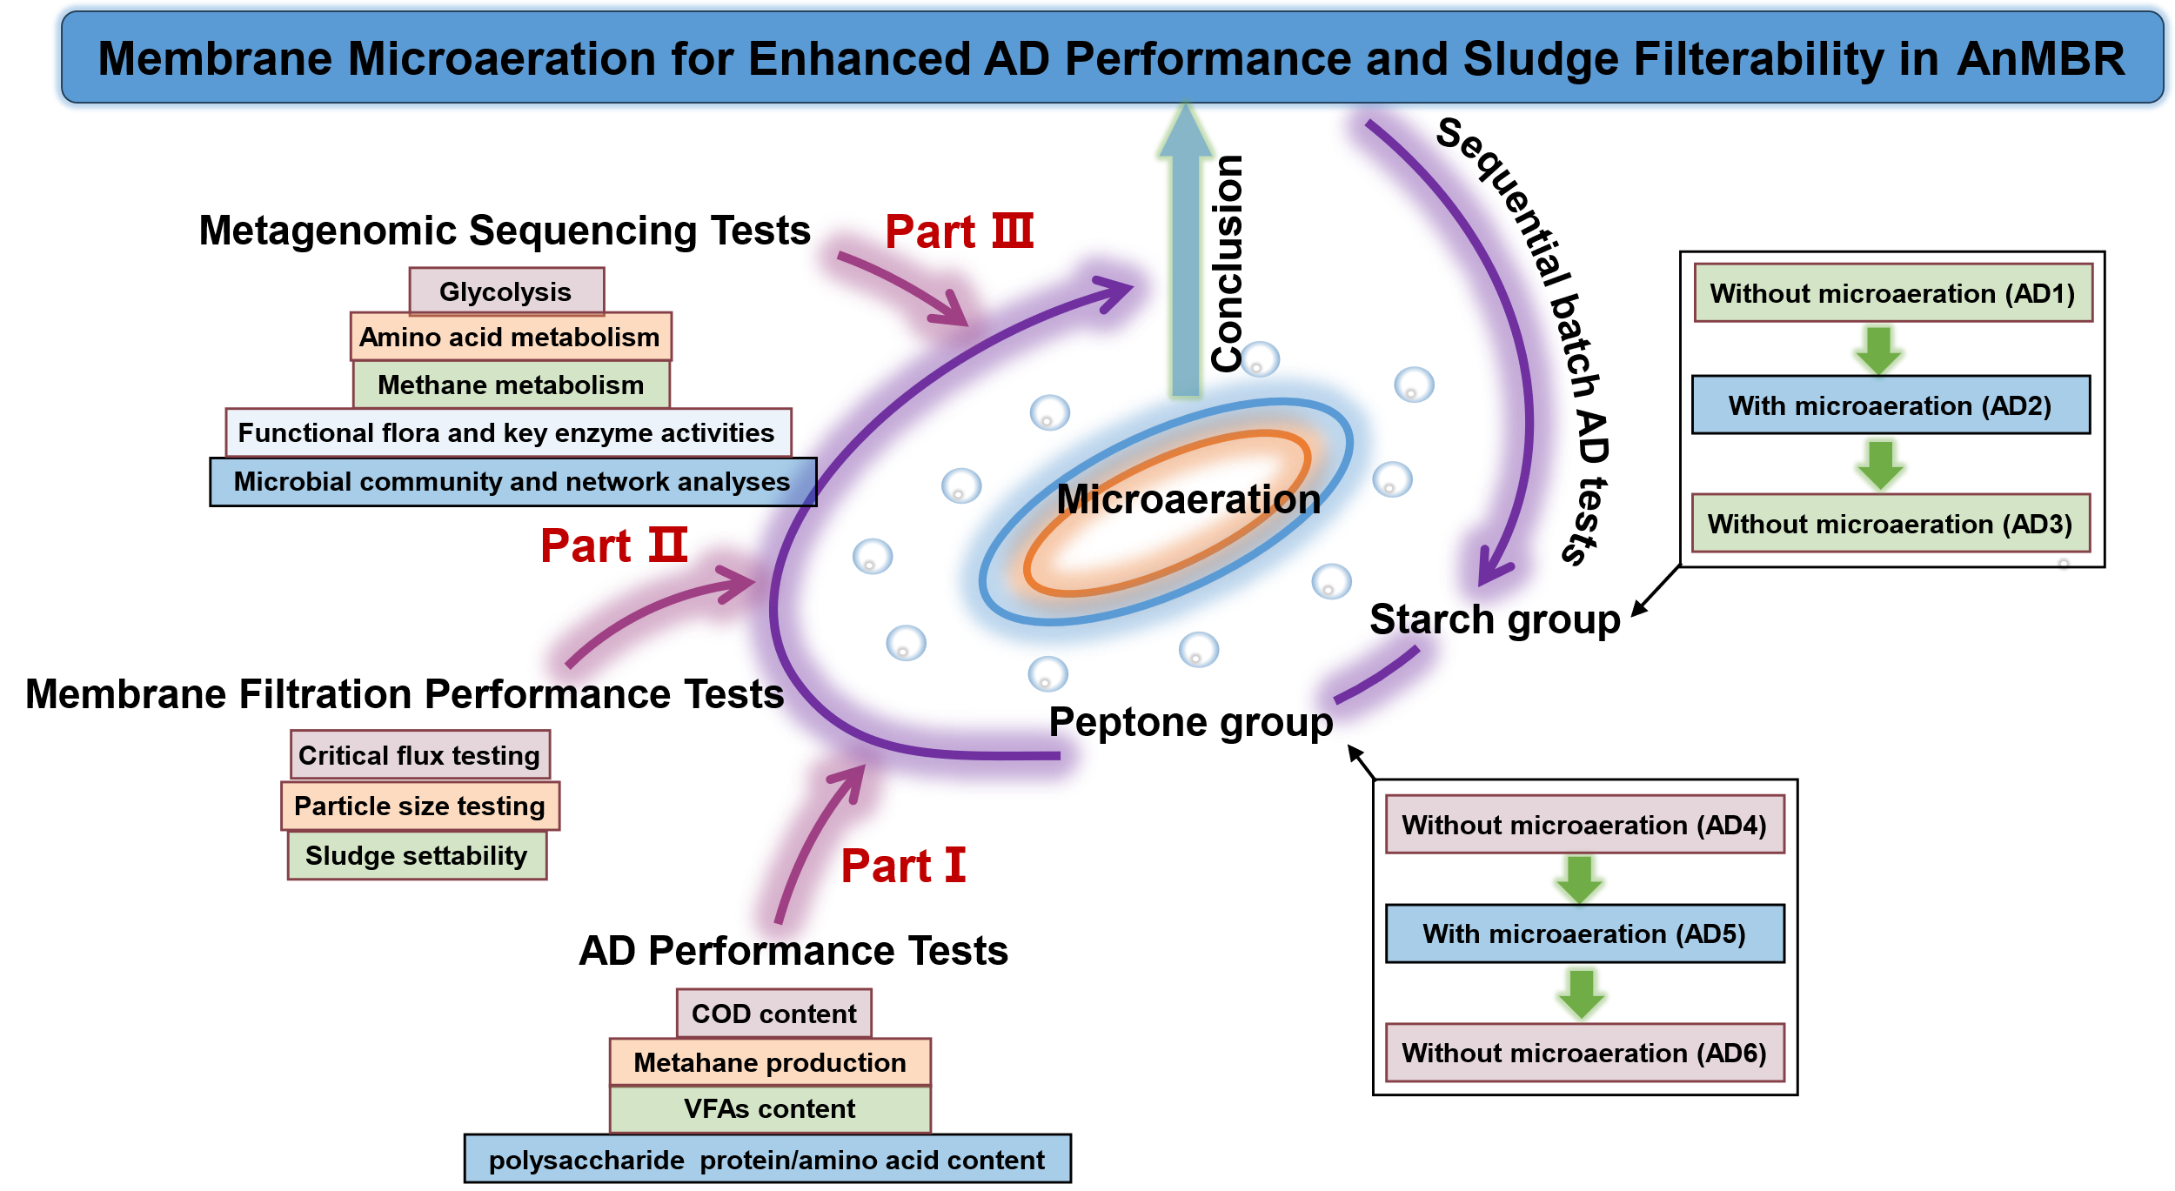

Fig. S1. Technical route in this study.

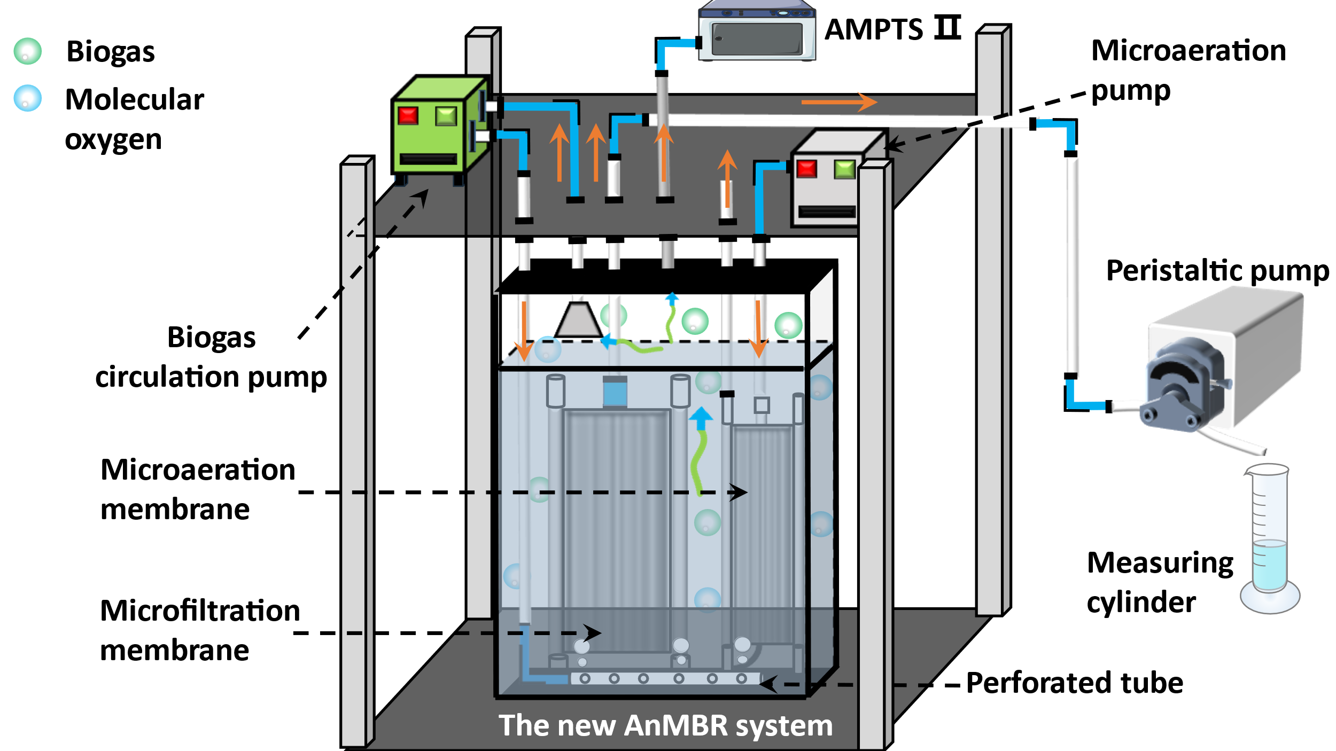
(A)

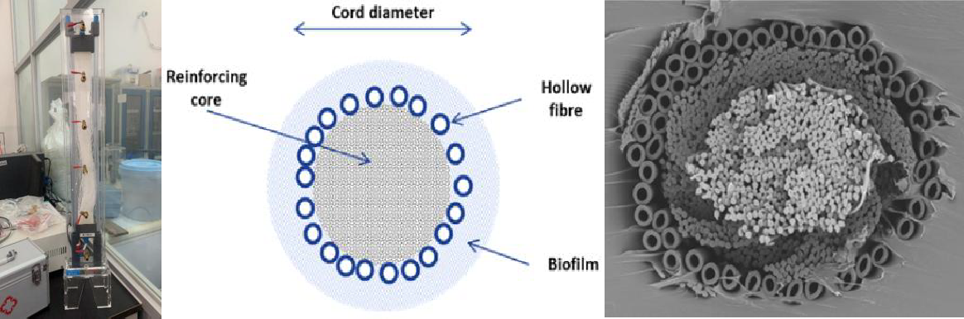
(B)
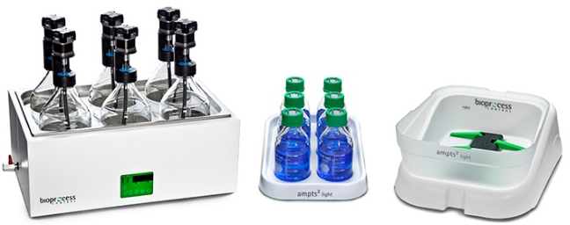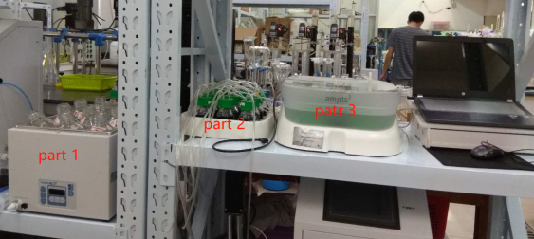
(C)

Fig. S2. Schematic diagram of the lab-scale AnMBR prototype with microaeration membrane (A); hollow fiber aeration membrane module (left), schematic diagram of membrane cord (center) and cross-sectional image via scanning electronic microscopy (right) (B); AMPTS fully automated methane potential testing system (C).

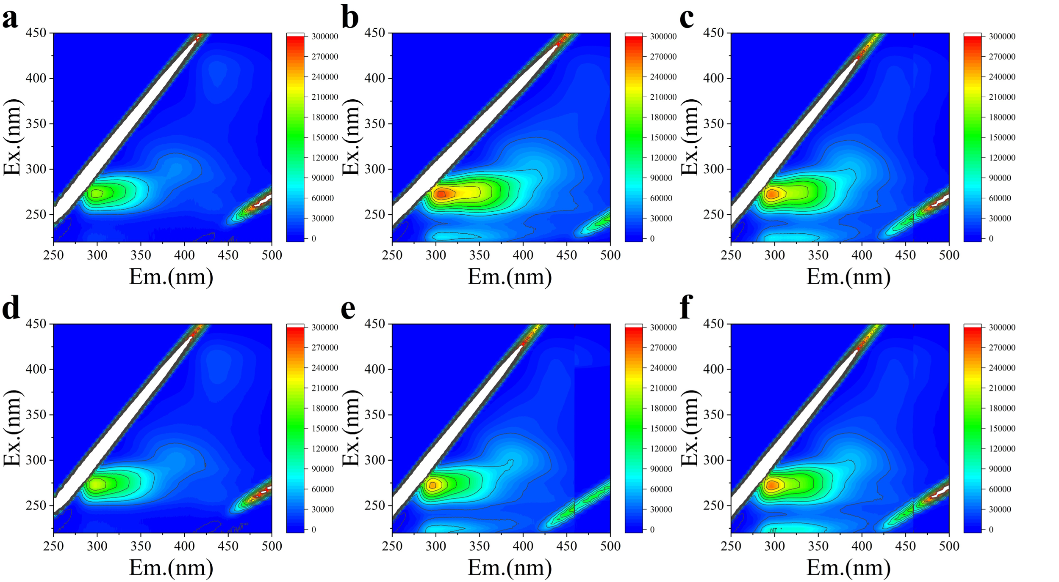
(A)
(B)
Fig. S3. Fluorescence excitation-emission-matrix spectra at the initial (a) and end (d) of AD4, at the initial (b) and end (e) of AD5 (b), at the initial (c) and end (f) of AD6 (A); percentage of different SS components (B).
Fig. S4. Relative abundance of genes encoding specific enzymes.

Table S1. Sludge characteristics in the bioreactor at the beginning of this study (A) and chemical reagents used in this study (B).
(A)
Parameters | Unit | Value (Average ± SD)
TCOD | g/L | 18.9±3.7
SCOD | g/L | 9.1±0.2
VS | g/L | 18.5±0.9
TS | g/L | 30.9±1.0
pH | - | 7.1±0.1
ORP | mV | -300.7±7.4

(B)
Name | Purity | Specification | Manufacturer
Starch | AR | 2.5 kg | Macklin Reagent Company, China
Na₂HPO₄ | AR | 500 g | Tianjin Zhiyuan Chemical Reagent Co, China
NH₄Cl | AR | 500 g | Tianjin Zhiyuan Chemical Reagent Co, China
Peptone | AR | 500 g | Guangdong Huankai Microbial Sci. & Tech Co., LTD., China
NaHCO₃ | AR | 500 g | Tianjin Zhiyuan Chemical Reagent Co, China
Phenol | AR | 500 g | Tianjin Damao Chemical Reagent Factory, China
H₂SO₄ | AR | 500 ml | Guangzhou Chemical Reagent Factory, China
2,2-Dihydroxyindane-1,3-dione | AR | 5 g | Tianjin Damao Chemical Reagent Factory, China
Coomassie  brilliant blue | - | 96 samples | Nanjing Jiancheng BioEngineering Institute, China

