Supplementary materials
Figure S1. Split half analysis.
Figure S2. Residual analysis.
Figure S3. pH, NH₄⁺-N and SCOD concentrations in leachate during dry AD process.
Figure S4. Accumulated biogas production (a) and methane percentage (b) during AD process.
Figure S5. Typical EEM spectra of DOM in the leachate from dry AD process with different pre-aeration durations; normalized to 5 mg/L DOC.

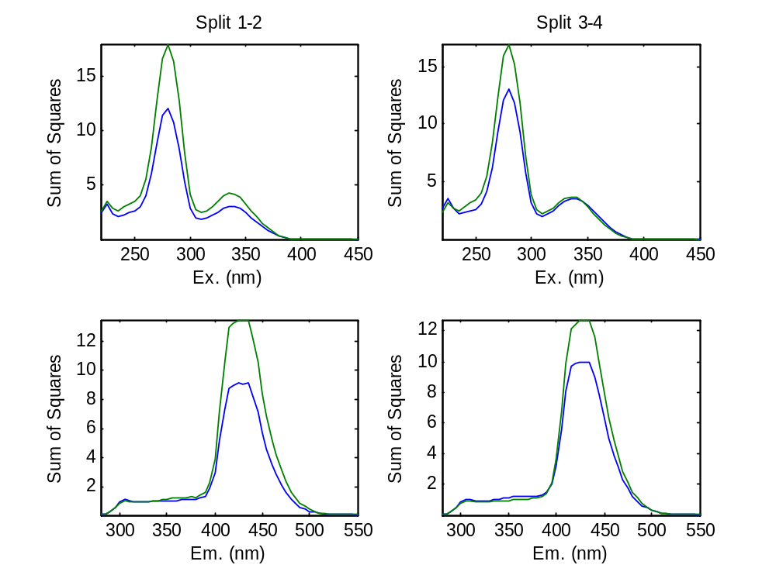
Fig. S1. Split half analysis.

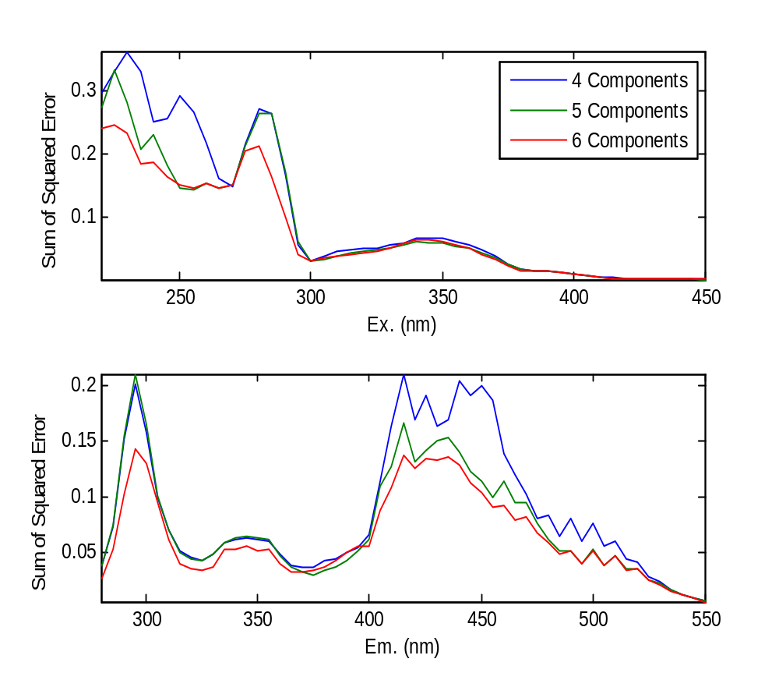
Fig. S2. Residual analysis.

Fig. S3. pH, NH₄⁺-N and SCOD concentrations in leachate during dry AD process.

Fig. S4. Accumulated biogas production (a) and methane percentage (b) during AD process.
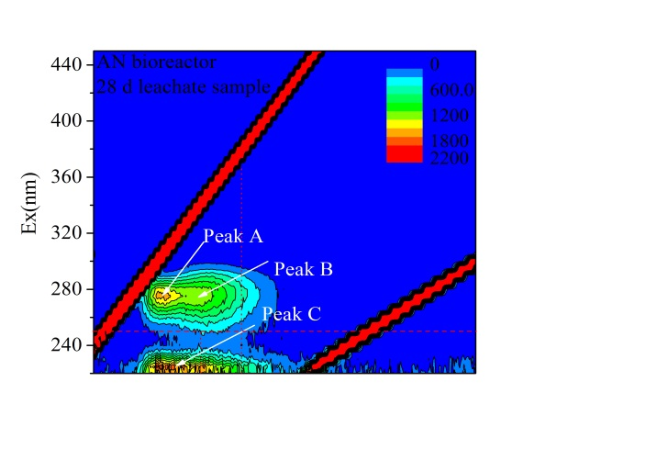
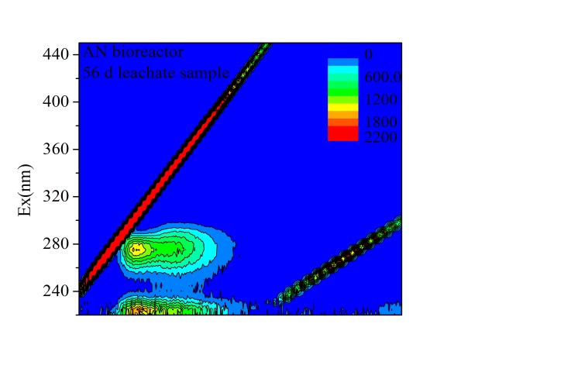
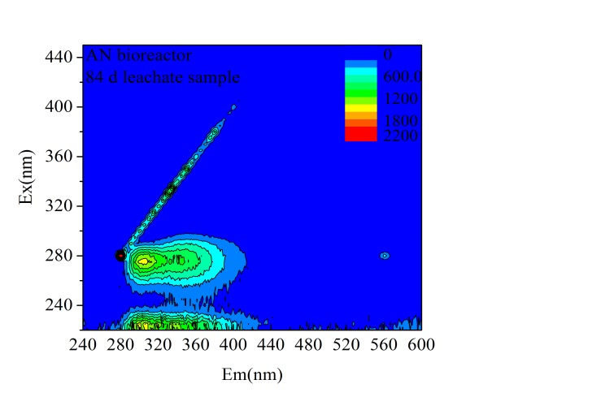
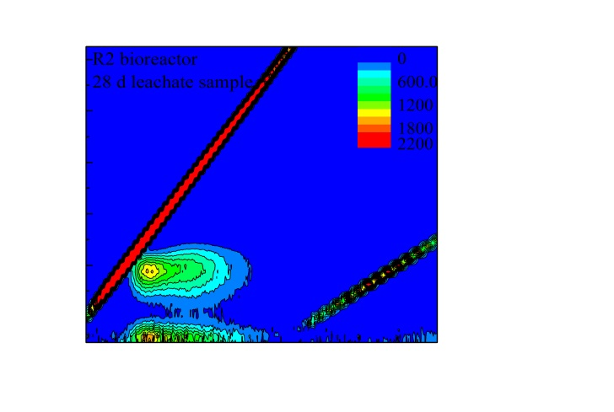
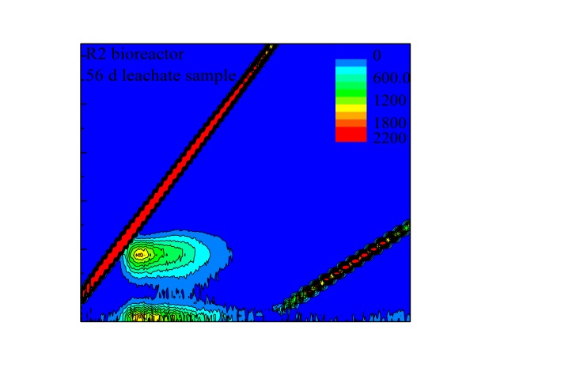
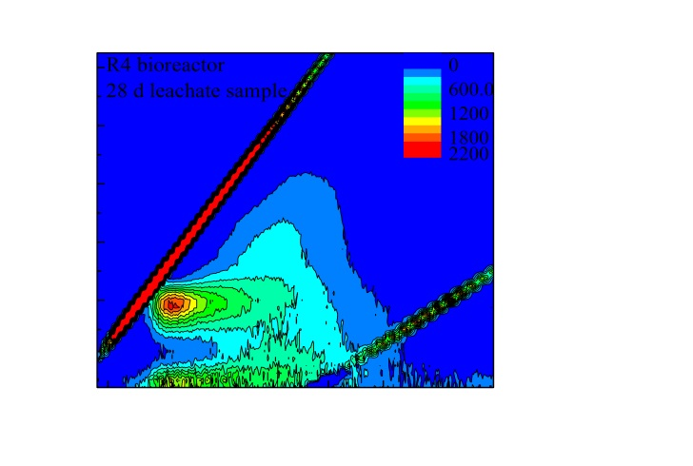
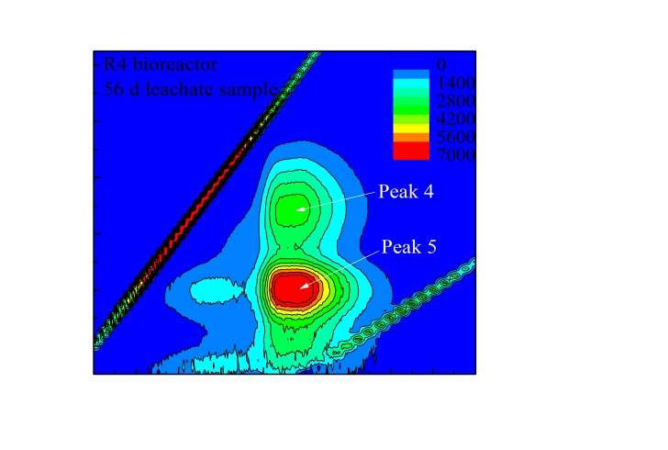
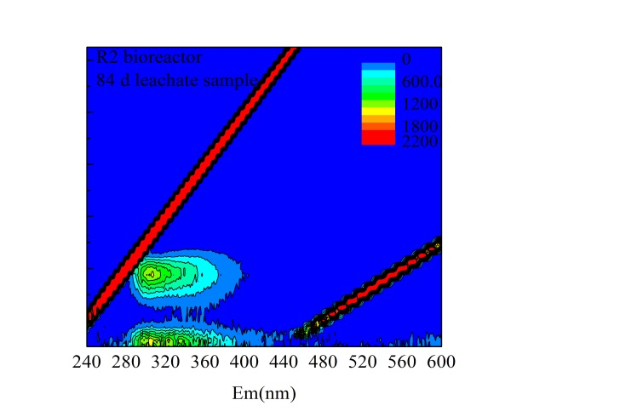
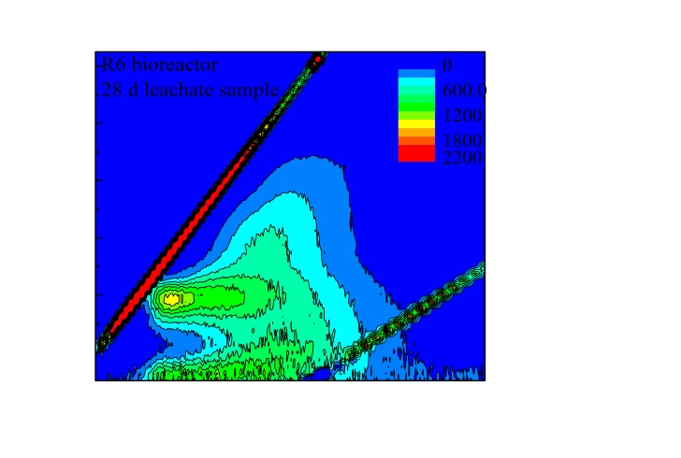
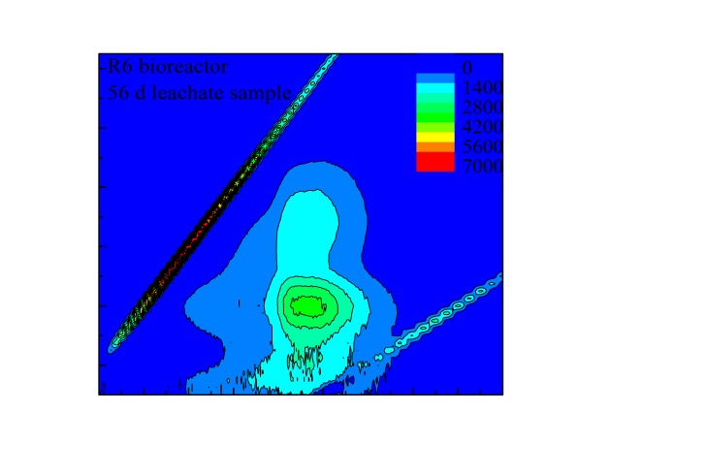
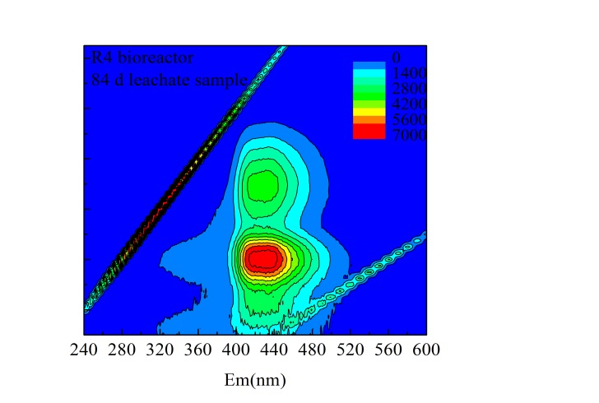
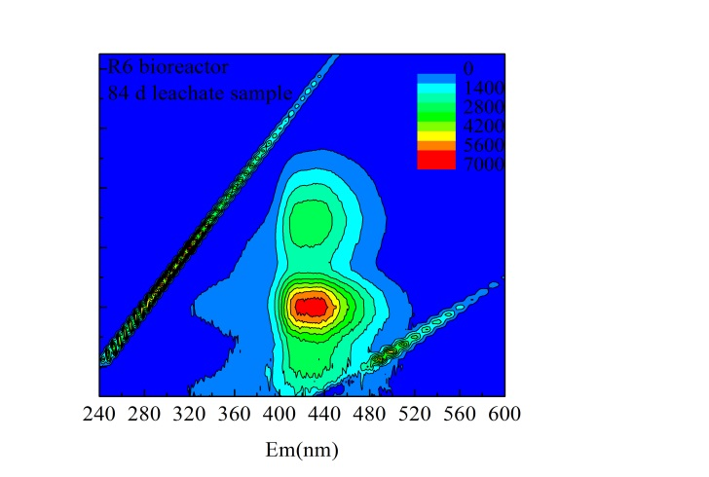
R(4) 56 day sample
Ⅴ
Ⅳ
Ⅰ
Ⅱ
Ⅲ
E
D
R(8) 28 day sample
R(4) 28 day sample
R(8) 56 day sample
R(8) 84 day sample
R(4) 84 day sample
R(4) 56 day sample
AN 28 day sample
AN 56 day sample
AN 84 day sample
R(14) 28 day sample
R(14) 56 day sample
R(14) 84 day sample
Fig. S5. Typical EEM spectra of DOM in the leachate from dry AD process with different pre-aeration durations; normalized to 5 mg/L DOC.

