The use of lytic polysaccharide monooxygenases in anaerobic digestion of lignocellulosic materials
Thales H.F. Costa¹; Vincent G.H. Eijsink¹; Svein Jarle Horn^{1*}

1) Faculty of Chemistry, Biotechnology and Food Science, Norwegian University of Life Sciences (NMBU), P.O. Box 5003, N-1432 Aas, Norway

*Corresponding author

Additional file

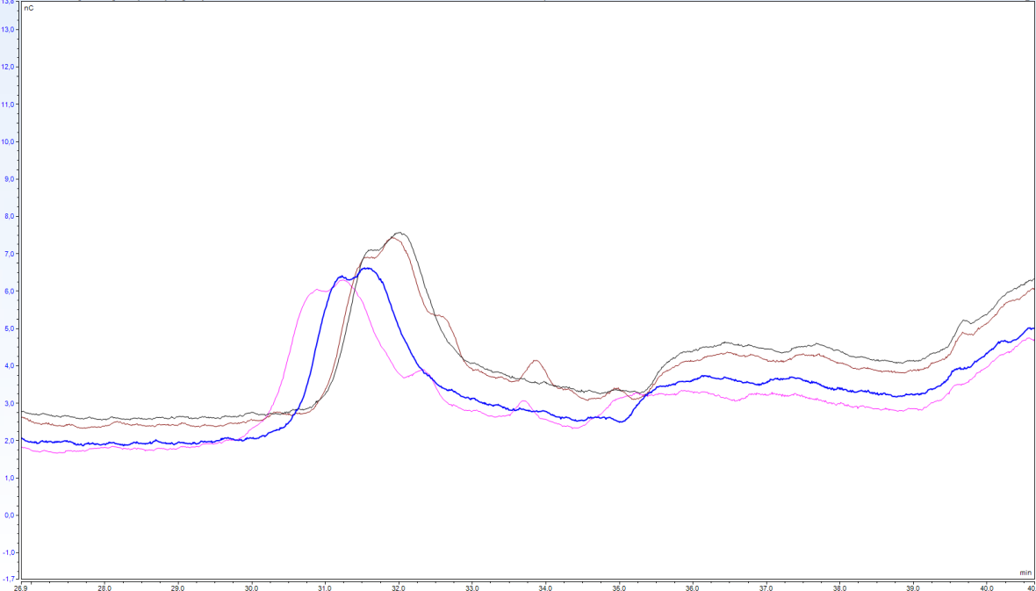
A
Inoculum-only
Avicel-NcLPMO9C
Avicel-only
Avicel-NcLPMO9C+H2O2
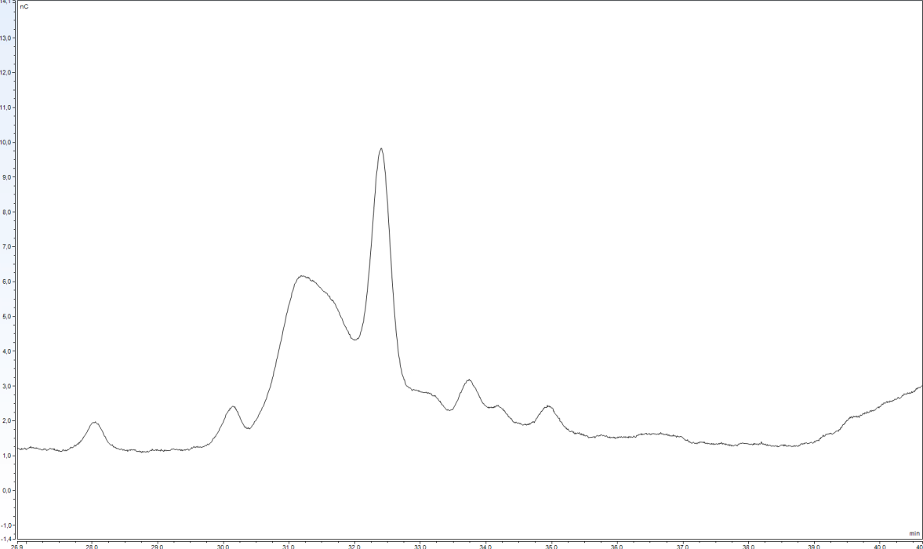
B
Positive control
Glc4gemGlc – 0.001g/L
Figure S1. (A) Chromatogram of soluble fractions of anaerobic digestion reactions with Avicel supplemented with purified NcLPMO9C as well as H₂O₂. Samples were taken initially in reactions supplemented with purified NcLPMO9C, after addition of H₂O₂ or H₂O. Shoulder peaks representing Glc4gemGlc, seen in reactions with NcLPMO9C only, are highlighted by the dashed lines. (B) Chromatogram of a standard sample (0,001 g/L) obtained after treating cellopentaose with NcLPMO9C, run together with other samples.

B
C
A
D
Figure S2. Rate of methane accumulation during anaerobic digestion of Avicel with addition of enzymes Cellic Ctec2 (A), Celluclast (B), NcLPMO9C (C) and a blend of 85 % Celluclast and 15 % NcLPMO9C (D). Enzymes were supplied once at day 0 at 4 mg of protein / g of substrate, with or without following addition of H₂O₂, as indicated in the figure. Hydrogen peroxide was supplied at 0h, 24h, 48h and 72h at 0.1 mM final concentration. Deionized water was added in all reactions without H₂O₂. Control reactions with boiled enzyme are also shown. Methane release by the inoculum methane was subtracted from all samples prior to calculation of methane production. The curves represent the average of two separate experiments.
B
A
C
D
Figure S3. Rate of methane accumulation during anaerobic digestion of birch with addition of enzymes Cellic Ctec2 (A), Celluclast (B), NcLPMO9C (C) and a blend of 85 % Celluclast and 15 % NcLPMO9C (D). Enzymes were supplied once at day 0 at 4 mg of protein / g of substrate, with or without following addition of H₂O₂, as indicated in the figure. Hydrogen peroxide was supplied at 0h, 24h, 48h and 72h at 0.1 mM final concentration. Deionized water was added in all reactions without H₂O₂. Control reactions with boiled enzyme are also shown. Methane release by the inoculum methane was subtracted from all samples prior to calculation of methane production. The curves represent the average of two separate experiments.
B
A
C
D
Figure S4. Rate of methane accumulation during anaerobic digestion of spruce with addition of enzymes Cellic Ctec2 (A), Celluclast (B), NcLPMO9C (C) and a blend of 85 % Celluclast and 15 % NcLPMO9C (D). Enzymes were supplied once at day 0 at 4 mg of protein / g of substrate, with or without following addition of H₂O₂, as indicated in the figure. Hydrogen peroxide was supplied at 0h, 24h, 48h and 72h at 0.1 mM final concentration. Deionized water was added in all reactions without H₂O₂. Control reactions with boiled enzyme are also shown. Methane release by the inoculum methane was subtracted from all samples prior to calculation of methane production. The curves represent the average of two separate experiments.
B
C
A
D
Figure S5. Rate of methane accumulation during anaerobic digestion of lignin-rich residue from birch (LRR) with addition of enzymes Cellic Ctec2 (A), Celluclast (B), NcLPMO9C (C) and a blend of 85 % Celluclast and 15 % NcLPMO9C (D). Enzymes were supplied once at day 0 at 4 mg of protein / g of substrate, with or without following addition of H₂O₂, as indicated in the figure. Hydrogen peroxide was supplied at 0h, 24h, 48h and 72h at 0.1 mM final concentration. Deionized water was added in all reactions without H₂O₂. Control reactions with boiled enzyme are also shown. Methane release by the inoculum methane was subtracted from all samples prior to calculation of methane production. The curves represent the average of two separate experiments.

Figure S6. Control reactions showing cumulative methane production during anaerobic digestion of Bovine Serum Albumin (BSA) with and without addition of H₂O₂ (methane production from inoculum-only has been substracted). As for all the other reactions with enzyme addition, the load of protein at day 0 were 9.2 mg/L of protein. H₂O₂ was supplied at 0h, 24h, 48h and 72h at 0.1 mM final concentration. Deionized water was added in all reactions without H₂O₂. The methane production was divided by the same amount of substrate (0.07 g VS) used in all reactions with lignocellulosic substrates for direct comparison. The curves represent the average of two separate experiments.

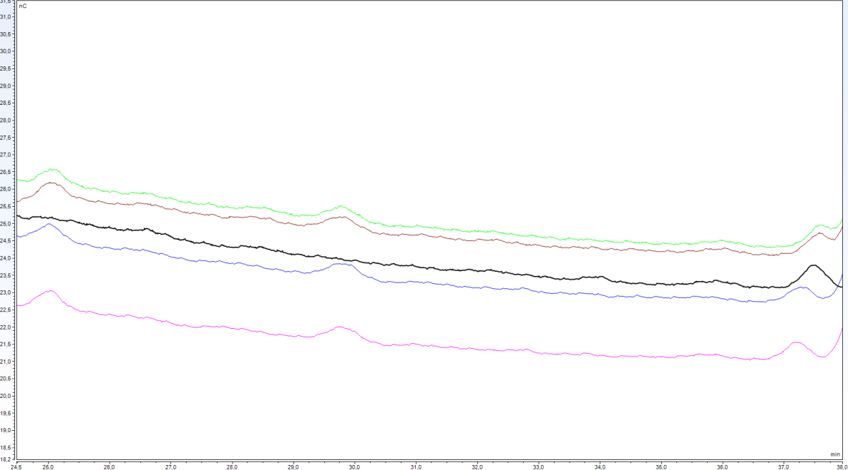
A
Birch-Cell+9C+H₂O₂
Spruce-Cell+9C
Negative control
Spruce-NcLPMO9C
Birch-NcLPMO9C+H₂O₂
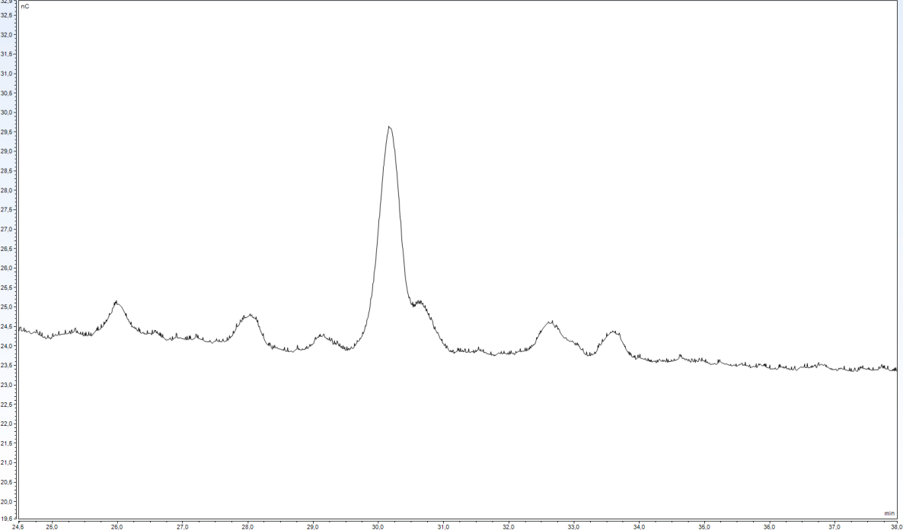
B
Positive control
Glc4gemGlc – 0.001g/L
Figure S7. (A) Chromatogram of soluble fractions of anaerobic digestion reactions with birch and spruce, supplemented with purified NcLPMO9C or the blend of 85 % Celluclast and 15 % NcLPMO9C (Cell+9C) as well as H₂O₂ or H₂O, under anaerobic conditions. The samples shown were taken after 4h of incubation from reactions. Peaks representing Glc4gemGlc for this run are highlighted by the dashed lines. (B) Chromatogram of a standard sample (0,001 g/L) obtained after treating cellopentaose with NcLPMO9C.

