Supplementary

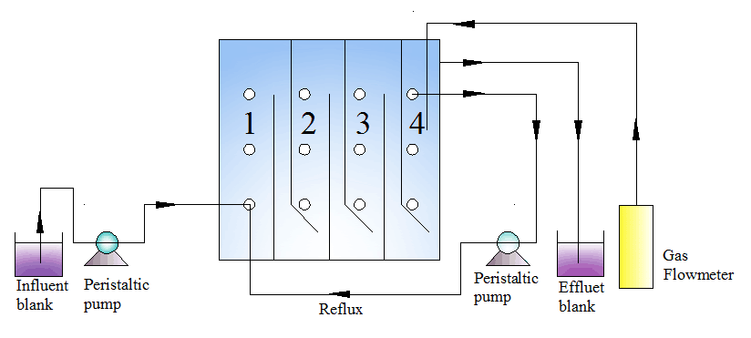
Fig. S1 Experimental apparatus of the modified ABR reactor.

