Supplementary Materials

Appendix Figures

Fig.S1 Schematic diagram of the reactor system

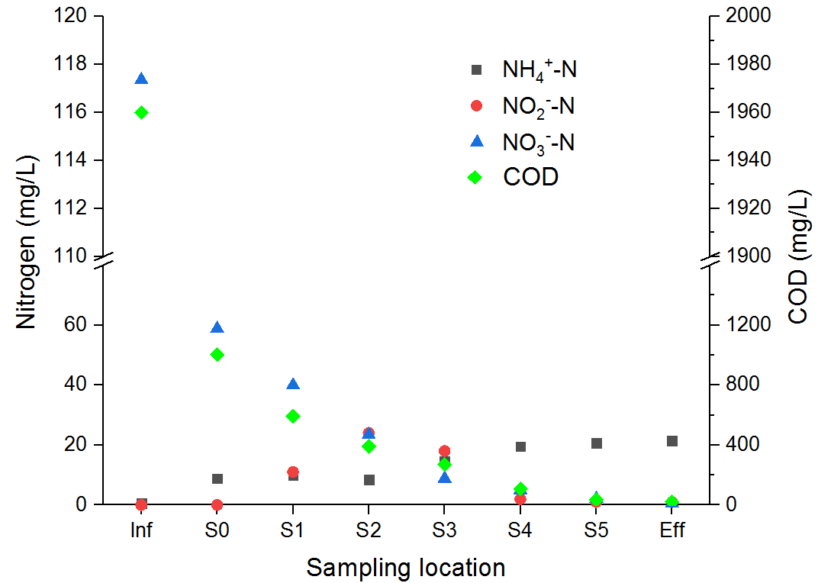
Fig.S2 COD and nitrate, nitrite,ammonia profiles along the reactor height on day 118

