Supporting Information

Upflow anaerobic-microaerobic fixed biofilm reactor integrating methanogenesis with partial nitrification

Abid Hussain, Jangho Lee, Robertson Reid, Hyung-Sool Lee*
Department of Civil and Environmental Engineering, University of Waterloo, 200 University Avenue West, Ontario, Canada, N2L3G1

*Corresponding author: Phone: +1-519-888-4567 Ext. 31095; Fax: +1-519-888-4349; E-mail: hyungsool@uwaterloo.ca

Estimation of Oxygen Supply Rate (OSR) through the gas membrane
OSR through the membrane was evaluated at different air pressures of 14, 28 and 41 kPa. A cylindrical vessel similar in design and volume to the microaerobic zone of the AMFB reactor was filled with distilled water that had been deoxygenated by continuous sparging of N₂ gas (99%). A DO meter was used for continuous monitoring of dissolved oxygen in the test vessel. Membrane aeration was initiated once a DO of < 0.1 mg/L was reached. The change in DO concentration with active membrane aeration was monitored with the DO meter and used for estimation of OSR according to equations (1) and (3) below [1, 2].
Oxygen transfer through the membrane can be described by the first order differential equation [1]:
$\frac{dC}{dt}= K_{L}$a ($C_{ct}$- $C_{t}$) (1)
Where: $C_{t}$ is the oxygen concentration in the liquid phase at any given time t (mg/L), $C_{ct}$ is the saturated oxygen concentration (mg/L), $K_{L}$ is the mass transfer coefficient based on liquid phase (m/h), t is the aeration time (h), a is the interfacial area available for mass transfer based on membrane surface area A (m²) and liquid volume V (m³).
Assuming that $C_{ct}$ is constant at all times, there is no chemical reaction, and initially (at t = 0) there is no oxygen in the test vessel, the solution of equation 1 yields:
ln $\left(\frac{C_{ct-C_{0}}}{C_{ct-C_{t}}}\right)$ = $K_{L}$a (t) (2)
Where: $C_{0}$ is the initial dissolved oxygen concentration in the liquid phase (mg/L)
Equation 2 corresponds to a linear relationship, in which the slope of the line is the volumetric mass transfer coefficient, $K_{L}$a [1-3]. Figure 1 shows the $K_{L}$a obtained for the membrane at different pressures in this study. The interfacial area, a can be deduced from the membrane surface area and liquid volume of the test vessel (A/V). OSR can then be calculated by the following equation [1]:
OSR = K_{L} X C_{ct} X 1000 (3)
Where: OSR is the oxygen supply rate (mg/m² h), 1000 is the unit conversion coefficient.

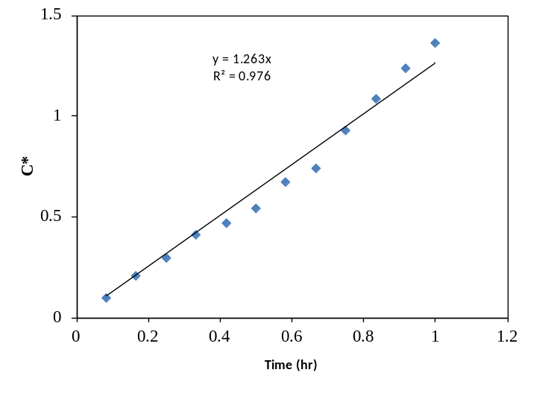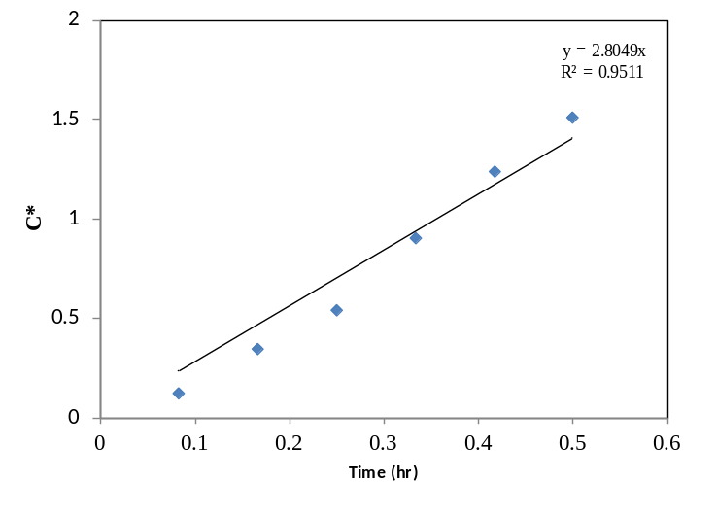
(B)
(A)
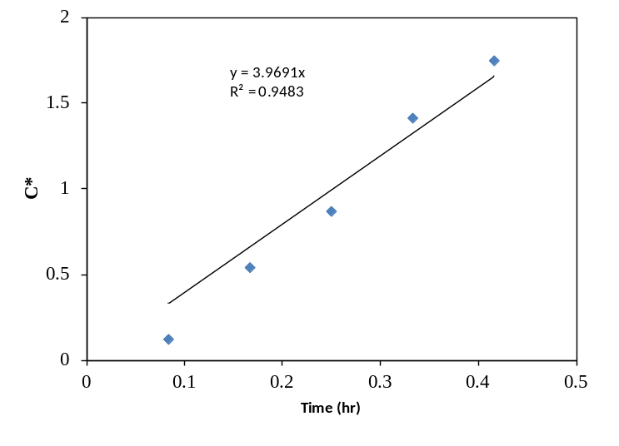
(C)

Figure 1. C* versus time for membrane at pressures of (A) 14 Kpa (B) 28 Kpa (C) 41 Kpa. Where: C* = ln $\left(\frac{C_{ct-C_{0}}}{C_{ct-C_{t}}}\right)$, $C_{t}$ is the oxygen concentration in the liquid phase at time t (mg/L), $C_{ct}$ is the saturated oxygen concentration (mg/L), $C_{0}$ is the initial dissolved oxygen concentration in the liquid phase (mg/L). The slope of the line is the volumetric mass transfer coefficient $K_{L}$a.
References
[1] W-Y. Dong, HJ. Wang, WG. Li, WC. Ying, GH. Gan, Y. Yang, Effect of DO on simultaneous removal of carbon and nitrogen by a membrane aeration/filtration combined bioreactor, J. Membrane Sci. 344 (2009) 219-224.

[2] P.C. Munasinghe, S.K. Khanal, Syngas fermentation to biofuel: Evaluation of carbon monoxide mass transfer coefficient (kLa) in different reactor configurations, Biotech. Prog. 26 (2010) 1616-1621.

[3] A. Hussain, B. Tartakovsky, S.R. Guiot, V. Raghavan, Use of silicone membranes to enhance gas transfer during microbial fuel cell operation on carbon monoxide, Bioresour. Technol. 102 (2011) 10898-10906.

