Supporting Information

Intermittent air mixing enhances dry anaerobic co-digestion of pig manure solid fraction and wheat straw: methane performance and machine-learning-guided parameter optimization

Table：S1-4
Figure：S1
Table S1. Physicochemical characteristics of the substrates and inoculum
Item | Wheat straw | Pig manure solid fraction | Inoculum sludge
pH | / | 7.4±0.2 | 7.1±0.1
Total solid (TS, %) | 90.6±0.5 | 24.0±0.4 | 20.8±0.1
Volatile solid (VS, %) | 77.4±0.9 | 19.8±0.2 | 8.9±0.3
VS/TS | 0.85 | 0.83 | 0.43
Total chemical oxygen demand (TCOD, g L⁻¹) | / | 312±19 | /
Soluble chemical oxygen demand (SCOD, g L⁻¹) | / | 39±11 | /
C/N | 29.5 | 14.0 | /

Table S2. Experimental design for anaerobic digestion with different PMSF-to-straw ratios
Item | Blank group | Treatment Groups
PMSF: straw ratio |  | 100:0 | 75:25 | 50:50 | 25:75 | 0:100
C/N of mixed feedstock | / | 14.0 | 17.9 | 21.8 | 25.6 | 29.5
PMSF TS added (g TS) | 0 | 34.5 | 25.9 | 17.3 | 8.6 | 0
PMSF VS added (g VS) | 0 | 29.6 | 21.1 | 13.3 | 6.3 | 0
Straw TS added (g TS) | 0 | 0 | 8.6 | 17.3 | 25.9 | 34.5
Straw VS added (g VS) | 0 | 0 | 7.0 | 13.3 | 18.8 | 23.6
PMSF fresh mass (g) | 0 | 150.0 | 112.5 | 75.0 | 37.5 | 0.0
Straw fresh mass (g) | 0 | 0 | 7.8 | 15.7 | 23.5 | 31.4
Inoculum added (g) | 150.0 | 150.0 | 150.0 | 150.0 | 150.0 | 150.0
Inoculum TS added (g TS) | 25.5 | 25.5 | 25.5 | 25.5 | 25.5 | 25.5
Deionized water added (g) | 150.0 | 0 | 29.7 | 59.3 | 89.0 | 118.6
Total working mass (g) | 300.0 | 300.0 | 300.0 | 300.0 | 300.0 | 300.0

Table S3. Operating conditions for the semi-continuous parameter optimization experiment
No. | TS (%) | HRT (d) | OLR (g TS L⁻¹ d⁻¹) | OLR (g VS L⁻¹ d⁻¹) | Daily out/in (g d⁻¹) | Straw (g d⁻¹) | PMSF (g d⁻¹) | Water (g d⁻¹)
1 | 20 | 25 | 8.0 | 6.7 | 12.1 | 1.3 | 5.0 | 5.8
2 | 20 | 35 | 5.7 | 4.8 | 8.5 | 0.9 | 3.6 | 4.0
3 | 20 | 45 | 4.4 | 3.7 | 6.5 | 0.7 | 2.8 | 3.0
4 | 25 | 25 | 10.0 | 8.4 | 11.9 | 1.7 | 6.2 | 4.0
5 | 25 | 35 | 7.1 | 6.0 | 8.7 | 1.2 | 4.5 | 3.0
6 | 25 | 45 | 5.6 | 4.7 | 6.7 | 0.9 | 3.5 | 2.3
7 | 30 | 25 | 12.0 | 10.1 | 12.5 | 2.0 | 7.5 | 3.0
8 | 30 | 35 | 8.6 | 7.2 | 8.8 | 1.4 | 5.4 | 2.0
9 | 30 | 45 | 6.7 | 5.6 | 6.8 | 1.1 | 4.2 | 1.5

Table S4. Representative sample groups for microbial community sequencing
Sample code | Air mixing intensity (mL L⁻¹ min⁻¹) | Loading level | TS (%) | HRT (d) | OLR (g TS L⁻¹ d⁻¹) |  | OLR (g VS L⁻¹ d⁻¹)
A0-L | 0 | Low | 20 | 45 | 4.4 |  | 3.7
A0-M | 0 | Medium | 25 | 35 | 7.1 |  | 6.0
A0-H | 0 | High | 30 | 25 | 12.0 |  | 10.1
A33.3-L | 33.3 | Low | 20 | 45 | 4.4 |  | 3.7
A33.3-M | 33.3 | Medium | 25 | 35 | 7.1 |  | 6.0
A33.3-H | 33.3 | High | 30 | 25 | 12.0 |  | 10.1
A66.7-L | 66.7 | Low | 20 | 45 | 4.4 |  | 3.7
A66.7-M | 66.7 | Medium | 25 | 35 | 7.1 |  | 6.0
A66.7-H | 66.7 | High | 30 | 25 | 12.0 |  | 10.1
Note: A0, A33.3, and A66.7 represent air mixing intensity of 0-, 33.3-, and 66.7-mL L⁻¹ d⁻¹, respectively; L, M, and H represent low-, medium-, and high-OLR sequencing samples.

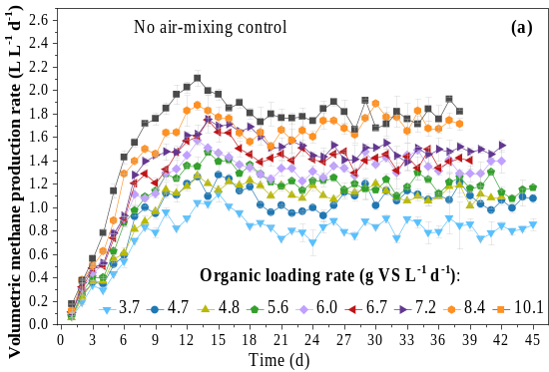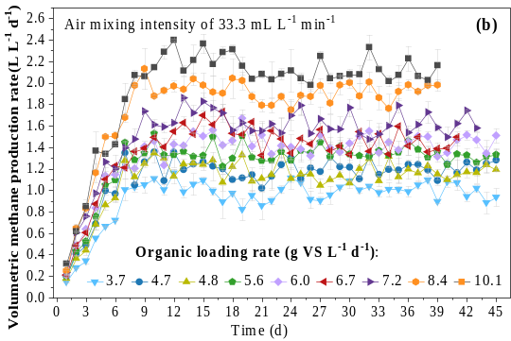
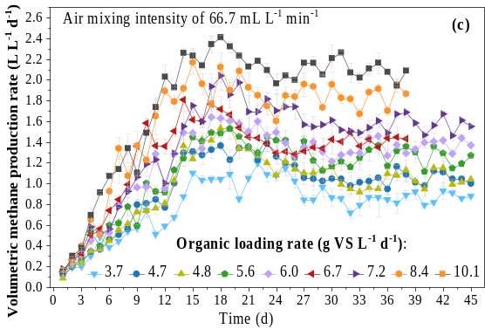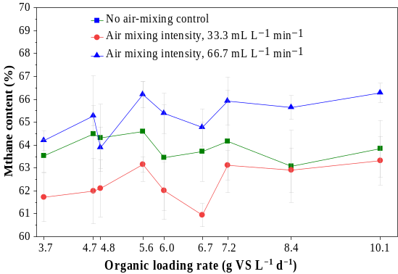
Figure S1. Volumetric methane production rate (a-b) and methane content (b) of anaerobic co-digestion of PMSF and straw under different OLR and intermittent air mixing intensities

