Supporting Information

Effect of process-based strategies on anaerobic digestion of 3D-printing-derived polylactic acid: biogas production and mechanistic interpretation
Davide Giandomenico^{1, 2}, Alessandro Gottuso^{3,4}, Rocco Rubino¹, Alberto Ferraro¹*, Luca Fambri³, Francesco Parrino³, Raffaele Morello¹, Francesco Bianco^{5,6}, Gennaro Trancone⁷, Umberto Fratino¹, Danilo Spasiano¹

¹ Department of Civil, Environmental, Land, Building Engineering and Chemistry, Polytechnic University of Bari, Via Orabona 4, Bari, 70125, Italy
² Department of Soil, Plant, and Food Sciences, University of Bari Aldo Moro, Via Amendola 165/A, Bari, 70126, Italy
³ Department of Industrial Engineering and INSTM Research Unit, University of Trento, Via Sommarive 9, Trento, 38123, Italy
⁴ School of Environmental Science and Engineering - Shanghai Jiao Tong University, Shanghai, 200240, China
⁵ Department of Civil and Mechanical Engineering, University of Cassino and Southern Lazio, Via di Biasio 43, 03043 Cassino, Italy
⁶ European University of Technology EUt+, Viale dell'Università, Campus Folcara, Cassino, 03043, Italy
⁷ Department of Civil, Architectural and Environmental Engineering, University of Naples “Federico II”, Via Claudio 21, Naples, 80125, Italy

*Corresponding Author: A. Ferraro (alberto.ferraro@poliba.it)

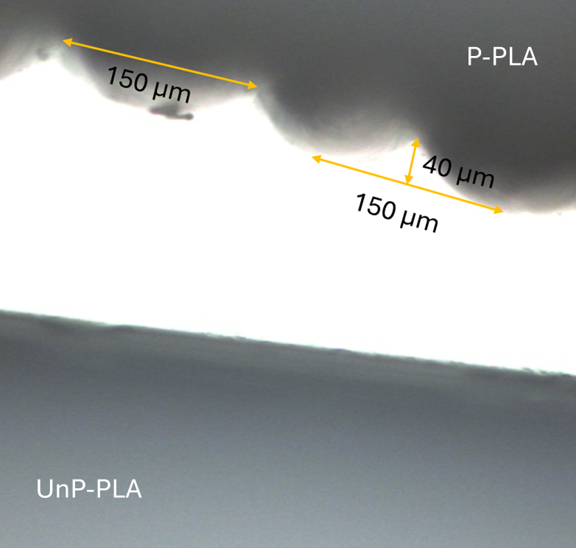
Figure S1. Comparison between the surfaces of UnP-PLA and P-PLA sticks.

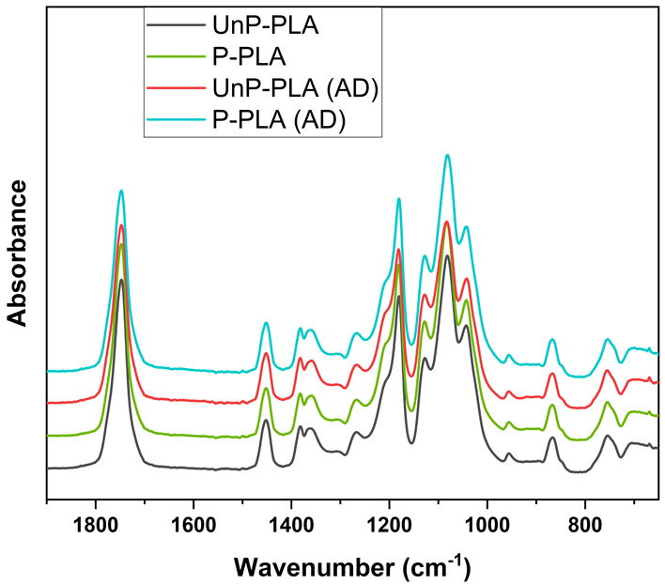
Figure S2. FT-IR spectra (1900-650 cm⁻¹) normalized to the ~1454 cm⁻¹ band (δ(CH₃) unprinted (UnP-PLA, black) and printed (P-PLA, green) PLA before and after anaerobic digestion (UnP-PLA (AD) red, P-PLA (AD) cyan).

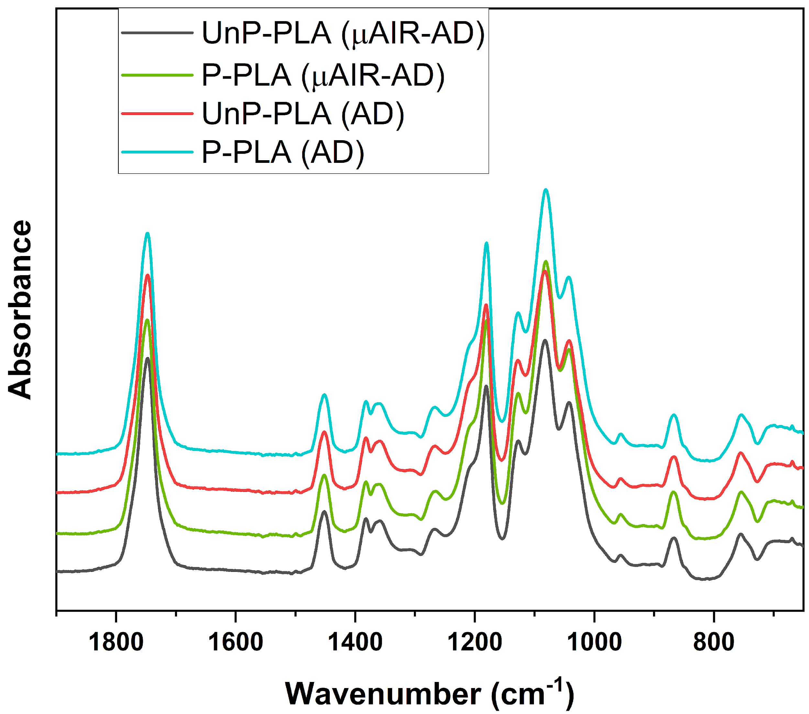
Figure S3. FT-IR spectra (1900-650 cm⁻¹) normalized to the ~1454 cm⁻¹ band (δ(CH₃), for unprinted and printed PLA samples after micro-aerated (UnP-PLA (Micro-AD), black, P-PLA (Micro-AD), green) and anaerobic digestion (UnP-PLA (AD) red, P-PLA (AD) cyan).
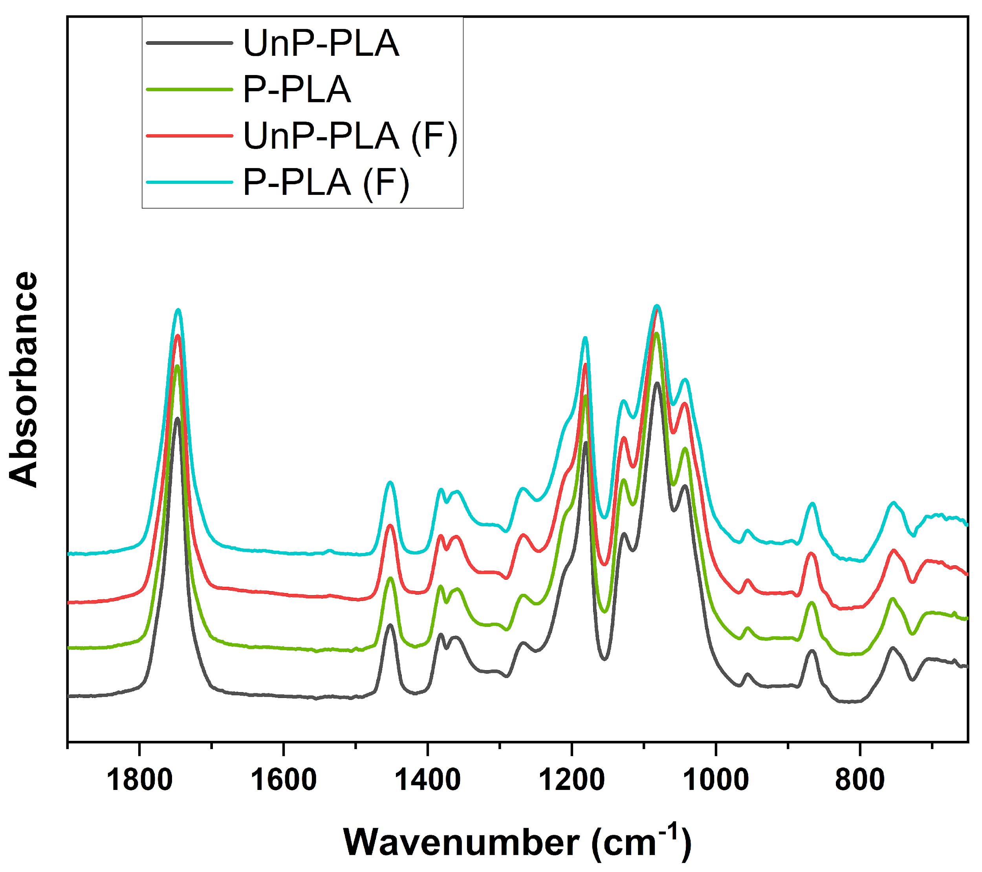
Figure S4. FT-IR spectra (1900-650 cm⁻¹) normalized to the ~1454 cm⁻¹ band (δ(CH₃) unprinted (UnP-PLA, black) and printed (P-PLA, green) PLA before and after Fenton treatment (UnP-PLA (F) red, P-PLA (F) cyan).

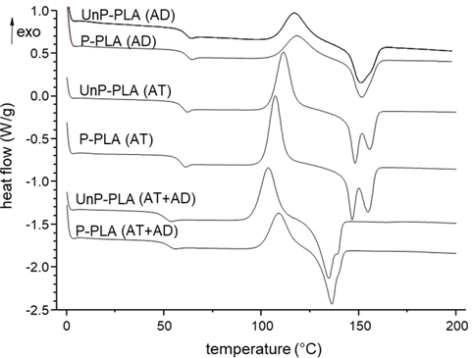
Figure S5. Selected DSC thermograms: second heating scan of PLA samples (AD, AT and AD+AT). In evidence glass transition temperature (T_{g2}), crystallization peak (T_{c2}) and melting peak/s (T_{m2}).
Table S1. DSC parameters from the cooling and second heating scan of PLA samples. Glass transition temperature (T_{g}) and correspondent variation of specific heat (ΔC_{p}); crystallization temperature (T_{c}) and enthalpy (ΔH_{c}); melting temperature (T_{m}) and enthalpy (ΔH_{m}). Pedix c and 2 refer to the cooling and second heating step, respectively. Crystallinity X_{C2} and crystallizability C₂ are also reported.
 | Cooling |  |  | 2nd Heating scan
Sample | T_{gc}  (°C) | ΔC_{pc}  (J/g∙°C) | T_{g2}  (°C) | ΔC_{p2}  (J/g∙°C) | T_{c2}  (°C) | ΔH_{c2}  (J/g) | T_{m2}  (°C) | ΔH_{m2}  (J/g) | ªX_{C2}  (%) | C₂*  (%)
UnP-PLA | 57.4 | 0.59 | 62.0 | 0.58 | 119.0 | 22.6 | 152.0 | 23.7 | 1.1 | 25.3
P-PLA | 57.5 | 0.63 | 62.0 | 0.58 | 118.5 | 25.2 | 151.3 | 26.3 | 1.2 | 28.1
UnP-PLA (AD) | 57.5 | 0.56 | 61.6 | 0.54 | 117.9 | 25.8 | 151.2 | 26.5 | 0.7 | 28.3
P-PLA (AD) | 57.4 | 0.59 | 61.4 | 0.59 | 116.9 | 29.2 | 150.9 | 30.0 | 0.8 | 32.0
UnP-PLA (µAIR-AD) | 55.5 | 0.52 | 61.0 | 0.53 | 118.0 | 22.9 | 150.4 | 23.7 | 0.9 | 25.3
P-PLA (µAIR-AD) | 56.7 | 0.56 | 60.5 | 0.54 | 116.4 | 26.6 | 149.2 | 26.8 | 0.2 | 28.6
P-PLA (F+AD) | 55.9 | 0.54 | 60.8 | 0.53 | 117.2 | 23.64 | 149.7 | 24.8 | 1.2 | 26.5
UnP-PLA (F+AD) | 55.4 | 0.56 | 60.6 | 0.56 | 115.8 | 27.5 | 149.8 | 27.6 | 0.01 | 29.5
UnP-PLA (AT) | 57.2 | 0.58 | 59.8 | 0.60 | 111.3 | 37.3 | 147.8** | 39.4 | 2.2 | 42.1
P-PLA (AT) | 56.4 | 0.58 | 58.6 | 0.62 | 107.2 | 39.9 | 146.3** | 41.4 | 1.6 | 44.3
UnP-PLA (AT+AD) | 48.7 | 0.57 | 50.7 | 0.58 | 103.5 | 38.6 | 134.3 | 39.5 | 0.9 | 42.2
P-PLA (AT+AD) | 50.4 | 0.45 | 52.5 | 0.48 | 108.2 | 29.0 | 135.8 | 29.8 | 0.4 | 31.8
ª Crystallinity X_{C2} has been calculated from Equation (2)
*Crystallizability is calculated from the melting enthalpy ΔH_{m2} normalized by 93.6 J/g
**double melting peak (see Figure S3)

Table S2. Integrated band areas from normalized FT-IR spectra and crystalline index of PLA samples.
Sample | Area of reference | Area of signals normalized by reference (A_{X}/A₁₄₅₄) |  |  |  |  |  | IR-C_{index}
Sample | ~1454  cm⁻¹ | ~1360 cm⁻¹ | ~1267 cm⁻¹ | ~1130 cm⁻¹ | ~1040 cm⁻¹ | ~956 cm⁻¹ | ~921 cm⁻¹ | $$\frac{A_{921}}{A_{921}+A_{956}}100$$
UnP-PLA | 0.946 | 0.238 | 0.277 | 0.634 | 0.369 | 0.109 | 0.004 | 3.5
P-PLA | 0.794 | 0.258 | 0.288 | 0.729 | 0.415 | 0.099 | 0.004 | 3.9
UnP-PLA (AD) | 0.639 | 0.241 | 0.285 | 0.623 | 0.344 | 0.096 | 0.007 | 6.8
P-PLA (AD) | 0.632 | 0.270 | 0.306 | 0.699 | 0.352 | 0.115 | 0.005 | 4.2
UnP-PLA (µAIR-AD) | 0.765 | 0.249 | 0.256 | 0.616 | 0.346 | 0.088 | 0.006 | 6.4
P-PLA (µAIR-AD) | 0.641 | 0.275 | 0.292 | 0.718 | 0.352 | 0.108 | 0.005 | 4.4
P-PLA (F+AD) | 0.355 | 0.218 | 0.346 | 0.564 | 0.281 | 0.115 | 0.007 | 5.7
UnP-PLA (F+AD) | 0.625 | 0.285 | 0.383 | 0.710 | 0.357 | 0.120 | 0.003 | 2.0
UnP-PLA (AT) | 0.813 | 0.405 | 0.246 | 0.893 | 0.491 | 0.087 | 0.016 | 15.5
P-PLA (AT) | 0.608 | 0.509 | 0.198 | 0.927 | 0.516 | 0.075 | 0.024 | 24.2
UnP-PLA (AT+AD) | 0.645 | 0.858 | 0.090 | 1.553 | 0.835 | 0.052 | 0.046 | 47.0
P-PLA (AT+AD) | 0.593 | 0.910 | 0.057 | 1.845 | 0.948 | 0.038 | 0.048 | 55.8

