Supplementary information

Text S1 Microbial community analysis

Fig. S1. Nitrate removal at different stages.

Fig. S2. The changes in pH at different stages.

Fig. S3. Morphology of granular sludge from different reactors.

Fig. S4. Nonmetric Multidimensional Scaling (NMDS) at OTU level.
Text. S1. Microbial community analysis
The V3-V4 region of the bacteria 16S ribosomal RNA gene were amplified by PCR（95 ℃ for 3min, followed by 30 cycles at 95 ℃ for 30 s, 55 ℃ for 30 s, and 72 ℃ for 45 s and a final extension at 72 ℃ for 10 min）using primers 515FmodF (GTGYCAGCMGCCGCGGTAA) and 806RmodR (GGACTACNVGGGTWTCTAA T), where barcode is an eight-base sequence unique to each sample. PCR reactions were performed in triplicate 20 μL mixture containing 4 μL of 5 × FastPfu Buffer, 2 μL of 2.5 mM dNTPs, 0.8 μL of each primer (5 μM), 0.4 μL of FastPfu Polymerase, and 10 ng of template DNA. Amplicons were extracted from 2% agarose gels and purified using the AxyPrep DNA Gel Extraction Kit (Axygen Biosciences, Union City, CA, U.S.) according to the manufacturer’s instructions and quantified using QuantiFluor™ -ST (Promega, U.S.). Purified amplicons were pooled in equimolar and paired-end sequenced (2 × 250) on an Illumina MiSeq platform according to the standard protocols.
Raw fastq files were demultiplexed, quality-filtered using QIIME (version 1.17) with the following criteria: (i) The 300 bp reads were truncated at any site receiving an average quality score <20 over a 50 bp sliding window, discarding the truncated reads that were shorter than 50bp. (ii) exact barcode matching, 2 nucleotide mismatch in primer matching, reads containing ambiguous characters were removed. (iii) only sequences that overlap longer than 10 bp were assembled according to their overlap sequence. Reads which could not be assembled were discarded. Operational Units (OTUs) were clustered with 97% similarity cutoff using UPARSE（version 7.1 http://drive5.com/uparse/) and chimeric sequences were identified and removed using UCHIME. The taxonomy of each 16S rRNA gene sequence was analyzed by RDP Classifier (http://rdp.cme.msu.edu/) against the silva (SSU115)16S rRNA database using confidence threshold of 70% (Amato et al., 2013).
The PICRUSt2 tool (http://huttenhower.sph.harvard.edu/galaxy) was employed to align the ASV sequences with their respective internal reference sequences, integrate the ASVs into the corresponding reference phylogenetic tree, estimate the copy number for each ASV gene family, predict the gene content for each ASV, and quantify the abundance of each gene family across the samples. The gene family data were compared against the KEGG database (Kyoto Encyclopedia of Genes and Genomes, http://www.genome.jp/kegg/) to derive the functional and abundance profiles for each sample.

Reference
Amato, K.R., Yeoman, C.J., Kent, A., Righini, N., Carbonero, F., Estrada, A., Rex Gaskins, H., Stumpf, R.M., Yildirim, S., Torralba, M., Gillis, M., Wilson, B.A., Nelson, K.E., White, B.A., Leigh, S.R. 2013. Habitat degradation impacts black howler monkey (Alouatta pigra) gastrointestinal microbiomes. The ISME Journal, 7(7), 1344-1353.

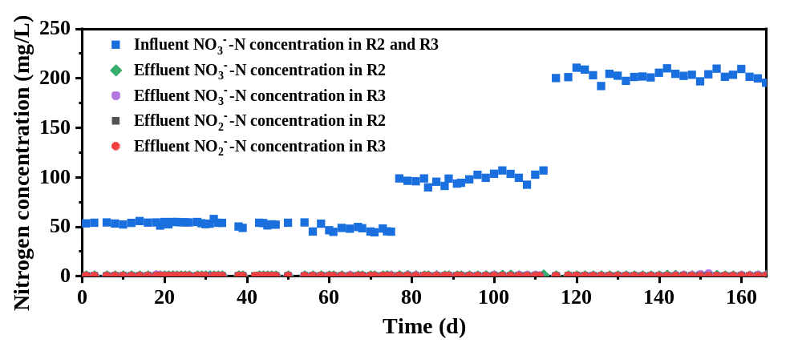
Fig. S1. Nitrate removal at different stages.

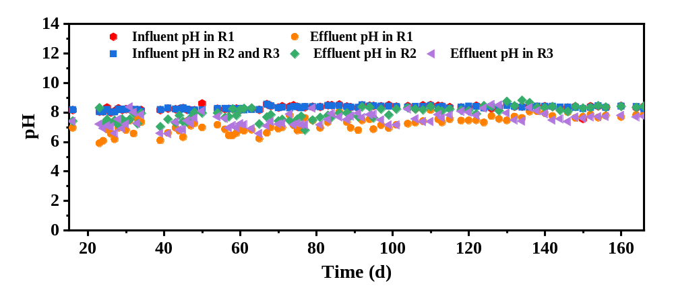
Fig. S2. The changes in pH at different stages.

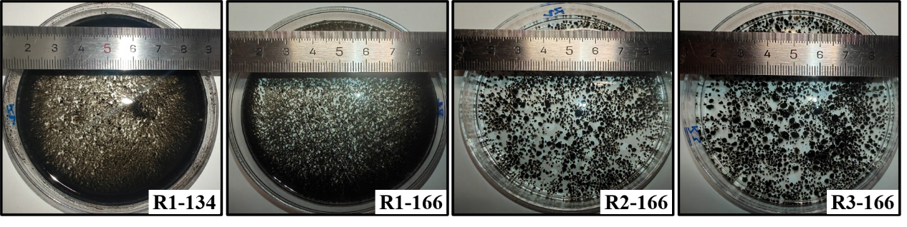
Fig. S3. Morphology of granular sludge from different reactors.

Fig. S4. Nonmetric Multidimensional Scaling (NMDS) at OTU level.

