Supplementary materials
Supporting methods
The modified Gompertz model
Analysis of soluble humic acids (SHAs)
Cyclic voltammetry (CV)
Supporting results
Fig.S1. Schematic diagram of anaerobic reactor
Fig. S2. FTIR spectra of extracted SHAs from digestate

Supporting methods

The modified Gompertz model
The modified Gompertz model (Eq. 1) [1] was adapted to fit the methane production data for analyzing the effects of micro-aeration on AD of corn straw.
$M_{t}=M_{m}×exp\left\{-exp\left\lceil \frac{R_{m}×e}{M_{m}}\left(λ-t\right)+1\right\rceil \right\}$ (1)
Where, M_{t} represents the cumulative methane production at time t (mL/g·VS), M_{m} represents the methane yield potential (mL/g·VS), R_{m} represents the maximum methane yield rate (mL/(g·VS)· d), λ represents the lag time (d), t represents the digestion time (d), and e =2.73.

Excitation emission matrix (EEM) fluorescence spectra
In order to study the effects of oxygen dose on the dissolved organic matter, EEM fluorescence spectra was applied to characterize dissolved organic matter in the digestates. digestates were filtered through 0.45-μm filters and diluted 5x using deionized water before the EEM measurement by a fluorescence spectrophotometer (F-7000 FL, HitachiCo, Japan). The excitation wavelength was gradually increased from 200 to 450 nm while emission wavelength was gradually increased from 250 to 650 nm by a 5-nm increment. The three-dimensional fluorescence region formed by the excitation and emission wavelengths was used to divide the organics in each digestates into five groups as shown in Table 1.
Table 1. Organics grouped by three-dimensional fluorescence region [2]
Group | EX (nm) | EM (nm) | Organics
Ⅰ | 200－250 | 250－330 | Tyrosine-like
Ⅱ | 200－250 | 330－380 | Tryptophan-like
Ⅲ | 200－250 | 380－650 | Fulvic acid-like
Ⅳ | 250－340 | 250－380 | Soluble microbial byproduct-like
Ⅴ | 250－450 | 380－650 | Humic acid-like

Soluble humic acids (SHAs) extraction and quantification
SHAs in the digestates were extracted according to the procedure developed by the International Humic Substances Society (IHSS) [3]. Before the extraction of SHAs, 20 mL samples were centrifuged at 5,000 rpm for 15 min and then filtered through 0.45-um filters. To the filtrates, 6 mol/L HCl was added to reduce the pH to 1.0 for precipitating out HAs, and 6 mol/L NaOH was then used to dissolve the HAs precipitates. Such a procedure of precipitation-dissolution-precipitation was repeated for three times to purify the SHAs precipitates. The extracted SHAs were quantified in g/L according to the gravimetric method [4].

Cyclic voltammetry (CV) and conductivity test of digestate
CV analysis could been performed to illustrate the redox property of special material and/or system [5]. The digestate sampleswere firstly centrifuged at 8,000 rpm for 10 min, the supernatants were used for CV and conductivity test. The CV experiment was carried out to excavate the redox reactions in digestates with a three-electrode electrochemical cell in a single chamber [6]. The reference electrode, counter electrode and working electrode in the electrochemical cell were saturated calomel electrode (SCE, Huachen, China), Pt and carbon cloth (2*2 cm), respectively. Digestates of 140 mL was added into the electrochemical cell, and the cell was purged with N₂ for 5 min to remove the dissolved oxygen. CV was tested on an electrochemical workstation (CHI600E, Huachen, China) with a scanning voltage in the range of -1.0 ~ 1.0 V (versus SCE) at 50 mV/S scan rate.

Supporting results
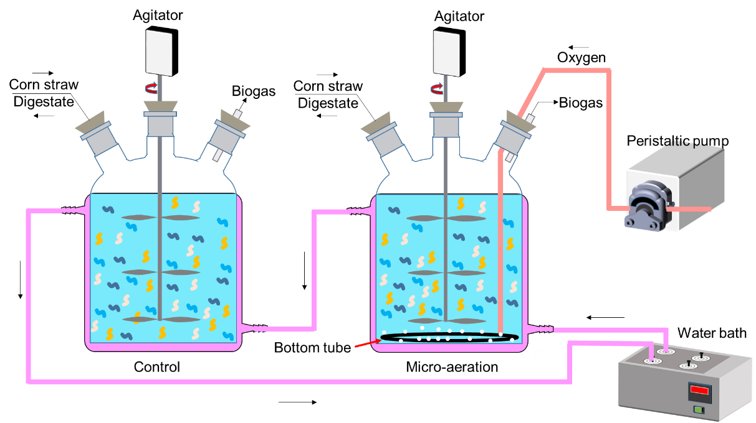
Fig.S1. Schematic diagram of anaerobic reactor
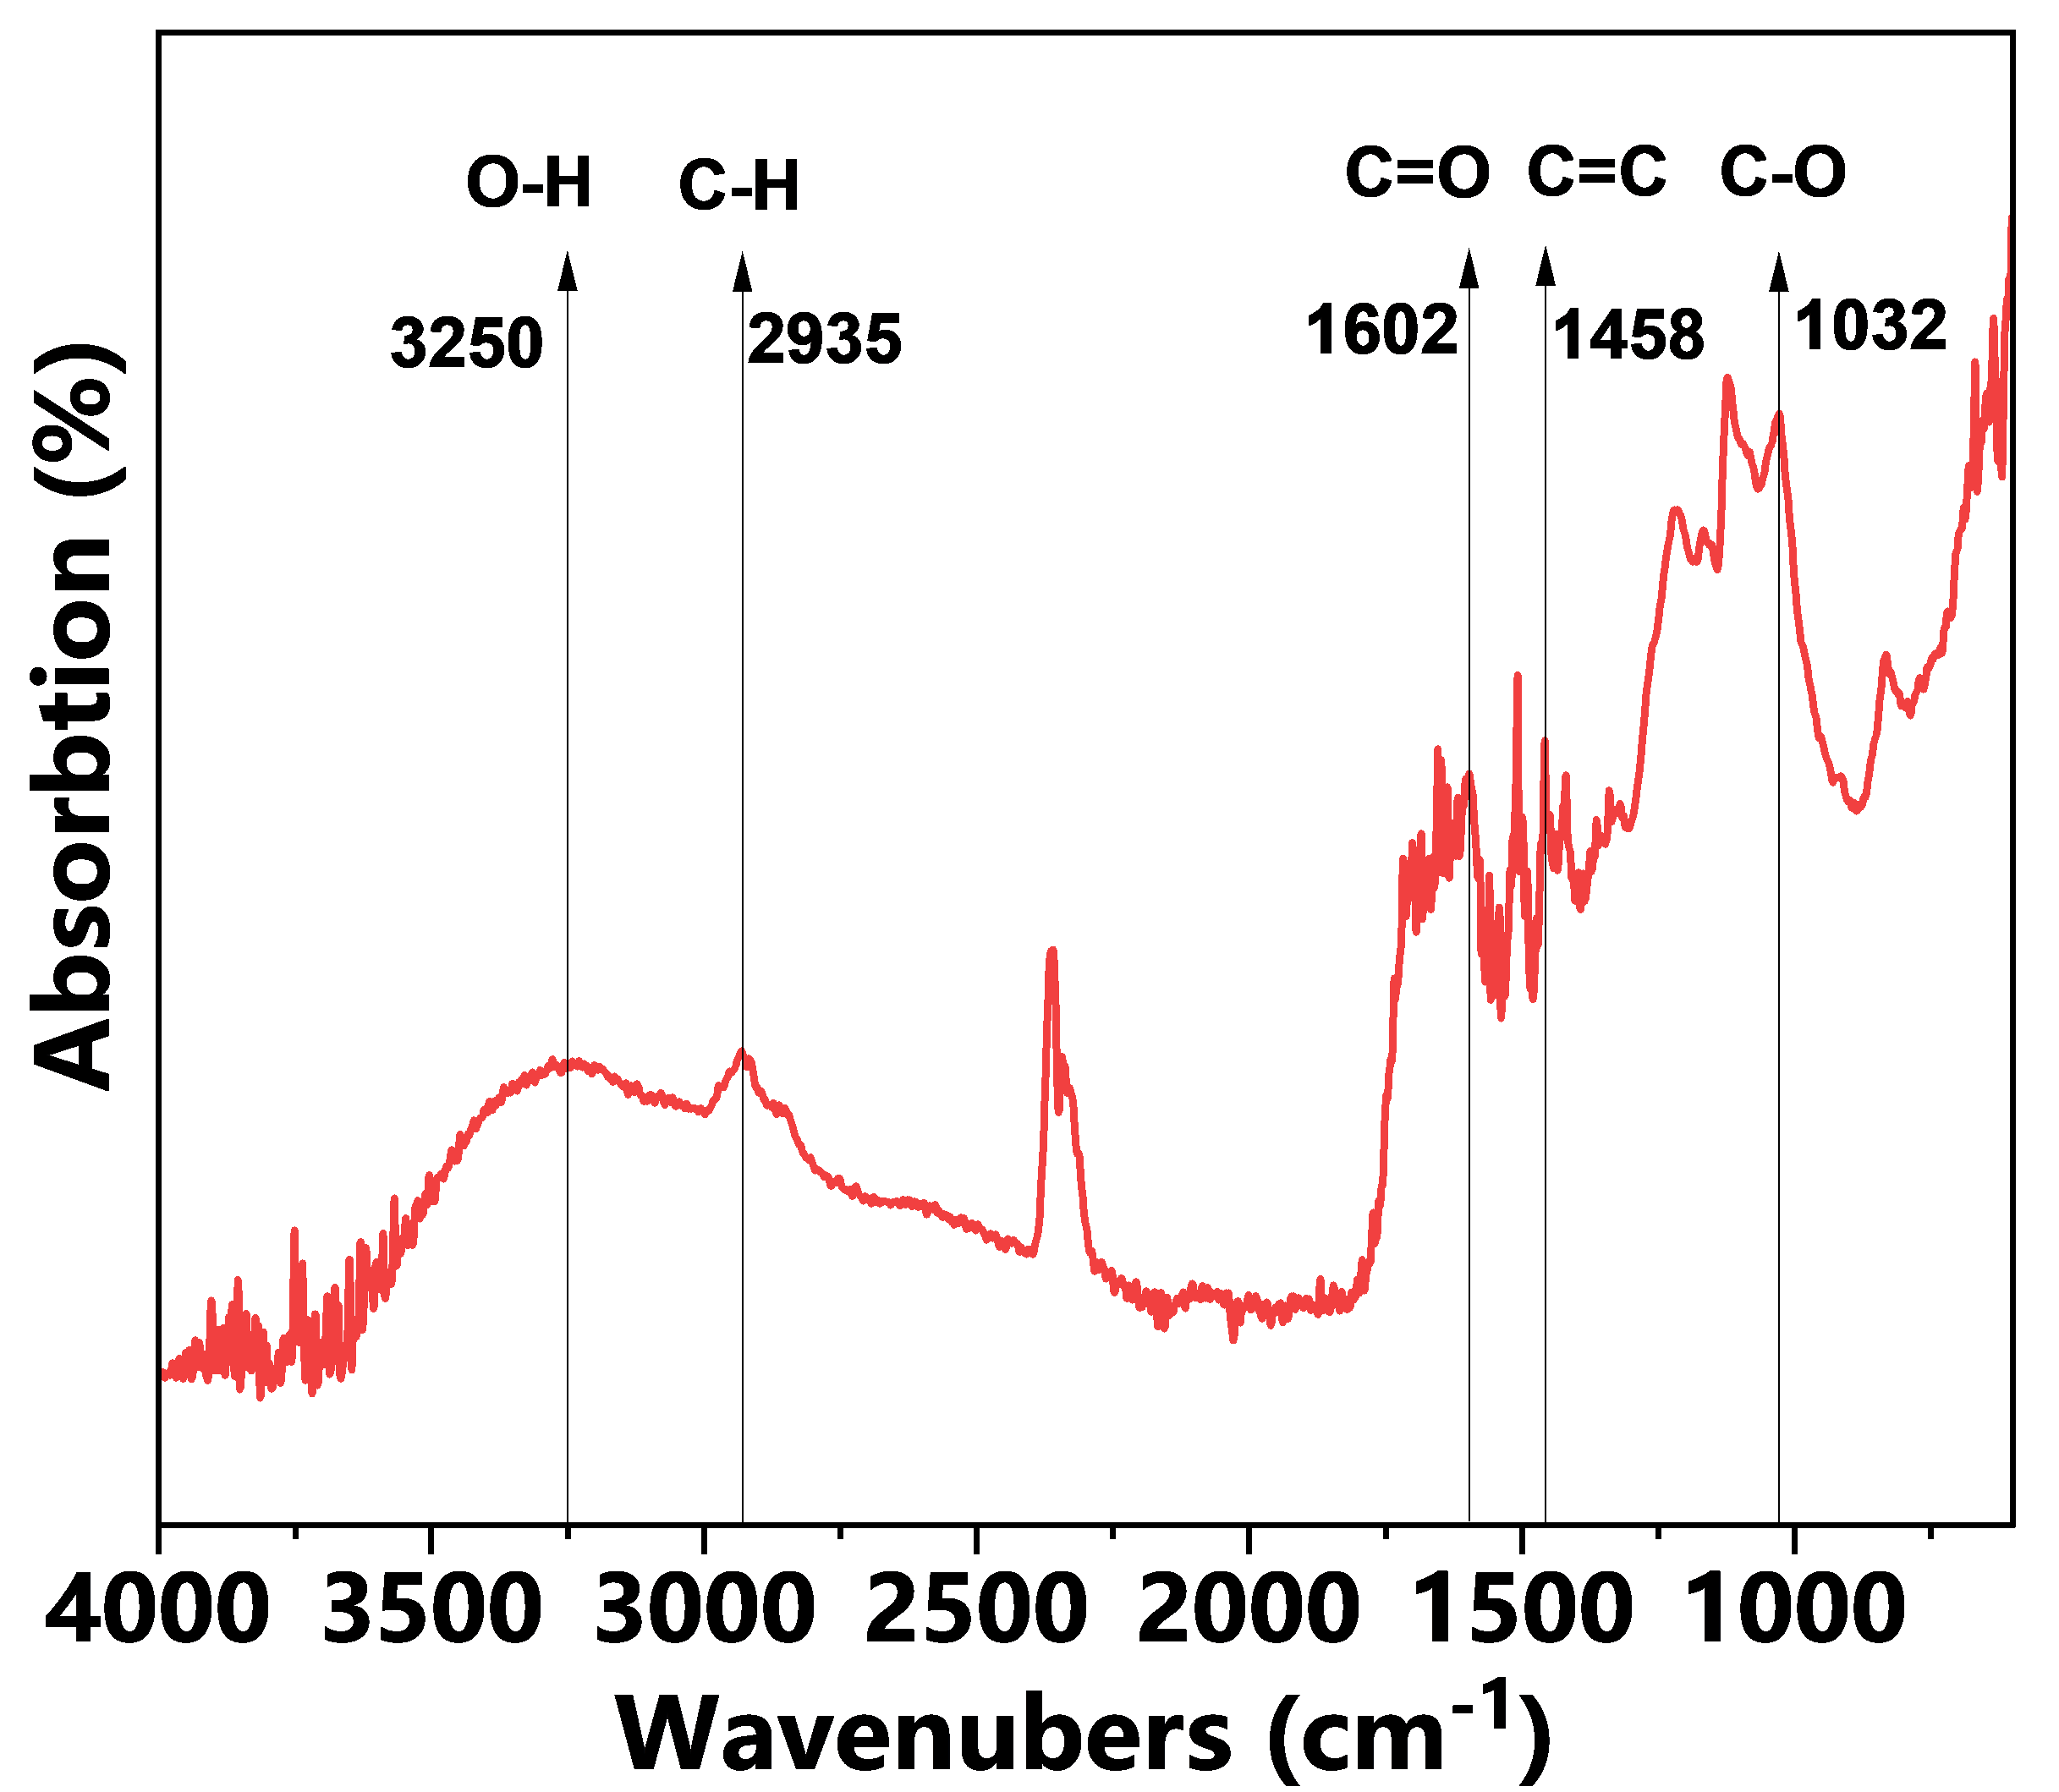
Fig. S2. FTIR spectra of extracted SHAs from diegestates

References
[1] J.-J. Lay, Y.-Y. Li, T. Noike, Influences of pH and moisture content on the methane production in high-solids sludge digestion, Water research 31(6) (1997) 1518-1524. https://doi.org/10.1016/S0043-1354(96)00413-7
[2] F. Huang, H. Liu, J. Wen, C. Zhao, L. Dong, H. Liu, Underestimated humic acids release and influence on anaerobic digestion during sludge thermal hydrolysis, Water research 201 (2021).https://doi.org/10.1016/j.watres.2021.117310
[3] E.M. Thurman, R.L. Malcolm, Preparative isolation of aquatic humic substances, Environ Sci Technol 15(4) (1981) 463-6.https://doi.org/10.1021/es00086a012
[4] S.C. Lee, L. Prosky, J.W. Devries, Determination of Total, Soluble, and Insoluble Dietary Fiber in Foods - Enzymatic Gravimetric Method, Mes-Tris Buffer - Collaborative Study, J Aoac Int 75(3) (1992) 395-416. https://doi.org/10.1016/S0308-8146(95)00231-6
[5] S. Ren, M. Usman, D.C.W. Tsang, O.T. S, I. Angelidaki, X. Zhu, S. Zhang, G. Luo, Hydrochar-Facilitated Anaerobic Digestion: Evidence for Direct Interspecies Electron Transfer Mediated through Surface Oxygen-Containing Functional Groups, Environ Sci Technol 54(9) (2020) 5755-5766.https://doi.org/10.1021/acs.est.0c00112
[6] J.Y. Lee, S.H. Lee, H.D. Park, Enrichment of specific electro-active microorganisms and enhancement of methane production by adding granular activated carbon in anaerobic reactors, Bioresource technology 205 (2016) 205-212.https://doi.org/10.1016/j.biortech.2016.01.054

