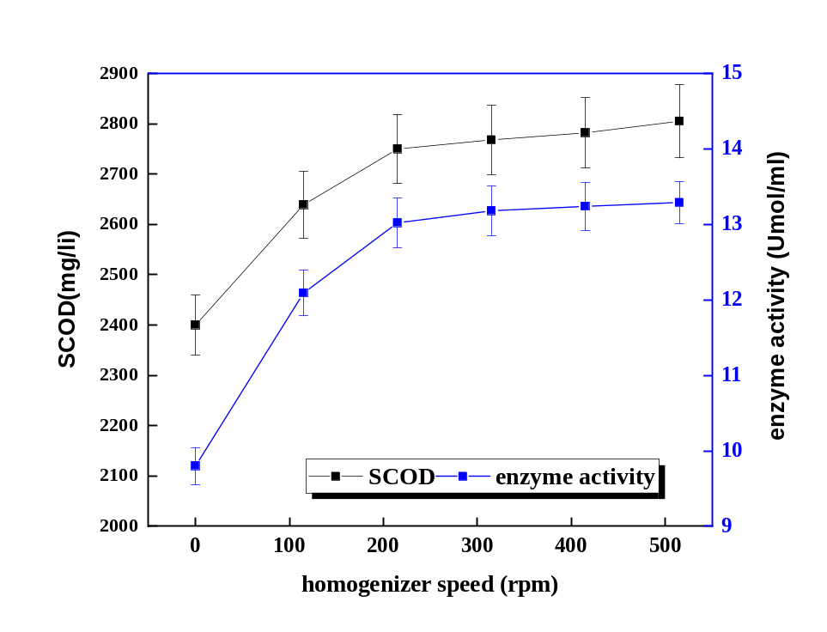

Fig. S1. The effects of different mixing ratio on sludge solubilization and lipase enzyme activity

