Lab to large-scale applications of microaeration in anaerobic digestion: Biowaste digestibility, microbiome nexus, and reactor stability

Ubaid Ullahª, Ali S. Alkorbid^{b}, Mohammed Jalalah^{c,d}, Farid A. Harraz^{b,c*}, Adel I. Alalawy^{e}, Sedky H.A Hassan^{f}, El-Sayed Salama^{a,*}

ªDepartment of Occupational and Environmental Health, School of Public Health, Lanzhou University, Lanzhou, 730000, Gansu, PR China
^{b}Department of Chemistry, Faculty of Science and Arts at Sharurah, Najran University, Sharurah 68342, Saudi Arabia
^{c}Advanced Materials and Nano-Research Centre (AMNRC), Najran University, Najran 11001, Saudi Arabia
^{d}Department of Electrical Engineering, College of Engineering, Najran University, Najran 11001, Saudi Arabia
^{e}Department of Biochemistry, Faculty of Science, University of Tabuk, Tabuk 71491, Saudi Arabia
^{f}Department of Biology, College of Science, Sultan Qaboos University, Muscat 123, Oman

* Correspondence to: Department of Occupational and Environmental Health, School of Public Health, Lanzhou University, Lanzhou, Gansu, PR China.
E-mail addresses: faharraz@nu.edu.sa (Farid A. Harraz), salama@lzu.edu.cn; sayed14@hanyang.ac.kr (E.-S. Salama)

Table S1. Differences between the content of the current review and previous published reviews that explore the effect of microaeration on AD.
Substrate digestibility | Microbial communities | Biomethane | Sulfide removal | Dosing approaches | Oxidation reduction potential | Oxidative stress | Antioxidative mechanisms | Large-scale applications | Integrated microaeration strategies | References
 |  |  |  |  |  |  |  |  |  | [108]
 |  |  |  |  |  |  |  |  |  | [36]
 |  |  |  |  |  |  |  |  |  | [109]
 |  |  |  |  |  |  |  |  |  | [110]
 |  |  |  |  |  |  |  |  |  | [111]
 |  |  |  |  |  |  |  |  |  | [65]
 |  |  |  |  |  |  |  |  |  | [3]
 |  |  |  |  |  |  |  |  |  | [14]
 |  |  |  |  |  |  |  |  |  | [40]
 |  |  |  |  |  |  |  |  |  | This study

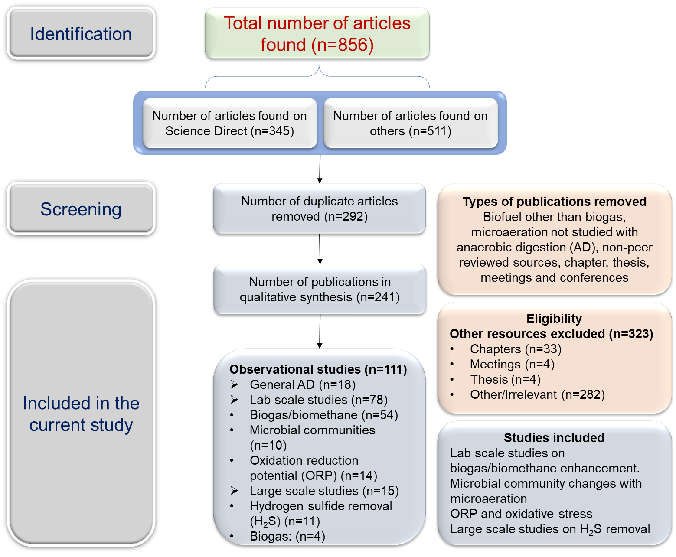
Fig. S1. The protocol followed for searching, obtaining and screening the articles used in the current study. Keywords (microaeration, anaerobic digestion, desulfurization and biogas production) were used to collect the articles from Science Direct, Web of Science, PubMed, and Springer. Duplicate articles, conferences, meetings, thesis, book chapters, non-peer-reviewed sources, other languages than English, and other irrelevant sources were omitted manually. Studies that addressed microaeration role in biogas/biomethane enhancement, microbial community alterations with microaeration, ORP and oxidative stress, and large-scale studies on H₂S removal, were included for the qualitative synthesis of the current review.

References:
[3] Chen Q, Wu W, Qi D, Ding Y, Zhao Z, Review on microaeration-based anaerobic digestion: State of the art, challenges, and prospectives, Sci Total Environ. 710 (2020) 136388.
[14] Fu S, Lian S, Angelidaki I, Guo R, Micro-aeration: an attractive strategy to facilitate anaerobic digestion, Trends Biotechnol. 41 (2023) 714-26.
[36] Jung H, Kim D, Choi H, Lee C, A review of technologies for in-situ sulfide control in anaerobic digestion, Renewable and Sustainable Energy Reviews. 157 (2022).
[40] Nguyen D, Khanal SK, A little breath of fresh air into an anaerobic system: How microaeration facilitates anaerobic digestion process, Biotechnol Adv. 36 (2018) 1971-83.
[65] Krayzelova L, Bartacek J, Díaz I, Jeison D, Volcke EIP, Jenicek P, Microaeration for hydrogen sulfide removal during anaerobic treatment: a review, Reviews in Environmental Science and Bio/Technology. 14 (2015) 703-25.
[108] Liu CG, Xue C, Lin YH, Bai FW, Redox potential control and applications in microaerobic and anaerobic fermentations, Biotechnol Adv. 31 (2013) 257-65.
[109] Muller C, Guevarra K, Summers A, Pierce L, Shahbaz P, Zemke PE, et al., A review of the practical application of micro-aeration and oxygenation for hydrogen sulfide management in anaerobic digesters, Process Safety and Environmental Protection. 165 (2022) 126-37.
[110] Azizi SMM, Zakaria BS, Haffiez N, Niknejad P, Dhar BR, A critical review of prospects and operational challenges of microaeration and iron dosing for in-situ biogas desulfurization, Bioresource Technology Reports. 20 (2022).
[111] Girotto F, Peng W, Rafieenia R, Cossu R, Effect of Aeration Applied During Different Phases of Anaerobic Digestion, Waste and Biomass Valorization. 9 (2016) 161-74.

