Supplemental Information

Micro-aeration for Hydrogen Sulfide Reduction in Full-Scale Anaerobic Digesters with Limited Headspace

Ali Khadirª, George Nakhlaª, Renisha Karki^{b}, Lutgarde Raskin^{b}, Christopher Muller^{c}, Karla Guevarra^{d}, Amanda Summers^{d}, Laurie Pierce^{d}, Parisa Shahbaz^{d}, Kati Bell^{c}, Steven Skerlos^{b}, Embrey Bronstad^{c*}
ª Department of Chemical and Biochemical Engineering, Thompson Engineering Building, Western University, London, Ontario, Canada, ^{b} Department of Civil and Environmental Engineering, University of Michigan, Ann Arbor, MI, United States, ^{c} Brown and Caldwell, 1527 Cole Blvd #300, Lakewood, CO 80401, United States, ^{d} Pierce County Planning and Public Works - Sewer Division, 9850 64th St. W, University Place, WA, United States
*Corresponding Author: Brown and Caldwell, 701 Pike St, Seattle, WA 98101, United States, ebronstad@brwncald.com (206) 749-2230
Supplementary Information
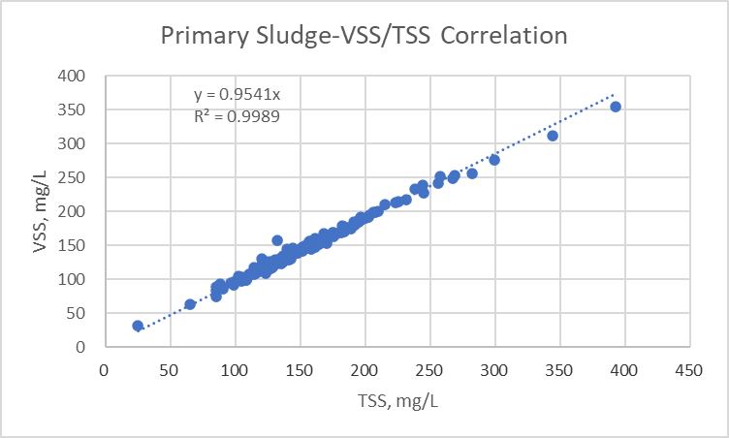
Figure SI-1. Volatile Fraction of Primary Sludge

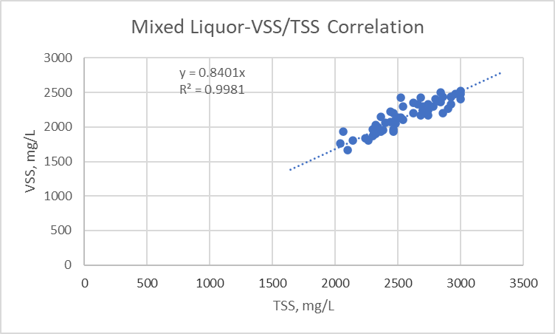
Figure SI-2. Volatile Fraction of Secondary Sludge
Subsequent field investigation of the biogas conveyance system revealed that further sulfur removal did in fact occur in the biogas line that ran between the digesters and the waste gas flares. The field investigation revealed that an inadvertently closed valve in the gas line had caused significant condensation to form in the pipe; Figure SI-3 replicates pictures taken during the field investigation, showing that sulfur deposits (seen as white in the photos) were found covering the bottom half and up to approximately the level of the “water line” of condensation as far away as 200 ft from the digester. This further substantiates the importance of gas phase RT for sulfur removal, as the volume of the gas line added to the total biogas “headspace” detention time resulting in the removal of sulfurous compounds from the biogas.

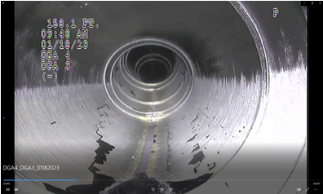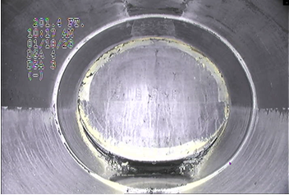
Sulfur deposits on the interior of the digester gas line
Figure SI-3. Sulfur Deposits in the Biogas Line

