Oxidation Reduction Potential as a Parameter to Regulate Micro-Oxygen Injection into Anaerobic Digester for Reducing Hydrogen Sulphide Concentration in Biogas
Supplementary Data
Bioresource Technology
Sep 2014
Long D. Nghiem ^{a,}*, Patrick Manassa ª, Marcia Dawson ^{b}, and Shona K. Fitzgerald ^{b}
ª Strategic Water Infrastructure Laboratory, School of Civil Mining and Environmental Engineering, University of Wollongong, Wollongong, NSW 2522, Australia
^{b} Sydney Water Corporation, Parramatta, NSW 2124, Australia
_______________________
* Corresponding author: Long Duc Nghiem, Email: longn@uow.edu.au; Ph +61 2 4221 4590
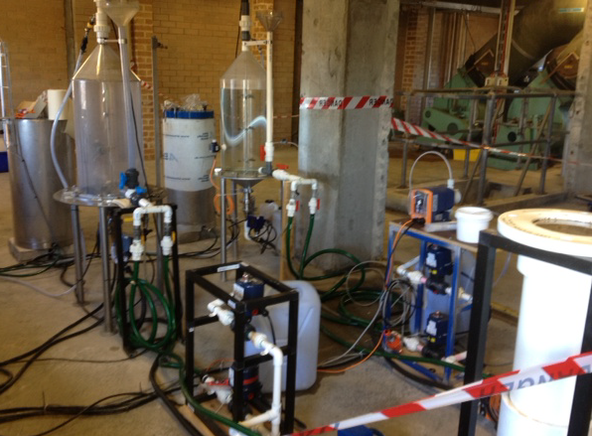
Figure S1: A photograph of the two anaerobic digester systems.

Table S1: Biogas composition of the two digesters during the experiment.
Date | Digester 1 (control system) |  |  |  | Digester 2 (test system)
Date | CH₄(%) | CO₂(%) | H₂S (ppm) | O₂% | CH₄(%) | CO₂(%) | H₂S (ppm) | O₂%
23/10/2013 | 55 | 36 | 135 | 0.7 | 42 | 26.1 | 70 | 4.6
24/10/2013 | 55.6 | 36.5 | 200 | 0.9 | 45 | 28.6 | 30 | 3.9
25/10/2013 | 56.4 | 37.1 | 160 | 0.6 | 48.1 | 30.7 | 60 | 3.2
28/10/2013 | 57.1 | 37.8 | 160 | 0.5 | 54.4 | 34.8 | 30 | 1.4
29/10/2013 | 52.4 | 38.1 | 160 | 0.5 | 56.1 | 35.1 | 30 | 1.1
30/10/2013 | 58.5 | 38.2 | 155 | 0.3 | 57.2 | 35.6 | 12 | 0.9
5/11/2013 | 57.6 | 38.5 | 155 | 0.3 | 58.2 | 37.3 | 40 | 0.5
6/11/2013 | 57.7 | 38.3 | 83 | 0.2 | 59.4 | 37.2 | 10 | 0.4
7/11/2013 | 57.6 | 38.2 | 118 | 0.4 | 59.1 | 37.9 | 22 | 0.2
8/11/2013 | 57.6 | 39 | 150 | 0.2 | 57.8 | 39.8 | 25 | 0.2
11/11/2013 | 58.1 | 39.5 | 170 | 0 | 58.9 | 39.5 | 25 | 0.3
12/11/2013 | 49.8 | 35.9 | 97 | 2.1 | 58.6 | 40.2 | 30 | 0.1
13/11/2013 | 51.1 | 36.5 | 91 | 1.7 | 58.3 | 40.6 | 28 | 0
14/11/2013 | 52.9 | 37.1 | 118 | 1.4 | 57.6 | 41.1 | 25 | 0
18/11/2013 | 54.7 | 38.8 | 124 | 0.8 | 58.2 | 40.7 | 20 | 0.1
19/11/2013 | 55 | 38.8 | 125 | 0.8 | 58.7 | 40.6 | 23 | 0
20/11/2013 | 55.8 | 38.6 | 136 | 0.6 | 58.6 | 40.4 | 46 | 0
21/11/2013 | 56.2 | 38.7 | 500 | 0.6 | 58.5 | 40.6 | 365 | 0
22/11/2013 | 56.4 | 36.7 | 902 | 3.3 | 57 | 40.6 | 495 | 1.2
26/11/2013 | 57.1 | 39.5 | 2150 | 0.5 | 58.8 | 40.2 | 700 | 0
27/11/2013 | 57.4 | 39.1 | 3410 | 0.2 | 58.9 | 39.4 | 1100 | 0
28/11/2013 | 57.5 | 38.8 | 3700 | 0.3 | 59.6 | 39 | 2200 | 0
30/11/2013 | 57.3 | 39 | 3400 | 0.6 | 58.7 | 39.8 | 3400 | 0
2/12/2013 | 56.9 | 38.8 | 4150 | 0.2 | 58.9 | 39.4 | 5411 | 0
3/12/2013 | 56.9 | 38.7 | 4225 | 0.2 | 58.9 | 39.3 | 5400 | 0
4/12/2013 | 57.1 | 38.3 | 4341 | 0.2 | 58.8 | 39.1 | 6012 | 0
5/12/2013 | 56.4 | 39.3 | 4400 | 0.7 | 58.4 | 40.3 | 6000 | 0.1
6/12/2013 | 56.7 | 39.5 | 4272 | 0.7 | 57 | 40 | 2540 | 1.8
7/12/2013 | 56.8 | 39.4 | 4563 | 0.3 | 58.3 | 39.2 | 1977 | 1.4
8/12/2013 | 56.9 | 39.7 | 4438 | 0.4 | 58.6 | 38 | 632 | 1.7
9/12/2013 | 57.2 | 39.1 | 4300 | 0.8 | 58.4 | 39.3 | 330 | 1.2
10/12/2013 | 57.8 | 38.2 | 4218 | 0.3 | 58.6 | 39.3 | 190 | 1
11/12/2013 | 57 | 39.1 | 4117 | 0.6 | 58.5 | 39.5 | 30 | 1

