Supplementary data for

Improving hydrolysis acidification by limited aeration in the pretreatment of petrochemical wastewater

Changyong Wu^{a,b*}, Yuexi Zhou^{a,b*}, Peichao Wang^{c}, Shujun Guo^{d}
ª State Key Laboratory of Environmental Criteria and Risk Assessment, Chinese Research Academy of Environmental Sciences, Beijing 100012, China
^{b} Research Center of Water Pollution Control Technology, Chinese Research Academy of Environment Sciences, Beijing 100012, China
^{c} School of Marine Science and Technology and Environment, Dalian Ocean University, Dalian, Liaoning 116032, China
^{d} Jilin Petrochemical Wastewater Treatment Plant, PetroChina Jilin Petrochemical Companay, Jilin 132000, China

* Corresponding author. Tel.: +86-010-84922161; fax: +86-010-84922161.
E-mail address: wuchangyong@vip.163.com (C. Wu), zhouyuexi@263.net (Y. Zhou), wpch120@163.com (P. Wang), jh_guosj@petrochina.com.cn (S. Guo).

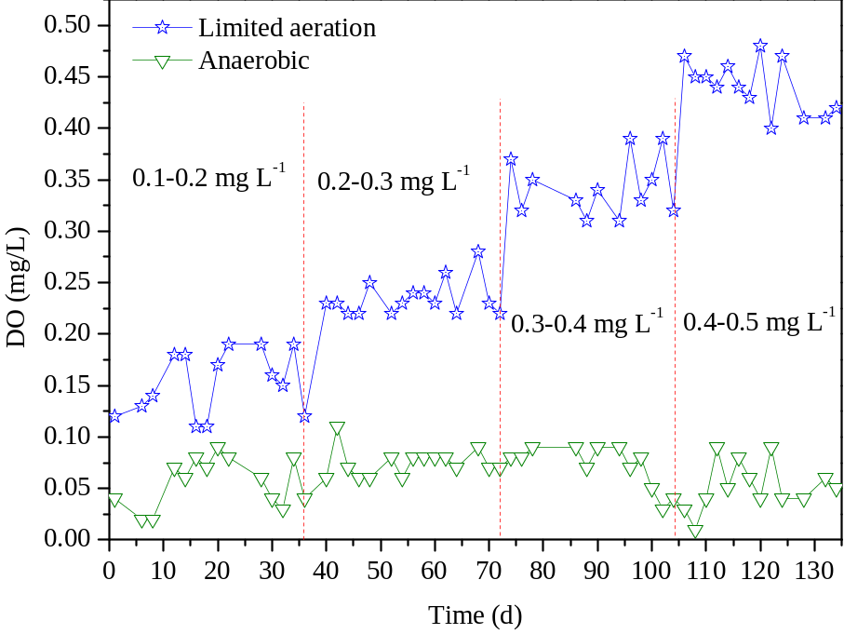
Figure S1. The variation of DO in limited aeration and anaerobic rectors

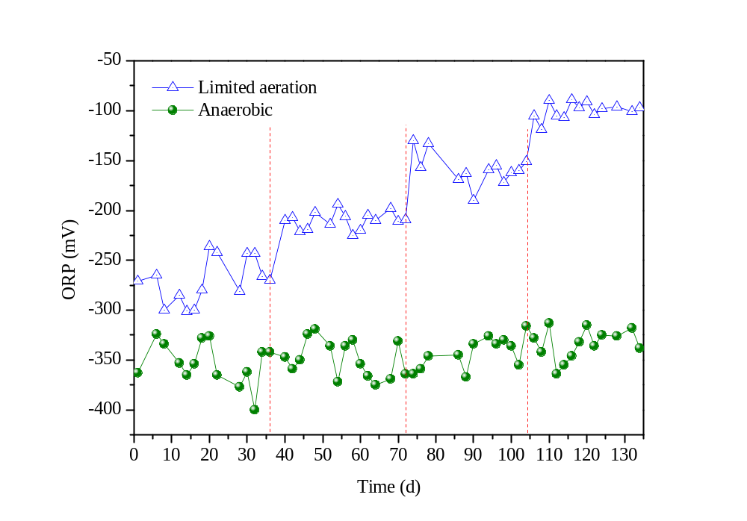
Figure S2. The variation of ORP in limited aeration and anaerobic rectors
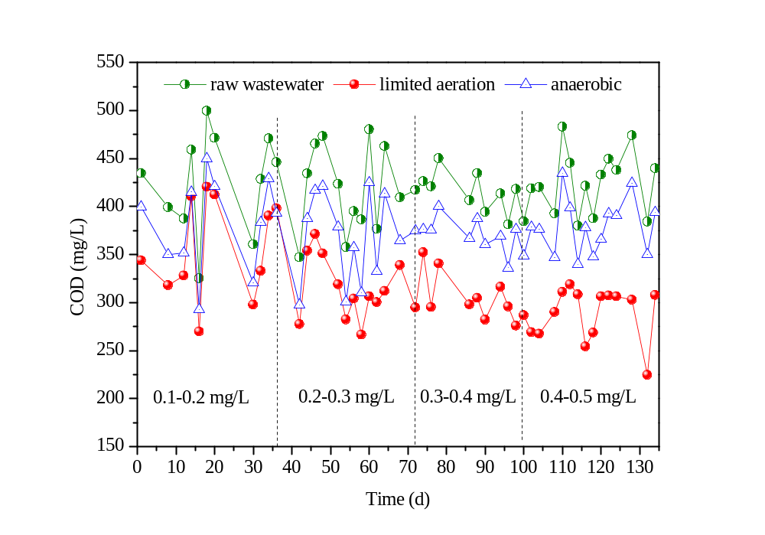
Figure S3 The variation of COD in raw wastewater, limited aeration and anaerobic effluents.
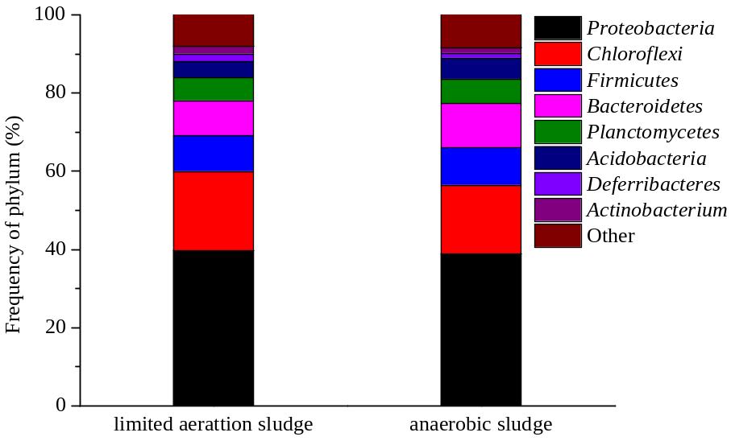
Figure S4 The abundances of different phylum in two reactor’s sludge.

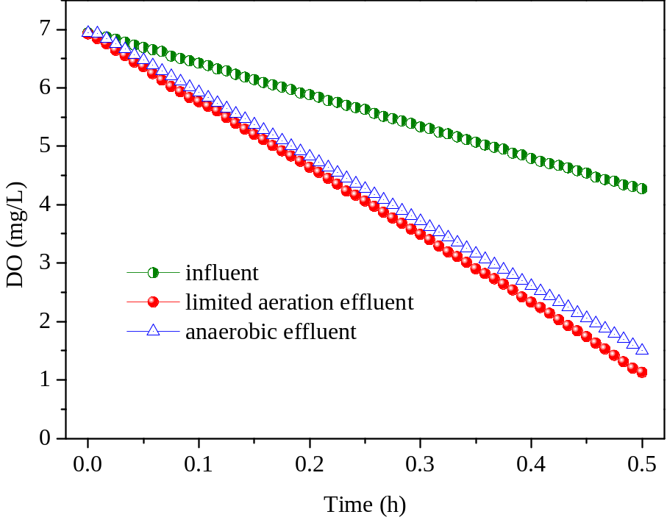
Figure S5. The DO variation during the OUR tests
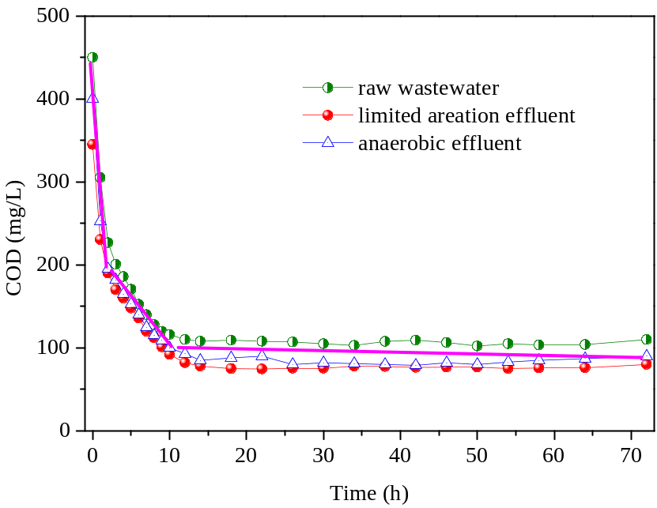
Figure S6 The COD variation during the biodegradability test.
The application of limited aeration hydrolysis acidification in a reformed anaerobic hydrolysis acidification tank (100000 m³)
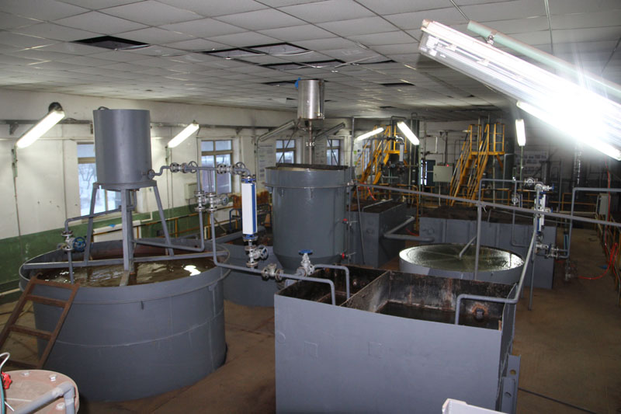
Figure S7. The pilot scale experiment (2m³/h) of limited aeration hydrolysis acidification
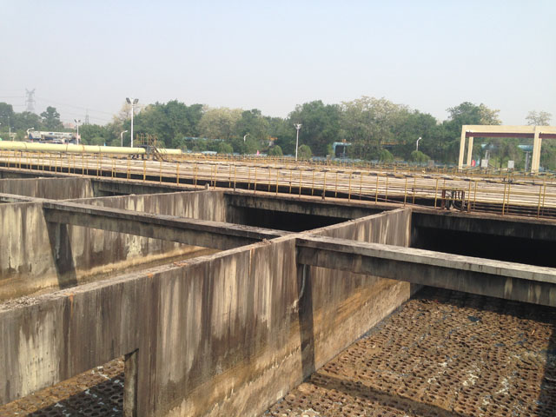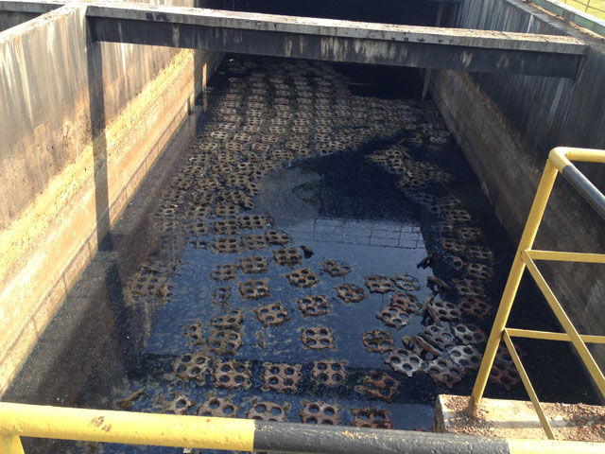
(A)
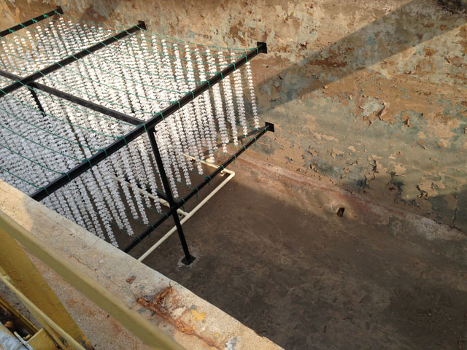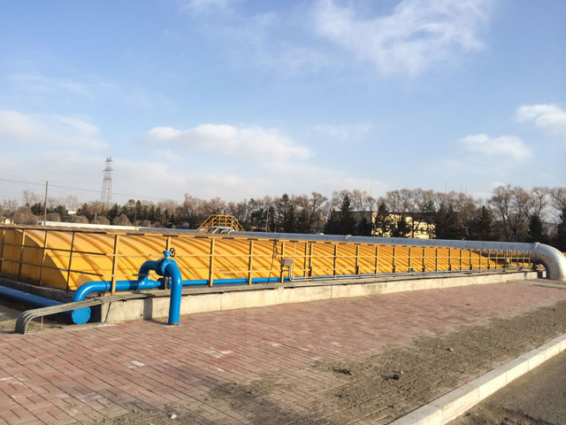
(B)
Figure S8. The reformation of a hydrolysis acidification tank (A- before reformation, B-after reformation - Blue pipes are aeration pipes)
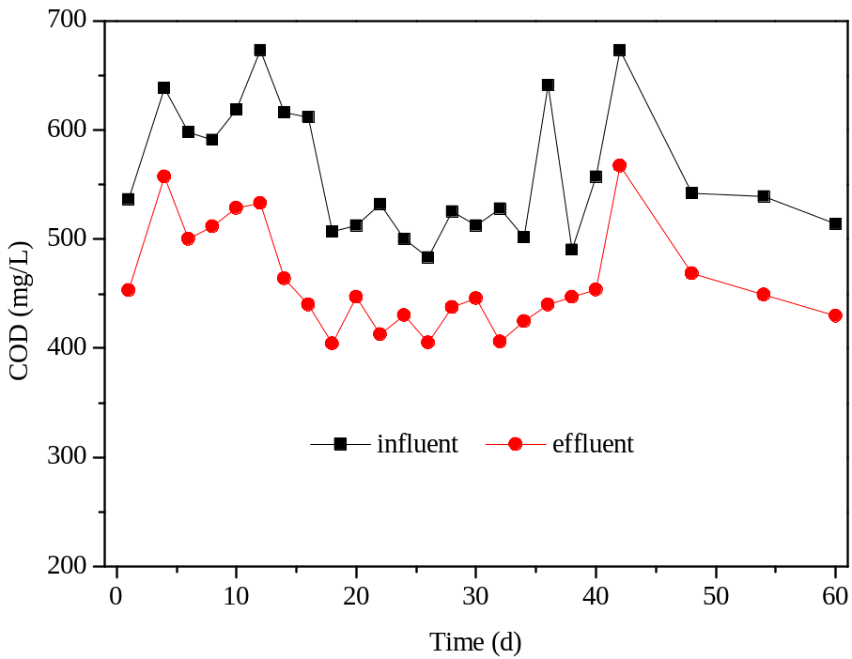
Figure S9. The COD variation of the reformed limited aeration hydrolysis acidification tank during stable period
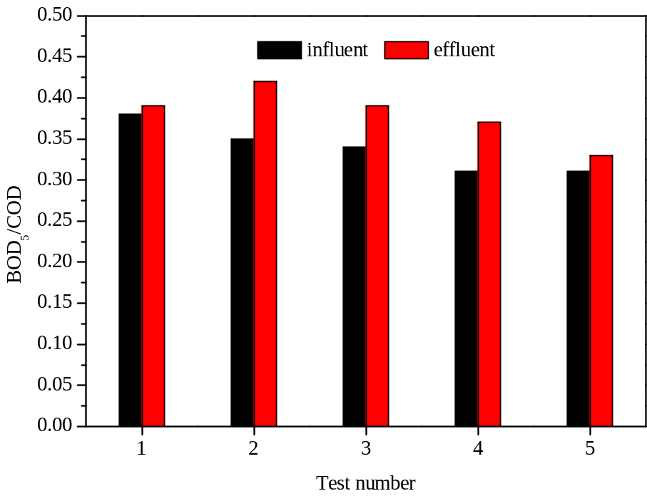
Figure S10. The BOD₅/COD variation of the reformed limited aeration hydrolysis acidification tank during stable period
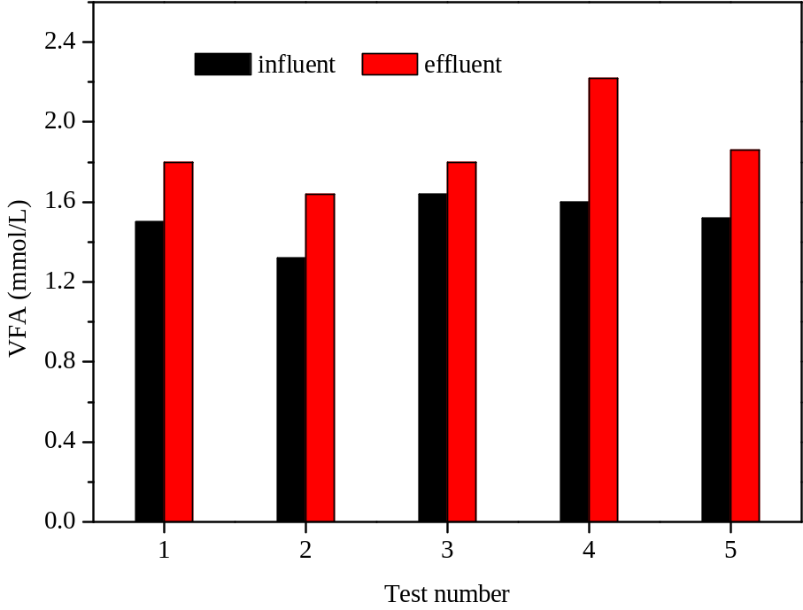
Figure S11. The VFA variation of the reformed limited aeration hydrolysis acidification tank during stable period
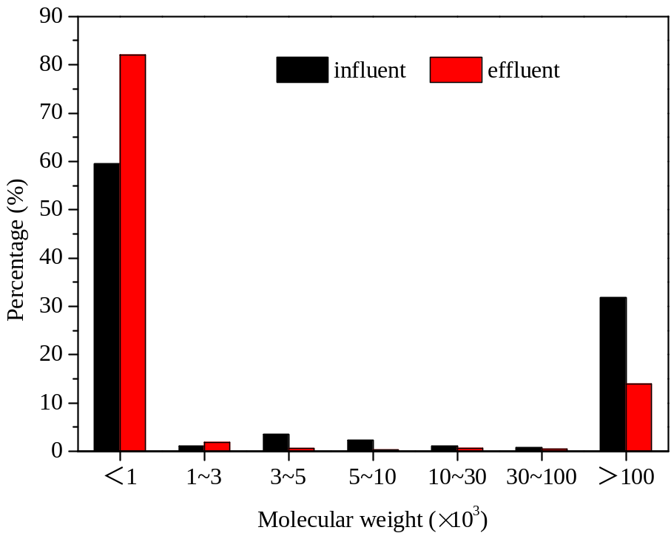
Figure S12. The molecular weight distribution of the reformed limited aeration hydrolysis acidification tank during stable period

