Supplementary data：
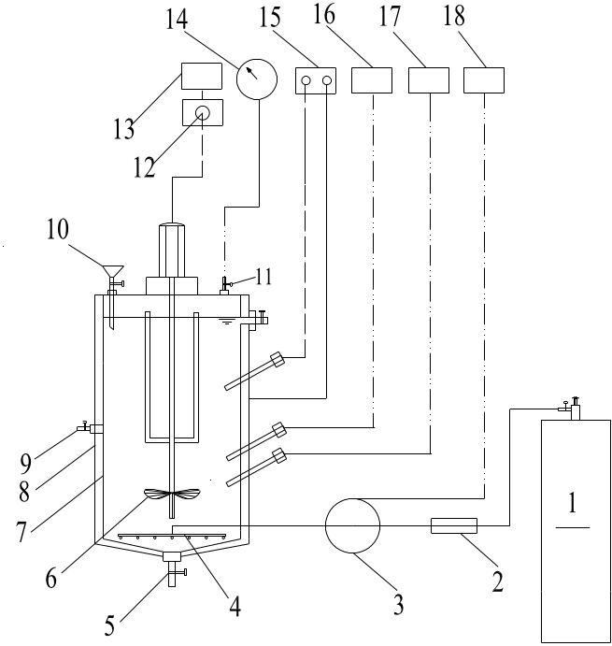
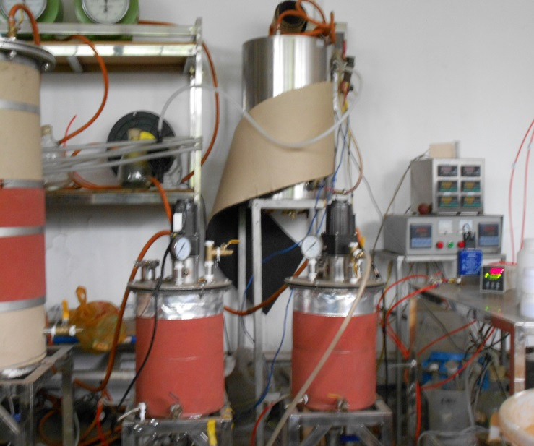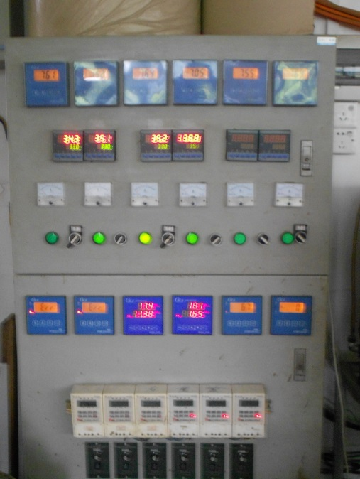
Fig. 1S. Experimental apparatus for micro-aerobic fermentation with a capacity of 10 L.
1. Oxygen gas cylinder; 2. valve; 3. mass flow controller; 4. gas distributor; 5. discharge port; 6. mixer; 7. digester; 8. heating layer; 9. liquid sampling port; 10. feed inlet; 11. biogas outlet; 12. rpm governor; 13. timer; 14. wet gas meter; 15. temperature controller; 16. pH probe; 17. oxidation reduction potential probe; 18. flow accumulator.

