Appendix A. Supplementary data
Intermittent micro-aeration: New strategy to control volatile fatty acid accumulation in high organic loading anaerobic digestion
Duc Nguyenª, Zhuoying Wu^{b}, Shilva Shrestha^{c}, Po-Heng Lee^{b}, Lutgarde Raskin^{c}, Samir Kumar Khanal^{a*}
ªDepartment of Molecular Biosciences and Bioengineering, University of Hawai’i at Mānoa, Honolulu, HI 96822, USA
^{b}Department of Civil and Environmental Engineering, Imperial College, London, The United Kingdom
^{c}Department of Civil and Environmental Engineering, University of Michigan, 1351 Beal Avenue, 107 EWRE Building, Ann Arbor, MI 48109-2125, USA
* Corresponding author:
E-mail: khanal@hawaii.edu; Tel: +1-808-956-3812; Fax: +1-808-956-3542

List of Supporting Information
Supporting materials and methods:

- ORP-controlled micro-aeration system

- Chemical analyses

- Thermodynamic calculations

Supporting tables:
Table S1: Feedstock and inoculum characteristics.
Table S2: Taxonomic classification and relative abundance of bacterial and methanogenic populations in three replicate experiments.
Table S3: Thermodynamics of reactions in anaerobic and micro-aerobic conditions.
Table S4: Typical kinetic parameters of bacterial and archaeal groups.
Table S5: Effects of different ORP control strategies on micro-aeration performance determined during an independent set of experiments.
Table S6: Timelines (in days) of three replicate experiments for different operational conditions.

Supporting figures:
Figure S1: Correlation between ORP (mV) and dissolved oxygen (DO) concentration (mg/L) (A) and between ORP and lnDO (B).
Figure S2: ORP profile of bioreactor under uncontrolled ORP and ORP-controlled micro-aeration for Replicate 1.
Figure S3: Reactor instability and recovery by micro-aeration at an OLR of 5.0 g VS/L/day for Replicate 2.
Figure S4: Reactor instability and recovery by micro-aeration at an OLR of 5.0 g VS/L/day for Replicate 3.
Figure S5: Dominant bacterial and methanogenic populations detected in three replicate experiments.
Figure S6: Hieratical clustering of the bacterial community in Replicate 1 and 2.
Supporting materials and methods

ORP-controlled micro-aeration system
The ORP of a solution is defined as the tendency of the solution to gain or lose electron.(Rittmann and McCarty, 2001) A solution with a positive ORP is characterized by oxidizing conditions (higher tendency to gain electron, e.g., ½ O₂ + 2H⁺ + 2e⁻ = H₂O), whereas a solution with negative ORP value represents a reducing environment (higher tendency to lose electron, e.g., H₂ = 2H⁺ + 2e⁻). The oxidation and reduction half-reactions always occur simultaneously to result in a combined reaction (e.g., ½ O₂ + H₂ = H₂O). The ORP was originally measured with a standard hydrogen electrode (SHE) as reference half-cell (E_{h}). However, the application of ORP electrode with a Ag/AgCl reference electrode (E_{Ag}) has gained popularity due to ease of operation and maintenance.(Cole-Parmer, 2018) The correlation between these two types of electrodes according to the manufacturer (Cole Parmer, USA) is: E_{Ag} = E_{h} + 200 mV(at 35 ºC). The ORP value is affected by temperature and pH according to the manufacturer and confirmed with experiments of measuring ORP at different temperatures (10 to 50 ºC, n = 9) and different pH buffers (pH 4, 7 and 10, n = 9). The effects are presented as: ORP (mV-E_{Ag}) = -1.32 Temperature (ºC) + 264, R² = 0.999 and ORP (mV-E_{Ag}) = -57.33 pH + 410, R² = 0.999.
ORP, due to its high sensitivity towards the dissolved oxygen (DO) concentration (ORP has a linear correlation with the natural logarithm (ln) of the DO concentration, Figure S1), was selected as the control parameter for micro-aeration in this research. A typical DO probe has a detection range of 0.1 to 10 mg/L with accuracy of 0.1- 0.2 mg/L, while an ORP probe operates within the range of -2,000 to 2,000 mV.(Cole-Parmer, 2018) According to the correlation between DO and ORP, a DO of 0.1 mg/L is equivalent to an ORP of -96 mV (Figure S1). Even though the correlation range is limited due to the DO probe detection limit (0.1 to 10 mg/L), a DO of less than 0.1 mg/L is likely to follow this exponential correlation trend line and could be predicted using the measured ORP value. Therefore, it can be estimated that anaerobic conditions with an ORP of -495 mV (Figure 2E) have an equivalent DO of 1.15 x 10⁻⁸ mg/L (or 0.36 x 10⁻³ nM O₂); and a 25 mV increase in ORP under micro-aerobic condition is equivalent to a DO increase of 1.98 x 10⁻⁸ mg/L (or 0.62 x 10⁻³ nM O₂).
When oxygen is supplied to an anaerobic process, it is consumed by the reducing equivalents available, resulting in a rise in the ORP. In other words, the extent of the change in ORP depends on the relative abundance of the electron acceptor (e.g., O₂, NAD⁺) and reducing equivalents (e.g., NADH) that subsequently influence the intracellular metabolism of the microbial populations. The redox potential difference between anaerobic and micro-aerobic conditions was reported to be +25mV (Khanal and Huang, 2006; Krayzelova et al., 2014), +35mV (Jenicek et al., 2011) and +50 to +100 mV(Khanal and Huang, 2003), with more positive values under micro-aerobic conditions. Thus, micro-aeration at a target ORP of >25 mV above the baseline ORP (anaerobic condition) was expected to provide micro-aerobic conditions in the bioreactor. In this research, micro-aerobic conditions were maintained via ORP-controlled intermittent micro-aeration (24-h on and 24-h off) at a target ORP of -470 mV, which was 25 mV above the baseline ORP of an anaerobic bioreactor, following the control scheme previously reported.(Khanal and Huang, 2003) When the ORP of the reactor reached 10 mV below the target value, the ORP controller triggered the solenoid valve (DVP-2DC1D, Automation Direct, GA, USA) to inject oxygen into the bottom of the reactor via a 2-mm inner diameter stainless steel tube. The injected oxygen promptly spiked up the ORP to approximately 10 mV above the target value, which then prompted the solenoid valve to close thereby stopping the micro-aeration. The ORP then gradually reduced until it reached below the set point, which started the next cycle of micro-aeration. Hence, a uniform ORP profile oscillating between 10 mV below and 10 mV above the target ORP was obtained as shown in Figure S2.

Besides the above mentioned ORP control strategy (24-h intermittent ORP-controlled micro-aeration at ORP setpoint = baseline + 25 mV), two independent sets of experiments with different ORP control strategies were conducted with results shown in Table S6. Both continuous ORP control at baseline ORP + 25 mV and 24-h intermittent (every other day) ORP control at baseline ORP + 50 mV showed adverse effects on reactor performance (increased VFA concentration and reduced methane yield, Table S5).

Chemical analyses
The pH was measured daily using a pH meter (Accumet AB15, Fisher, OH, USA). ORP was measured on-line using an ORP probe with Pt electrode and Ag/AgCl reference electrode filled with 3-M KCl (EW-27003-40, Cole-Parmer, IL, USA). All ORP or redox potential values in this study were reported in mV with Ag/AgCl as a reference electrode (E_{Ag}). The standard redox potential value (E_{h}) with standard hydrogen electrode (SHE) at 35 ºC can be calculated according to the manufacturer’s guidelines using the following expression: E_{h} = E_{Ag} – 200 mV.
Daily biogas production was collected in a 10-L Tedlar gas bag (CEL Scientific Corporation, CA, USA) and quantified using a milli-gas counter (Ritter US LLC, NY, USA). Gas volumes were normalized to standard temperature (0 ºC or 273 K) and pressure (1 atm) and reported as NmL. Biogas composition (i.e., CH₄, CO₂, N₂, H₂ and O₂) was determined using gas chromatography equipped with thermal conductivity detector (GC-TCD) at 80 ºC (GC2014, Shimadzu, Japan) using a packed column (80/100 Hayesep D column, 2 m x 2.1 mm ID, Supelco, PA, USA). The column temperature was programmed at 80 ºC and held for 40 min. Daily methane yield was calculated and reported as NmL CH₄/g VS added.
Total VFA-to-total alkalinity (VFA/ALK) ratio was analyzed every two days using an autotitrator (TitraLab AT1000, Hach, Germany) with FOS/TAC software (HACH, Germany) based on the method of (Kafle et al., 2012). The VFA/ALK ratio was reported as a mass ratio of acetic acid (HAc) equivalent over CaCO₃ equivalent. The total VFA values from the autotitrator were reported as g/L as acetic acid (HAc) equivalent and were not statistically different (p > 0.05) with the values obtained by adding the concentrations of individual VFA.
Individual VFAs (acetic, propionic, butyric, iso-butyric, valeric, and iso-valeric acids) were determined every two days using gas chromatography equipped with flame-ionization detector (GC-FID) (GC2014, Shimadzu, Japan) using a capillary column (ZB-Wax Plus column, 30 m x 0.25 mm x 0.25 μm, Phenomenex, CA, USA). Helium was used as the carrier gas at a flow rate of 2 mL/min. The temperature was programmed to increase from 50 ºC to 180 ºC at a rate of 20 ºC/min, and held for 10 min, the split ratio was 20, the purge flow was 1 mL/min, and injector and detector temperatures were 250 ºC each. The samples for individual VFA analyses were prepared as previously described.³ TS and VS were analyzed following Standard Methods (APHA-AWWA-WEF, 2005). Fiber compositions (e.g., hemicellulose, cellulose, and acid insoluble lignin) were analyzed using a cell wall fractionation method(Faithfull, 2002) using the Fiber Analyzer (ANKOM 200, ANKOM, NY, USA).
For the carbon mass balance analysis (Figure 3), the carbon contents of influent and effluent samples were obtained from total carbon content (g C/g TS) analysis at Agricultural Diagnostic Service Center, University of Hawaii at Manoa; data of CH₄ and CO₂ were converted to g C from gas production at standard temperature and pressure (273 K and 1 atm) using ideal gas law equation PV = nRT; data of “Biomass & Intermediates” representing unmeasured components were calculated from influent carbon (4.88 g C/day at OLR 5.0 g VS/L/day) minus carbon content from other components. Samples for carbon mass balance were collected on three consecutive days during anaerobic and micro-aerobic conditions of three replicate experiments (Anaerobic condition: days 114-116 of Replicate 1, days 164-166 of Replicate 2, days 83-85 of Replicate 3; Micro-aerobic condition: days 153-155 of Replicate 1, days 214-216 of Replicate 2, days 108-110 of Replicate 3). Data from days after bicarbonate addition were avoided to minimize interference to biogas composition.

Thermodynamic calculations

Thermodynamic calculations of reactions under anaerobic and micro-aerobic conditions (Table S3 and Figure 5) were performed as described in (Thauer et al., 1977) and (Dolfing, 2015) with all components in aqueous phase.

Change in Gibbs free energy at standard conditions (∆Gº’) with temperature of 25 ºC and substance concentration of 1M was calculated using the following equation:

∆Gº’ (kJ) = ΣGº_{f} products - ΣGº_{f} reactants (1)

Where, Gº_{f} is Gibbs free energy formation of substance in aqueous phase, with values found in Thauer et al. (1977)(Thauer et al., 1977).

Change in Gibbs free energy at actual reactor condition (∆G_{R}’) of reaction aA + bB = cC + dD was calculated using the following equation:

∆G_{R}’ (kJ) = ∆Gº’ + R*T*ln [(C^{c}*D^{d})/(Aª*B^{b})] (2)

Where, R is gas constant (8.314*10⁻³ kJ/K/mol), T is temperature of reactor (K), and A, B, C, D are concentrations of all substances in aqueous phase (M).

For a fair comparison of thermodynamics between reactions under anaerobic and micro-aerobic conditions, ∆Gº’ and ∆G_{R}’ were divided by the total amount of electron transferred in that reaction (Table S3) and the unit is presented as kJ/e⁻ equivalent.

Example calculation of reaction M4 in Table S3:

CH₃COO⁻ + H⁺ + 2 O₂ = 2 CO₂ + 2 H₂O

According to (1):

∆Gº’ = (2*Gº_{f CO2} + 2*Gº_{f H2O}) - (Gº_{fCH3COO-} + Gº_{f H+} + 2*Gº_{fO2})

= (2*(-386.23) + 2*(-237.19)) - (-369.41 + (-39.87) + 2*16.32)

= -870.2 kJ

= -870.2/8 e⁻ = -108.8 kJ/e⁻

To calculate ∆G_{R}’ of this reaction in reactor under actual ORP-controlled micro-aerobic condition (started on day 117), concentrations of solutes and gases (except O₂) in aqueous phase on day 116 (prior to the start of micro-aeration) were used to calculate the bioenergetics of this reaction when O₂ is supplied on day 117. Due to this reason, the concentration of O₂ on day 117 (calculated from the correlation in Figure S1 with ORP set point of -470 mV) was used for the calculation. The concentration of H₂O was set at 1 M and temperature of 35 ºC was used. All concentrations were converted to molar (M):

[CO₂] = composition in gas*gas pressure*Henry constant of CO₂

= 35.8% * 1atm * 2.62 * 10⁻² M/atm = 9.37*10⁻³ M

[H₂O] = 1 M

[CH₃COO⁻] = concentration in liquid/molecular weight = 4.004 g/L / 59 g/mol = 0.068 M

[H⁺] = 10^{-pH} = 10^{-6.8} = 1.41*10⁻⁷ M

[O₂] = 4.57*e^{0.04*ORP} = 4.57*e^{0.04*(-470)} = 1.01*10⁻¹² M

According to (2):

∆G_{R}’ = ∆Gº’ + R*T*ln [(CO₂² * H₂O²)/(CH₃COO⁻* H⁺ *O₂² )]

= -870.2+8.314*10⁻³*(273.15+35)*ln[(9.37*10⁻³)²*(1)²/(6.8*10⁻²)*(1.41*10⁻⁷)*(1.01*10⁻¹²)²]

= -705.29 kJ

= -705.29/8e⁻ = -88.16 kJ/e⁻
Supporting tables
Table S1: Feedstock and inoculum characteristics.
 | Feedstock* | Inoculum*
TS (% of wet weight) | 88.5 ± 0.1 | 3.7 ± 0.0
VS (% of TS) | 89.1 ±0.2 | 73.1 ± 0.1
Hemicellulose (% of TS) | 26.6 ± 0.0 | NA
Cellulose (% TS) | 42.1 ± 0.7 | NA
Acid insoluble lignin (% of TS) | 5.3 ± 0.7 | NA
C/N ratio (gC/gN) | 56.8 ± 0.9 | 3.1 ± 0.1
VFA/ALK (g acetate equivalent/g CaCO₃ equivalent) | NA | 0.1 ± 0.0
*Data shown as mean ± standard deviation of triplicate samples. NA: Not available

Table S2: Taxonomic classification and relative abundance of bacterial and methanogenic populations in three replicate experiments.
 |  | Relative abundance (%)
 |  | Replicate 1 |  | Replicate 2 |  | Replicate 3
Taxonomy  (Family or Genus) | OTU_No. | Anaerobic 1 | Micro-aerobic 1 | Anaerobic 2 | Micro-aerobic 2 | Anaerobic 3 | Micro-aerobic 3 | Group of microorganism
Bacteria |  |  |  |  |  |  |  | Facultative | Anaerobic
Proteiniphilum | Otu0001, 0002 | 15.74 | 31.81 | 2.27 | 64.46 | 1.13 | 43.18 | + | -
Bacteroidaceae | Otu0007, 0011,0060 | 6.38 | 5.69 | 29.54 | 8.35 | 45.69 | 8.51 | + | -
Prevotellaceae | Otu0035,0067 | 0 | 0 | 15.28 | 4.78 | 24.41 | 18.87 | - | +
Tannerella | Otu0024 | 3.00 | 0.28 | 0.05 | 0.06 | 0.05 | 0.11 | - | +
Marinilabiliaceae | Otu0003 | 12.80 | 9.97 | 0.01 | 0.25 | 0 | 0.20 | + | -
Tolumonas | Otu0073 | 0.35 | 0.33 | 0 | 0.01 | 0 | 2.01 | + | -
Actinomyces | Otu0135 | 0.01 | 0 | 3.19 | 0.11 | 0 | 0
Synergistaceae | Otu0005,0009,0077 | 8.22 | 1.60 | 0.56 | 8.81 | 0.15 | 0.54 | - | +
Enterococcus | Otu0072 | 0 | 0 | 0.60 | 0 | 10.60 | 0.02 | - | +
Lachnospiraceae | Otu0008,0038 | 2.39 | 1.31 | 0.01 | 0 | 4.58 | 0.67 | + | -
Ruminococcaceae | Otu0004 | 3.07 | 5.98 | 0.01 | 0 | 0.02 | 0 | - | +
Firmicutes_unclassified | Otu0016,0093,0131,0778 | 4.81 | 1.07 | 4.92 | 3.25 | 0.70 | 0.06 | NA | NA
 | Sum | 56.78 | 58.09 | 56.70 | 90.10 | 87.36 | 76.63
Syntrophs
Syntrophaceae &  Syntrophomonadaceae | Otu0143,0159,0174,0283,0578,0597,0713,0714,0742,0938,0958,1059,1069,1085,1265,1266,1977,2773,3158 | 0.62 | 1.02 | 0.05 | 0.02 | 0.01 | 0.03 | - | +
Methanogens |  |  |  |  |  |  |  | Hydrogenotrophic | Aceticlastic
Methanosarcina | Otu_1,6,11,14,15,21,23,32,41,42,46,50,77 | 65.44 | 56.79 | 76.32 | 25.13 | 71.93 | 11.20 | + | +
Methanobrevibacter | Otu_4 | 0 | 1.38 | 3.38 | 53.87 | 0.50 | 0.37 | + | -
Methanobacterium | Otu_8,9 | 11.44 | 8.22 | 0.88 | 3.02 | 10.79 | 9.35 | + | -
Methanocorpusculum | Otu_12,16,33,35,83,84 | 0 | 0 | 0 | 0 | 0.50 | 45.85 | + | -
Methanomethylovorans | Otu_58 | 0 | 0 | 2.76 | 0 | 0 | 0 | + | +
Candidatus Methanomethylophilus | Otu_45 | 0 | 0 | 0 | 4.92 | 0.10 | 1.00 | - | -
 | Sum | 76.88 | 66.39 | 83.33 | 86.93 | 83.82 | 66.77

Note: OTUs: operational taxonomic units. Only OTUs with a relative abundance >2% at the genus level in at least one of the samples are included, except for syntrophs. Anaerobic and micro-aerobic biomass samples were collected on days 79 and 149 for Replicate 1, days 150 and 192 for Replicate 2, and days 64 and 108 for Replicate 3, respectively.
Table S3: Thermodynamics of reactions at anaerobic and micro-aerobic conditions.
No. | Reactions | Electrons transferred |  |  | ∆Gº’ (kJ/e⁻) |  | ∆G’_{R} (kJ/e⁻)
Anaerobic condition
A1 | Valerate + 3 H₂O = 2.5 Acetate + 3 H₂ + 1.5 H⁺ |  | 6 | 20.9 |  | -10.9
A2 | Butyrate + 2 H₂O = 2 Acetate + 2 H₂ + H⁺ |  | 4 | 20.9 |  | -11.1
A3 | Propionate + 1 H₂O = 1.5 Acetate + H₂ + 0.5 H⁺ |  | 2 | 20.9 |  | -11.0
A4 | Acetate + H⁺+ 2 H₂O = 2 CO₂ + 4 H₂ |  | 8 | 22.7 |  | 6.9
Micro-aerobic condition
M1 | Valerate + H⁺ + 6.5 O₂ = 5 CO₂ + 5 H₂O | 26 |  | -109.2 |  | -91.7
M2 | Butyrate + H⁺ + 5 O₂ = 4 CO₂ + 4 H₂O | 20 |  | -109.1 |  | -91.3
M3 | Propionate + H⁺ + 3.5 O₂ = 3 CO₂ + 3 H₂O | 14 |  | -109.0 |  | -90.4
M4 | Acetate + H⁺ + 2 O₂ = 2 CO₂ + 2 H₂O | 8 |  | -108.8 |  | -88.2
M5 | 2H₂ + O₂ = 2 H₂O | 4 |  | -131.5 |  | -92.7
Methanogenesis
AM | Acetate + H⁺ = CO₂ + CH₄ | 8 |  | -1.4 |  | 0.6
HM | CO₂ + 4 H₂ = 2 H₂O + CH₄ | 8 |  | -24.1 |  | -4.0
Note: The change in Gibbs free energy at standard conditions (∆Gº’) and at reactor conditions on day 116 (Replicate 1), prior to the start of micro-aeration (∆G’_{R}) (except O₂, which was calculated from ORP of -470 mV set point from days 117 to 155, following the correlation in Figure S1) were calculated as previously described (Dolfing, 2015) with all standard values of aqueous phase. Specifically, concentrations were as follows: acetate = 0.068 M, propionate = 0.032 M, butyrate (iso- and n-butyrate) = 0.016 M, valerate (iso- and n-valerate)= 0.005 M, H⁺ at pH 6.8 =10^{-6.8} = 1.41*10⁻⁷ M,CH₄ = 5.56*10⁻⁴ M (0.471 atm with Henry constant at 35 ºC (k_{HCH4}) = 1.18*10⁻³ M/atm), CO₂ = 9.37*10⁻³ M (0.358 atm with k_{HCO2} = 2.62*10⁻² M/atm), H₂ = 7.40*10⁻⁸ M (1*10⁻⁴atm with k_{HH2} = 7.40*10⁻⁴ M/atm), and O₂ = 1.01*10⁻¹²M (from correlation: DO (or O₂ concentration) = 4.57*e^{0.04*ORP}, with ORP set point of -470 mV during micro-aeration period from days 117 to 155). Details of calculation method are described in supporting material and method section “Thermodynamic calculations” on page 8 of this SI. A: Anaerobic condition, M: Micro-aerobic condition, AM: Aceticlastic methanogenesis, HM: Hydrogenotrophic methanogenesis.
Table S4: Typical kinetic parameters of bacterial and archaeal groups.
 | µ_{m} | K_{S} | Y | Ref.
Aerobic heterotrophic bacteria | 13.20 | 20 | 0.49 | (Rittmann and McCarty, 2001)
Aerobic hydrogen-utilizing bacteria | 10.08 | - | 0.28 | (Matassa et al., 2015)
Carbohydrate fermentative bacteria | 1.20 | 500 | 0.10 | (Ni et al., 2015)
Anaerobic acetate degrader | 0.38 | 165 | 0.04 | (Lawrence and McCarty, 1969)
Anaerobic propionate degrader | 0.31 | 60 | 0.04 | (Lawrence and McCarty, 1969)
Anaerobic butyrate degrader | 0.35 | 13 | 0.05 | (Lawrence and McCarty, 1969)
Aceticlastic methanogens | 0.30 | - | 0.04 | (Rittmann and McCarty, 2001)
Hydrogenotrophic methanogens | 0.50 | - | 0.06 | (Rittmann and McCarty, 2001)
Note: µ_{m}: maximum specific growth rate (1/day), K_{S}: half-saturation constant (mg COD/L). Y: biomass yield (g VSS/g COD).
Table S5: Effects of different ORP control strategies on micro-aeration performance determined during an independent set of experiments.
 | Anaerobic condition |  |  | Micro-aerobic condition
OLR | Baseline ORP | Total VFA | Methane yield | Controlled ORP | Total VFA | Methane yield
1.5 | -470 ± 12 | 0.16 | 120.7 | -440 ± 11ª | 0.90 | 16.9
5.0 | -475 ± 4 | 4.93 | 72.34 | -426 ± 2^{b} | 5.43 | 49.54
Note: OLR: organic loading rate (g VS/L/day); ORP: oxidation-reduction potential (mV); Total VFA (g HAc/L); Methane yield (NmL CH₄/g VS); ªContinuous micro-aeration at ORP setpoint: -445 mV (baseline +25 mV); ^{b} Every other day micro-aeration at ORP setpoint: -425 mV (baseline +50 mV, Figure S3).
Table S6: Timelines (in days) of three replicate experiments for different operational conditions.
 | Organic loading rate (g VS/L/day)
Replicate | 1.5 | 3.0 | 5.0 stable | 5.0 unstable | 5.0 micro-aerobic
1 | 1-30  (26-30) | 42-60  (56-60) | 75-94  (86-90) | 95-116  (112-116) | 117-155  (151-155)
2 | 1-11  (7-11) | 23-51  (47-51) | 137-149  (145-149) | 150-176  (162-166) | 177-216  (212-216)
3 | 1-11  (7-11) | 16-34  (30-34) | 46-65  (61-65) | 66-85  (81-85) | 86-110  (106-110)
Note: Day from the start of the experiment (after 45 days of startup period). In parentheses are the five days of stable operation (period when all monitoring parameters were not significantly different from each other, ANOVA test p > 0.05) from which data were used for statistical analysis in Table 1. The gaps between periods of different OLRs (length varied among experiments) correspond to the periods that were needed to increase the OLR from 1.5 to 3.0 and 3.0 to 5.0 g VS/L/day with a step-wise increment of 0.5 g VS/L/day.
Supporting figures
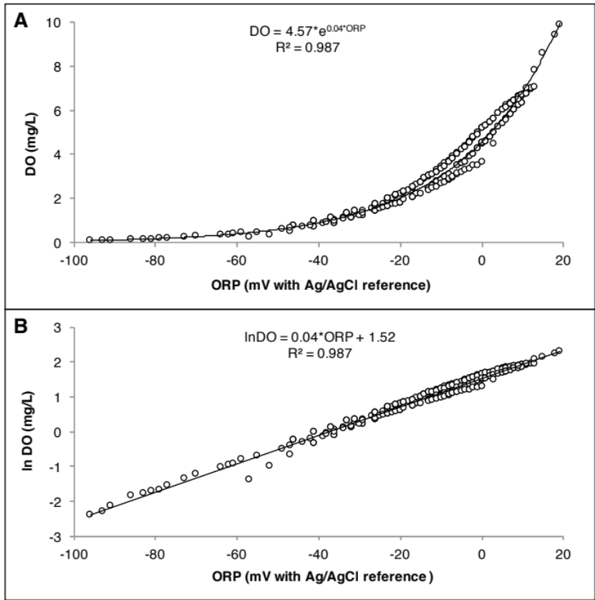
Figure S1: Correlation between ORP (mV) and dissolved oxygen (DO) concentration (mg/L) (A) and between ORP and lnDO (B).
Triplicate experiments were conducted with a total of 250 observations at standard conditions (1 atm, 25 ºC, pH 7.0) with the effluent of the reactor operated at an OLR 5.0 g VS/L/day from a stable period (days 80 to 83 of Replicate 1). The effluent was filtered through GF/C paper to eliminate microbial oxygen consumption. The experiment was conducted in a 120-mL gas-tight bottle filled with 100 mL of prepared effluent. The bottle was flushed with N₂ gas for 5 min to create anaerobic conditions (the DO reached its limit of detection of 0.1 mg/L). Air was then slowly injected into the bottle using a glass syringe to increase the DO from 0.1 to 10 mg/L, while ORP and DO probes (Cole Parmer, USA) were simultaneously used to monitor and record values every 5 s.
Figure S2: ORP profile of bioreactor under uncontrolled ORP and ORP-controlled micro-aeration for Replicate 1: daily average ORP of uncontrolled ORP (open circles) and controlled ORP (closed circles) (A); ORP profile at micro-aerobic condition for three days (B); ORP profile at micro-aerobic condition for one day with data recorded every 10 min, ORP controller setpoint: value at which solenoid valve open to start injecting oxygen, average ORP setpoint: target ORP value (C); micro-aeration intensity over time (D).
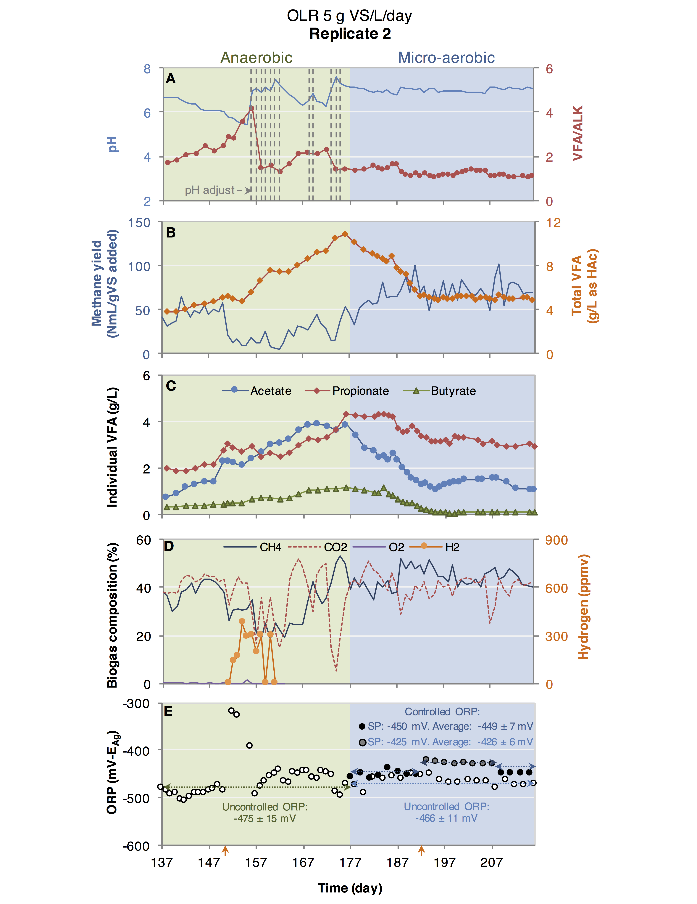
Figure S3: Reactor instability and recovery by micro-aeration at an OLR of 5.0 g VS/L/day for Replicate 2 (days 137 to 216). Process performance in terms of pH and VFA/ALK ratio with vertical lines indicating additions of NaHCO₃ to control pH (A); total VFA and methane yield (B); individual VFA concentrations (iso-butyric, valeric, and iso-valeric acid concentrations were below 0.2 g L⁻¹ at all times and are not shown) (C); biogas composition (D); and daily average ORP of uncontrolled ORP (open circles) and controlled ORP every other day at ORP set point (SP) of -450 mV (black closed circles) and -425 mV (gray closed circle) (E). The mean (± standard deviation) uncontrolled ORP during anaerobic period from days 137 to 176 was calculated to be -475 ± 15 mV. The mean controlled ORP with set point of -450 mV (black closed circles: days 177 to 193 and 209 to 216) was -449 ± 7 mV. The mean controlled ORP with set point of -425 mV (gray closed circles: days 194 to 208) was -426 ± 6 mV. Since micro-aeration was performed every other day, the uncontrolled ORP values (open circles) reported after day 177 represent the daily average ORP on the days without micro-aeration (the mean from days 177 to 216 was calculated to be -466 ± 11 mV). Orange arrows in the x-axis indicate the days that biomass samples were taken for microbial community analysis (days 150 and 192).
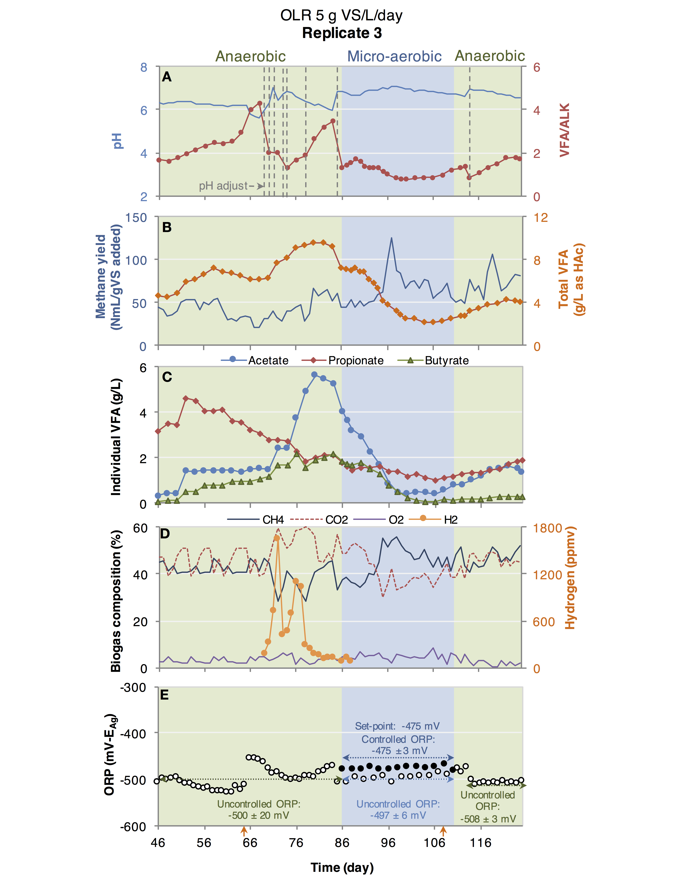
Figure S4: Reactor instability and recovery by micro-aeration at an OLR of 5.0 g VS/L/day for Replicate 3 (days 46 to 125). Process performance in terms of pH and VFA/ALK ratio with vertical lines indicating additions of NaHCO₃ to control pH (A); total VFA and methane yield (B); individual VFA concentration (iso-butyric, valeric, and iso-valeric acid concentrations were below 0.2 g/L at all times and are not shown) (C); biogas composition (D); and daily average ORP of uncontrolled ORP (open circles) and controlled ORP every other day (closed circles) (E). The mean (± standard deviation) uncontrolled ORP from days 46 to 85 was calculated to be -500 ± 20 mV. The mean of controlled ORP (-475 ± 3 mV) was the average of ORP values of days with ORP-based micro-aeration (closed circles) from days 86 to 110. Since micro-aeration was performed every other day, the mean of uncontrolled ORP values (open circles) from days 86 to 110 was -497 ± 5 mV, representing the daily average ORP on the days without micro-aeration. The mean value of uncontrolled ORP after micro-aeration period (days 111 to 125) was -508 ± 3 mV. Orange arrows in the x-axis indicate the days that biomass samples were taken for microbial community analysis (days 64 and 108).
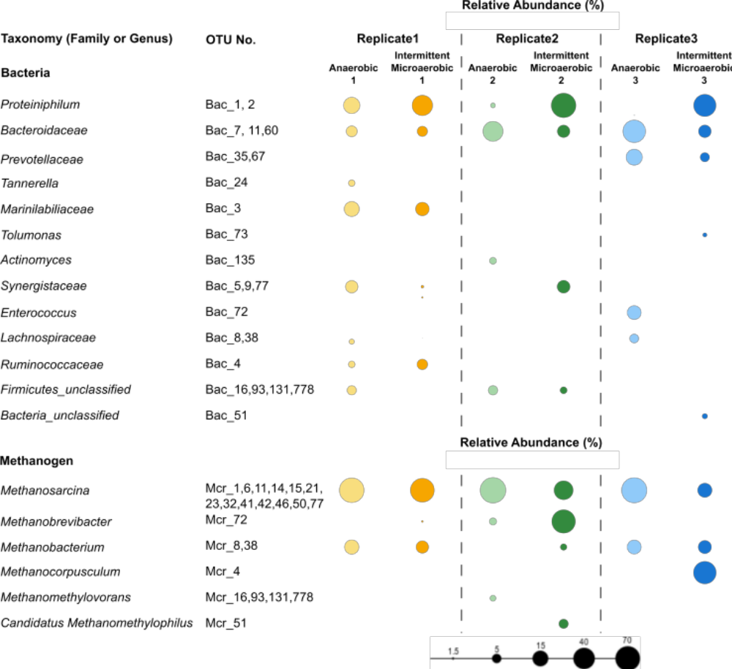
Figure S5: Dominant bacterial and methanogenic populations detected in the three replicate experiments. Biomass samples of anaerobic and intermittent ORP-controlled micro-aeration conditions were collected on days 79 and 149 for Replicate 1, days 150 and 192 for Replicate 2, and days 64 and 108 for Replicate 3, respectively. Relative abundance values of identified OTUs are presented in Table S2.
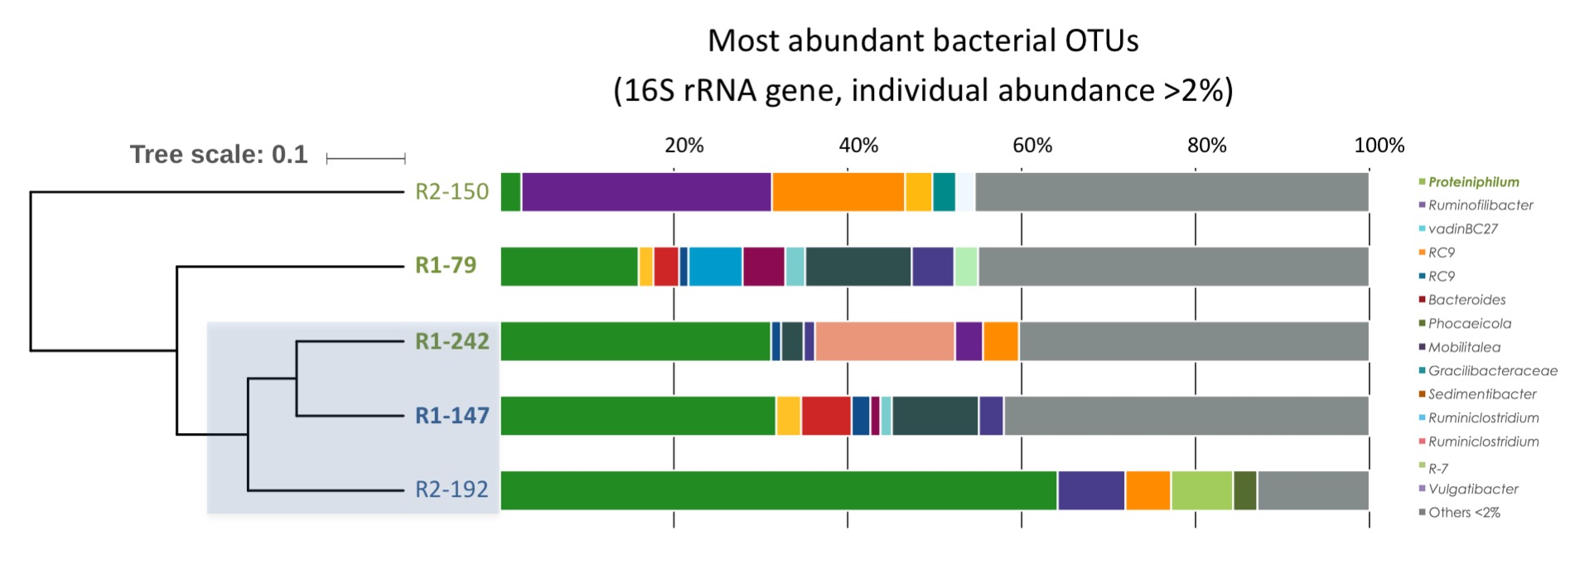
Figure S6. Hieratical clustering of the bacterial community in Replicate 1 and 2. Besides biomass samples collected as mentioned in Fig. S5, extra biomass sample during anaerobic condition after micro-aeration period was collected on day 242 of Replicate 1.
References
APHA-AWWA-WEF, 2005. Standard methods for the examination of water and wastewater. APHA-AWWA-WEF, Washington, D.C.
Cole-Parmer, 2018. Cole-Parmer [WWW Document]. URL https://www.coleparmer.com
Dolfing, J., 2015. Protocols for Calculating Reaction Kinetics and Thermodynamics, in: Hydrocarbon and Lipid Microbiology Protocols. Springer, pp. 1–29. doi:10.1007/8623
Faithfull, N.T., 2002. Methods in Agricultural Chemical Analysis: A Practical Handbook. CABI Publishing, New York, NY, USA.
Jenicek, P., Celis, C. a., Koubova, J., Pokorna, D., 2011. Comparison of microbial activity in anaerobic and microaerobic digesters. Water Sci. Technol. 63, 2244–2249. doi:10.2166/wst.2011.579
Kafle, G.K., Kim, S.-H., Shin, B.-S., 2012. Anaerobic digestion treatment for the mixture of chinese cabbage waste juice and swine manure. J. Biosyst. Eng. 37, 58–64. doi:10.5307/JBE.2012.37.1.058
Khanal, Huang, J.-C., 2003. ORP-based oxygenation for sulfide control in anaerobic treatment of high-sulfate wastewater. Water Res. 37, 2053–62. doi:10.1016/S0043-1354(02)00618-8
Khanal, S.K., Huang, J.-C., 2006. Online oxygen control for sulfide oxidation in anaerobic treatment of high-sulfate wastewater. Water Environ. Res. 78, 397–408.
Krayzelova, L., Bartacek, J., Kolesarova, N., Jenicek, P., 2014. Microaeration for hydrogen sulfide removal in UASB reactor. Bioresour. Technol. 172, 297–302. doi:10.1016/j.biortech.2014.09.056
Lawrence, A.W., McCarty, P.L., 1969. Kinetics of Methane Fermentation in Anaerobic Treatment. J. Water Pollut. Control Fed. 41, 1–17. doi:10.2307/25036255
Matassa, S., Boon, N., Verstraete, W., 2015. Resource recovery from used water: The manufacturing abilities of hydrogen-oxidizing bacteria. Water Res. 68, 467–478. doi:10.1016/j.watres.2014.10.028
Ni, B.J., Batstone, D., Zhao, B.H., Yu, H.Q., 2015. Microbial internal storage alters the carbon transformation in dynamic anaerobic fermentation. Environ. Sci. Technol. 49, 9159–9167. doi:10.1021/acs.est.5b01855
Rittmann, B.E., McCarty, P.L., 2001. Environmental biotechnology: principles and applications. McGrawHill, New York.
Thauer, R.K., Jungermann, K., Decker, K., Pi, P.P.H.--, 1977. Energy Conservation in Chemotrophic Anaerobic Bacteria 41, 100–180.

