Table S1
Physicochemical characteristics of seed sludge.
Parameter | Unit | Seed sludge
Total COD | mg/L | 10,862±89
Soluble COD | mg/L | 460±33
Total solids | mg/L | 16,700±167
Total volatile solids | mg/L | 9,042±167
Total suspended solids | mg/L | 12,900±167
Volatile suspended solids | mg/L | 8,643

Fig S1. Effects on COD removal efficiency by adding different sizes of magnetite particles into AS system.
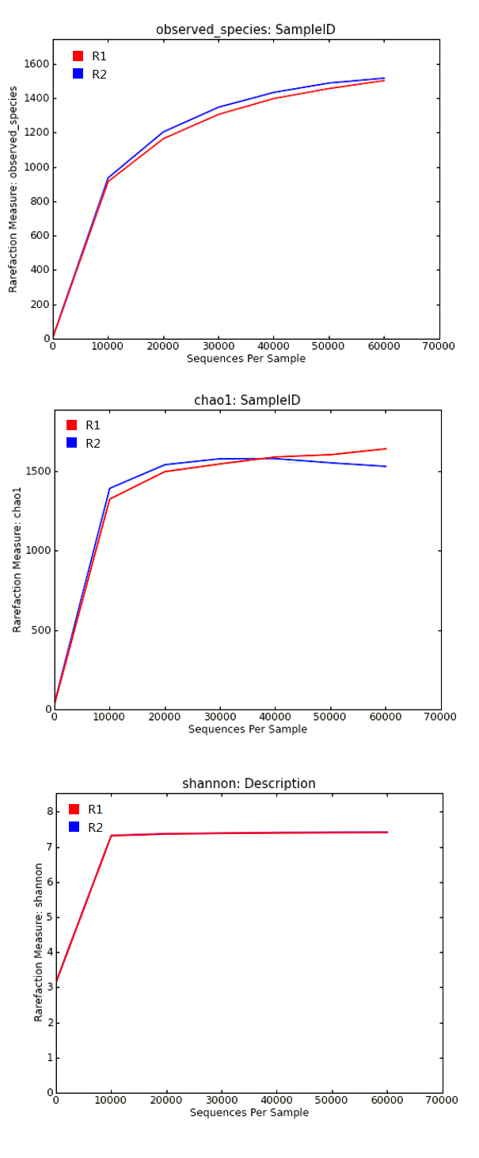

Fig S2. Rarefaction Curves in both reactors.
Fig S3. Effects on biodegradation of AS system by different Fe(II) concentration.

