Bio-pretreatment promote hydrolysis and acidification of oilseed rape straw: Roles of fermentation broth and micro-oxygen
Chuqiao Wang ^{1 a}, Jiajie Zhang ^{1 a}, Fengping Hu ª, Shuai Zhang ^{b *}, Ji Lu ^{c}, Shuai Liu ^{d}

ª School of civil engineering and architecture, East China Jiaotong University, Nanchang 330013, China
^{b} Jiangsu Key Laboratory of Atmospheric Environment Monitoring and Pollution Control (AEMPC), Collaborative Innovation Center of Atmospheric Environment and Equipment Technology (CIC-AEET), Nanjing University of Information Science &Technology, Nanjing 210044, China
^{c}Advanced Water Management Centre (AWMC), The University of Queensland, St Lucia, Brisbane, QLD, 4072, Australia
^{d} College of Environment and Safety Engineering, Qingdao University of Science and Technology, Qingdao, Shandong Province, 266042, P.R. China
* Corresponding author. E-mail addresses: zhangshuai198702@163.com (S. Zhang)
Author contributions
1 These authors contributed equally to the work.

Fig. A.1 Mycelium morphology of ORS surface in different pretreatment time.
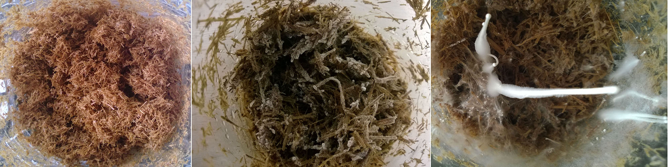

Fig. A.2 Optical micrographs and scanning electron microscopic photo of ORS before and after pretreatment. A, un-treated straw (optical micrograph); B, pretreated straw (optical micrograph); C, un-treated straw (SEM, 500×); D, pretreated straw (SEM, 500×); E, un-treated straw (SEM, 1000×); F, pretreated straw (SEM, 1000×).
Fig. A.3 FTIR spectrum of pre-treated and un-treated straw. Pretreatment conditions: 65% moisture content, 20 mL/gVS/d oxygen load, and 10 d pretreatment time.
Fig. A.4 XRD patterns of untreated and pretreated rape straw.

