Supporting Information
Using air instead of biogas for mixing and its effect on anaerobic digestion of animal wastewater with high suspended solids
Hongnan Yang^{a,b}, Liangwei Deng^{a,b*}
ªBiogas Institute of Ministry of Agriculture and Rural Affairs, Chengdu 610041, P. R. China
^{b}Laboratory of Development and Application of Rural Renewable Energy, Ministry of Agriculture and Rural Affairs, Chengdu 610041, P. R. China

*Corresponding author:
E-mail: dengliangwei@caas.cn
Tel/ Fax: +86-28-85236376

List of Supporting Information
Supporting materials and methods:

- Calculation of power per unit volume

- Analytical methods

- Microbiological analysis

- Thermodynamic calculations

Supporting tables:
Table S1 Characteristics of both swine wastewater and inoculum sludge.
Table S2 Sulfide oxidizing bacteria (SOB) and aerobic hydrogen oxidizing bacteria (AHOB) found in the four anaerobic digesters.
Table S3 Kinetic parameters of O₂-consuming bacteria under air mixing condition.
Table S4: Thermodynamics of reactions under air mixing condition.

Supporting figures:
Fig. S1. ORP profiles in air-mixed digester and biogas-mixed digester (A) and the relationship between dissolved oxygen (DO) and ORP in the air-mixed reactor.
Supporting materials and methods
Calculation of power per unit volume
All three reactors were mixed at the same power input per unit volume of mixed liquid condition (i.e., 5 W/m³). The gas flow rate for R-a and R-b and the impeller speed for R-m were calculated using Eqs. (1) and (2), respectively (Casey, 1986).
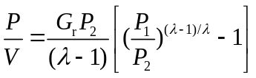 (1)
In Eq. (1), P is the power (W), V is the volume of the slurry mixed (m³), G_{r} is the air or biogas flow rate (m³/s/m³), P₂ is the head space pressure (101,416.83 N/m²), P₁ is the pressure at the injection point (i.e., P₂ plus static head of slurry), and λ is 1.01 at 35 ºC.
(2)
Analytical methods
The pH and ORP were monitored online by pH and ORP probes (InPro 325X probe, M300 controller, Mettler Toledo, Urdof, Switzerland). Dissolved oxygen was measured using an oxygen probe (InPro 6800, Mettler Toledo,Urdof, Switzerland) The H₂ concentration in the skin flap tissue was measured using a H₂ sensor (Unisense, Denmark). TS and VS were measured over time in duplicate samples and were analyzed according to APHA standard methods (Association). VFAs (acetic, propionic and butyric acids) were assayed using an Agilent 7820A gas chromatograph (Agilent Technologies Inc., Santa Clara, CA, USA) coupled with a flame ionization detector (FID). The injector, oven and detector temperatures were 230, 220 and 240 ºC, respectively. Nitrogen was used as the carrier gas (flow rate 50 mL/min). Samples and standards were acidified by the addition of 20 µL of H₂SO₄ (96–97% (w/v)) to each 1 mL sample before VFA analysis. A sample volume of 1 µL was injected. The sum of measured acetic, propionic and butyric acids was the total amount of VFA. The biogas produced in the bioreactors was collected in gas-tight bags. Biogas composition was determined using a gas chromatograph (GC) (SP-2100, Beijing Beifen-Ruili Analytical Instrument Co., Ltd., China) equipped with a thermal conductivity detector (TCD) and a packed Porapak Q column (3 m × 3 mm). Helium gas was used as the carrier gas (flow rate 10 mL/min). The temperatures of the inlet, the oven and the TCD were 100, 100 and 55 ºC, respectively. The crude protein, crude fiber and crude fat contents were determined according to the standard method prescribed by the Chinese National Standards (GB/T6432-1994, GB/T6434-2006 and GB/T6433-2006)(Wang et al., 2018). Carbohydrate was calculated by subtracting the amount of crude fat, crude protein and crude fiber from the amount of VS.
Microbiological analysis
At the conclusion of the experiment, sludge samples were collected from each reactor. Total genomic DNA was extracted using a PowerSoil DNA Isolation Kit (MO BIO, Carlsbad, CA, USA) according to the manufacturer’s protocol. The extracted DNA concentrations of all samples were measured using a NanoDrop 2000 Spectrophotometer (Thermo Fisher, Waltham, MA, USA), and the DNA was stored at −20 °C until use.
To investigate the changes in bacterial and archaeal communities, the V3–V4 region of the bacterial 16S rRNA gene was amplified using the primers 338F (5′-ACTCCTACGGGAGGCAGCAG-3′) and 806R (5′-GGACTACHVGGGTWTCTAAT-3′). The V3–V5 region of the archaeal 16S rRNA gene was amplified using the primers Arch344F (5′-ACGGGGYGCAGCAGGCGCGA-3′) and Arch915R (5′-GTGCTCCCCCGCCAATTCCT-3′). The DNA sequence was analyzed using an Illumina® MiSeq PE300 platform at Majorbio Bio-Pharm Technology Co., Ltd. (Shanghai, China). The optimized sequences were clustered into operational taxonomic units with a 97% similarity cut-off using the Usearch algorithm (version 7.1, http://drive5.com/uparse/). In addition, the Chao estimator was used to indicate the community richness and the Shannon and Simpson indexes were used to represent the community diversity.

Thermodynamic calculations

Thermodynamic calculations of reactions under air mixing condition (Table S5) were performed as described in Thauer et al. (1977) and Dolfing (2015) with all compounds in the aqueous phase.

Change in Gibbs free energy for the reaction (∆Gº’) under standard conditions: i.e., for a temperature of 25 ºC, pH of 7.0, solutes at 1 M concentrations, and gases at partial pressures of 1 atm, was calculated via:

∆Gº’ (kJ) = ΣGº_{f} products - ΣGº_{f} reactants (3)

Where, Gº_{f} (Gibbs free energy) values were taken from Thauer et al. (1977)

Change in Gibbs free energy at actual reactor condition (∆G_{R}’) of reaction aA + bB = cC + dD was calculated via the mass equation:

∆G_{R}’ (kJ) = ∆Gº’ + R*T*ln [(C^{c}*D^{d})/(Aª*B^{b})] (4)

Where, R is universal gas constant (8.314*10⁻³ kJ/K/mol), T is temperature of reactor (K), and A, B, C, D are concentrations of all substances in aqueous phase (M).

The volatile fatty acids (VFAs) concentrations of effluent in the steady-state (Table 1) were used to calculate the bioenergetics of this reaction. H₂ concentration in aqueous phase was measured before air mixing. The concentration of O₂ was measured when air mixing ended. The concentration of H₂O was set at 1 M and temperature of 35 ºC was used. All concentrations were converted to molar (M).
Supporting tables
Table S1 Characteristics of both swine wastewater and inoculum sludge.
Parameter | Swine wastewater | Inoculation sludge
Total solid (TS) (g/L) | 60.33 ±1.93 | 82.46 ±0.15
Volatile solid (VS) (g/L) | 47.38 ±1.77 | 48.73 ±0.52
Suspended solid (SS) (g/L) | 51.29 ±12.04
TCOD /(g/L) | 59.79 ±5.85
SCOD /(g/L) | 6.75 ±1.23
TCOD/SCOD | 8.54 ±1.42
pH | 7.1 ±0.3 | 6.8 ±0.2
ORP (mV) | -312.7 ±9.9

Table S2 Sulfide oxidizing bacteria (SOB) and aerobic hydrogen oxidizing bacteria (AHOB) found in the four anaerobic digesters.
 | Genus | Relative abundance /%
 | Genus | R-a | R-b | R-m | R-n
SOB | Acinetobacter | 0.33 | 0.18 | 0.26 | 0.15
SOB | Rhodococcus | 0.87 | 0.61 | 0.70 | 0.84
SOB | Sum | 1.20 | 0.79 | 0.96 | 0.99
AHOB | Alcaligenes | 0.01 | 0 | 0.01 | 0
 | Pseudomonas | 0.10 | 0.06 | 0.06 | 0.05
 | Sum | 0.11 | 0.06 | 0.07 | 0.05
R-a = air-mixed digester; R-b = biogas-mixed digester; R-m = mechanically mixed digester; R-n = unmixed control digester.
Table S3 Kinetic parameters of O₂-consuming bacteria under air mixing condition.
 | µ_{m} | K_{S} | Y | Ref.
Aerobic heterotrophic bacteria | 13.20 | 20 | 0.49 | (Rittmann & McCarty, 2012)
Aerobic H₂-utilizing bacteria | 3.6 | 2.22 | 0.25 | (Jiang et al., 2007)
Sulfide oxidizing bacteria | 8.64 | 63.64 |  | (Krayzelova et al., 2015)
Note: µ_{m}: maximum specific growth rate (1/day), K_{S}: half-saturation constant (mg COD/L). Y: biomass yield (g VSS/g COD).
Table S4: Thermodynamics of reactions under air mixing condition.
Reactions | Electrons transferred | ∆Gº’ (kJ/e⁻) | ∆G’_{R} (kJ/e⁻)
Glucose + 6 O₂ = 6 CO₂ + 6 H₂O | 24 | -155.9 | -110.9
Butyrate + H⁺ + 5 O₂ = 4 CO₂ + 4 H₂O | 20 | -109.1 | -97.0
Propionate + H⁺ + 3.5 O₂ = 3 CO₂ + 3 H₂O | 14 | -109.0 | -96.3
Acetate + H⁺ + 2 O₂ = 2 CO₂ + 2 H₂O | 8 | -108.8 | -94.0
2H₂ + O₂ = 2 H₂O | 4 | -131.5 | -99.6
2H₂S + O₂ = 2 S⁰ + 2 H₂O | 4 | -104.7 | -91.8

Supporting figures
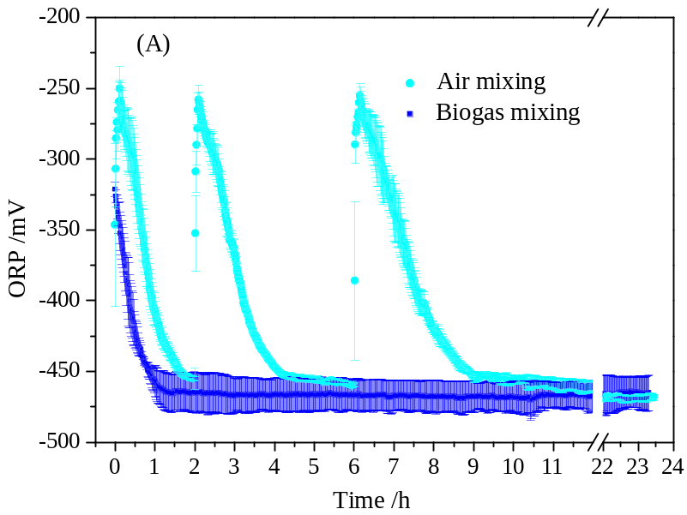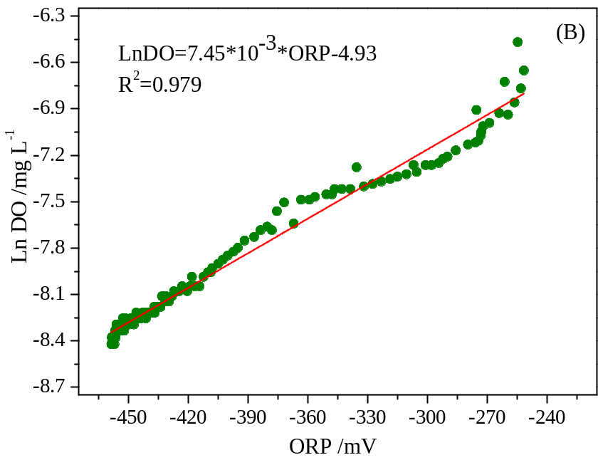
Fig. S1. ORP profiles in air-mixed digester and biogas-mixed digester (A) and the relationship between dissolved oxygen (DO) and ORP in the air-mixed reactor.
References
- Association, A.P.H. Water Environment Federation (APHA).(1998). Standard methods for the examination of water and wastewater.
- Casey, T. 1986. Requirements and methods for mixing in anaerobic digesters. Anaerobic digestion of sewage sludge and organic agricultural wastes. Proceedings of a seminar organized by the Commission of the European Communities, Athens, Greece, 14-15 May 1984. Elsevier Applied Science Publishers Ltd. pp. 90-103.
- Dolfing, J. 2015. Protocols for calculating reaction kinetics and thermodynamics. in: Hydrocarbon and Lipid Microbiology Protocols, Springer, pp. 155-163.
- Jiang, Y., Wen, J., Bai, J., Jia, X., Hu, Z. 2007. Biodegradation of phenol at high initial concentration by Alcaligenes faecalis. Journal of Hazardous Materials, 147(1), 672-676.
- Krayzelova, L., Bartacek, J., Díaz, I., Jeison, D., Volcke, E.I.P., Jenicek, P. 2015. Microaeration for hydrogen sulfide removal during anaerobic treatment: a review. Reviews in Environmental Science and Bio/Technology, 14(4), 703-725.
- Rittmann, B.E., McCarty, P.L. 2012. Environmental biotechnology: principles and applications. Tata McGraw-Hill Education.
- Thauer, R.K., Jungermann, K., Decker, K. 1977. Energy conservation in chemotrophic anaerobic bacteria. Bacteriological Reviews, 41(1), 100-180.
- Wang, W., Huang, G., An, C., Zhao, S., Chen, X., Zhang, P. 2018. Adsorption of anionic azo dyes from aqueous solution on cationic gemini surfactant-modified flax shives: Synchrotron infrared, optimization and modeling studies. Journal of Cleaner Production, 172, 1986-1997.

