Supplementary Information

Effects of Micro-Aeration on Microbial Niches and Antimicrobial Resistances in Blackwater Anaerobic Digesters

Bing Guo^{a,b,1,2}, Najiaowa Yu^{a,1}, David G. Weissbrodt^{b}, Yang Liu^{a *}
ª Department of Civil and Environmental Engineering, University of Alberta, Edmonton, Alberta, T6G 1H9, Canada
^{b} Department of Biotechnology, Delft University of Technology, Delft, Netherlands

*Corresponding Author: Y. Liu, Department of Civil and Environmental Engineering, University of Alberta, 7-263 Donadeo Innovation Centre for Engineering, Edmonton, Alberta, T6G 1H9, Canada Tel: (780) 492-5115 E-mail: yang.liu@ualberta.ca
¹ Equal contribution of first authorship.

This supplementary material contains 12 pages including 3 tables, 6 figures and References.

Table S1. Oligonucleotide probes and primers and qPCR conditions for bacteria (16S and rpoB), ARGs and AMRs.
Target gene | Probe name | Oligonucleotide sequence 5’-3’ | Concentration in reaction | Annealing temperature | Reference
Target gene | Probe name | Oligonucleotide sequence 5’-3’ | (nmol L⁻¹) | Annealing temperature | Reference
16S rRNA | 338F | ACTCCTACGGGAGGCAGCAG | 300 | 60 | (Muyzer et al., 1993)
16S rRNA | 518R | ATTACCGCGGCTGCTGG | 300 | 60 | (Muyzer et al., 1993)
rpoB | rpoB-F | ACTCCTACGGGAGGCAGCAG | 300 | 60 | (Florentino et al., 2019)
rpoB | rpoB-R | ATTACCGCGGCTGCTGG | 300 | 60 | (Florentino et al., 2019)
qnrS | qnrSrtF11 | GACGTGCTAACTTGCGTGAT | 400 | 60 | (Marti et al., 2013)
qnrS | qnrSrtR11 | TGGCATTGTTGGAAACTTG | 400 | 60 | (Marti et al., 2013)
tet(M) | tet(M)F | GGTTTCTCTTGGATACTTAAATCAATCR | 500 | 60 | (Peak et al., 2007)
tet(M) | tet(M)R | CCAACCATAYAATCCTTGTTCRC | 500 | 60 | (Peak et al., 2007)
sul1 | Sul1-F | CGCACCGGAAACATCGCTGCAC | 300 | 65 | (Pei et al., 2006)
sul1 | Sul1-R | TGAAGTTCCGCCGCAAGGCTCG | 300 | 65 | (Pei et al., 2006)
sul2 | Sul2-F | TCCGGTGGAGGCCGGTATCTGG | 400 | 61 | (Pei et al., 2006)
sul2 | Sul2-R | CGGGAATGCCATCTGCCTTGAG | 400 | 61 | (Pei et al., 2006)
erm(B) | ErmB-F | AAAACTTACCCGCCATACCA | 400 | 60 | (Knapp et al., 2010)
erm(B) | ErmB-R | TTTGGCGTGTTTCATTGCTT | 400 | 60 | (Knapp et al., 2010)
bla _{ctxM} | q_CTXM-F | CTATGGCACCACCAACGATA | 400 | 60 | (Marti et al., 2013)
bla _{ctxM} | q_CTXM-R | ACGGCTTTCTGCCTTAGGTT | 400 | 60 | (Marti et al., 2013)
inti1 | IntI-F | GATCGGTCGAATGCGTGT | 400 | 60 | (Barraud et al., 2010)
inti1 | IntI-R | GCCTTGATGTTACCCGAGAG | 400 | 60 | (Barraud et al., 2010)
korB (IncP-1) | IncP-F | TCATCGACAACGACTACAACG | 300 | 54 | (Jechalke et al., 2013)
korB (IncP-1) | IncP-Fz | TCGTGGATAACGACTACAACG | 300 | 54 | (Jechalke et al., 2013)
korB (IncP-1) | IncP-R | TTCTTCTTGCCCTTCGCCAG | 300 | 54 | (Jechalke et al., 2013)
korB (IncP-1) | IncP-Rd | TTCTTG ACTCCCTTCGCCAG | 300 | 54 | (Jechalke et al., 2013)
korB (IncP-1) | IncP-Rge | TTYTTCYTGCCCTTGGCCAG | 300 | 54 | (Jechalke et al., 2013)
korB (IncP-1) | Probe-P | TCAGYTCRTTGCGYTGCAGGTTCTCVAT | 300 | 54 | (Jechalke et al., 2013)
korB (IncP-1) | Probe-Pgz | TSAGCTCGTTGCGTTGCAGGTTYUCAAT | 300 | 54 | (Jechalke et al., 2013)

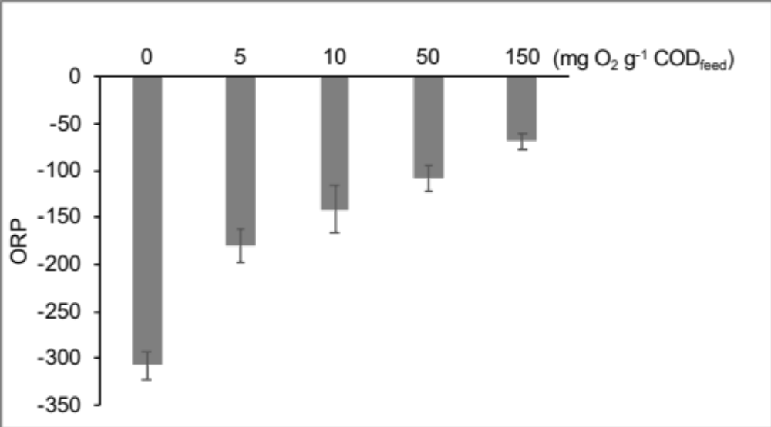
Figure S1. Oxidation reduction potential (ORP) of the five reactors. Error bar represents the standard deviation of 4 stages’ last cycles.

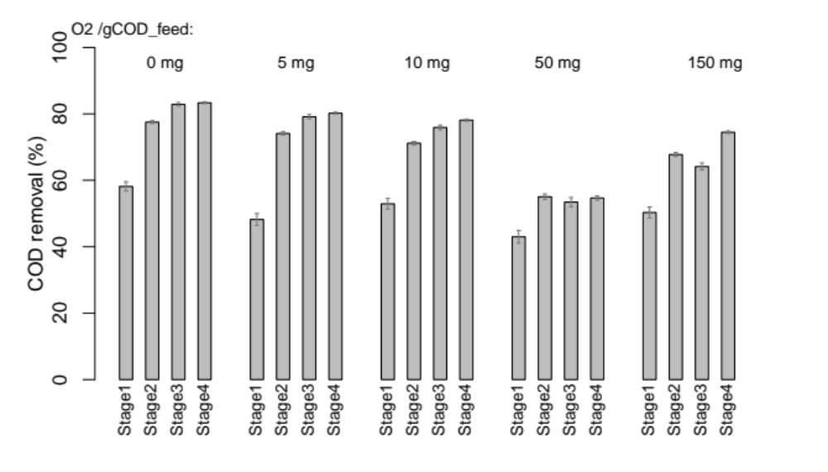
Figure S2. COD removal efficiency in the last cycle of each stage. Error bar represents standard deviation of two measurements.
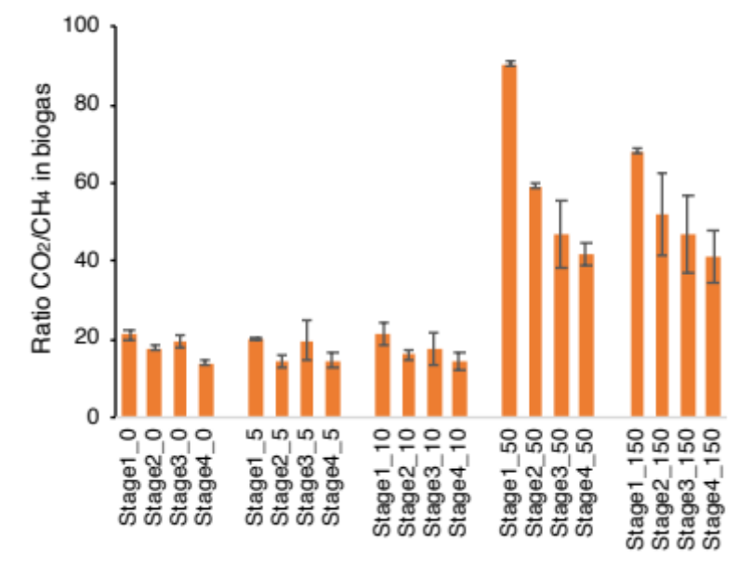
Figure S3. Ratio of CO₂/CH₄ in the biogas. Error bar represents standard deviation of two measurements.

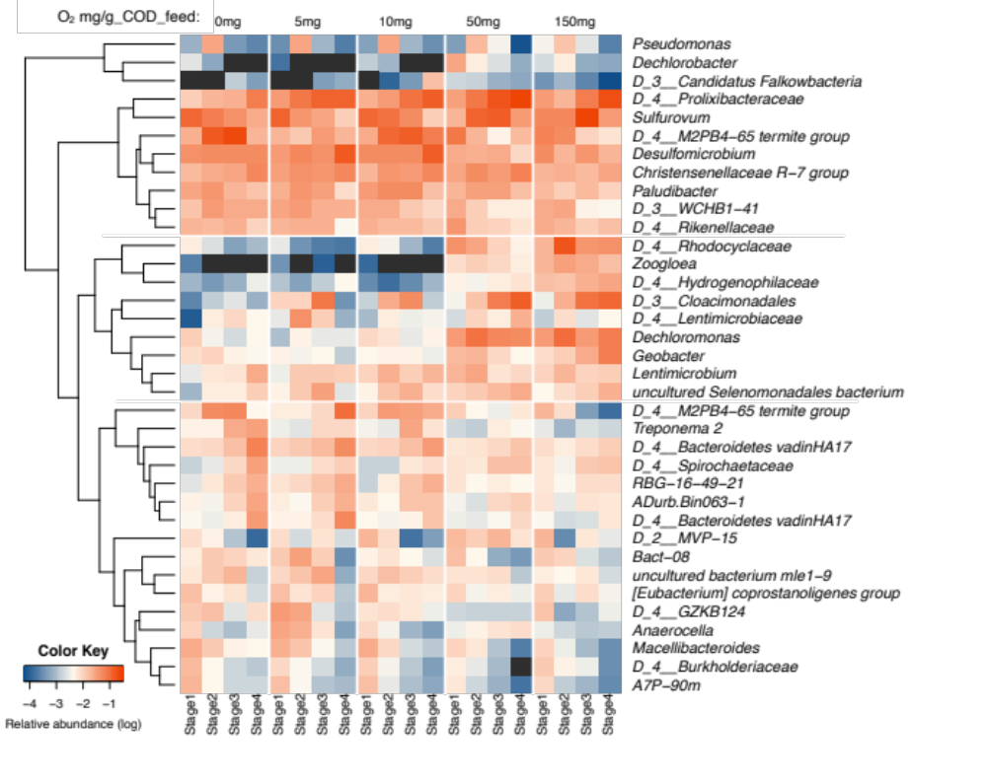
Figure S4. Assemblage of the top 10 genera from each reactor. Taxon names are shown at genus level, or higher level if not identified, family level (D_4), order level (D_3), and class level (D_2).

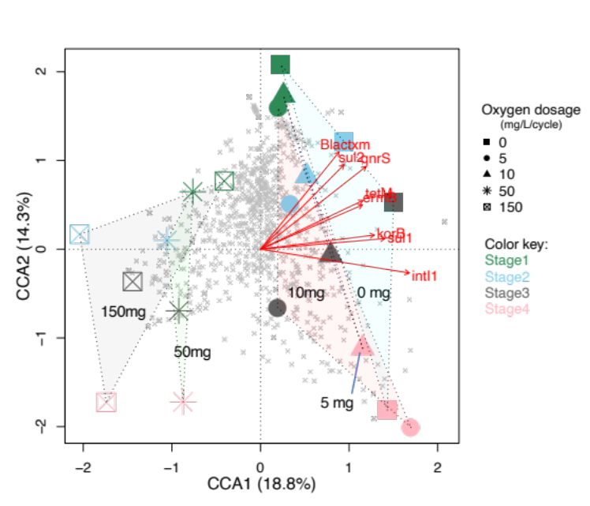
Figure S5. Canonical Correspondence Analysis (CCA) between microbial community and ARGs’ abundances. Class 1 integrase gene (intI1), IncP-1 plasmid RK2 specific gene (korB), tetracyclines (tetM), macrolides (ermB), sulfonamides (sul1 and sul2), extended-spectrum beta-lactamases (blaCTX-M), and fluoroquinolones (qnrS). Grey crosses (×) represent genera. Permutations of 999 were run for ANOVA CCA resulting p<0.01.

Table S3. Significance of two-way ANOVA test (HRT and oxygen dosage) on the ARGs relative abundances.
 | p-values
 | HRT | Oxygen dosage | HRT*Oxygen dosage
intI1 | 0.095 | 0.005 | 0.084
korB | 0.586 | 0.005 | 0.483
tetM | 0.911 | 0.022 | 0.960
ermB | 0.892 | 0.007 | 0.937
sul1 | 0.531 | 0.046 | 0.445
sul2 | 0.167 | 0.007 | 0.589
Blactxm | 0.123 | 0.006 | 0.317
qnrS | 0.338 | 0.019 | 0.628

Table S3. List of efflux pump genes from the KEGG database.
Multidrug resistance, efflux pump MexAB-OprM [MD:M00718]
K18131 mexR; MarR family transcriptional regulator, repressor of the mexAB-oprM multidrug resistance operon
K03585 acrA, mexA, adeI, smeD, mtrC, cmeA; membrane fusion protein, multidrug efflux system
K18138 acrB, mexB, adeJ, smeE, mtrD, cmeB; multidrug efflux pump
K18139 oprM, emhC, ttgC, cusC, adeK, smeF, mtrE, cmeC, gesC; outer membrane protein, multidrug efflux system
Multidrug resistance, efflux pump MexCD-OprJ [MD:M00639]
K18294 nfxB; TetR/AcrR family transcriptional regulator, mexCD-oprJ operon repressor
K18295 mexC; membrane fusion protein, multidrug efflux system
K18296 mexD; multidrug efflux pump
Multidrug resistance, efflux pump MexEF-OprN [MD:M00641]
K18297 mexT; LysR family transcriptional regulator, mexEF-oprN operon transcriptional activator
K18298 mexE; membrane fusion protein, multidrug efflux system
K18299 mexF; multidrug efflux pump
K18300 oprN; outer membrane protein, multidrug efflux system
Multidrug resistance, efflux pump MexJK-OprM [MD:M00642]
K18301 mexL; TetR/AcrR family transcriptional regulator, mexJK operon transcriptional repressor
K18302 mexJ; membrane fusion protein, multidrug efflux system
K18303 mexK; multidrug efflux pump
K18139 oprM, emhC, ttgC, cusC, adeK, smeF, mtrE, cmeC, gesC; outer membrane protein, multidrug efflux system
Multidrug resistance, efflux pump MexXY-OprM [MD:M00643]
K18129 mexZ; TetR/AcrR family transcriptional regulator, mexXY operon repressor
K18094 mexX, amrA; membrane fusion protein, multidrug efflux system
K18095 mexY, amrB; multidrug efflux pump
K18139 oprM, emhC, ttgC, cusC, adeK, smeF, mtrE, cmeC, gesC; outer membrane protein, multidrug efflux system
Multidrug resistance, efflux pump MexPQ-OpmE [MD:M00769]
K18304 lasR; LuxR family transcriptional regulator, quorum-sensing system regulator LasR
K19591 cueR; MerR family transcriptional regulator, copper efflux regulator
K19595 gesA, mexP; membrane fusion protein, gold/copper resistance efflux system
K19594 gesB, mexQ; gold/copper resistance efflux pump
K19593 opmE; outer membrane protein, multidrug efflux system
Multidrug resistance, efflux pump AdeABC [PATH:map01501] [MD:M00649]
K18143 adeS; two-component system, OmpR family, sensor histidine kinase AdeS [EC:2.7.13.3]
K18144 adeR; two-component system, OmpR family, response regulator AdeR
K18145 adeA; membrane fusion protein, multidrug efflux system
K18146 adeB; multidrug efflux pump
K18147 adeC; outer membrane protein, multidrug efflux system
Multidrug resistance, efflux pump AcrEF-TolC [MD:M00696]
K18140 envR, acrS; TetR/AcrR family transcriptional regulator, acrEF/envCD operon repressor
K18141 acrE; membrane fusion protein, multidrug efflux system
K18142 acrF; multidrug efflux pump
K12340 tolC; outer membrane protein
Multidrug resistance, efflux pump MdtEF-TolC [MD:M00697]
K07690 evgA, bvgA; two-component system, NarL family, response regulator EvgA
K18898 mdtE; membrane fusion protein, multidrug efflux system
K18899 mdtF; multidrug efflux pump
K12340 tolC; outer membrane protein
Multidrug resistance, efflux pump BpeEF-OprC [MD:M00698]
K18900 bpeT; LysR family transcriptional regulator, regulator for bpeEF and oprC
K18901 bpeE; membrane fusion protein, multidrug efflux system
K18902 bpeF; multidrug efflux pump
K18903 oprC, opcM; outer membrane protein, multidrug efflux system
Multidrug resistance, efflux pump AbcA [MD:M00700]
K18906 mgrA; MarR family transcriptional regulator, multiple gene regulator MgrA
K18907 norG; GntR family transcriptional regulator, regulator for abcA and norABC
K18104 abcA, bmrA; ATP-binding cassette, subfamily B, bacterial AbcA/BmrA [EC:7.6.2.2]
Multidrug resistance, efflux pump NorB [MD:M00702]
K18906 mgrA; MarR family transcriptional regulator, multiple gene regulator MgrA
K18907 norG; GntR family transcriptional regulator, regulator for abcA and norABC
K08170 norB, norC; MFS transporter, DHA2 family, multidrug resistance protein
Multidrug resistance, efflux pump QacA [MD:M00714]
K18938 qacR; TetR/AcrR family transcriptional regulator, repressor for qacA
K08167 smvA, qacA, lfrA; MFS transporter, DHA2 family, multidrug resistance protein
Multidrug resistance, efflux pump MepA [MD:M00705]
K18909 mepR; MarR family transcriptional regulator, repressor for mepA
K18908 mepA; multidrug efflux pump

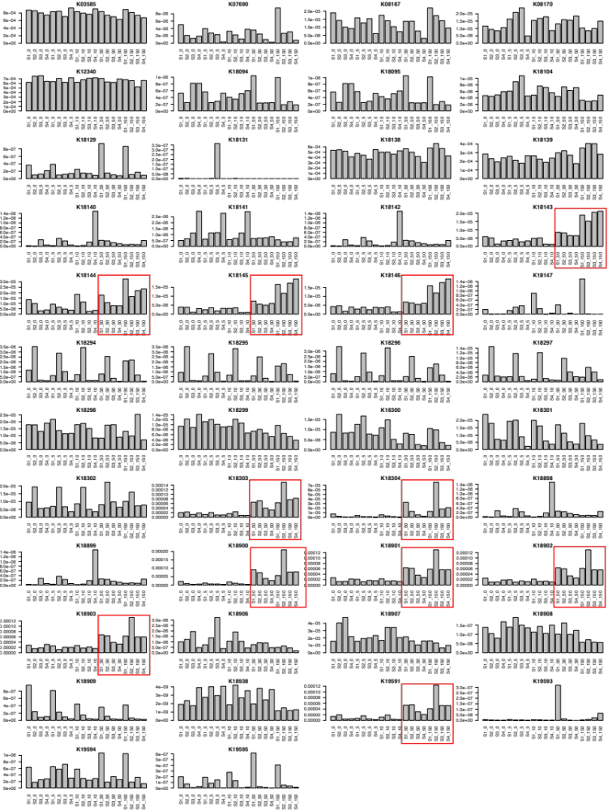
Figure S6. Relative gene abundance of efflux pump genes predicted using PICRUSt2. Red boxes indicate higher gene abundances at high-oxygen (50 and 150 mg g⁻¹ COD_{feed}) than at low-oxygen (0, 5, and 10 mg g⁻¹ COD_{feed}) conditions.

References

Barraud, O., Baclet, M.C., Denis, F. and Ploy, M.C. 2010. Quantitative multiplex real-time PCR for detecting class 1, 2 and 3 integrons. J Antimicrob Chemother 65(8), 1642-1645.
Florentino, A.P., Xu, R., Zhang, L. and Liu, Y. 2019. Anaerobic digestion of blackwater assisted by granular activated carbon: From digestion inhibition to methanogenesis enhancement. Chemosphere 233, 462-471.
Jechalke, S., Dealtry, S., Smalla, K. and Heuer, H. 2013. Quantification of IncP-1 plasmid prevalence in environmental samples. Appl Environ Microbiol 79(4), 1410-1413.
Knapp, C.W., Zhang, W., Sturm, B.S. and Graham, D.W. 2010. Differential fate of erythromycin and beta-lactam resistance genes from swine lagoon waste under different aquatic conditions. Environ Pollut 158(5), 1506-1512.
Marti, E., Jofre, J. and Balcazar, J.L. 2013. Prevalence of antibiotic resistance genes and bacterial community composition in a river influenced by a wastewater treatment plant. PLoS One 8(10), e78906.
Muyzer, G., de Waal, E.C. and Uitterlinden, A.G. 1993. Profiling of complex microbial populations by denaturing gradient gel electrophoresis analysis of polymerase chain reaction-amplified genes coding for 16S rRNA. Applied and Environmental Microbiology 59(3), 695.
Peak, N., Knapp, C.W., Yang, R.K., Hanfelt, M.M., Smith, M.S., Aga, D.S. and Graham, D.W. 2007. Abundance of six tetracycline resistance genes in wastewater lagoons at cattle feedlots with different antibiotic use strategies. Environ Microbiol 9(1), 143-151.
Pei, R., Kim, S.C., Carlson, K.H. and Pruden, A. 2006. Effect of river landscape on the sediment concentrations of antibiotics and corresponding antibiotic resistance genes (ARG). Water Res 40(12), 2427-2435.

