Enhanced methane production and energy potential from rice straw by employing microaerobic pretreatment via anaerobic digestion

Farrukh Raza Amin^{a,b}, Habiba Khalidª, Wanwu Liª, Chang Chenª*, Guangqing Liuª*
ªCollege of Chemical Engineering, Beijing University of Chemical Technology, Beijing 100029, China.
^{b}Center for Climate Research and Development, COMSATS University, Islamabad, Park Road, Tarlai Kalan, Islamabad 45550, Pakistan.

Correspondence:
*Chang Chen’s e-mail: chenchang@mail.buct.edu.cn
*Guangqing Liu’s e-mail: gqliu@mail.buct.edu.cn
Tel: +86-10-64442375
Address: 505A Zhonghe Building, Beijing University of Chemical Technology, 15th North 3rd Ring East Road, Beijing 100029, P. R. China

AD system stability
The characterization of the final digestate was done after 50 days of AD, as a reference for methane production process stability as given in Table S1. The final pH value of the digestates of RS pretreated by all five microbial reagents was between (6.76-7.72), which was in the appropriate pH range for methane production of AD (Qin et al., 2019). After AD process the concentrations of VFAs in all digesters were lower than 41.5 mg/L. AD instability might occur as an outcome of TAN levels higher than 1500 mg/L (Li et al., 2018). In this research, however, TAN concentrations lay between 550-998 mg/L for all groups, which does not impede the methane generation process. The concentration of TA also amplified with increasing the O₂ concentration in all groups. The VFAs/TA value is normally perceived as a stability index of AD process, and a value below 0.4 is ideal, hence, TVFA/TA in our study was found to be less than 0.4, indicating process stability for RS pretreatment with different microbial groups and O₂ concentrations. Therefore, all the above-mentioned parameters together indicated that the methane generation process was stable, and no inhibition factor affected the AD process.

Table S1: Properties of digestate of RS pretreated by different microbial reagents
Pretreatment microbial reagents | VFAs after AD | TAN (mg/L).NH₃N | TA  (mg CaCO₃/L) | VFAs/TA | pH after AD
URS | 18.1 ± 0.1 | 334 ± 22 | 4390 ± 110 | 0.0041 | 7.06 ± 0.01
LC 0 mL_{O2}/gVS | 8.6 ± 1.5 | 626 ± 6 | 4170 ± 130 | 0.0021 | 7.27 ± 0.0
LC 6 mL_{O2}/gVS | 5.6 ± 1.4 | 592 ± 2 | 4130 ± 30 | 0.0014 | 7.26 ± 0.0
LC 12 mL_{O2}/gVS | 18.6 ± 14.8 | 622±12 | 4060±0 | 0.0046 | 7.18±0.0
LC 24 mL_{O2}/gVS | 6.3 ± 2.0 | 550 ± 8 | 4240 ± 40 | 0.0015 | 7.26 ± 0.0
CM 0 mL_{O2}/gVS | 15.0 ± 7.5 | 588 ± 14 | 4000 ± 115 | 0.0038 | 7.23 ± 0.1
CM 6 mL_{O2}/gVS | 5.7 ± 1.0 | 604 ± 17 | 4550 ± 50 | 0.0013 | 7.3 ± 0.0
CM 12 mL_{O2}/gVS | 5.8 ± 0.3 | 596 ± 10 | 4630 ± 50 | 0.0013 | 7.27 ± 0.0
CM 24 mL_{O2}/gVS | 6.2 ± 3.1 | 570 ± 8 | 4660 ± 120 | 0.0013 | 7.28 ± 0.0
SD 0 mL_{O2}/gVS | 9.9 ± 1.1 | 630 ± 18 | 4270 ± 120 | 0.0023 | 7.29 ± 0.0
SD 6 mL_{O2}/gVS | 15.4 ± 10.0 | 570 ± 12 | 4210 ± 50 | 0.0037 | 7.30 ± 0.0
SD 12 mL_{O2}/gVS | 14.6 ± 6.2 | 612 ± 4 | 4540 ± 20 | 0.0032 | 7.22 ± 0.0
SD 24 mL_{O2}/gVS | 14.6 ± 3.0 | 632 ± 6 | 4470 ± 10 | 0.0033 | 7.32 ± 0.0
BS 0 mL_{O2}/gVS | 12.0 ± 6.0 | 754 ± 2 | 4780 ± 80 | 0.0025 | 7.33 ± 0.0
BS 6 mL_{O2}/gVS | 5.3 ± 0.3 | 702 ± 5 | 5680 ± 20 | 0.0009 | 7.46 ± 0.0
BS 12 mL_{O2}/gVS | 16.3 ± 1.6 | 682 ± 9 | 5050 ± 100 | 0.0032 | 7.36 ± 0.03
BS 24 mL_{O2}/gVS | 5.1 ± 1.0 | 682 ± 13 | 5110 ± 90 | 0.0010 | 7.34 ± 0.0
SC 0 mL_{O2}/gVS | 26.1 ± 6 | 976 ± 4 | 3790 ± 65 | 0.0068 | 6.87 ± 0.1
SC 6 mL_{O2}/gVS | 32.2 ± 9.4 | 990 ± 2 | 4460 ± 110 | 0.0072 | 7.72 ± 0.0
SC 12 mL_{O2}/gVS | 41.5 ± 16.3 | 958 ± 26 | 3525 ± 165 | 0.0117 | 6.85 ± 0.0
SC 24 mL_{O2}/gVS | 32.2 ± 10.6 | 998 ± 2 | 3620 ± 30 | 0.0088 | 6.76 ± 0.0
LC: liquid consortium, CM: cow manure, SD: sheep dung, BS: biogas slurry, SC: straw-decomposing consortia, URS: untreated rice straw

Structural analysis (SEM)

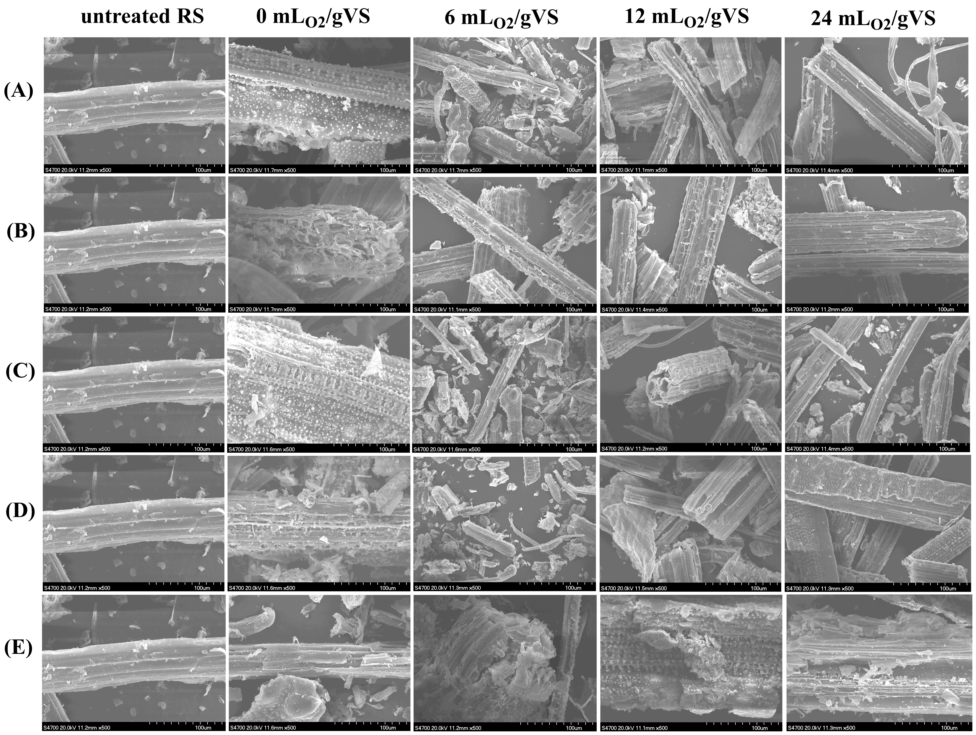

Fig. S1. SEM images of RS pretreated by (A) LC, (B) CM, (C) SD, (D) BS, and (E) SC at magnification of 500 times, with and without oxygen supply.

Diversity of microorganisms by using PcoA graph
According to the 16s rRNA sequencing data, we have made Graph A to compare the bacterial community similarity in different groups, as well as for archaeal community similarity (Graph B). In graph A, we found the SD group showed long distance to BS group, indicating bacterial community of these two groups were quite different. The main reason is likely that BS was taken from anaerobic environment such as biogas digester, while SD was mainly made for aerobic degradation of stalk. In the graph B, the anaerobic pretreatment group showed relatively long distance to microaerobic and untreated groups, indicating anaerobic pretreatment resulted in unique archaeal community as compared with two other groups. What’s more, the microaerobic and untreated groups showed relatively short distance, implying there was some difference in the archaeal community of the two groups.
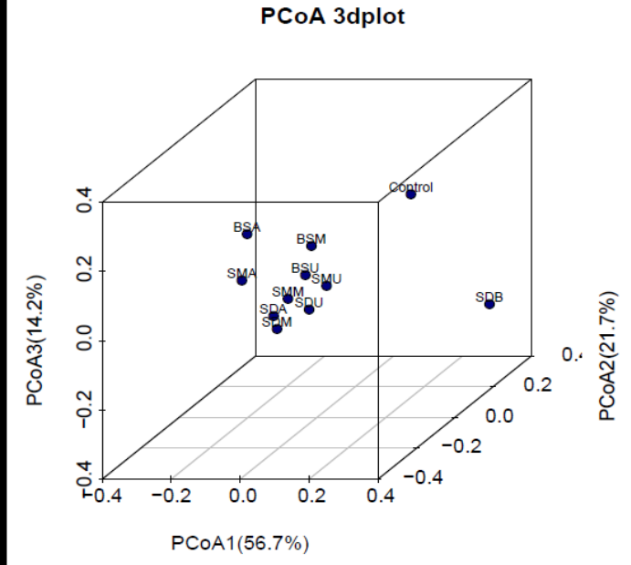
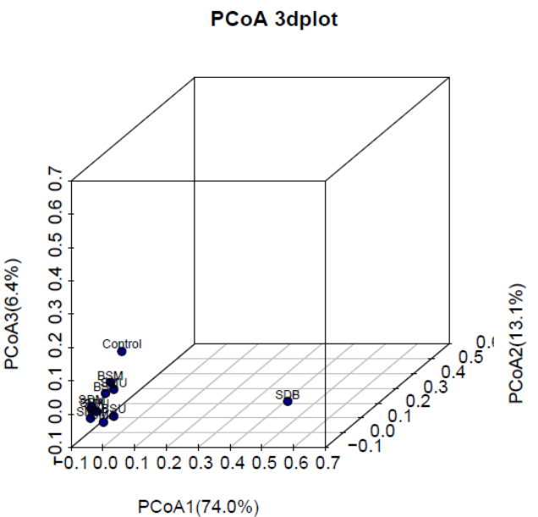

(A) (B)

Figure S2: Comparing the bacterial community similarity (A) in different groups, as well as for archaeal community similarity (B).

References
Li, W., Siddhu, M.A.H., Amin, F.R., He, Y., Zhang, R., Liu, G., Chen, C., 2018. Methane production through anaerobic co-digestion of sheep dung and waste paper. Energy Convers. Manag. 156, 279–287. https://doi.org/10.1016/j.enconman.2017.08.002
Qin, Y., Chen, L., Wang, T., Ren, J., Cao, Y., Zhou, S., 2019. Impacts of ferric chloride, ferrous chloride and solid retention time on the methane-producing and physicochemical characterization in high-solids sludge anaerobic digestion. Renew. Energy 139, 1290–1298. https://doi.org/10.1016/j.renene.2019.02.139

