Supporting Information
Intermittent air mixing system for anaerobic digestion of animal wastewater: Operating conditions and full-scale validation
Hongnan Yang^{a,b}, Liangwei Deng^{a,b*}, Jianwang Wu^{c}, Wenguo Wang^{a,b}, Dan Zheng^{a,b}, Zhiyong Wang^{a,b}, Yi Liu^{a,b}
ªBiogas Institute of Ministry of Agriculture and Rural Affairs, Chengdu 610041, P. R. China
^{b}Key Laboratory of Development and Application of Rural Renewable Energy, Ministry of Agriculture and Rural Affairs, Chengdu 610041, P. R. China
^{c}Shijiazhuang Chengding Environmental Protection Technology Co. Ltd., Shijiazhuang 050000, P. R. China

*Corresponding author:
E-mail: dengliangwei@caas.cn
Tel/ Fax: +86-28-85236376

Table：S1-3
Figure：S1-2
Supporting tables
Table S1 Characteristics of swine wastewater and sludge inoculum
Parameter | Swine wastewater | Sludge inoculum
Total solid (TS) (g/L) | 60.33 ±1.93 | 82.46 ±0.15
Volatile solid (VS) (g/L) | 47.38 ±1.77 | 48.73 ±0.52
Suspended solid (SS) (g/L) | 51.29 ±12.04
TCOD (g/L) | 59.79 ±5.85
SCOD (g/L) | 6.75 ±1.23
TCOD/SCOD | 8.54 ±1.42
pH | 7.1 ±0.3 | 6.8 ±0.2
ORP (mV) | -312.7 ±9.9

Table S2 Overview of the facilities and equipment used at the biogas plant for treating swine wastewater
Item | Volume | Specification of affiliated equipment
Collecting tank | 500 m³ | Lift pump: Flow rate 100 m³/h, head 20 m, power 7.5 kw
Vertical sedimentation tank | 300 m³ | CSTR feeding pump: Flow rate 100 m³/h, head 20 m, power 7.5 kw;  UASB feeding pump: Flow rate 20 m³/h, head 30 m, Power 3 kw
CSTR for the anaerobic digestion of the concentrated liquid | 2,000 m³
UASB for the anaerobic digestion of low content liquid | 450 m³
Air buffer tank | 1.0 m³ | Air compressor: Pressure 0.8 MPa, Flow rate 0.6 m³/h, Power 4 kw
Biogas holder | 500 m³ | Air blower: Flow rate 0.6 500 m³/h，Pressure 0.02 MPa，  Power 4 kw
Electric generator | 500 kW | Power 200 kw
CSTR: continuous stirred-tank reactor; UASB: upflow anaerobic sludge blanket.

Table S3 Effects of the mixing intensity on the biogas production time, biogas composition, and degree of mixing
Mixing intensity (Air flow rate) | 33.3 L/L/min | 66.7 L/L/min
Volumetric biogas production rate (L/L/min) | 2.377 ±0.198 | 2.543 ±0.130
CH₄ content (%) | 53.0 ±2.2 | 53.8 ±1.5
O₂ content (%) | 3.7 ±0.4 | 2.2±0.2
N₂ content (%) | 13.5 ±0.5 | 8.3 ±0.7
H₂S (ppm) | 88 ±48 | 100 ±65

Supporting Figures
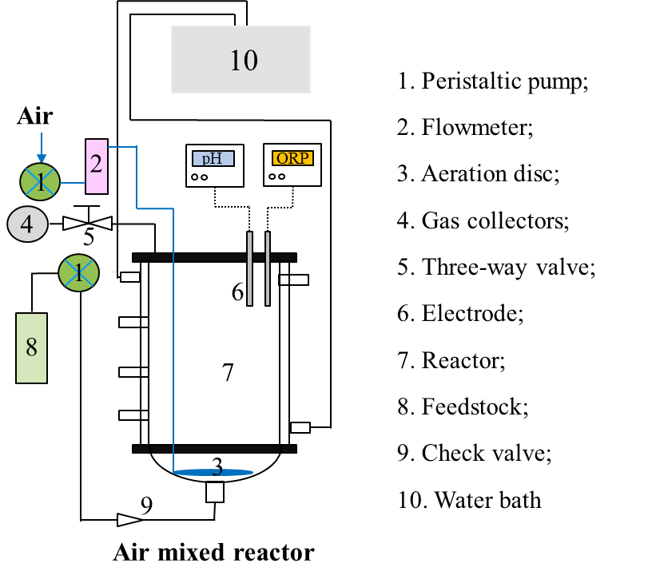
Fig. S1. Schematic diagram showing components of air mixed reactor.

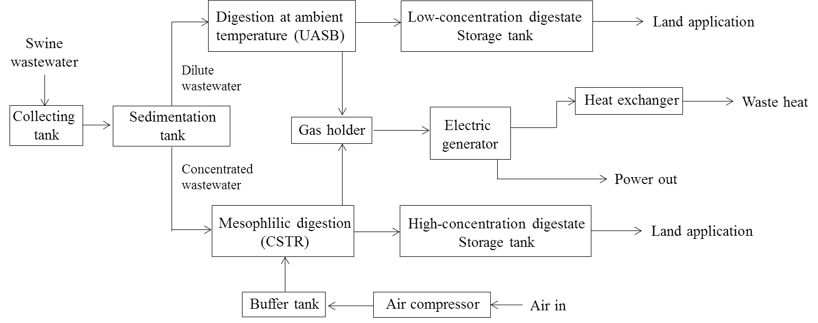
Fig. S2. Flow diagram illustrating the operation of a full-scale biogas plant.

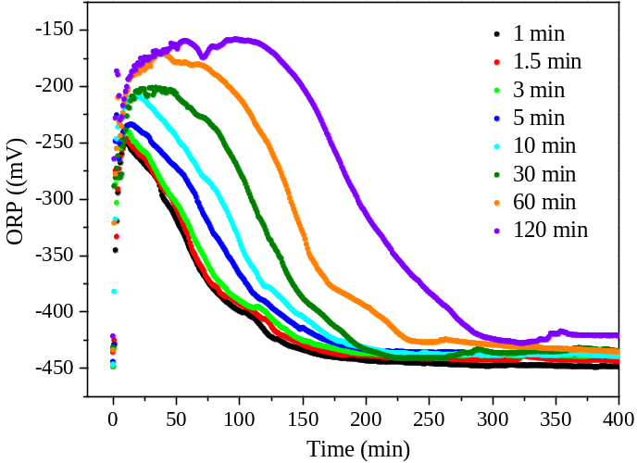
Figure S3. Influence of the air mixing time on the oxidation-reduction potential (ORP).

