Support Material
Understanding the Mechanisms behind Micro-aeration to Enhance Anaerobic Digestion of Corn Straw

Rong Zhu^{a, d}, Dong-Hui Wang ª, Yi Zheng^{d}, Hua Zou^{a, c}∗, Shan-Fei Fu^{a, b, c}
ª Jiangsu Key Laboratory of Anaerobic Biotechnology, School of Environment and Civil Engineering, Jiangnan University, NO.1800 Lihu Avenue, Wuxi, Jiangsu Province 214122, P. R. China
^{b} Shandong Industrial Engineering Laboratory of Biogas Production & Utilization, Key Laboratory of Biofuels, Shandong Provincial Key Laboratory of Synthetic Biology, Qingdao Institute of Bioenergy and Bioprocess Technology, Chinese Academy of Sciences, NO. 189 Songling Road, Qingdao 266101, PR China
^{c} Jiangsu Collaborative Innovation Center of Technology and Material of Water Treatment, Suzhou University of Science and Technology, Suzhou 215009, PR China
^{d} Department of Grain Science and Industry, Kansas State University, Manhattan, KS 66506, United State

Contains: 4 figures
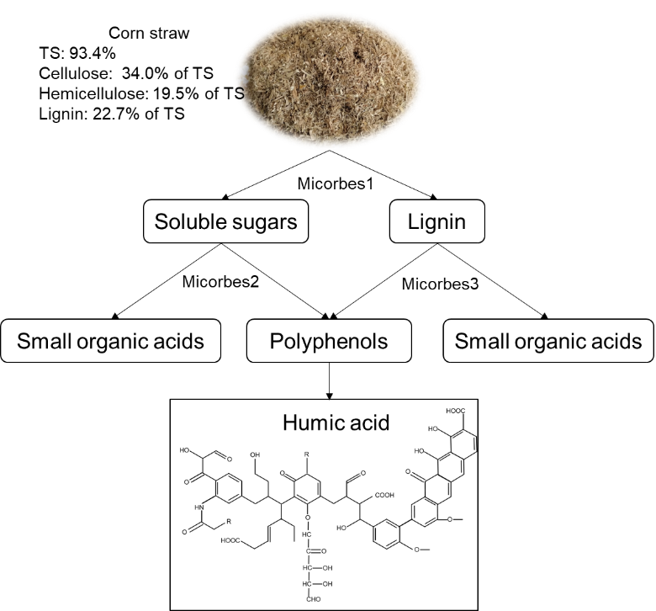
Fig. S1. Polyphenol theory of humus formation from corn straw
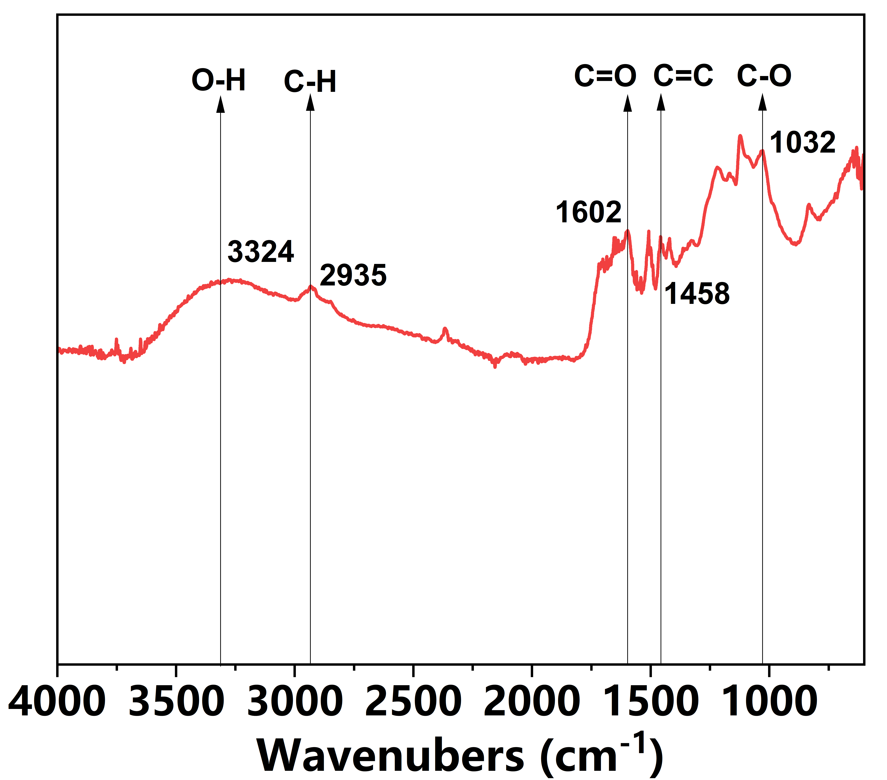
Fig. S2. FTIR analysis of the soluble humic acids extracted from digestate

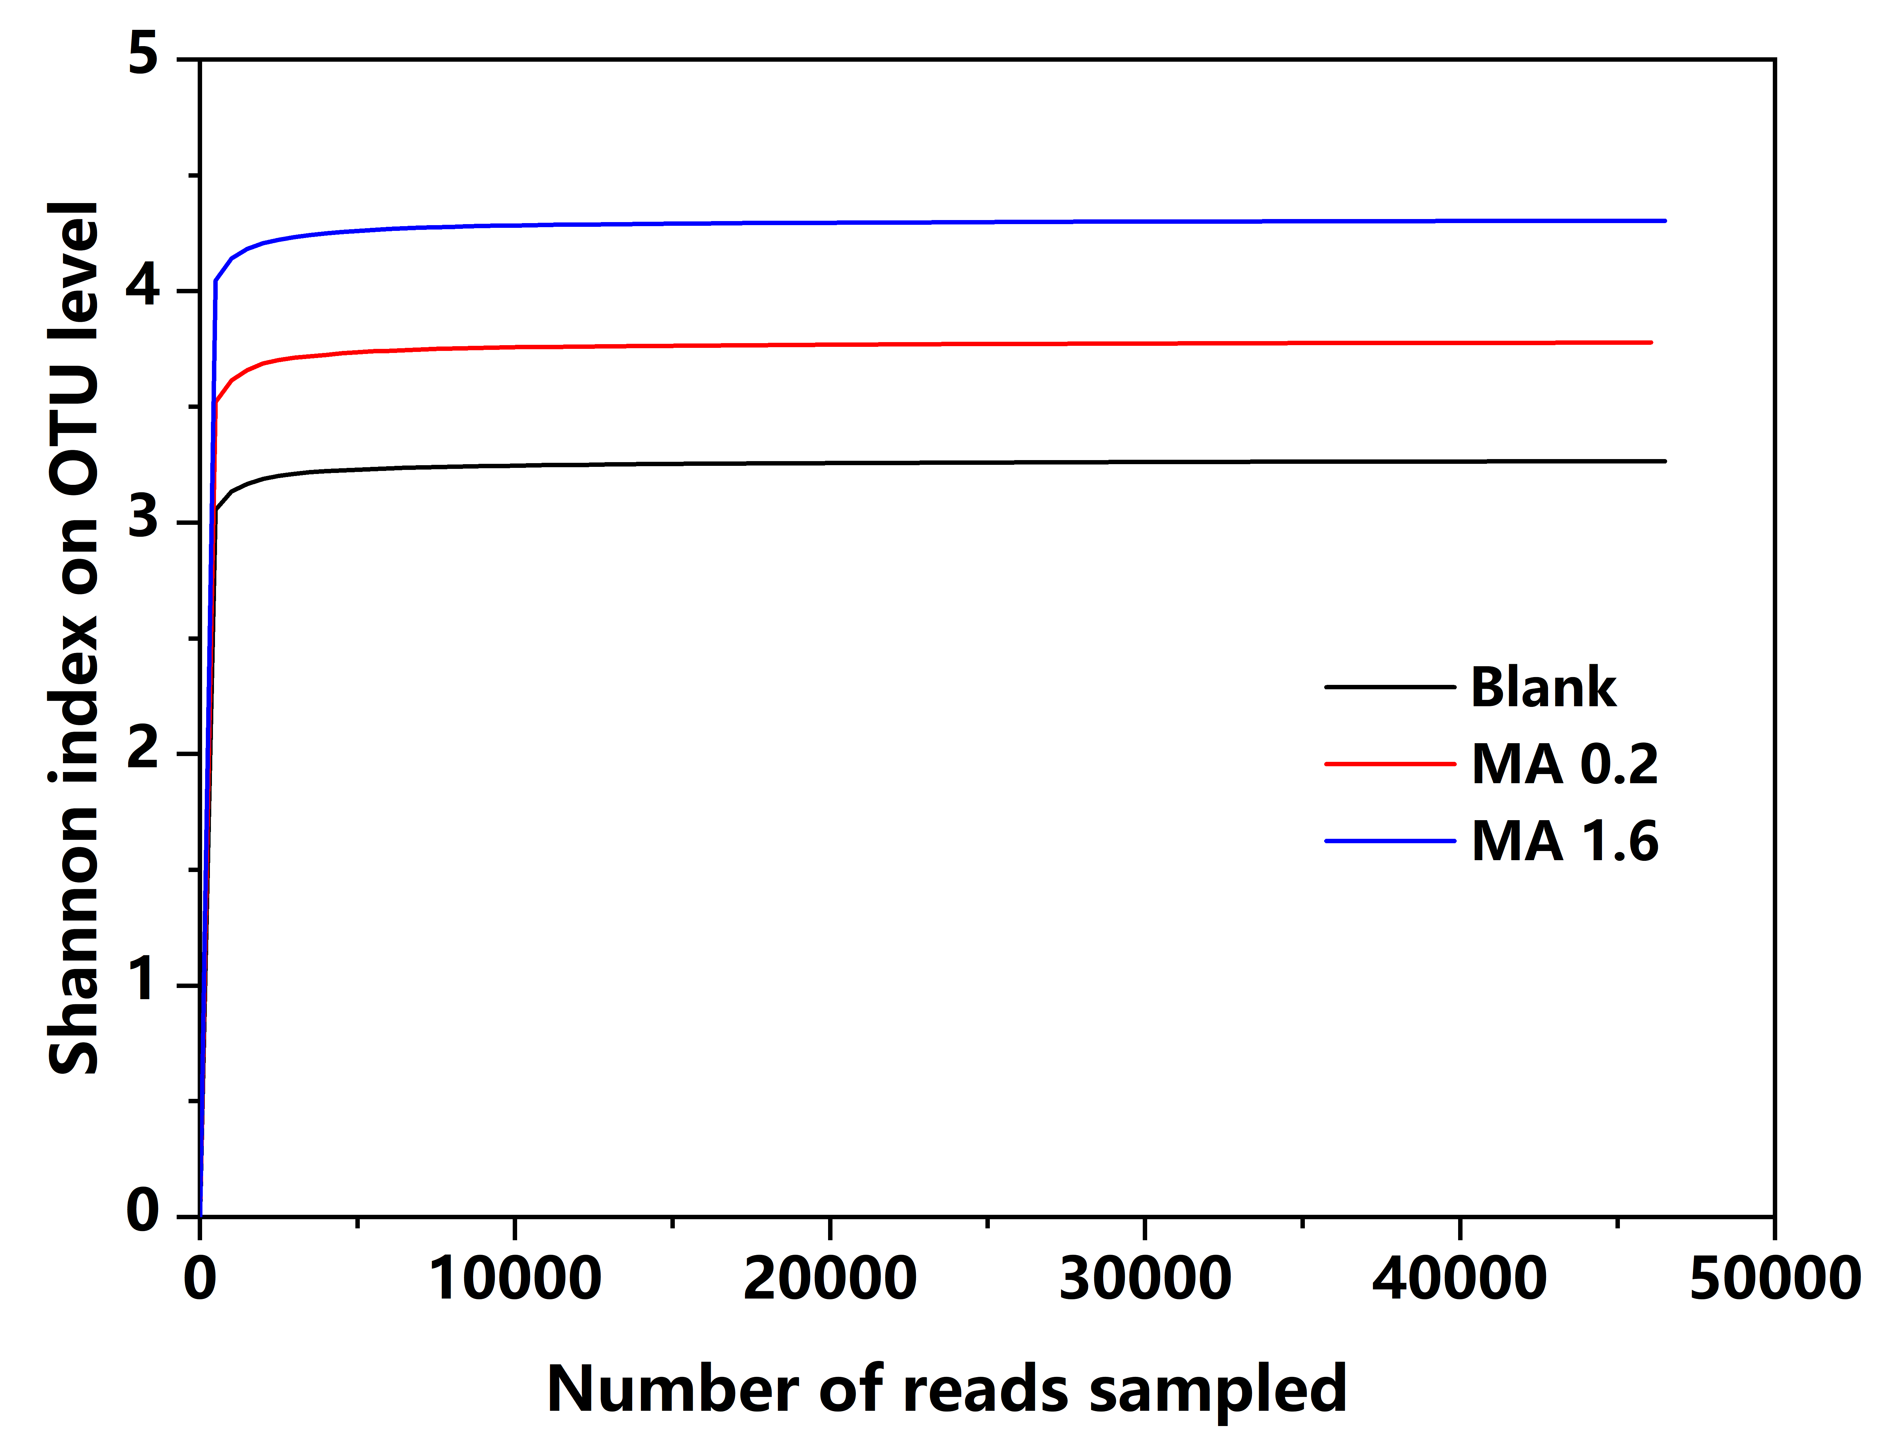
Fig. S3. Shannon index of bacteria in MA0, MA0.2 and MA1.6
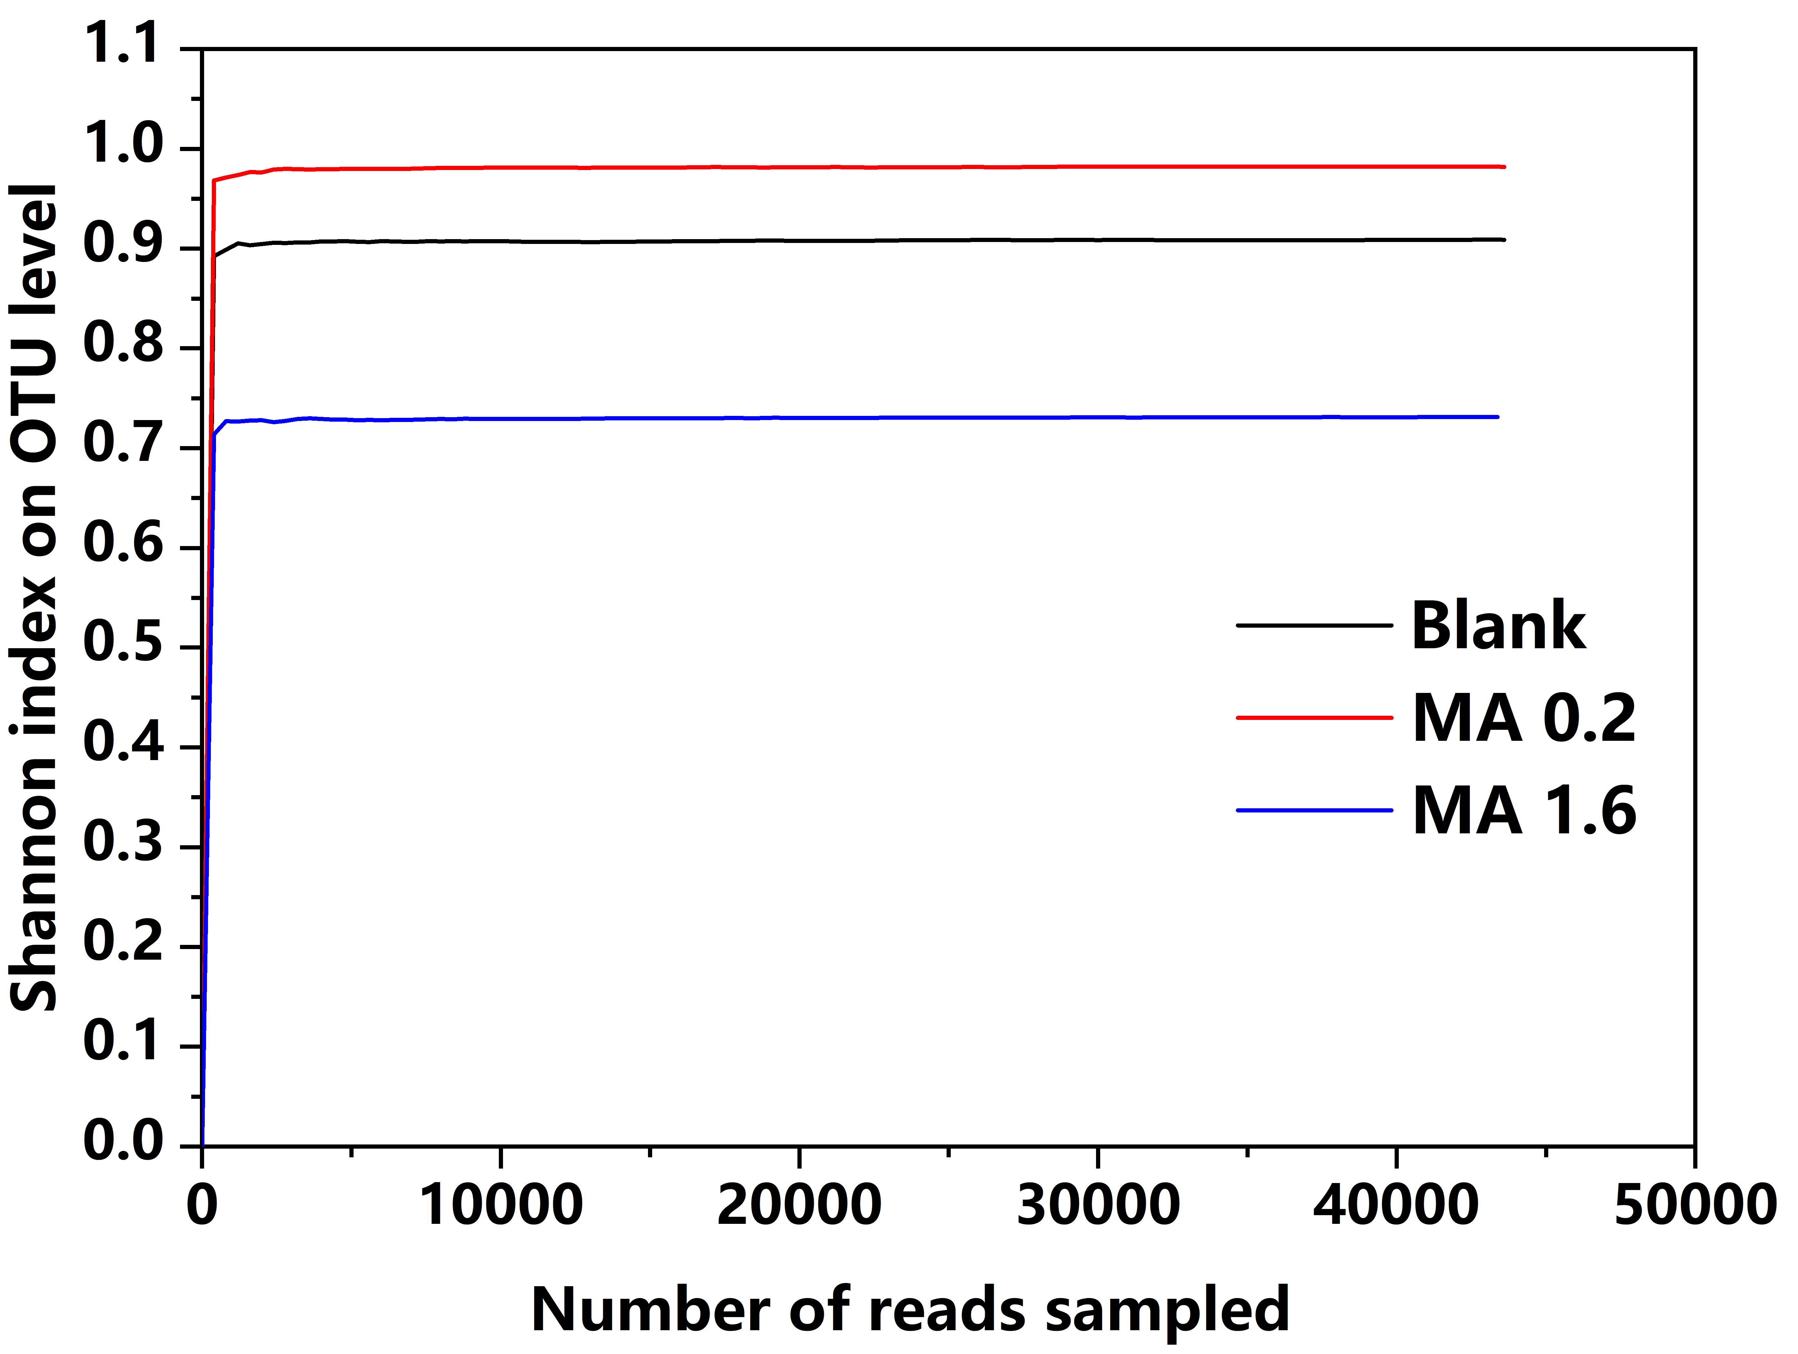
Fig. S4. Shannon index of methanogens in MA0, MA0.2 and MA1.6

∗ First author: Rong Zhu (7181401009@stu.jiangnan.edu.cn) Corresponding author: Hua Zou (zouhua@jiangnan.edu.cn) School of environment and civil engineering, Jiangnan University, Wuxi, Jiangsu province 214122, P. R. China Note: The authors declare no competing financial interest.

